#Assignment:Hive Assignment

#referral_id:DIRSS3134

#Name:Gauri Vijay Kolte

1.You need to check the data in case if the column contain null value so replace it with 0 or ‘ZERO’ based om the data type of the function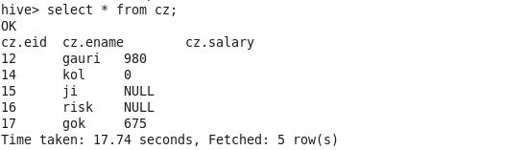

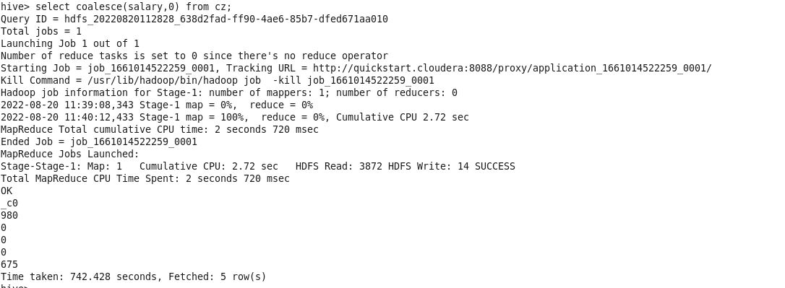

2.Now take a table which contain atleast four column as id, name, dept, salary

-in case if the person is having the salary less than 500 do a increament by 50%(hike)

-in case the salary is in between 5000 to 10000 hike the salary should be (25%) and other cases will be same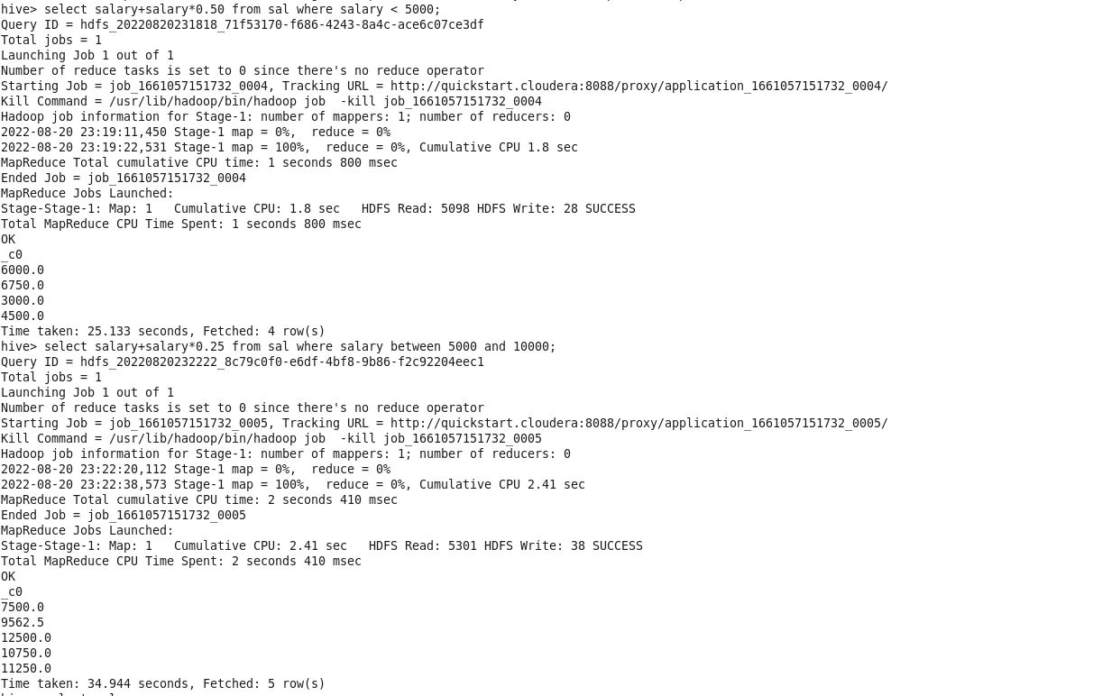

3.Know the difference between the joins operation and set operation like (union, intersect)

Join:

* Join is used to combine rows from two or more tables, based on a related column between them.
* There are 4 types of join: Inner Join, Left Join, Right join, Full Outer Join
* Inner join: Return records that have matching values join both tables
* Left join: Returns all records from left table, and matched records from the right table
* Right join: Returns all records from right table, and matched records from the left table
* Full join: Returns all records when there is match in either left or right table.

Set:

* Set operators are which is used to combine the information of similar type from one or more than one table set operator combine rows from distinct queries.
* Set Operator: Union, Union All, Intersect and minus
* This set operator is used to combine the outputs of two or more queries into a single set of rows and column having different records.
* Intersect: This set operator is available to retrieve the information which is common in both tables. The number of columns and data type, use be same in intersect set operator.

4.Try to implement the same kind of left, right and full outer join on the same employee and department

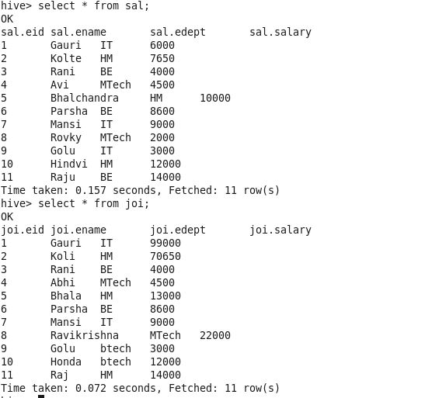

Left join

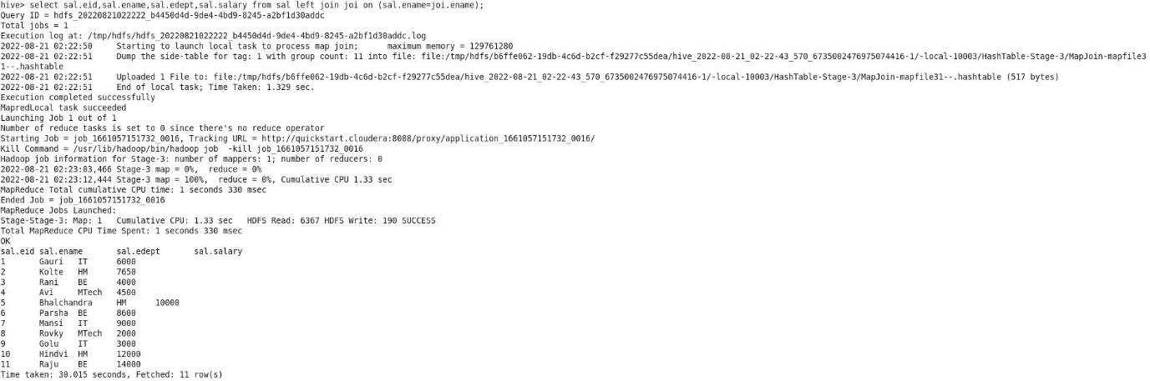

Right join

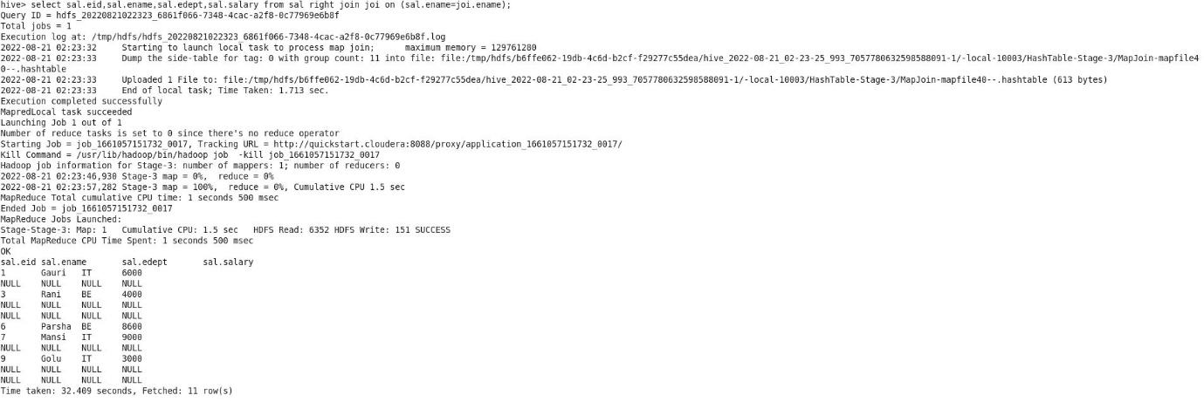

Full join

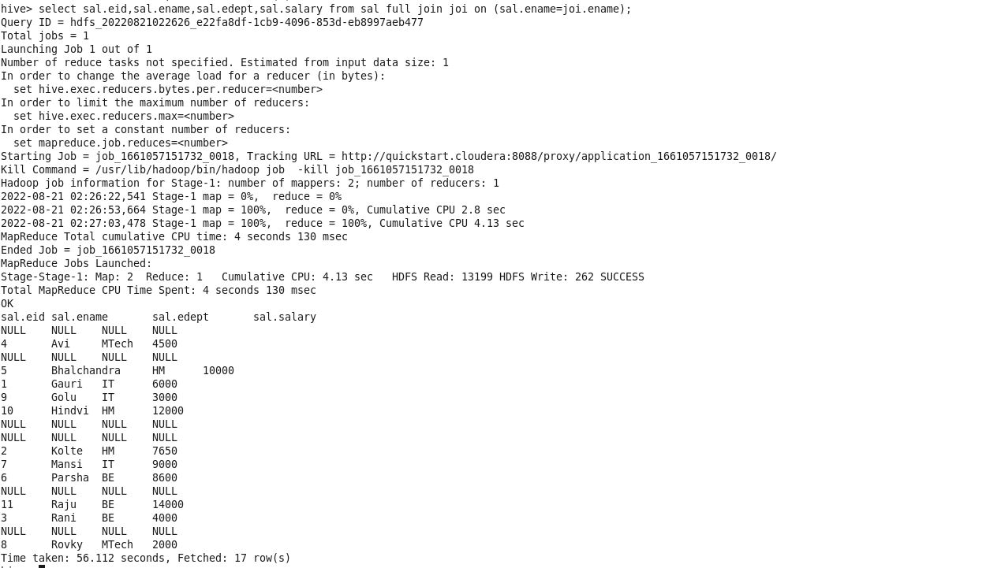

5.You need to create a view by joining the above two table in Q4

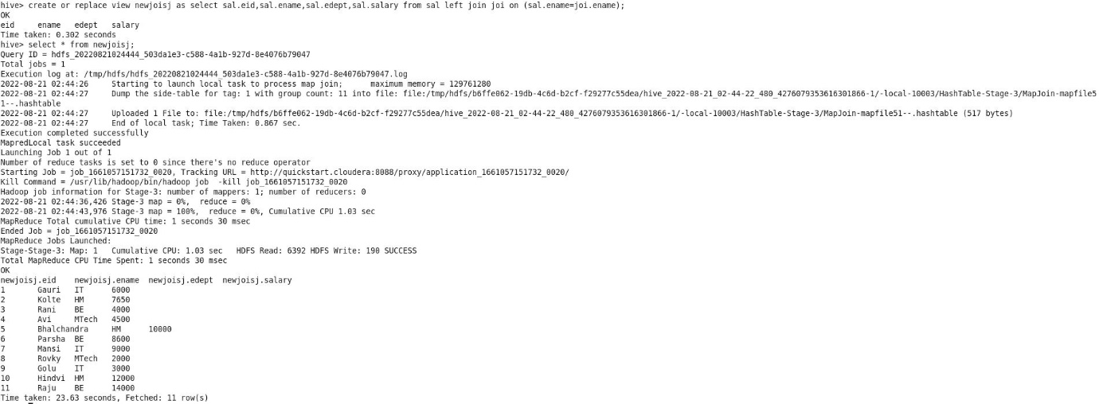

6.Try to alter the view by dropping certain columns

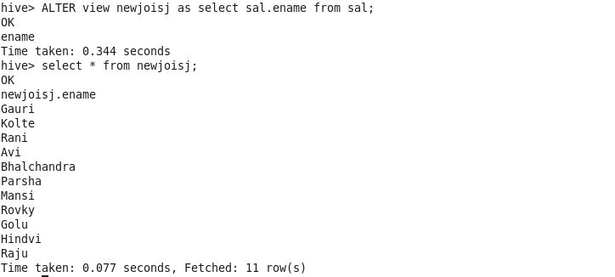

7.Try to change the name of your view without replacing it with the new creation

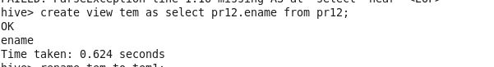

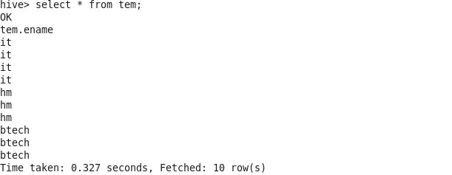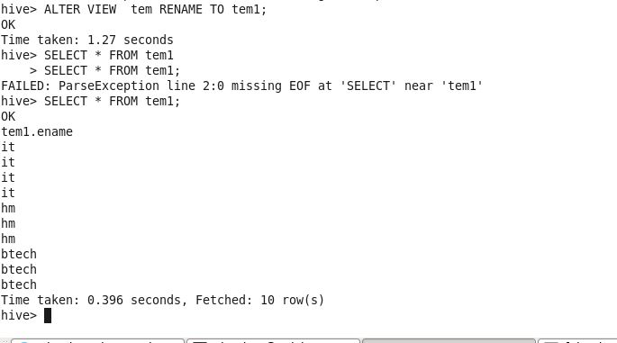

8.For any table try to change the column data type of any column from string to int.

