**VOTERCHAIN PROJECT**

**System analysis of a blockchain voting app**

**specifications requirements**

-The application should have three main components which are the mobile voter app, admin web interface and the smart contract.

-The smart contract will handle storage of voting data and also contain critical logic necessary for voting processes to be executed

-The admin web interface should be able to create an election

-The admin web interface should be able to register voters.

-The admin web interface should be able to provide realtime analytics of the voting exercise

-The mobile app should be able to allow the voter create a voting wallet

-The mobile app should be able to allow the voter import his or her existing voting wallet

-The mobile app should be able to provide realtime analytics of the voting exercise

-The mobile app should be able to allow the user to vote once and only once with his or her wallet address

**Use case Diagrams**

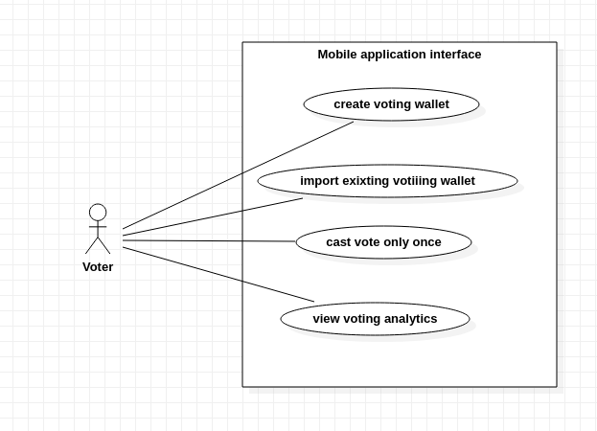

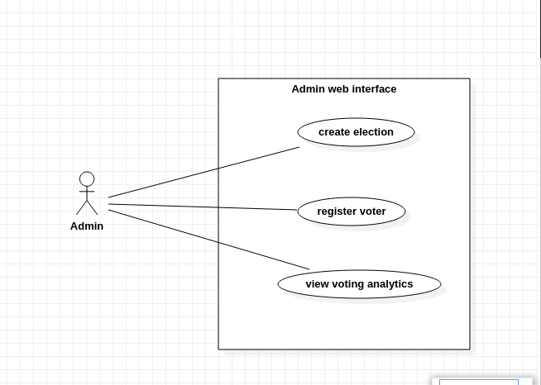

**Component Diagram**

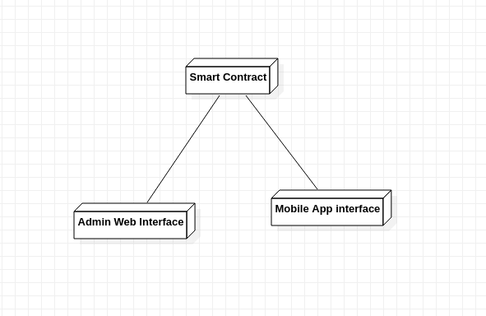

**Class Diagram**

