1.1
ASIC Application-Specific Integrated Circuit
CAD Computer-Aided Design
CD Compact Disc
CO Central Office
CPLD Complex Programmable Logic Device
DAT Digital Audio Tape
DIP Dual In-line Pin
DVD Digital Versatile Disc
FPGA Field-Programmable Gate Array
HDL Hardware Description Language
IC Integrated Circuit
IP Internet Protocol
LSI Large-Scale Integration
MCM Multichip Module
MSI Medium-Scale Integration
NRE Nonrecurring Engineering
PBX Private Branch Exchange
PCB Printed-Circuit Board
PLD Programmable Logic Device
PWB Printed-Wiring Board
SMT Surface-Mount Technology
SSI Small-Scale Integration
VHDL VHSIC Hardware Description Language
VLSI Very Large-Scale Integration

ASIC Application-Specific Integrated Circuit 专用集成电路
CAD Computer-Aided Design 计算机辅助设计
CPLD Complex Programmable Logic Device 复杂可编程逻辑器件
FPGA Field-Programmable Gate Array 现场可编程门阵列
HDL Hardware Description Language 硬件描述语言
IC Integrated Circuit 集成电路
IP Internet Protocol 互联网协议
LSI Large-Scale Integration 大规模集成
MCM Multichip Module 多芯片模块
SSI Small-Scale Integration 小规模集成
MSI Medium-Scale Integration 中规模集成
LSI Large-Scale Integration 大规模集成
VLSI Very Large-Scale Integration 超大规模集成
NRE Nonrecurring Engineering 非再现工程
PCB Printed-Circuit Board 印刷电路板
PLD Programmable Logic Device 可编程逻辑器件
SMT Surface-Mount Technology 表面安装技术
SSI Small-Scale Integration 小规模集成
VHDL VHSIC Hardware Description Language 超高速集成电路硬件描述语言
VLSI Very Large-Scale Integration 超大规模集成​

1.2
ABEL Advanced Boolean Equation Language
CMOS Complementary Metal-Oxide Semiconductor
JPEG Joint Photographic Experts Group
MPEG Moving Picture Experts Group
OK OK is based on a sort of joke. Someone pronounced the phrase “all correct” as “oll (or orl) correct,” and the same person or someone else spelled it “oll korrect,” which abbreviated gives us OK.
PERL According to some, it’s “Practical Extraction and Report Language.” But the relevant Perl FAQ entry, in perlfaq1.pod, says “never write ‘PERL’, because perl isn't really an acronym, apocryphal folklore and post-facto expansions notwithstanding.” (Thanks to Anno Siegel for enlightening me on this.)

1.3
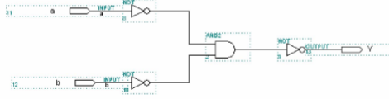
真值表：
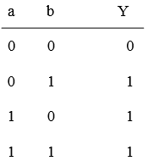
简化图：
