电子科技大学2011 -2012学年第 二 学期期 末 考试 A 卷

课程名称：_数字逻辑设计及应用__ 考试形式： 闭卷 考试日期： 20 12 年 07 月 02 日
考试时长：_120___分钟
课程成绩构成：平时 30 %， 期中 30 %， 实验 0 %， 期末 40 %
本试卷试题由___七__部分构成，共__6___页。

题号 | 一 | 二 | 三 | 四 | 五 | 六 | 七 | 八 | 九 | 十 | 合计
得分

得 分
I. Fill out your answers in the blanks (3’ X 10=30’)

1. The inputs of a full-adder are A =1, B=1, C_{in}=1. Then the output C_{out} is ( ).
2. If an 74x148 priority encoder has its 0, 2, 4, and 6 inputs at the active level, the active LOW binary output is ( ).
3. If an J-K flip-flop with J=1 and K=1 has a 10kHz clock input, the Q output is a ( ) Hz square wave.
4. A sequential circuit whose output depends on the state and inputs is called a ( ) state machine.
5. If we observed the waveforms of output Q₁、Q₂、Q₃ of three flip-fl0ps of a counter as the Figure 1, the modulo of the counter should be ( ).
CP
Q₁
Q₂
Q₃

Figure 1
6. State/output table for a sequential circuit is shown as table 1. X is input and Z_{n} is output. Assume that the initial state is S₀, if the input sequence is X=01011101, the output sequence should be ( ).
Table 2 Transition/output table
X  Q₂Q₁ | 0 | 1
00  01  10  11 | 10/1  00/0  01/0  10/0 | 01/0  10/0  00/1  00/0
Q₂*Q₁*/Y
Table 1 State/output table
X  S_{n} | 0 | 1
S₀  S₁  S₂  S₃ | S₀/1  S₁/0  S₂/0  S₂/0 | S₁/1  S₂/0  S₀/0  S₀/0
S_{n+1}/Z_{n}

7.Transition/output table for a sequential circuit is shown in Table 2, X is input and Y is output, the sequential circuit is a modulus ( ) up/down counter.
8. A 4-bit linear feedback shift-register (LFSR) counter with no self-correction can have ( ) normal states.
9. A serial sequence generator by feedback shift registers 74x194 is shown in Figure 2, assume the initial state is Q₂Q₁Q₀=110, the feedback function LIN = Q₂/Q₁/ + Q₂Q₀/, the output sequence in Q₂ is ( ).
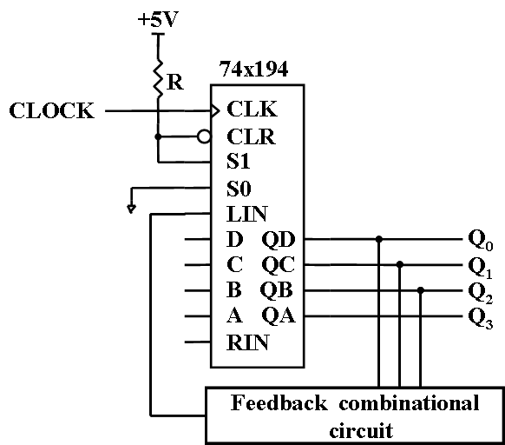

Figure 2
10. When the input is 01000000 of an 8 bit DAC, the corresponding output voltage is 2V. The output voltage range for the DAC is 0 ~ ( )V.

得 分

II. Please select the only one correct answer in the following questions.(2’ X 5=10’)

1. If a 74x85 magnitude comparator has ALTBOUT=AGTBOUT=0, AEQBOUT=1 on its outputs, the cascading inputs are ( ).
A) ALTBIN=0, AEQBIN=0, AGTBIN=0 B) ALTBIN=0, AEQBIN=1, AGTBIN=0
C) ALTBIN=1, AEQBIN=0, AGTBIN=1 D) ALTBIN=1, AEQBIN=1, AGTBIN=1
2. For an edge-triggered D flip-flop, ( ) is correct.
A) a change in the state of the flip-flop can only at a clock pulse edge
B) the state that the flip-flop goes to depends on the D input
C) the output follows the input at each clock pulse
D) all of these answers
3. An asynchronous counter differs from a synchronous in ( ).
A) the number of states in its sequence B) the method of clocking
C) the type of flip-flop used D) the value of the modulus
4. A modulus-10 Johnson counter requires ( ).
A) ten flip-flops B) four flip-flops C) five flip-flops D) twelve flip-flops
5. The capacity of a memory that has 10 bits address bus and can store 8 bits at each address is ( ).
A) 1024 B) 8192 C) 80 D) 256
得 分

III. A D Latch and a D Flip-flop are shown in Figure 3. The waveforms of a clock CP and an input D are shown in Figure 4. Assume the initial state of Q is 1. Try to draw the waveforms of Q of the D Latch and the D Flip-flop. Ignore the delay of the circuit. (15’ )

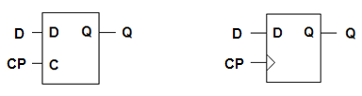
Figure 3
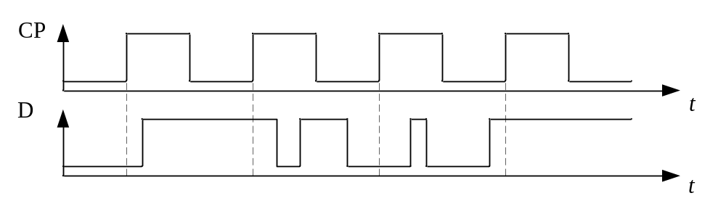
Figure 4

得 分

IV. Analyze the clocked synchronous state machine shown in Figure 5. (15’)
- Write out the excitation equations, the state transition equations and the output equations of the circuit. (5’)
- Fill out the transition/output table, and draw the state transition/output diagram, determine whether the circuit can start itself automatically. (8’)
- Describe the logic function of the FSM.(2’)
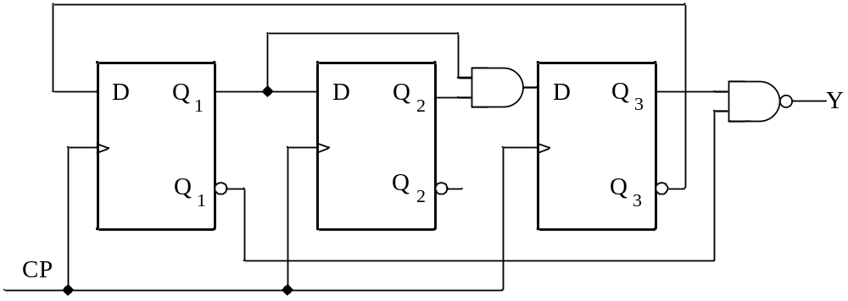
Figure 5
The transition /output table:
Q3Q2Q1 | Q3*Q2*Q1* | Y
000
001
010
011
100
101
110
111

得 分

V. Design a variable modulus counter only with 74x163, which will be a module-6 counter when the input control signal M = 1 or a module-8 counter when M = 0. The states of module-6 counter should be（0,11,12,13,14,15）.The states of module-8 counter should be (0,9,10,11,12,13,14,15）. (10’)
- Please write out the input equations of LD_L, A, B, C, D. ( 5’)
- Draw the circuit linked line of 74x163. (5’)

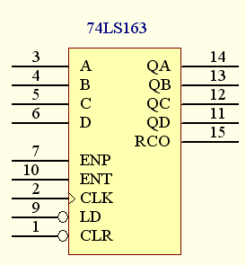

74X163的功能表
输入 |  |  |  | 当前状态 | 下一状态 | 输出
CLR_L | LD_L | ENT | ENP | QD QC QB QA | QD* QC* QB* QA* | RCO
0 | X | X | X | X X X X | 0 0 0 0 | 0
1 | 0 | X | X | X X X X | D C B A | 0
1 | 1 | 0 | X | X X X X | QD QC QB QA | 0
1 | 1 | X | 0 | X X X X | QD QC QB QA | 0
1 | 1 | 1 | 1 | 0 0 0 0 | 0 0 0 1 | 0
1 | 1 | 1 | 1 | 0 0 0 1 | 0 0 1 0 | 0
1 | 1 | 1 | 1 | 0 0 1 0 | 0 0 1 1 | 0
1 | 1 | 1 | 1 | 0 0 1 1 | 0 1 0 0 | 0
1 | 1 | 1 | 1 | …………. | ………….. | 0
1 | 1 | 1 | 1 | 1 1 1 1 | 0 0 0 0 | 1

得 分

VI. Fill out the state/output table for a Mealy machine that can detect the pattern 01010 or 01110 . The output Z=1 when the pattern is detected. Your model should also be able to detect overlapping sequences. (10’)
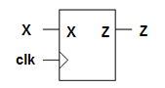
State/output table
State meaning | S | X
State meaning | S | 0 | 1
Initial state | A
 | B
 | C
 | D
 | E
 | F
 | G
 |  | S*, Z

得 分

VII. The transition equations and output equitation of a clocked synchronous state machine is shown as bellows. Please fill out the transition/output table and the state/output table. The states Q1 Q0=00~11, use the state name A~D. [10']

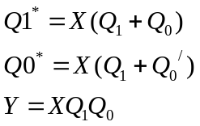
Transition/output table
Q1Q0 | X
Q1Q0 | 0 | 1
00
01
10
11
 | Q1*Q0*,Y

State/output table
S | X
S | 0 | 1
A
B
C
D
 | S*,Y

参考解答
电子科技大学2011 -2012学年第 二 学期期 末 考试 A 卷

课程名称：_数字逻辑设计及应用__ 考试形式： 闭卷 考试日期： 20 12 年 07 月 02 日
考试时长：_120___分钟
课程成绩构成：平时 30 %， 期中 30 %， 实验 0 %， 期末 40 %
本试卷试题由___六__部分构成，共__6___页。

题号 | 一 | 二 | 三 | 四 | 五 | 六 | 七 | 八 | 九 | 十 | 合计
得分

得 分
I. Fill out your answers in the blanks (3’ X 10=30’)

1. The inputs of a full-adder are A =1, B=1, C_{in}=1. Then the output C_{out} is ( 1 ).
2. If an 74x148 priority encoder has its 0, 2, 4, and 6 inputs at the active level, the active LOW binary output is ( 001 ).
3. If an J-K flip-flop with J=1 and K=1 has a 10kHz clock input, the Q output is a ( 5k ) Hz square wave.
4. A sequential circuit whose output depends on the state and inputs is called a ( Mealy ) state machine.
5. If we observed the waveforms of output Q₁、Q₂、Q₃ of three flip-fl0ps of a counter as the Figure 1, the modulo of the counter should be ( 6 ).
CP
Q₁
Q₂
Q₃

Figure 1
6. State/output table for a sequential circuit is shown as table 1. X is input and Z_{n} is output. Assume that the initial state is S₀, if the input sequence is X=01011101, the output sequence should be ( 11000100 ).
Table 2 Transition/output table
X  Q₂Q₁ | 0 | 1
00  01  10  11 | 10/1  00/0  01/0  10/0 | 01/0  10/0  00/1  00/0
Q₂*Q₁*/Y
Table 1 State/output table
X  S_{n} | 0 | 1
S₀  S₁  S₂  S₃ | S₀/1  S₁/0  S₂/0  S₂/0 | S₁/1  S₂/0  S₀/0  S₀/0
S_{n+1}/Z_{n}

7.Transition/output table for a sequential circuit is shown in Table 2, X is input and Y is output, the sequential circuit is a modulus ( 3 ) up/down counter.
8. A 4-bit linear feedback shift-register (LFSR) counter with no self-correction can have ( 15 ) normal states.
9. A serial sequence generator by feedback shift registers 74x194 is shown in Figure 2, assume the initial state is Q₂Q₁Q₀=110, the feedback function LIN = Q₂/Q₁/ + Q₂Q₀/, the output sequence in Q₂ is ( 110100 ).

Figure 2
10. When the input is 01000000 of an 8 bit DAC, the corresponding output voltage is 2V. The output voltage range for the DAC is ( 0 ~ 7.97 )V.

得 分

II. Please select the only one correct answer in the following questions.(2’ X 5=10’)

1. If a 74x85 magnitude comparator has ALTBOUT=AGTBOUT=0, AEQBOUT=1 on its outputs, the cascading inputs are ( B ).
A) ALTBIN=0, AEQBIN=0, AGTBIN=0 B) ALTBIN=0, AEQBIN=1, AGTBIN=0
C) ALTBIN=1, AEQBIN=0, AGTBIN=1 D) ALTBIN=1, AEQBIN=1, AGTBIN=1
2. For an edge-triggered D flip-flop, ( D ) is correct.
A) a change in the state of the flip-flop can only at a clock pulse edge
B) the state that the flip-flop goes to depends on the D input
C) the output follows the input at each clock pulse
D) all of these answers
3. An asynchronous counter differs from a synchronous in ( B ).
A) the number of states in its sequence B) the method of clocking
C) the type of flip-flop used D) the value of the modulus
4. A modulus-10 Johnson counter requires ( C ).
A) ten flip-flop B) four flip-flop C) five flip-flop D) twelve flip-flop
5. The capacity of a memory that has 10 bits address bus and can store 8 bits at each address is ( B ).
A) 1024 B) 8192 C) 80 D) 256

得 分

III. A D Latch and a D Flip-flop are shown in Figure 3. The waveforms of a clock CP and an input D are shown in Figure 4. Assume the initial state of Q is 1. Try to draw the waveforms of Q of the D Latch and the D Flip-flop. Ignore the delay of the circuit. (15’ )

Figure 3

Figure 4
Answer:
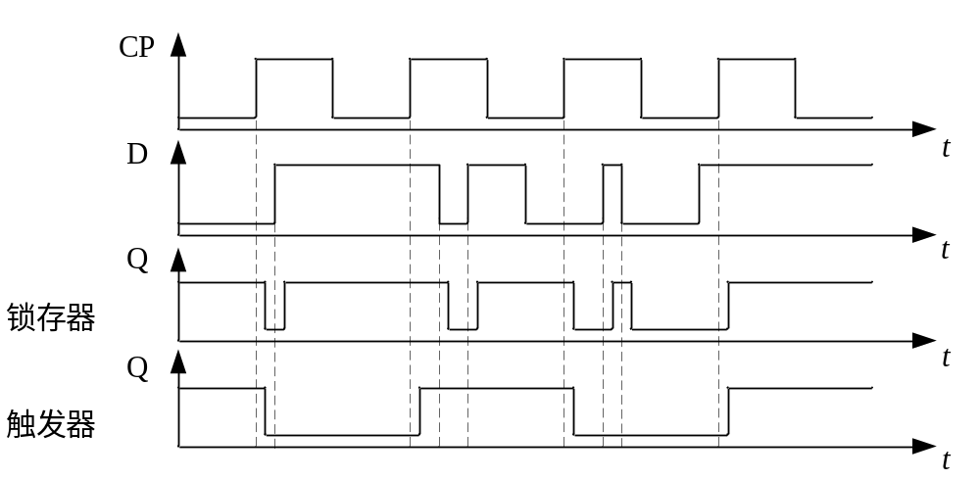
In the waveform of the output, the delay of the gate circuit has been taken into consideration.

得 分

IV. Analyze the clocked synchronous state machine shown in Figure 5. (15’)
- Write out the excitation equations, the state transition equations and the output equations of the circuit. (5’)
- Fill out the transition/output table, and draw the state transition/output diagram, determine whether the circuit can start itself automatically. (8’)
- Describe the logic function of the FSM.(2’)
Figure 5
Solution：
（1）The excitation equation:
D1=Q3’, D2=Q1, D3=Q1Q2
The state equation and the output equation:
Q1*=D1=Q3’, Q2*=D2=Q1, Q3*=D3=Q1Q2, Y=(Q3Q1’)’=Q3’+Q1
（2）The transition /output table:
Q3Q2Q1 | Q3*Q2*Q1* | Y
000 | 001 | 1
001 | 011 | 1
010 | 001 | 1
011 | 111 | 1
100 | 000 | 0
101 | 010 | 1
110 | 000 | 0
111 | 110 | 1
The sate transition /output diagram:
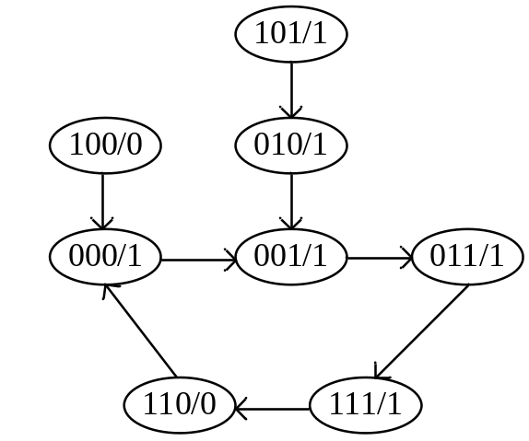
Since all the unused states can enter the asserted state after several states transition, it can start itself automatically.
(3) This circuit is a mould-5 counter.

得 分

V. Design a variable modulus counter only with 74x163, which will be a module-6 counter when the input control signal M = 1 or a module-8 counter when M = 0. The states of module-6 counter should be（11,12,13,14,15,0）.The states of module-8 counter should be (9,10,11,12,13,14,15,0）. (10’)
- Please write out the input equations of LD_L, A, B, C, D. ( 5’)
- Draw the circuit line linked of 74x163.(5’)

74X163的功能表
输入 |  |  |  | 当前状态 | 下一状态 | 输出
CLR_L | LD_L | ENT | ENP | QD QC QB QA | QD* QC* QB* QA* | RCO
0 | X | X | X | X X X X | 0 0 0 0 | 0
1 | 0 | X | X | X X X X | D C B A | 0
1 | 1 | 0 | X | X X X X | QD QC QB QA | 0
1 | 1 | X | 0 | X X X X | QD QC QB QA | 0
1 | 1 | 1 | 1 | 0 0 0 0 | 0 0 0 1 | 0
1 | 1 | 1 | 1 | 0 0 0 1 | 0 0 1 0 | 0
1 | 1 | 1 | 1 | 0 0 1 0 | 0 0 1 1 | 0
1 | 1 | 1 | 1 | 0 0 1 1 | 0 1 0 0 | 0
1 | 1 | 1 | 1 | …………. | ………….. | 0
1 | 1 | 1 | 1 | 1 1 1 1 | 0 0 0 0 | 1

【Solution】：the input equations:
LD_L=Q3
D=A=1
C=0
B=M
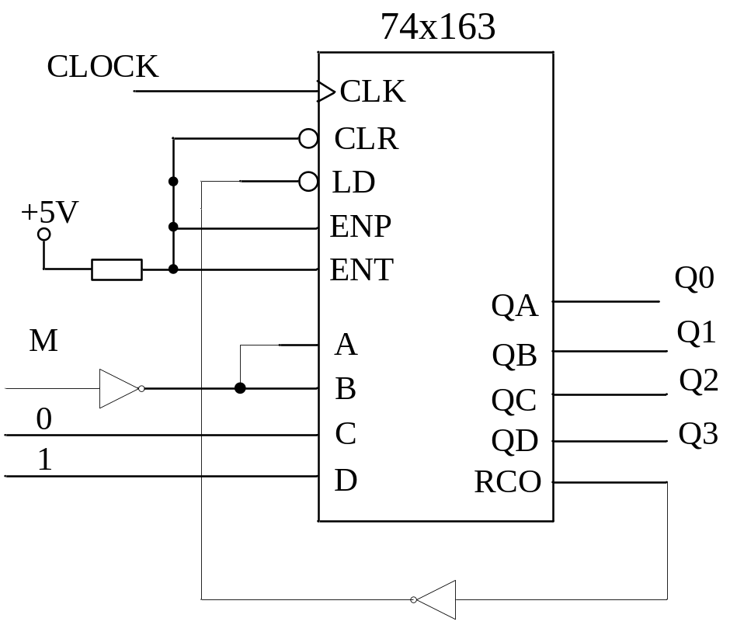

得 分

VI. Write out the state/output table for a Mealy machine that can detect the pattern 01010 or 01110 . The output Z=1 when the pattern is detected. Your model should also be able to detect overlapping sequences. (10’)
State meaning | S | X
State meaning | S | 0 | 1
Initial state | A | B, 0 | A, 0
Got 0 | B | B, 0 | C, 0
Got 01 | C | D, 0 | E, 0
Got 010 | D | B, 0 | F, 0
Got 011 | E | B, 0 | G, 0
Got 0101 | F | D, 1 | E, 0
Got 0111 | G | B, 1 | A, 0
 |  | S*, Z

得 分

VII. The transition equations and output equitation of a clocked synchronous state machine is shown as bellows. (10’) Please fill out the transition/output table and the state/output table. [10']

Transition/output table
Q1Q0 | X
Q1Q0 | 0 | 1
00 | 00,0 | 01,0
01 | 00,0 | 10,0
10 | 00,0 | 11,0
11 | 00,0 | 11,1
 | Q1*Q0*,Y

State/output table
S | X
S | 0 | 1
A | A,0 | B,0
B | A,0 | C,0
C | A,0 | D,0
D | A,0 | D,1
 | S*,Y

