电子科技大学2011-2012学年第 二 学期期 末 考试 B 卷

课程名称：_数字逻辑设计及应用__ 考试形式： 闭卷 考试日期： 20 12 年 7 月 2 日 考试时长：_120___分钟
课程成绩构成：平时 30 %， 期中 30 %， 实验 0 %， 期末 40 %
本试卷试题由__六___部分构成，共__6___页。

题号 | 一 | 二 | 三 | 四 | 五 | 六 | 七 | 八 | 九 | 十 | 合计
得分

得 分
I. Fill your answers in the blanks (2’ X 15=30’)

- If the two adders of a 4-bit binary adder 74x283 （Figure 1.）are (1010)_{two’s} and (1101)_{two’s}, its sum is not overflow. Then its input C₀ should be （ ）, its sum S3S2S1S0= ( ) _{two’s} .

74x283
C0
A0
B0
A1
B1
A2
B2
A3
B3
S0
S1
S2
S3
C4
7
5
6
3
2
14
15
12
11
4
1
13
10
9
Figure 1.
- A circuit with 4 flip-flops can store ( ) bit binary numbers, that is, include ( ) states at most.
- If 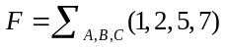, then F^{D} =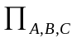( ), and 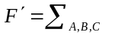( ).
- A modulo-20 counter circuit needs ( ) D filp-flops at least. A modulo-196 counter circuit needs ( ) 4-bit counters of 74x163 at least.
- An 8-bit ring counter has ( ) normal states. If we want to realize the same number normal states, we need a ( ) bit twisted-ring counter.
- To design a "01101100" serial sequence generator by shift registers, we need a ( )-bit shift register as least.
- A sequential circuit whose output depends on the states and inputs is called a ( ) state machine.
- A 8×4 ROM stores a truth table of combinational logic function. This combinational logic function has ( ) inputs and ( ) outputs.
- The state diagram of a Moore state machine is shown as Figure 2. If the initiate state Q3Q2Q1Q0 is 1001, the output sequence of Q3 is （ ）.
1001
0011
0111
1111
1110
1100
Figure 2.

得 分
II. Please select the only one correct answer in the following questions.(2’ X 5=10)

1. For Johnson counter and ring counter, ( ) is correct.
A. An n-bit ring counter has 2n active states.
B. An n-bit Johnson counter has 2n active states.
C. An n-bit ring counter has 2^{n}-2n active states.
D. An n-bit Johnson counter has 2^{n}-n active states.
2. Using 4-bit synchronous binary counter 74x163 or decade counter 74x162 to design a counter from 0 to 193, ( ) is correct.
A. It needs at least three 74x163.
B. It needs at least three 74x162.
C. It needs at least two 74x162.
D. It needs at least four 74x163.
3. For the disposition of unused states, ( ) is not correct.
A. In minimal risk, the next state of the unused state is marked as “don’t-cares d”.
B. Minimal risk can get a self-correct circuit.
C. Minimal cost can get a simplest circuit.
D. In minimal cost, the next state of the unused state is marked as “don’t-cares d”.
4. If the next state of an edge-triggered J-K flip-flop is “0”, then which of following is not the possible of (J, K) ( )
A. (0, 0) B. (0, 1) C. (1, 1) D. (1, 0)
5. There is a state/output table of a sequential machine as the table 1, what the input sequences is detected? ( )
A. 11110 B. 11010 C. 10110 D. 10010
Table 1
S | X
S | 0 | 1
A | A,0 | B,0
B | C,0 | B,0
C | A,0 | D,0
D | C,0 | E,0
E | C,1 | B,0
 | S*,Z

得 分

III.There is a logic circuit and the inputs A, B and C are corresponding to the outputs F_{A}, F_{B} and F_{C .}The waveforms of inputs and outputs are shown in Fig. 3. Analyze the circuit. [15’]
- Fill out the truth table. [9’]
- Write out the expression of the outputs F_{A}, F_{B} and F_{C.} [6’]
Fig. 3
A
B
C
F_{A}
F_{B}
F_{C}
A | B | C | F_{A} | F_{B} | F_{C}
0 | 0 | 0
0 | 0 | 1
0 | 1 | 0
0 | 1 | 1
1 | 0 | 0
1 | 0 | 1
1 | 1 | 0
1 | 1 | 1

IV. Analyze the clocked synchronous state machine shown in Fig. 4. [15’]
得 分
- Write out the excitation equations and output equation of the circuit. [5’]
- Fill out the transition/output table. [10’]
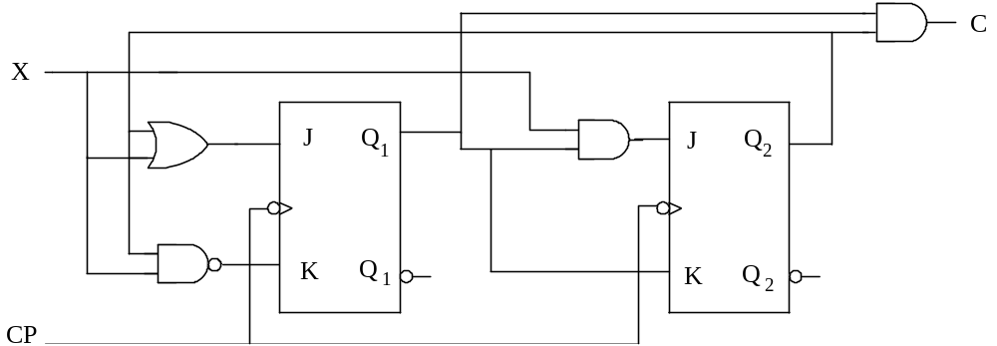
Fig. 4

The transition/output table:
Q2Q1 | X | C
Q2Q1 | 0 1 | C
00
01
10
11
 | Q2*Q1*

V. Design a clock synchronous state machine with D Flip-Flops. Its state/output table is shown in Table. 2. The state assignment are A: Q₁Q₂=00，B: Q₁Q₂=01，C: Q₁Q₂=11，D: Q₁Q₂=10. [15’]
得 分
(1). Write out the transition/output table. [6’]
(2). Write out the excitation equations and the output equation. [9’]
Table.2 state/output table transition/output table
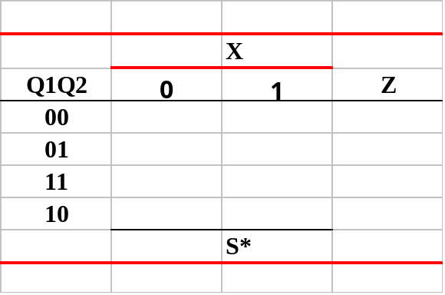

VI. Design a sequence signal “110010” generator only with 74x163 and 74x151. [15’]
得 分
(1). Write out the input equation of LD_L and the load value “DCBA”. [4’]
(2). Finish the uncompleted link lines of circuit shown in Fig. 5. [11’]
(Note: a. only with 74x163 and 74x151, no other gates; b. the initial state QDQCQBQA=0000)
74X163的功能表
输入 |  |  |  | 当前状态 | 下一状态 | 输出
CLR_L | LD_L | ENT | ENP | QD QC QB QA | QD* QC* QB* QA* | RCO
0 | X | X | X | X X X X | 0 0 0 0 | 0
1 | 0 | X | X | X X X X | D C B A | 0
1 | 1 | 0 | X | X X X X | QD QC QB QA | 0
1 | 1 | X | 0 | X X X X | QD QC QB QA | 0
1 | 1 | 1 | 1 | 0 0 0 0 | 0 0 0 1 | 0
1 | 1 | 1 | 1 | 0 0 0 1 | 0 0 1 0 | 0
1 | 1 | 1 | 1 | 0 0 1 0 | 0 0 1 1 | 0
1 | 1 | 1 | 1 | 0 0 1 1 | 0 1 0 0 | 0
1 | 1 | 1 | 1 | …………. | ………….. | 0
1 | 1 | 1 | 1 | 1 1 1 1 | 0 0 0 0 | 1

74x151 的真值表
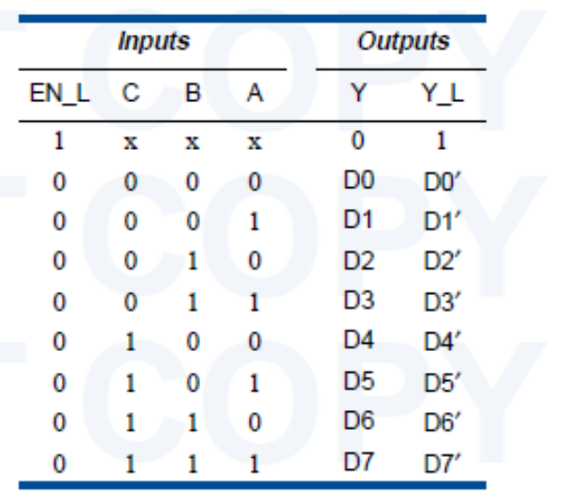

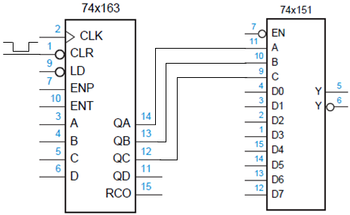
Fig. 5

参考解答
电子科技大学2011-2012学年第 二 学期期 末 考试 B 卷

课程名称：_数字逻辑设计及应用_考试形式： 闭卷 考试日期：20 12 年 7 月 2 日 考试时长：120_分钟
课程成绩构成：平时 30 %， 期中 30 %， 实验 0 %， 期末 40 %
本试卷试题由__六___部分构成，共__6___页。

题号 | 一 | 二 | 三 | 四 | 五 | 六 | 七 | 八 | 九 | 十 | 合计
得分

得 分
I. Fill your answers in the blanks (2’ X 15=30’)

- If the two adders of a 4-bit binary adder 74x283 （Figure 1.）are (1010)_{two’s} and (1101)_{two’s}, its sum is not overflow, its input C₀ is （ 1 ）, its sum S3S2S1S0= ( 1000 )_{two’s} .

74x283
C0
A0
B0
A1
B1
A2
B2
A3
B3
S0
S1
S2
S3
C4
7
5
6
3
2
14
15
12
11
4
1
13
10
9
Figure 1.
- A circuit with 4 flip-flops can store ( 4 ) bit binary numbers, that is, include ( 16 ) states at most.
- If , then F^{D} =( 0，2，5，6 ), and ( 0，3，4，6 ).
- A modulo-20 counter circuit needs ( 5 ) D filp-flops at least. A modulo-196 counter circuit needs ( 2 ) 4-bit counters of 74x163 at least.
- A 8-bit ring counter has ( 8 ) normal states. If we want to realize the same number normal states, we need a ( 4 ) bit twisted-ring counter.
- To design a "01101100" serial sequence generator by shift registers, we need a ( 5 )-bit shift register as least.
- A sequential circuit whose output depends on the states and inputs is called a ( Mealy ) state machine.
- A 8×4 ROM stores a truth table of combinational logic function. This combinational logic function has ( 3 ) inputs and ( 4 ) outputs.
- The state diagram of a Moore state machine is shown as Figure 2. If the initiate state Q3Q2Q1Q0 is 1001, the output sequence of Q3 is （ 100111 ）.
1001
0011
0111
1111
1110
1100
Figure 2.

得 分
II. Please select the only one correct answer in the following questions.(2’ X 5=10)

- 1. For Johnson counter and ring counter, ( B ) is correct.
- A. A n-bit ring counter has 2n active states.
- B. A n-bit Johnson counter has 2n active states.
- C. A n-bit ring counter has 2^{n}-2n active states.
- D.A n-bit John counter has 2^{n}-n active states.

- 2. Using 4-bit synchronous binary counter 74x163 or decade counter 74x162 to design a counter from 0 to 193, ( B ) is correct.
- A. It needs at least three 74x163.
- B. It needs at least three 74x162.
- C. It needs at least two 74x162.
- D. It needs at least four 74x163.
- 3. For the disposition of unused states, ( A ) is not correct.
- A. In minimal risk, the next state of the unused state is marked as “don’t-cares d”.
- B. Minimal risk can get a self-correct circuit.
- C. Minimal cost can get a simplest circuit.
- D. In minimal cost, the next state of the unused state is marked as “don’t-cares d”.

4. If the next state of an edge-triggered J-K flip-flop is “0”, then which of following is not the possible (J, K) ( D )
A) (0, 0) B) (0, 1) C) (1, 1) D) (1, 0)
5. There is a state/output table of a sequential machine as the table 1, what the input sequences is detected? ( C )
A) 11110 B) 11010 C) 10110 D) 10010
S | X
S | 0 | 1
A | A,0 | B,0
B | C,0 | B,0
C | A,0 | D,0
D | C,0 | E,0
E | C,1 | B,0
 | S*,Z
Table 1

得 分

- There is a logic circuit and the inputs A, B and C are corresponding to the outputs F_{A}, F_{B} and F_{C .}The waveforms of inputs and outputs are shown in Fig. 1. Analyze the circuit. [15’]
- Fill out the truth table. [9’]
- Write out the expression of the outputs F_{A}, F_{B} and F_{C.} [6’]
A
B
C
F_{A}
F_{B}
F_{C}
A | B | C | F_{A} | F_{B} | F_{C}
0 | 0 | 0
0 | 0 | 1
0 | 1 | 0
0 | 1 | 1
1 | 0 | 0
1 | 0 | 1
1 | 1 | 0
1 | 1 | 1
Fig.1 1
A | B | C | F_{A} | F_{B} | F_{C}
0 | 0 | 0 | 0 | 0 | 0
0 | 0 | 1 | 0 | 0 | 1
0 | 1 | 0 | 0 | 1 | 0
0 | 1 | 1 | 0 | 0 | 1
1 | 0 | 0 | 1 | 0 | 0
1 | 0 | 1 | 0 | 0 | 1
1 | 1 | 0 | 0 | 1 | 0
1 | 1 | 1 | 0 | 0 | 1

F_{A}= AB’C’
F_{B}= BC’
F_{C}= C

- Analyze the clocked synchronous state machine shown in Fig. 2. [15’]
得 分
- Write out the excitation equations and output equation of the circuit. [5’]
- Fill out the transition/output table. [10’]
Fig. 2

The transition/output table:
Q2Q1 | X | C
Q2Q1 | 0 1 | C
00
01
10
11
 | Q2*Q1*
Q2Q1 | X | C
Q2Q1 | 0 1 | C
00 | 0 0 0 1 | 0
01 | 0 0 1 0 | 0
10 | 1 1 1 1 | 0
11 | 0 0 0 1 | 1
 | Q2*Q1*

激励方程：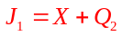 ; 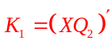 ; 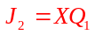 ; 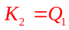 ;
输出方程：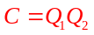

V. Design a clock synchronous state machine with D Flip-Flops. Its state/output table is shown in Table. 2. The state assignment are A: Q₁Q₂=00，B: Q₁Q₂=01，C: Q₁Q₂=11，D: Q₁Q₂=10. [15’]
得 分
(1). Write out the transition/output table. [6’]
(2). Write out the excitation equations and the output equation. [9’]
- 转移输出表为：
Table.2 state/output table

- 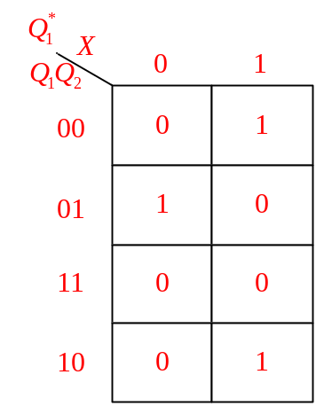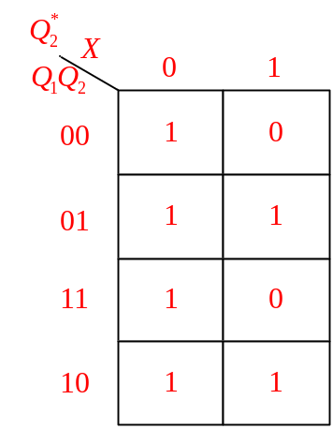方程

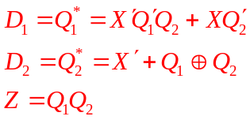

VI. Design a sequence signal “110010” generator only with 74x163 and 74x151. [15’]
得 分
(1). Write out the input equation of LD_L and the load value “DCBA”. [4’]
(2). Finish the uncompleted link lines of circuit shown in Fig. 3. [11’]
(Note: a. only with 74x163 and 74x151, no other gates; b. the initial state QDQCQBQA=0000)
74X163的功能表
输入 |  |  |  | 当前状态 | 下一状态 | 输出
CLR_L | LD_L | ENT | ENP | QD QC QB QA | QD* QC* QB* QA* | RCO
0 | X | X | X | X X X X | 0 0 0 0 | 0
1 | 0 | X | X | X X X X | D C B A | 0
1 | 1 | 0 | X | X X X X | QD QC QB QA | 0
1 | 1 | X | 0 | X X X X | QD QC QB QA | 0
1 | 1 | 1 | 1 | 0 0 0 0 | 0 0 0 1 | 0
1 | 1 | 1 | 1 | 0 0 0 1 | 0 0 1 0 | 0
1 | 1 | 1 | 1 | 0 0 1 0 | 0 0 1 1 | 0
1 | 1 | 1 | 1 | 0 0 1 1 | 0 1 0 0 | 0
1 | 1 | 1 | 1 | …………. | ………….. | 0
1 | 1 | 1 | 1 | 1 1 1 1 | 0 0 0 0 | 1

74x151 的真值表

Fig. 3
- LD_L=QD; DCBA=1011
- QDQCQBQA初始为0000，由于QD为低，加载有效，加载1011，则0000-1011-1100-1101-1110-1111，形成模6计数器。后接74x151，形成计数型序列产生。
QCQBQA：0-3-4-5-6-7,74x151的D0D3D4D5D6D7加电位：110010
