Ques1. Write a program to print a square pattern using a do-while loop.

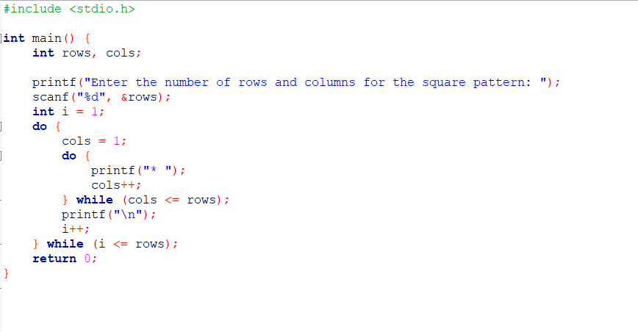

OUTPUT:

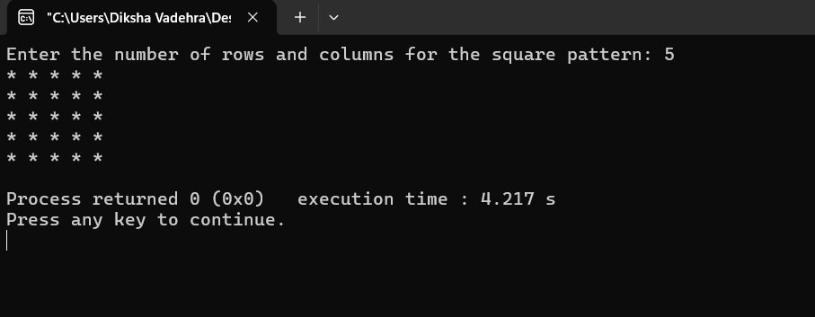

Ques 2. Develop a recursive function to calculate the factorial of a given number. Use this function to find the factorial of a user-input number.

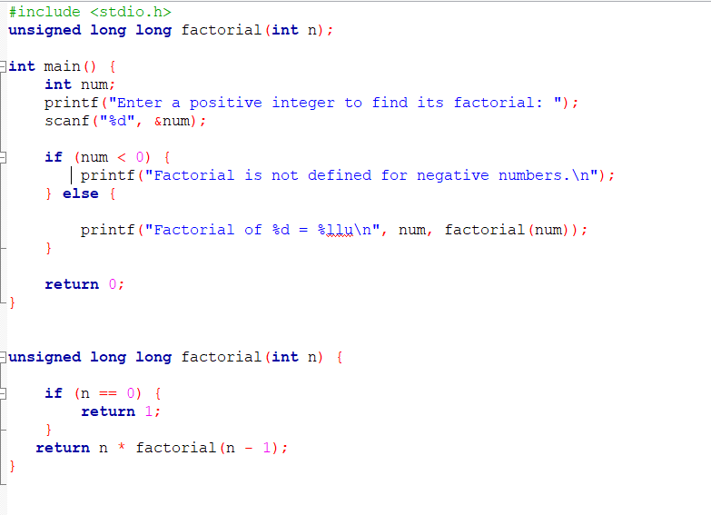OUTPUT:

