1. What is the output of the following code?

nums = set([1,1,2,3,3,3,4,4])

print(len(nums))

**Ans :** 4

1. What will be the output? d = {"john":40, "peter":45} print(list(d.keys()))

**Ans : Syntax Error**

1. A website requires a user to input username and password to register. Write a program to check the validity of password given by user. Following are the criteria for checking password:
2. At least 1 letter between [a-z]
3. At least 1 number between [0-9]
4. At least 1 letter between [A-Z]
5. At least 1 character from [$#@]
6. Minimum length of transaction password: 6
7. Maximum length of transaction password: 12

**Ans :** 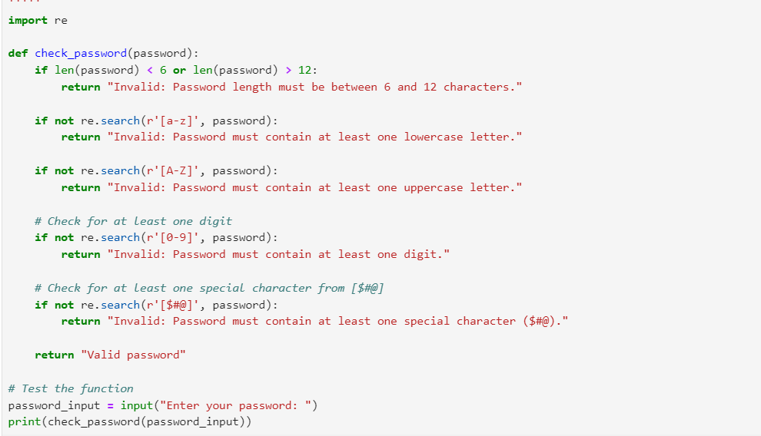

1. Write a for loop that prints all elements of a list and their position in the list.

a = [4,7,3,2,5,9]

**Ans :**



1. Please write a program which accepts a string from console and print the characters that have even indexes.

Example: If the following string is given as input to the program: H1e2l3l4o5w6o7r8l9d

Then, the output of the program should be: Helloworld

**Ans :**

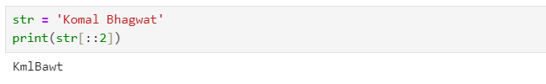

1. Please write a program which accepts a string from console and print it in reverse order.

Example: If the following string is given as input to the program: **rise to vote sir**

Then, the output of the program should be: **ris etov ot esir**

**Ans :**



1. Please write a program which count and print the numbers of each character in a string input by console.

Example: If the following string is given as input to the program: **abcdefgabc**

Then, the output of the program should be:

a,2

c,2

b,2

e,1

d,1

g,1

f,1

Ans : 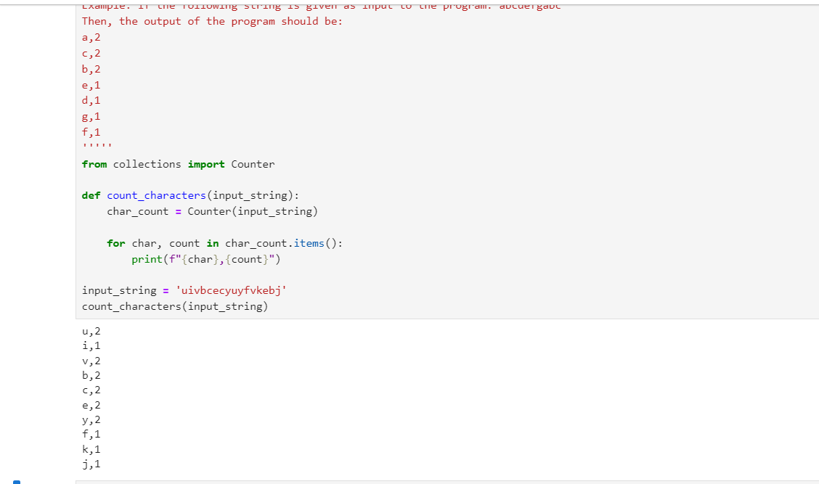

1. With two given lists [1,3,6,78,35,55] and [12,24,35,24,88,120,155], write a program to make a list whose elements are intersection of the above given lists.

Ans :

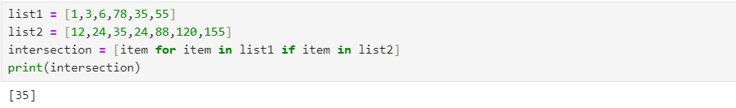

1. With a given list [12,24,35,24,88,120,155,88,120,155], write a program to print this list after removing all duplicate values with original order reserved.

Ans

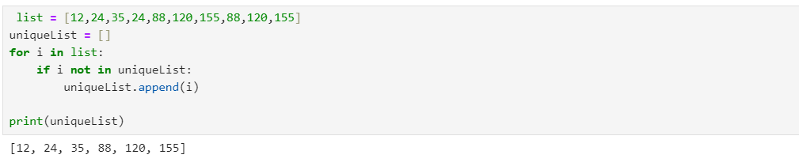

1. By using list comprehension, please write a program to print the list after removing the value 24 in [12,24,35,24,88,120,155].

Ans :

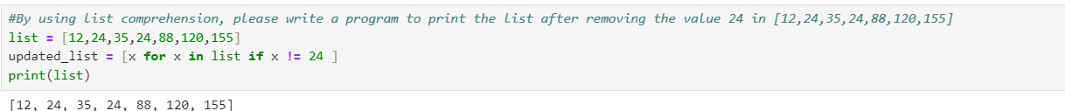

1. By using list comprehension, please write a program to print the list after removing the 0th,4th,5th numbers in [12,24,35,70,88,120,155].

Ans : 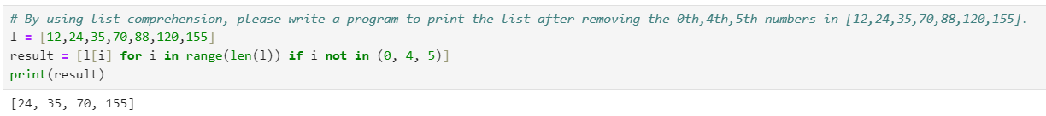

1. . By using list comprehension, please write a program to print the list after removing delete numbers which are divisible by 5 and 7 in [12,24,35,70,88,120,155].

Ans :

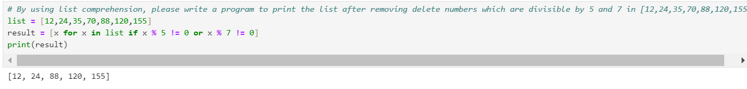

1. Please write a program to randomly generate a list with 5 numbers, which are divisible by 5 and 7 , between 1 and 1000 inclusive.

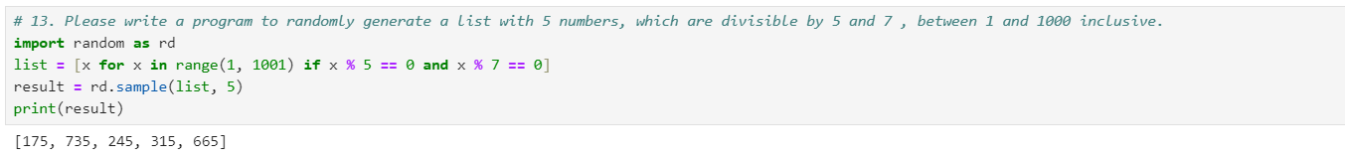

1. Write a program to compute 1/2+2/3+3/4+...+n/n+1 with a given n input by console (n>0).

Example: If the following n is given as input to the program: 5

Then, the output of the program should be: 3.55

