Form- Letters

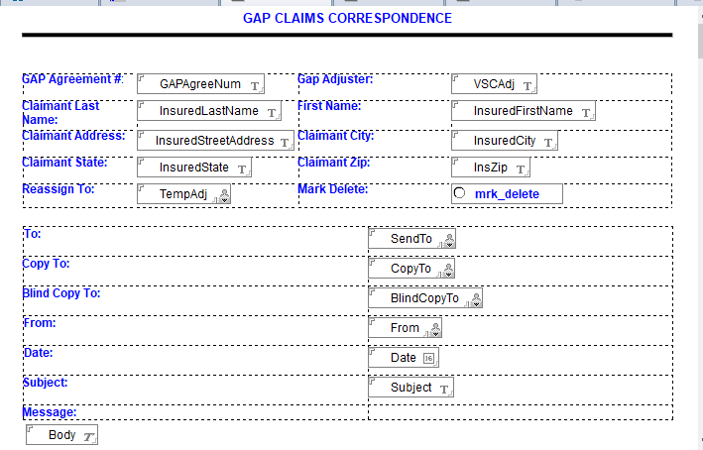

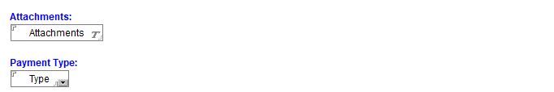

Required Fields-

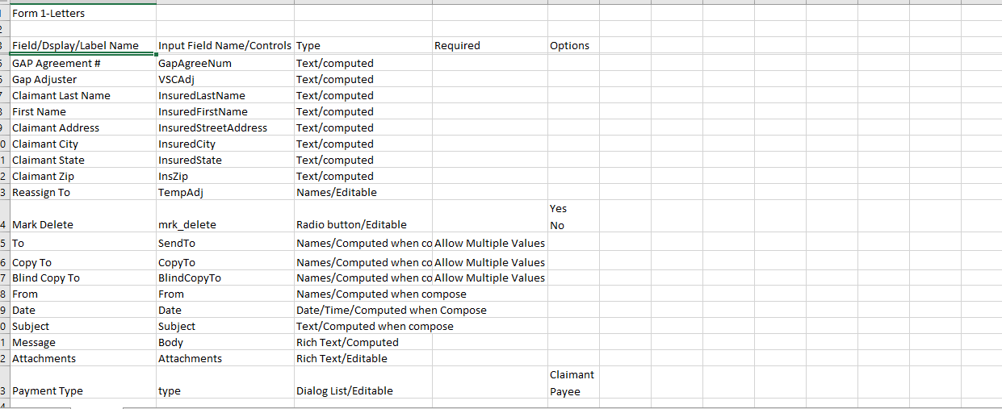

Form2-Letters SCS

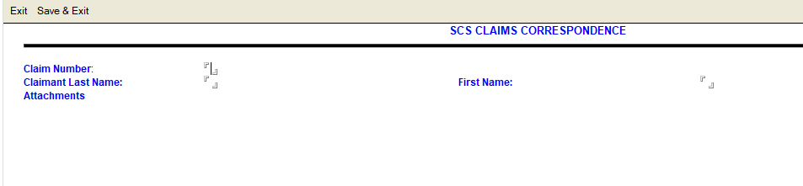

Required Fields-

