1. **Simple Calculator:**

**Cal.js**

// Returns addition of two numbers

exports.add = function (a, b) {

return a+b;

};

// Returns difference of two numbers

exports.subtract = function (a, b) {

return a-b;

};

// Returns product of two numbers

exports.multiply = function (a, b) {

return a*b;

};

**Main.js**

var calculator = require('./cal');

var a=10, b=5;

console.log("Addition : "+calculator.add(a,b));

console.log("Subtraction : "+calculator.subtract(a,b));

console.log("Multiplication : "+calculator.multiply(a,b));

Run:

Node Main.js

1. **Calculator web application**

**Calc.js**

// Creating function for adding two values

exports.Addition = function(val1, val2)

{

return (val1 + val2)

}

// Creating function for subtracting two values

exports.Subtract = function(val1, val2)

{

return (val1 - val2)

}

// Creating function for multiplying two values

exports.Multiplication = function(val1, val2)

{

return (val1 * val2)

}

// Creating function for dividing two values

exports.Division = function(val1, val2)

{

return (val1 / val2)

}

**Math.js**

// Import bulit-in and custom modules

var http = require('http');

var cm = require('./cal');

//Create server

http.createServer(function (req, res) {

res.writeHead(200, {'Content-Type': 'text/html'});

res.write('Addition: ' + cm.Addition(25,50) + '</br>');

res.write('Subtraction: ' + cm.Subtract(25,50) + '</br>');

res.write('Multiplication: ' + cm.Multiplication(25,50) + '</br>');

res.write('Division: ' + cm.Division(25,50));

res.end();

}).listen(4200, console.log('Server running on port 4200'));

Run:

<http://localhost:4200>

1. **Illustrate and analyze the Blocking(Synchronous) and Non-blocking(Asynchronous) features example:**

**Input.txt**

Hi Welcome to Department of MCA

I am studying in second semester

I like programming

End of the program.

**Sync.js:**

var fs = require("fs");

var data = fs.readFileSync('input.txt');

console.log(data.toString());

console.log("Program Ended");

Output:

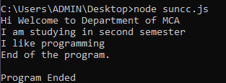

**Async.js:**

var fs = require("fs");

fs.readFile('input.txt', function (err, data)

{

if (err) return console.error(err);

console.log(data.toString());

});

console.log("Program Ended");

Output:

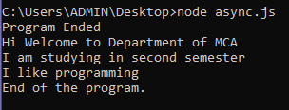

1. **Develop a script to display current date and time by creating your own Date –Time module:**

**Module.js:**

exports.myDateTime = function () {

return Date();

};

**Date.js:**

var http = require('http');

var dt = require('./module');

http.createServer(function (req, res) {

res.writeHead(200, {'Content-Type': 'text/html'});

res.write("The date and time are currently: " + dt.myDateTime());

res.end();

}).listen(8080);

**Run:**



**Output:**

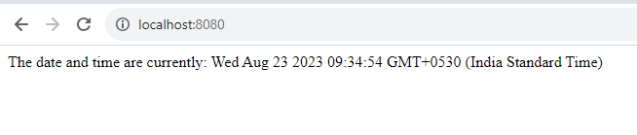

1. **Develop a script to read the part of the query string that comes after the domain name:**

**url.js:**

var http = require('http');

http.createServer(function (req, res) {

res.writeHead(200, {'Content-Type': 'text/html'});

res.write(req.url);

res.end();

}).listen(8080);

Run:



Output:

