

Internship Report on

**Python Developer Inter**

Submitted in Partial fulfilment of Requirement for the award of the Degree of

**MASTER OF COMPUTER APPLICATIONS**

Submitted by

**Komal S Kallanagoudar**

**1MS22MC016**

Internship Carried out

at

**TECHPLEMENT**

Internal Guide External Guide

**Prof. Abhishek K L Rahul K**

**Assistant Professor Project Manager**

**Department of Master of Computer Applications**

**RAMAIAH INSTITUTE OF TECHNOLOGY**

(Autonomous Institute, Affiliated to VTU)

Accredited by the National Board of Accreditation & NAAC with ‘A+’ Grade

MSR Nagar, MSRIT Post, Bangalore-560054

[www.msrit.edu](http://www.msrit.edu)

**2024**



**CERTIFICATE**

This is to certify that the Internship entitled **Python Developer Intern** is carried out by **Komal S Kallanagoudar** a bonafide student of Ramaiah Institute of Technology, Bangalore, in partial fulfillment for the award of Master of Computer Applications of the Visvesvaraya Technological University, Belgaum,during the year 2024. The internship report has been approved as it satisfies the academic requirements in respect to dissertation work prescribed for the said degree.

**Guide HOD**

**Prof. Abhishek K L Dr. Monica R Mundada**

**Assistant Professor**

**Name & Signature of Examiners with Date: -**

**1)**

**2)**

**INTERSHIP CERTIFICATE**

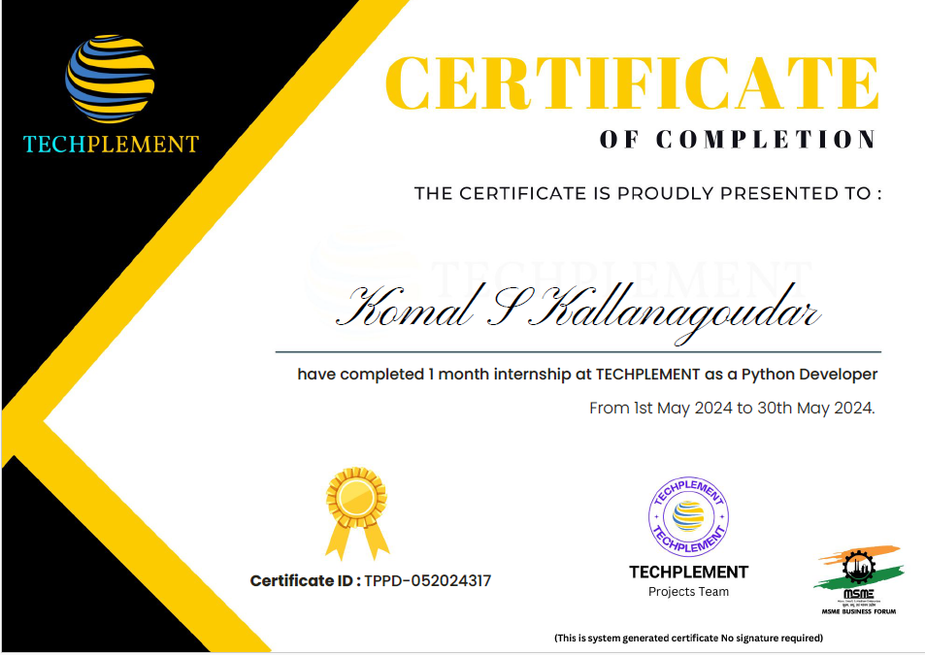

**Table of contents**

|  |  |  |
| --- | --- | --- |
| **Chapter No.** | **Title** | **Page No.** |
|  |  |  |
|  | Objectives | 1 |
|  | Company Profile | 3 |
|  | Work Responsibilities during the Internship | 4 |
|  | Skills Learned | 10 |
|  | Conclusion | 11 |

**List of Figures**

|  |  |  |
| --- | --- | --- |
| **Figure No** |  | **Page No.** |
|  |  |  |
|  | Home Page | 8 |
|  | Object Detection | 9 |

**List of Tables**

|  |  |  |
| --- | --- | --- |
| **Table No** |  | **Page No.** |
|  |  |  |
|  | Gantt Chart | 9 |

**1.Objectives**

During my internship I aimed to achieve several specific objectives to enhance my skills, contribute meaningfully to projects, and expand my knowledge in software development:

**Develop Advanced Python Programming Skills:**

1. **Enhance Proficiency in Python:**
   * Master the core concepts of Python, including object-oriented programming, data structures, and algorithms.
   * Develop a deep understanding of Python's standard library and its wide array of built-in functions.
2. **Write Efficient, Clean, and Maintainable Code:**
   * Adhere to coding best practices and standards such as PEP 8 to ensure code readability and consistency.
   * Implement design patterns and refactor code to enhance maintainability and scalability.
   * Employ techniques for optimizing code performance, such as efficient use of data structures and algorithmic optimizations.
3. **Learn and Apply Advanced Python Features and Libraries:**
   * Gain expertise in advanced Python features like decorators, context managers, and metaclasses to write more powerful and flexible code.
   * Utilize popular Python libraries and frameworks to solve complex problems:
     + **NumPy and pandas:** For numerical computations and data manipulation.
     + **TensorFlow and Keras:** For building and training machine learning models.
     + **Flask and Django:** For developing robust web applications.
     + **Beautiful Soup and Scrapy:** For web scraping and data extraction.
4. **Develop Automated Testing and Debugging Skills:**
   * Write unit tests using frameworks like unittest, pytest, or nose to ensure code reliability.
   * Practice test-driven development (TDD) to catch and fix issues early in the development process.
   * Utilize debugging tools such as pdb and logging modules to effectively troubleshoot and resolve bugs.
5. **Work on Real-World Projects:**
   * Participate in hands-on projects that require integrating multiple Python libraries and frameworks.
   * Solve real-world problems by implementing Python applications in various domains such as data science, web development, and automation.
6. **Enhance Collaboration and Code Review Practices:**
   * Engage in peer code reviews to receive and provide constructive feedback, fostering a culture of continuous learning and improvement.
   * Use version control systems like Git to collaborate with team members, manage code changes, and track project progress.

Furthermore, I sought to expand my knowledge in areas such as machine learning, web development frameworks, and database management systems, thereby broadening my skill set and making myself more versatile as a software developer. Additionally, I aimed to enhance my communication and collaboration skills by actively engaging with team members, participating in discussions, and contributing constructively to project planning and execution. Overall, my internship objectives were designed to provide a comprehensive learning experience and prepare me for future challenges in the field of software development.

**2.Company Profile**

Techplement is a forward-thinking Software Development and Services Company, founded with a passion for innovation and excellence. The company was created to empower clients in the digital age by crafting cutting-edge solutions that simplify complexities and drive success.

**Mission Statement:**

Our mission at Techplement is to deliver exceptional technology solutions that exceed expectations and catalyse success for our clients. We are committed to fostering a culture of continuous learning, collaboration, and innovation. Through our expertise, we aim to simplify complexities, enhance efficiency, and contribute to the growth and prosperity of our clients and the global tech community.

**Regular Business Activities:**

Techplement specializes in delivering cutting-edge services, including:

Website Development

DevOps Implementations

Software Development

AWS Cloud Solutions

Educational Development Services

**Internship Role:**

As a Python development intern, in first week I completed the individual task assigned to me to build command line tool to generate the random password and for next three weeks a group project was assigned to develop the image recognition and object detection system project. The duration of internship duration was one month that is from 1/05/2024 to 31/05/2024.

**Reporting Person:**

During my internship, I reported to Rahul K, Project manager. This person provided guidance, mentorship, and feedback, ensuring alignment with the company's goals and standards.

**3.Work Responsibilities during the Internship**

In the first week of Internship period, I completed the following task

**Python Week 1 Task: Random Password Generator**

**Description:** Develop a command-line tool for generating random passwords with customizable length and complexity. Allow users to specify password requirements such as including uppercase letters, lowercase letters, digits, and special characters. The application ensures that the generated passwords are secure and random, making them resistant to brute-force attacks and guessing.

The given code works as follows:

First, we create ArgumentParser object from the argparse module to read the command line.

Then read the requirements specified by the user on command line and it to the ArgumentParser object.

After adding all requirements from command line call password_generator function to generate random password.

The password generator function checks for the digit, specialz-character, lowercase and uppercase letters.

If result is true then it appends all of them like

* If uppercase is True, it appends all uppercase letters (from A to Z) to the characters string
* If lowercase is True, it appends all lowercase letters (from a to z) to the characters string
* If digit is True, it appends all digits (from 0 to 9) to the characters string
* If special_chars is True, it appends all punctuation characters (e.g., !, @, #, $, etc.) to the characters string

Then generate the password with the help of random module of length which is specified in the command line and return the password.

To generate the random password user had to give the requirements on the command line as follows

**python password_generator.py 12 --uppercase --lowercase --digits --special-chars**

This will generate the 12-character password with digit, special_char, uppercase and lowercase letters.



User can specify their requirements in command line

* **Example 1:** Password of length 12 and include uppercase and lowercase letters.



* **Example 2:** Password of length 4 and include lowercase letters and digits



* **Example 3:** Password of length 8 and include digits, uppercase and lowercase letters.



As a Python Development Intern, I was an integral part of the development team, contributing significantly to the image recognition and object detection system project. My role involved:

* **Developing and optimizing Python applications:** I implemented key components of the image recognition system, including data preprocessing, model training, and inference scripts. I optimized the code for efficiency and accuracy, ensuring the system performed well with large datasets.
* **Assisting in DevOps implementations:** I supported the deployment of the trained model on cloud platforms, ensuring the system could handle concurrent requests efficiently. This included setting up CI/CD pipelines and automating deployment processes.
* **Collaborating with cross-functional teams:** I worked closely with data scientists, frontend developers, and project managers to integrate the image recognition model with the user interface. This collaboration ensured seamless functionality and a user-friendly experience.
* **Participating in code reviews and contributing to continuous improvement:** I took part in regular code reviews, providing and receiving feedback to enhance code quality and maintain best practices. I also contributed to the continuous improvement of development processes by suggesting optimizations and new approaches based on the latest industry trends and technologies.

**Details of project completed during internship is as follows:**

**Project Title:** Object Detection Using YOLO

**Project Overview:**

This project is a web-based object detection application using Flask and YOLOv3 (You Only Look Once version 3). The main objective is to provide users with a simple interface to upload images and receive detected objects in the images with their respective bounding boxes and confidence scores.

**Objectives**

* Image Upload and Handling: Allow users to upload images via a web interface.
* Object Detection: Utilize YOLOv3 to detect objects within the uploaded images.
* Result Display: Show the detected objects with bounding boxes and labels on the image, along with confidence scores.

**Scope**

* **Frontend:** A simple HTML page (index.html) for image upload.
* **Backend:** A Flask server to handle image uploads, process the images using YOLOv3, and return the detection results. Project Team: Project Technologies:
* **Object Detection:** Integrate YOLOv3, configured to use pre-trained weights and configuration files (yolov3.cfg, yolov3.weights, coco.names for class labels).

**Project Technologies**

* **Object Detection:** Integrate YOLOv3, configured to use pre-trained weights and configuration files (yolov3.cfg, yolov3.weights, coco.names for class labels).
* **Flask:** Flask is a micro web framework written in Python, known for its simplicity and flexibility. It provides the essentials needed to build web applications, such as routing, request handling, and rendering templates, without imposing a specific structure or requiring large libraries.
* **OpenCV:** OpenCV (Open-Source Computer Vision Library) is designed to accelerate the use of machine perception in commercial products. It includes several hundred computer vision algorithms and provides functionalities such as image processing, video capture, and analysis, which are crucial for the image manipulation tasks in this project.
* **YOLOv3 (You Only Look Once version 3):** YOLOv3 is a real-time object detection system that processes images using a single neural network. It divides images into regions and predicts bounding boxes and probabilities for each region, offering a high-speed and high-accuracy method for detecting multiple objects in an image.
* **NumPy:** NumPy is a library for Python that supports large, multi-dimensional arrays and matrices, along with a collection of mathematical functions to operate on these arrays. It is essential for handling the numerical computations involved in image processing and manipulation.
* **HTML/CSS:** HTML (HyperText Markup Language) and CSS (Cascading Style Sheets) are the core technologies for building and designing web pages. HTML provides the structure, while CSS styles the appearance of the web pages, making the user interface more appealing and user-friendly.
* **JavaScript:** JavaScript is a versatile scripting language used to create dynamic and interactive effects within web browsers. In this project, it enhances the user experience by providing immediate feedback and interactivity, such as handling image uploads and displaying detection results without reloading the page.
* **cv2.dnn:** The cv2.dnn module in OpenCV provides deep neural network functionality, enabling the loading and execution of pre-trained models like YOLOv3. It allows for efficient image analysis and object detection by leveraging the power of deep learning.
* **OS Library:** The OS library in Python provides a way of using operating system-dependent functionality such as reading or writing to the filesystem, creating directories, and handling file paths. It is crucial for managing the uploaded and output images in this project.

**Results**

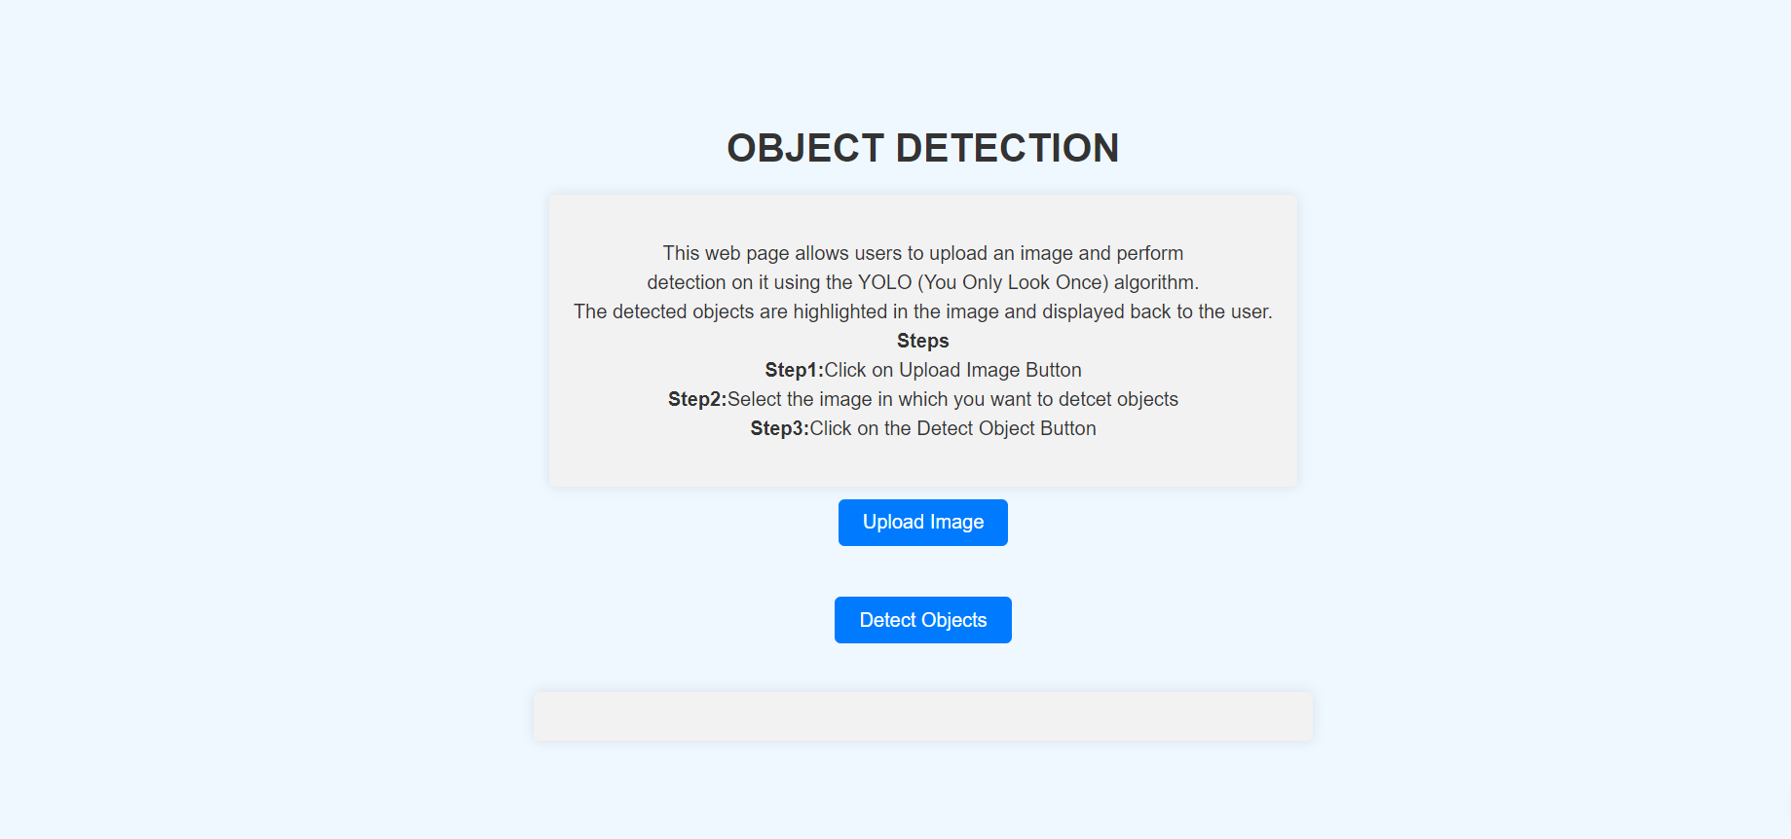

**Figure 1: Home Page**

As shown in the Figure 1, this page is to upload the image for object detection in the provided image.

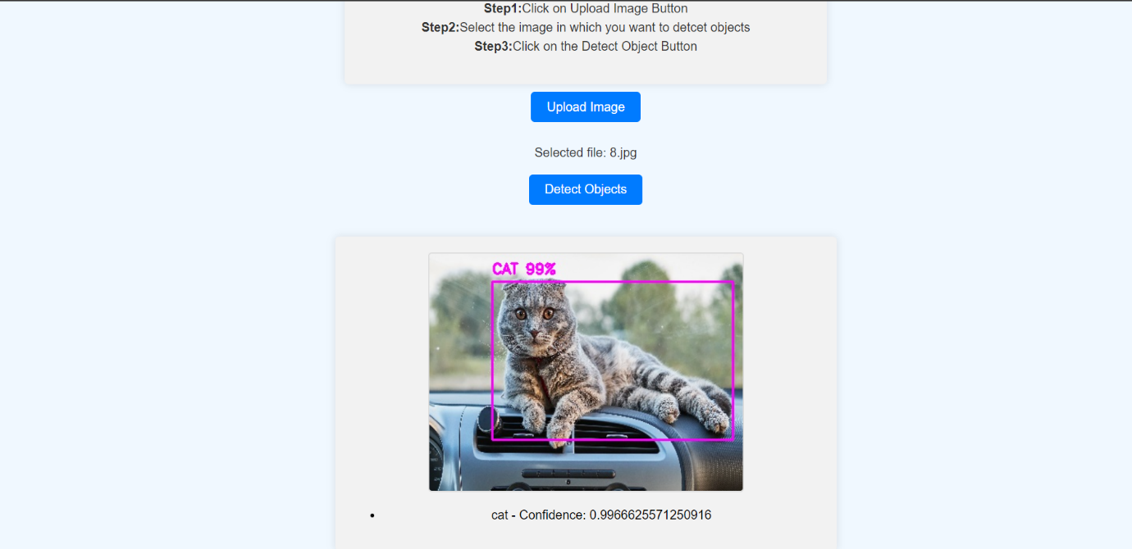

**Figure 2: Object Detection**

As shown in the Figure 2 once you upload the image and click on the Detect object button you can see the output image with the box around the detected object and the name of object on the box.

**Gantt Chart:**

**Table 1: Gantt Chart**

|  |  |  |  |  |
| --- | --- | --- | --- | --- |
|  | Week1 | Week2 | Week3 | Week4 |
| Task1 |  |  |  |  |
| Task2 |  |  |  |  |

The table 1 explains the workflow during internship that is as follows

|  |  |
| --- | --- |
|  | Develop a command-line tool for generating random passwords with customizable length and complexity |
|  | Literature survey on the project Object Detection Using YOLO and Collecting dataset and data pre processing |
|  | Understanding the algorithm |
|  | Implementing and testing the code, documentation. |

**4.Skills Learned**

During this internship project, I developed and honed several skills relevant to my educational experiences and career goals:

1. **Machine Learning and Deep Learning:**
   * Gained practical experience in training and fine-tuning machine learning models using TensorFlow.
   * Developed an understanding of model architectures such as Convolutional Neural Networks (CNNs) and Faster R-CNN for image recognition and object detection tasks.
2. **Data Preprocessing:**
   * Learned techniques for cleaning and preprocessing image datasets to ensure data quality and consistency.
   * Implemented data augmentation methods to increase dataset variability and improve model generalization.
3. **Model Selection and Training:**
   * Conducted research to select appropriate model architectures based on project requirements and dataset characteristics.
   * Trained and fine-tuned machine learning models using labeled datasets, optimizing model hyperparameters for improved performance.
4. **Model Implementation and Deployment:**
   * Implemented machine learning models using Python programming language and deep learning frameworks.
   * Developed skills in deploying machine learning models on local machines or cloud platforms for real-world applications.
5. **User Interface Design:**
   * Designed and developed user-friendly interfaces for image input and result visualization.
   * Implemented features to enable users to upload images from various sources and view object detection results with bounding boxes and labels.

**5.Conclusion**

As I continue to progress in my internship and pursue future opportunities, there are several skills and experiences I would like to focus on developing further:

1. **Advanced Machine Learning Techniques:**
   * I aim to deepen my understanding of advanced machine learning concepts, such as reinforcement learning, generative adversarial networks (GANs), and natural language processing (NLP).
   * Experience in these areas would allow me to explore more complex and diverse applications of machine learning in real-world scenarios.
2. **Cloud Computing and Deployment:**
   * I am interested in gaining hands-on experience with cloud computing platforms such as AWS, Google Cloud Platform, or Microsoft Azure.
   * Learning how to deploy and manage machine learning models in cloud environments would be invaluable for scaling applications and optimizing performance.
3. **Software Engineering Best Practices:**
   * I aim to further improve my skills in software engineering practices such as code design, testing, version control, and code review.
   * Exposure to industry-standard tools and methodologies would help me develop software that is robust, maintainable, and scalable.
4. **Cross-Functional Collaboration:**
   * I value opportunities to collaborate with professionals from diverse backgrounds, including data scientists, engineers, designers, and business stakeholders.
   * Working in multidisciplinary teams fosters creativity, innovation, and holistic problem-solving approaches.
5. **Professional Development and Mentorship:**
   * I aspire to receive mentorship from experienced professionals who can provide guidance, feedback, and career advice.
   * Continuous learning and personal growth are essential aspects of my professional journey, and I am eager to learn from seasoned mentors.
6. **Project Ownership and Leadership:**
   * I look forward to taking on more responsibility and ownership of projects, leading initiatives, and driving results.
   * Leadership opportunities would allow me to demonstrate initiative, decision-making, and project management skills.

By focusing on these areas, I aim to further develop my expertise, broaden my skill set, and contribute meaningfully to the organization and its objectives. I believe that a collaborative and supportive environment that encourages continuous learning and professional growth would be conducive to achieving these goals.