

**Department of Master of Computer Applications**

*A Seminar Report on*

**Decoding the Layers: Understanding the Architecture of CNN**

*Submitted in partial fulfillment of the requirements for the award of degree in*

**Bachelor of Master of Computer Applications**

*by*

**Komal S Kallanagoudar**

**1MS22MC016**

Under the guidance of

**Prof.Abhishek K L**

**Assistant Professor**

**M S RAMAIAH INSTITUTE OF TECHNOLOGY**

**(Autonomous Institute, Affiliated to VTU)**

**BANGALORE-560054**

**www.msrit.edu**

**2023- 2024**



**Department of Master of Computer Applications**

# CERTIFICATE

Certified that the seminar work entitled “**Innovations in Object Detection: The Power of Convolutional Neural Networks**” carried out by **Komal S Kallanagoudar – 1MS22MC016** a bonafide student of M.S.Ramaiah Institute of Technology Bengaluru in partial fulfillment for the award of Master of Computer Applications of the Visvesvaraya Technological University, Belagavi during the year 2023-24. It is certified that all corrections/suggestions indicated for Internal Assessment have been incorporated in the report.

**Project Guide** **Head of the Department**

**Prof.Abhishek K L Dr. Monica R Mundada**

**Name of the Examiners: Signature with Date**

**1.**

**2.**



**Department of Master of Computer Applications**

# DECLARATION

I, hereby, declare that the entire work embodied in this seminar report has been carried out by me at M.S.Ramaiah Institute of Technology, Bengaluru, under the supervision of **Prof.Abhishek K L, Assistant Professor, Dept of MCA.** This report has not been submitted in part or full for the award of any diploma or degree of this or to any other university.

Signature

Komal S Kallanagoudar

1MS22MC016

# ACKNOWLEDGEMENT

The satisfaction and euphoria that accompany the successful completion of any task would be incomplete without mention of the people who made it possible and support had been a constant source of encouragement which crowned my efforts with success. I am deeply indebted and would like to express my sincere thanks to our beloved principal **Dr. N.V.R Naidu**, for providing us an opportunity to do this technical seminar. My special gratitude to **Dr.Monica R Mundada,** HOD, Department of Master of Computer Applications, RIT for her guidance, constant encouragement and wholehearted support. My sincere thanks to my guide **Prof**.**Abhishek K L,** Assistant Professor, Department of Master of Computer Applications, RIT for his/her guidance, constant encouragement and wholehearted support. Finally, I would like to express my sincere thanks to all the staff members of department of Master of Computer Applications for their valuable guidance and support.

Komal S Kallanagoudar

1MS22MC016

# ABSTRACT

Convolutional Neural Networks (CNNs) have revolutionized the field of computer vision, offering remarkable capabilities in image recognition, object detection, and segmentation tasks. This report delves into the architecture of CNNs, exploring the intricate layers that enable their impressive performance. The selection of this topic stems from the increasing importance of CNNs in various domains and the necessity to understand their underlying mechanisms for effective utilization in practical applications.

The scope of this report encompasses a comprehensive examination of CNN architecture, including convolutional layers, pooling layers, and fully connected layers. Methodologies employed for understanding and dissecting CNNs involve studying the mathematical operations within each layer, analyzing the flow of information, and exploring real-world applications.

Through this exploration, key insights into the hierarchical feature learning process within CNNs are uncovered, elucidating how these networks automatically extract and learn meaningful features from raw data. The report concludes by emphasizing the significance of understanding CNN architecture for effectively leveraging its capabilities in practical applications. Overall, this study contributes to a deeper understanding of CNNs, paving the way for advancements in computer vision and related fields.

**TABLE OF CONTENTS**

CERTIFICATE ii

DECLARATION iii

ACKNOWLEDGEMENT iv

ABSTRACT v

LIST OF FIGURES vii

LIST OF TABLES viii

LIST OF ABBREVIATIONS ix

1. INTRODUCTION 1

**1.1. General Introduction 1**

**1.2. Problem Statement 2**

**1.3. Objectives of the seminar 2**

**1.4. Current Scope 3**

2. LITERATURE SURVEY 5

**2.1. Introduction 5**

**2.2. Related Works with citation of References 6**

**2.3. Conclusion of Survey 7**

3. RESEARCH GAP ANALYSIS 8

**3.1. Comparative Study of different existing system 8**

4. SOCIAL IMPACT 9

5. IMPLEMENTATION 11

**5.1. Tools Introduction 11**

**5.2. Overall view of the case study 11**

**5.3. Explanation of case study 12**

**5.4. Information about case study 14**

**5.5. Conclusion 21**

6. RESULTS & PERFORMANCE ANALYSIS 23

**6.1. Result 23**

7. CONCLUSION 24

8. FUTURE WORK 25

9. REFERENCES 26

# LIST OF FIGURES

**Figure 1: CNN Architecture 12**

**Figure 2: 1D Convolution 14**

**Figure 3: Example of Padding 15**

**Figure 4: N layer Convolution 16**

**Figure 5: Example of Pooling 17**

**Figure 6: Pooling cascading 17**

**Figure 7: Classification in Fully Connected Layer 18**

**Figure 8: Fully Connected layer Cascading 20**

**Figure 9: Cascade Convolutional Layers 21**

**Figure 10: Complete CNN Architecture 23**

# LIST OF TABLES

**Table 1: Example of Softmax 19**

# LIST OF ABBREVIATIONS

|  |  |  |
| --- | --- | --- |
| **Abbreviation** | **FULL FORM** | **Page No.** |
| **CNN** | Convolutional Neural Network | **1** |
| **YOLO** | You Only Look Once | **3** |
| **R-CNN** | Region-based Convolutional Neural Network | **3** |
| **MNIST** | Modified National Institute of Standards and Technology | **5** |
| **Faster-RCNN** | Faster Region-based CNN | **5** |
| **NLP** | Natural Language Processing | **8** |
| **IoT** | Internet of Things | **10** |

#### 

#### 

# INTRODUCTION

## **General Introduction**

Object detection, a core aspect of computer vision, has undergone remarkable advancements due to the emergence of Convolutional Neural Networks. In simple terms, CNNs are specialized types of artificial intelligence that allow computers to automatically identify and locate objects within images and videos. This capability has revolutionized the way machines interpret visual data, making processes faster, more accurate, and highly efficient. Unlike traditional image processing methods, which required manual feature extraction and were often error-prone, CNNs learn to recognize patterns and features directly from the data, leading to significant improvements in performance.

My interest in this topic stems from its transformative potential across various fields. The ability of machines to "see" and understand their environment as humans do is not just a technological marvel but a cornerstone for future innovations. This fascination is further fueled by the broad spectrum of applications that benefit from object detection, from enhancing the safety of autonomous vehicles to enabling advanced medical diagnostics. The context of this work is set within the rapidly evolving landscape of AI and machine learning, where CNNs play a pivotal role in pushing the boundaries of what is possible.

As someone deeply interested in web and app development, understanding the principles and applications of CNNs can significantly enhance my skill set. Integrating advanced object detection capabilities into applications can lead to innovative solutions and improved user experiences. This knowledge is also pertinent to the current trends in technology, where AI and machine learning are becoming increasingly integral to software development. By grasping the advancements in CNNs and their applications, I can contribute to creating smarter, more responsive technologies that meet the needs of modern users.

The work on CNN-based object detection is not only original and novel but also elegant in its design and implementation. By leveraging deep learning, these models have surpassed traditional methods, offering superior accuracy and processing speed. The utility of this work extends across numerous domains, enhancing existing technologies and enabling new applications. In the field of autonomous driving, for example, CNNs enable vehicles to understand and respond to their environment, significantly enhancing safety and efficiency. In security surveillance, real-time object detection capabilities lead to faster response times and improved incident management.

The objective of this study is to address these challenges by exploring the latest advancements in CNN architectures for object detection, evaluating their integration with emerging technologies, and discussing their applications and potential improvements in various fields. By focusing on these areas, we aim to identify solutions that enhance real-time processing capabilities, optimize integration with edge and IoT technologies, and overcome the constraints posed by training data and hardware limitations. This seminar will provide a comprehensive understanding of the current state and future directions of CNN-based object detection, highlighting its transformative impact on technology and industry.

## **Problem Statement**

How can we enhance real-time object detection capabilities using advanced Convolutional Neural Network (CNN) architectures while addressing computational and integration challenges?

Object detection, the task of identifying and localizing objects within images and videos, has experienced significant advancements with the introduction of Convolutional Neural Networks (CNNs). These advancements have led to substantial improvements in accuracy and efficiency, yet several challenges must be addressed to fully realize the potential of these technologies in real-time applications

## **Objectives of the seminar**

The objectives of this seminar are to:

* Provide a clear and accessible introduction to Convolutional Neural Networks, explaining their fundamental principles and how they function in an understandable manner.
* Discuss the significant advancements in CNN architectures specifically designed for object detection, highlighting key innovations that have improved speed and accuracy.
* Explore the diverse applications of CNN-based object detection, illustrating the practical impact and utility of these advancements in various industries.

This study begins with an introduction to Convolutional Neural Networks (CNNs). CNNs are deep learning models designed to process and analyze visual data. Imagine teaching a child to recognize different objects by showing them thousands of pictures—CNNs operate in a similar way but on a much larger scale and with far greater efficiency. They consist of multiple layers that automatically detect and learn relevant features from the data, such as edges, textures, and patterns, which are crucial for identifying objects in images and videos.

Following this, we will delve into the advancements in CNN architectures that have significantly improved object detection. We will explore three significant architectures: YOLO,Faster R-CNN, and SSD (Single Shot MultiBox Detector). These models represent significant leaps in balancing detection speed and accuracy. For example, YOLO is renowned for its real-time processing capabilities, making it invaluable for applications that require immediate object detection, such as in autonomous driving, where the ability to quickly and accurately identify objects on the road is crucial for safety and navigation.

Faster R-CNN, on the other hand, excels in accuracy and is widely used in applications where precision is paramount, such as in medical imaging for detecting anomalies in X-rays or MRI scans. SSD combines the strengths of both YOLO and Faster R-CNN, offering a balanced approach that performs well in both speed and accuracy, making it versatile for various use cases.

This study will provide an in-depth exploration of how Convolutional Neural Networks have transformed object detection. From their theoretical foundations to practical applications, we will examine the significant advancements and their impact on various industries. By understanding these developments, we can appreciate the transformative potential of CNNs and envision new possibilities for their use, driving innovation and enhancing our technological capabilities.

## **Current Scope**

The scope of Convolutional Neural Networks (CNNs) has expanded significantly over recent years, reflecting their versatility and effectiveness in a wide range of applications.

**Advanced CNN Architectures:** State-of-the-Art Models: The development of sophisticated CNN architectures like YOLO, Faster R-CNN, and SSD has significantly improved the speed and accuracy of object detection. These models are capable of processing visual data quickly, making them suitable for real-time applications. Innovations such as anchor-free models and attention mechanisms have been introduced to further enhance the detection capabilities of CNNs. These improvements aim to reduce computational complexity while maintaining high detection accuracy.

**Hardware Acceleration:** The use of GPUs and TPUs has become commonplace for training and deploying CNN models. These specialized hardware accelerators are designed to handle the intensive computational demands of deep learning, enabling faster processing and real-time performance. There is an increasing focus on edge computing, where computations are performed close to the data source (e.g., IoT devices). This reduces latency and bandwidth usage, making it feasible to deploy real-time object detection models on devices with limited resources.

**Integration with Emerging Technologies:** Integration of CNN-based object detection with IoT systems is expanding, enabling real-time analysis and decision-making in various applications such as smart cities, healthcare, and industrial automation.

**Applications Across Domains: Autonomous Vehicles:** Real-time object detection is a critical component in the development of self-driving cars, where it is used for identifying pedestrians, vehicles, and obstacles to ensure safe navigation. Enhanced object detection capabilities are being utilized in security systems for monitoring and identifying potential threats in real-time. CNNs are being applied to medical imaging for detecting anomalies and aiding in diagnostics, improving the accuracy and efficiency of medical assessments.

The scope of Convolutional Neural Networks (CNNs) has significantly expanded, reflecting their versatility and effectiveness across various applications. Advanced architectures like YOLO, Faster R-CNN, and SSD have revolutionized object detection by enhancing speed and accuracy while innovations such as anchor-free models and attention mechanisms further improve performance. The use of specialized hardware like GPUs and TPUs enables faster processing and real-time performance, with edge computing reducing latency and bandwidth usage for resource-constrained devices. Integration with IoT systems enhances real-time analysis and decision-making in applications like smart cities, healthcare, and industrial automation. CNNs play critical roles in autonomous vehicles for safe navigation, security systems for real-time threat monitoring, and medical imaging for accurate diagnostics.

# LITERATURE SURVEY

## **Introduction**

Deep learning has significantly advanced object recognition, leveraging Convolutional Neural Networks (CNNs) for improved accuracy and efficiency. CNNs are particularly effective in pattern recognition, with applications spanning computer vision, image segmentation, and natural language processing. These networks consist of multiple layers, including convolutional, non-linearity, pooling, and fully connected layers, with the convolutional layers being key to reducing parameters and enhancing feature extraction. Historically, CNNs evolved from artificial neural networks, with milestones like the LeNet for handwritten digit recognition and AlexNet's breakthrough in the 2012 ImageNet competition.

In practical applications, CNNs have demonstrated robust performance across various datasets, achieving high accuracy rates, such as 99.6% on MNIST and 90.12% on a multi-class object dataset using TensorFlow. These models have been successfully applied to tasks like facial recognition, self-driving cars, and medical imaging. The effectiveness of CNNs lies in their ability to learn hierarchical features, from simple edges to complex shapes, which are crucial for accurate object detection and classification.

Comparative studies highlight different CNN architectures, such as SSD and Faster-RCNN, tailored for specific needs like real-time applications or high-accuracy detection. The continuous development and refinement of CNNs promise further enhancements in object recognition capabilities, driven by ongoing research and practical implementations across diverse fields.

In addition to their application in image recognition, CNNs are also utilized in natural language processing and other domains where pattern recognition is crucial. Their ability to reduce the number of parameters while retaining essential features makes them more efficient and powerful compared to traditional artificial neural networks.

Ongoing research continues to push the boundaries of CNN capabilities, exploring new architectures, improving training techniques, and applying these models to more complex and varied tasks. As a result, CNNs remain at the forefront of deep learning technologies, driving innovation and advancements in various industries and research fields.

## **Related Works with citation of References**

The comparison between CNNs and classical BOW approaches, particularly in the domain of recognizing wild animals, highlights the superior performance of CNNs [1]. CNNs excel in object recognition tasks due to their ability to automatically learn hierarchical features from raw data, such as images, without the need for manual feature engineering. In contrast, BOW approaches rely on handcrafted features and suffer from limitations in capturing spatial information and contextual relationships within images.

While CNNs demonstrate superior performance in object recognition tasks, there is a pressing need to improve the speed and efficiency of CNN models for real-time applications. Real-time object detection and recognition are crucial for various applications, including surveillance, autonomous vehicles, and augmented reality. Enhancements in model architecture, optimization techniques, and hardware acceleration can contribute to achieving faster inference speeds and improved efficiency in CNN-based object recognition systems.

Deep learning-based object identification offers several advantages over traditional approaches, including better learning skills and robustness in handling scale transformations, interference, and background changes [4]. Deep learning models, such as CNNs, can automatically learn intricate patterns and representations from large datasets, leading to improved accuracy and generalization performance in object identification tasks.

An experiment is conducted on an image dataset where a model is trained to classify images as either character "X" or "O" based on extracted features [6]. Similar classification approaches can be applied to different types of objects, images, etc. The accuracy of the model on the training set can be further improved by adding more hidden layers, increasing the model's capacity to capture complex relationships and patterns in the data.

Overall, advancements in deep learning techniques, coupled with efforts to enhance the speed and efficiency of CNN models, hold promise for revolutionizing object recognition and identification across various domains and applications.

## **Conclusion of Survey**

In conclusion, the rapid advancement of Convolutional Neural Networks (CNNs) has significantly transformed the landscape of object recognition and identification. With their ability to automatically learn hierarchical features from raw data, CNNs have demonstrated superior performance over classical approaches, particularly in tasks such as recognizing wild animals. However, there remains a critical need to enhance the speed and efficiency of CNN models for real-time applications.

Real-time object detection and recognition are vital for numerous domains, including surveillance, autonomous vehicles, and augmented reality. Improvements in model architecture, optimization techniques, and hardware acceleration are essential for achieving faster inference speeds and improved efficiency in CNN-based object recognition systems.

Deep learning-based object identification offers several advantages over traditional approaches, including better learning skills and robustness in handling scale transformations, interference, and background changes. The ongoing research and practical implementations across diverse fields continue to drive innovation and advancements in CNN capabilities.

As CNNs remain at the forefront of deep learning technologies, ongoing research efforts aim to explore new architectures, improve training techniques, and apply these models to more complex and varied tasks. The combination of these advancements holds promise for revolutionizing object recognition and identification across various domains and applications, paving the way for future breakthroughs in the field.

Furthermore, the evolution of CNNs from their inception to their current state underscores their adaptability and versatility in addressing a wide range of object recognition challenges. As researchers continue to push the boundaries of CNN capabilities, exploring new architectures and refining existing methodologies, the potential for CNNs to revolutionize object recognition and identification across diverse domains remains unparalleled. With ongoing advancements in deep learning techniques and the relentless pursuit of real-time efficiency, CNNs are poised to drive further innovation and transformation, shaping the future of artificial intelligence and computer vision.

# RESEARCH GAP ANALYSIS

## **Comparative Study of different existing system**

Convolutional neural networks (CNNs) are indispensable in various fields due to their unique capabilities in handling spatial data, particularly in tasks like image recognition, object detection, and image segmentation. CNNs automatically learn hierarchical representations of features from raw data through convolutional and pooling layers, extracting meaningful features such as edges, textures, shapes, and object parts without the need for manual feature engineering. These networks preserve the spatial structure of data, making them effective for tasks where the spatial arrangement of features is crucial.

CNNs possess translation invariance, meaning they can recognize patterns regardless of their position in the input, making them robust to shifts and distortions in the data. This property is especially valuable in tasks like object detection in images. Moreover, CNNs efficiently share parameters across spatial locations using convolutional filters, significantly reducing the number of parameters compared to fully connected networks, which enables them to handle large inputs while maintaining a relatively small number of learnable parameters.

The architecture of CNNs aligns well with modern GPU architectures, making them highly suitable for efficient training and inference on parallel computing platforms. With their consistent state-of-the-art performance in various computer vision tasks, including image classification, object detection, and semantic segmentation, CNNs have become indispensable tools in modern artificial intelligence and computer vision applications, enabling the automation of complex tasks involving understanding and processing visual information.

Additionally, CNNs have found applications beyond computer vision, including NLP, speech recognition, and medical image analysis. In NLP, CNNs are used for tasks such as text classification, sentiment analysis, and language translation, where they can effectively capture local patterns in sequences of words. In speech recognition, CNNs have been employed to extract features from spectrograms or waveforms, improving accuracy and robustness in speech recognition systems. Moreover, in medical image analysis, CNNs have shown promising results in tasks like tumor detection, organ segmentation, and disease classification, assisting healthcare professionals in diagnosing and treating various medical conditions. This versatility and effectiveness across different domains highlight the wide-ranging impact of CNNs in advancing technology and solving real-world problems.

# SOCIAL IMPACT

The advancements in CNN for real-time object detection have significant contributions to society across various domains:

* **Improved Safety and Operational Efficiency in Autonomous Vehicles**

The implementation of advanced Convolutional Neural Networks in autonomous vehicles promises significant contributions to road safety and traffic efficiency. Accurate Object Detection, CNNs enhance the ability of autonomous vehicles to detect and classify various objects on the road, such as pedestrians, cyclists, animals, other vehicles, and road signs. This precise detection is crucial for avoiding collisions and ensuring the safety of all road users. The ability to process visual data in real time ensures that autonomous vehicles can make split-second decisions, which is essential for navigating dynamic and unpredictable road environments.

Efficient Traffic Flow: Autonomous vehicles equipped with advanced object detection can communicate with each other and with traffic management systems to optimize route planning and reduce traffic congestion. By selecting the most efficient routes and adjusting speeds dynamically, these vehicles can smooth traffic flow. Real-time data sharing among autonomous vehicles allows for coordinated driving strategies that prevent bottlenecks and minimize stop-and-go traffic, which is a common cause of traffic jams. In the event of an accident, autonomous vehicles can quickly reroute to avoid the affected area, and they can also communicate with emergency services to provide real-time updates on the situation. Integration with smart traffic signals that respond to real-time traffic conditions can further enhance traffic flow. Autonomous vehicles can communicate with these signals to ensure minimal waiting times at intersections.

* **Improved Security and Surveillance**

Deterrence Effect: Visible deployment of advanced surveillance systems equipped with CNNs acts as a deterrent to criminal behavior. The presence of sophisticated security measures sends a clear message to potential wrongdoers that their actions are being monitored and that there is a high likelihood of detection and apprehension. Real-time object detection powered by CNNs enables security systems to swiftly identify and classify potential threats, such as intruders, suspicious objects, or unauthorized vehicles. This rapid detection allows for immediate response actions, mitigating the risk of criminal activities and minimizing their impact.

CNNs analyze vast amounts of surveillance data to extract actionable insights that inform strategic security decisions. By identifying patterns, trends, and anomalies in security-related data, these systems enable security managers to proactively address emerging threats, allocate resources strategically, and optimize security protocols to better protect assets and personnel.

* **Advancements in Healthcare**

The integration of advanced CNNs in healthcare offers significant advancements in disease diagnosis, patient care, and operational efficiency. CNN-powered diagnostic tools automate and streamline medical imaging interpretation, reducing the reliance on manual review by radiologists and healthcare professionals. This automation accelerates the diagnostic process, leading to faster turnaround times for patient reports and treatment plans.

By automating routine tasks such as image analysis and pattern recognition, CNNs alleviate the workload on healthcare professionals, allowing them to focus on more complex cases and patient care activities. This not only enhances the efficiency of healthcare delivery but also mitigates the risk of human error and fatigue-related diagnostic inaccuracies.

* **Smart Cities and IoT Applications**

The integration of CNNs in smart city initiatives and IoT applications offers transformative benefits for urban planning, resource management, and overall quality of life. CNN-based object detection systems analyze traffic flow and congestion levels in real-time, enabling dynamic traffic management strategies. By adjusting traffic signal timings, rerouting vehicles, and optimizing public transportation routes, cities can reduce travel times, fuel consumption, and emissions, promoting sustainable urban mobility.

Real-time data collected from various IoT sensors and devices, coupled with CNN-based object detection, provides valuable insights for urban planners. By analyzing traffic patterns, pedestrian movements, and public transportation usage, city planners can make informed decisions about infrastructure development, transportation networks, and land use zoning.

The integration of advanced Convolutional Neural Networks (CNNs) in various domains promises transformative benefits for safety, efficiency, and quality of life. In autonomous vehicles, CNN-powered object detection ensures precise identification of road objects, enhancing safety by avoiding collisions and navigating complex environments. Improved security and surveillance systems equipped with CNNs offer swift threat detection, deterrence of criminal behavior, and data-driven decision-making for proactive security measures. In healthcare, CNN-based diagnostic tools streamline medical imaging interpretation, leading to faster diagnoses and reduced workload for healthcare professionals. Additionally, in smart cities and IoT applications, CNNs optimize traffic flow, enhance urban planning, and enable efficient resource management, contributing to sustainable and livable urban environments. Overall, CNNs drive advancements across domains, revolutionizing safety, efficiency, and urban development.

# IMPLEMENTATION

## **Tools Introduction**

**What is a Convolutional Neural Network (CNN)?**

A CNN, also known as a ConvNet, is a specialized deep learning model primarily used for tasks that require object recognition, such as image classification, detection, and segmentation. CNNs are widely utilized in real-world applications like autonomous vehicles and security camera systems.

## **Overall view of the case study**

**CNNs hold significant importance in today's world for several reasons:**

1. **Autonomous Feature Extraction:** Unlike traditional machine learning algorithms like SVMs and decision trees, CNNs can automatically extract features from data, eliminating the need for manual feature engineering and thus improving efficiency.
2. **Translation Invariance:** he convolutional layers in CNNs allow them to recognize and extract patterns regardless of variations in position, orientation, scale, or translation, making them robust to such changes.
3. **Pre-trained Architectures:** There are numerous pre-trained CNN models like VGG-16, ResNet50, Inceptionv3, and EfficientNet, which have shown high performance. These models can be fine-tuned for new tasks with relatively small amounts of data.
4. **Versatility:** Beyond image classification, CNNs are versatile and can be applied to various fields such as natural language processing, time series analysis, and speech recognition.

**CNN Architecture**

The number of layers in a Convolutional Neural Network can vary widely depending on the architecture and the specific task it is designed for. Here are some general types of layers found in CNN

1. Convolutional Layers
2. Pooling Layers
3. Fully Connected Layers

## **Explanation of case study**

**Architecture of the CNN**

The number of layers in a Convolutional Neural Network can vary widely depending on the architecture and the specific task it is designed for. Here are some general types of layers found in CNN

1. Convolutional Layers
2. Pooling Layers
3. Fully Connected Layers

Conv

 

Pool

Conv

 

Pool

Input Image

Conv + Pool

 

18*1

|  |  |  |  |  |  |  |  |  |  |  |  |  |  |  |  |  |  |
| --- | --- | --- | --- | --- | --- | --- | --- | --- | --- | --- | --- | --- | --- | --- | --- | --- | --- |
|  |  |  |  |  |  |  |  |  |  |  |  |  |  |  |  |  |  |

3*6

|  |  |  |  |  |  |
| --- | --- | --- | --- | --- | --- |
|  |  |  |  |  |  |
|  |  |  |  |  |  |
|  |  |  |  |  |  |

**Classifier**

**Output**

**Figure 1: CNN Architecture**

As shown in figure1a typical CNN architecture consists of three main types of layers: convolutional layers, pooling layers, and fully connected layers.

Convolutional layers are the backbone of CNNs, responsible for extracting features from the input image. These layers utilize a set of filters, which are small, learnable matrices of weights. By sliding these filters across the input image and performing a convolution operation, the network generates feature maps, which are 2D arrays highlighting the presence and location of specific features like edges, textures, and patterns. Early convolutional layers might capture simple features such as edges and corners, while deeper layers can identify more complex structures like faces or objects. The filters' translation invariance allows the network to recognize features regardless of their position in the input image, enhancing the robustness and effectiveness of the model.

Pooling layers follow the convolutional layers to reduce the dimensionality of the feature maps, thus decreasing the computational load and helping to prevent overfitting. The most common type is max pooling, which down samples the feature map by taking the maximum value from small, non-overlapping regions of the input. This process not only reduces the spatial dimensions but also retains the most significant features, making the model more efficient. Other pooling methods, like average pooling, take the average value of these regions, but max pooling is more frequently used due to its effectiveness in highlighting dominant features.

Finally, fully connected layers are used towards the end of the CNN architecture. These layers resemble traditional neural network layers and are responsible for making predictions or classifications based on the extracted features. Each neuron in a fully connected layer is connected to every neuron in the previous layer, allowing the network to combine the features detected by the convolutional and pooling layers to make final decisions. Typically, the final fully connected layer has as many neurons as there are classes in the classification task, each producing a probability score for a specific class.

## **Information about case study**

**Convolutional Layers**

Convolution is a mathematical operation where a filter (small matrix of numbers) slides over the input data (such as an image) to produce an output (feature map). This process involves the dot product of the filter and the sub-regions of the input.

|  |  |  |  |  |  |  |  |  |  |  |
| --- | --- | --- | --- | --- | --- | --- | --- | --- | --- | --- |
| 9 | 7 | 2 | 4 | 8 | 7 | 3 | 1 | 5 | 9 | Feature Vector 10*1 |

|  |  |
| --- | --- |
| 6 | Filter/ Weights 1*1 |

|  |  |  |  |  |  |  |  |  |  |  |
| --- | --- | --- | --- | --- | --- | --- | --- | --- | --- | --- |
| 54 | 42 | 12 | 24 | 48 | 42 | 18 | 6 | 30 | 54 | Feature Map 10*1 |

**Figure 2: 1D Convolution**

As shown in the figure 2 input matrix is of size 10*1 is called as Feature Vector. The filter/weight is of size 1*1 is multiplied with feature vector to get the output map of size 10*1 is called as Feature Map. The weight is slide by 1 window at a time.

We can calculate the size of output map using the formula

***((W-F+2P)/S)+1***

Where:

* **W** – size of Feature Vector
* **F -** Size of filter
* **P –** Padding size
* **S –** amount of slide of filter

In the above example shown in figure 1 filter is of size 1*1 there therefore the size of input and output vector remains same. If the size of the filter is other then 1*1 then the size of output vector will be reduced. To overcome this problem, we have to do padding to the input matrix as shown in the below figure 3.

Padding in convolution refers to the addition of extra pixels around the edges of an input image before applying a convolutional filter. This process helps control the spatial dimensions of the output feature map.

**Figure 3: Example of Padding**

|  |  |  |  |  |  |  |  |  |  |  |
| --- | --- | --- | --- | --- | --- | --- | --- | --- | --- | --- |
| 9 | 7 | 2 | 4 | 8 | 7 | 3 | 1 | 5 | 9 | Feature Vector 10*1 |

|  |  |  |  |
| --- | --- | --- | --- |
| 1 | 3 | 6 | Filter/ Weights 3*1 |

|  |  |  |  |  |  |  |  |  |
| --- | --- | --- | --- | --- | --- | --- | --- | --- |
| 42 | 37 | 62 | 70 | 47 | 22 | 36 | 70 | Feature Map 8*1 |

**After padding**

|  |  |  |  |  |  |  |  |  |  |  |  |  |
| --- | --- | --- | --- | --- | --- | --- | --- | --- | --- | --- | --- | --- |
| 0 | 9 | 7 | 2 | 4 | 8 | 7 | 3 | 1 | 5 | 9 | 0 | Feature Vector 10*1 |

|  |  |  |  |
| --- | --- | --- | --- |
| 1 | 3 | 6 | Filter/ Weights 3*1 |

|  |  |  |  |  |  |  |  |  |  |  |
| --- | --- | --- | --- | --- | --- | --- | --- | --- | --- | --- |
| 69 | 42 | 37 | 62 | 70 | 47 | 22 | 36 | 70 | 80 | Feature Map 10*1 |

As shown in the figure 3 when the size of filter is 3*1 is applied to input vector of size 10*1 we get the output map of size 8*1. After padding that is appending zeros at both ends and performing convolutional, we get 10*1 output map.

Keeping the image size the same after each convolutional layer in a CNN is beneficial because it preserves spatial hierarchies, facilitates deeper networks, simplifies architecture design, prevents information loss at borders, enhances compatibility with skip connections, and provides flexibility with pooling and striding. This approach helps build effective and flexible CNN architectures capable of handling complex tasks while maintaining essential spatial information.

**N layer Convolution**

Using N layers in a convolutional neural network is highly beneficial for several reasons. Each layer in a CNN contributes to hierarchical feature learning, where early layers detect simple edges or textures and deeper layers capture more sophisticated patterns and objects. More layers increase the model's capacity and complexity, allowing it to model intricate data relationships and improve performance on tasks such as image recognition and object detection. Non-linear transformations, introduced by activation functions after each convolutional layer, help in capturing complex patterns. Stacking multiple layers with small filters allows the network to effectively capture local patterns with fewer parameters, leading to more efficient learning.

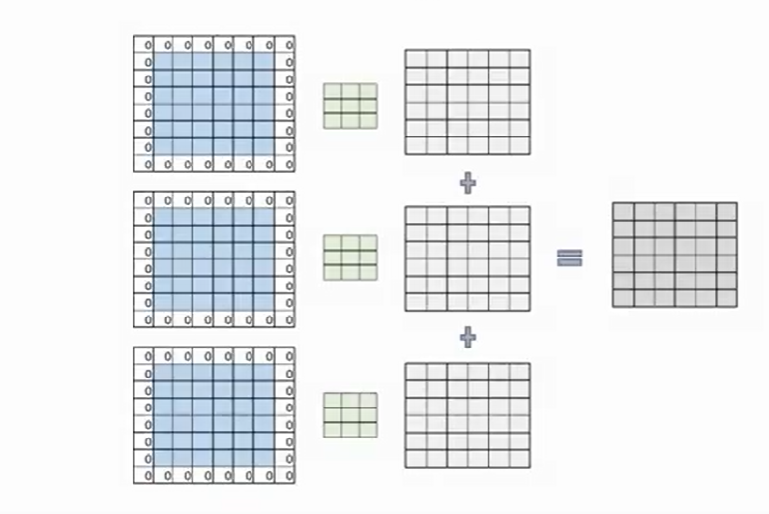

**Figure 4: N layer Convolution**

Figure 4 shows the n layer convolution, the dot product of 3 input vectors with different filters is obtained and all the outputs added to obtain a single output map. In the same way to get multiple feature maps we need multiple filters to perform the same operation. For example, to get 6 frature maps from 3 input vectors we need 3 * 6 filters.

Deeper networks also generalize better to unseen data, enhancing the model's robustness and accuracy. Additionally, NNN-layer CNNs are better equipped to handle large and complex datasets, making them suitable for various applications like computer vision and natural language processing. Overall, using NNN layers enables the progressive learning of detailed and hierarchical features, resulting in powerful and versatile models capable of tackling complex tasks.

**Pooling Layers**

Pooling layers are a crucial component in CNNs that serve to downsample the feature maps produced by convolutional layers. They play a vital role in reducing the spatial dimensions of the input while retaining the most important features

|  |  |  |  |  |  |  |  |  |  |  |
| --- | --- | --- | --- | --- | --- | --- | --- | --- | --- | --- |
| 9 | 7 | 2 | 4 | 8 | 7 | 3 | 1 | 5 | 9 | Feature Vector 10*1 |

|  |  |  |
| --- | --- | --- |
| 1 | 1 | Filter/ Weights 2*1 |

|  |  |  |  |  |  |  |  |  |  |
| --- | --- | --- | --- | --- | --- | --- | --- | --- | --- |
| 9 |  | 4 |  | 8 |  | 3 |  | 9 | Feature Map 5*1 |

**Figure 5: Example of Pooling**

As shown in the figure 5 pooling reduces the size of input vector to half and provide the output map. In the above example size of input vector is 10*1 and size of filter is 2*1 and the size of output map is 5*1. Here the filter slides one window at a time, when 9 and 7 are multiplied by one the output with maximum number is retained in the output map that is max (9*1 and 7*1).

Cascading pooling layers in convolutional neural networks is crucial as it serves multiple purposes: it reduces the spatial dimensions of feature maps, thereby decreasing computational load and memory usage; it enhances feature extraction by summarizing local neighborhood features, aiding generalization; it provides translation invariance, making the model robust to small input shifts; and it helps prevent overfitting by reducing the number of parameters, especially in deep networks.

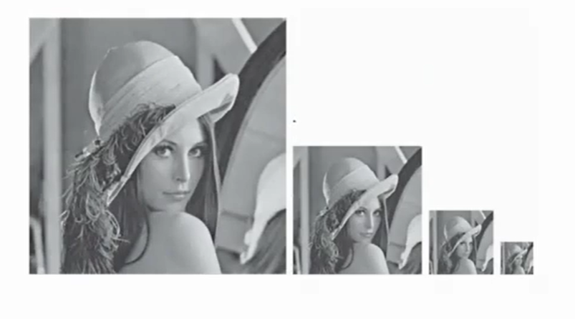

**Figure 6: Pooling cascading**

As shown in the figure 6 when pooling cascading is done it takes the important information of image and discard the unimported one and reduces the size of image to half of its original size.

**Fully Connected Layers**

Fully connected layers, also known as dense layers, are an essential component of neural networks, including Convolutional Neural Networks.

**Purpose of Fully Connected Layers:**

**Classification and Regression:**

They take the high-level features extracted by the preceding convolutional and pooling layers and use them to make predictions. In the classification tasks, each neuron in the final fully connected layer corresponds to a class, and the output represents the probability of the input belonging to each class. In regression tasks, the fully connected layer predicts continuous values based on the extracted features.

**Complex Pattern Recognition**:

Fully connected layers allow the network to learn complex patterns and relationships between features. They perform non-linear transformations on the input data, enabling the network to capture intricate patterns that may not be discernible in the raw input.

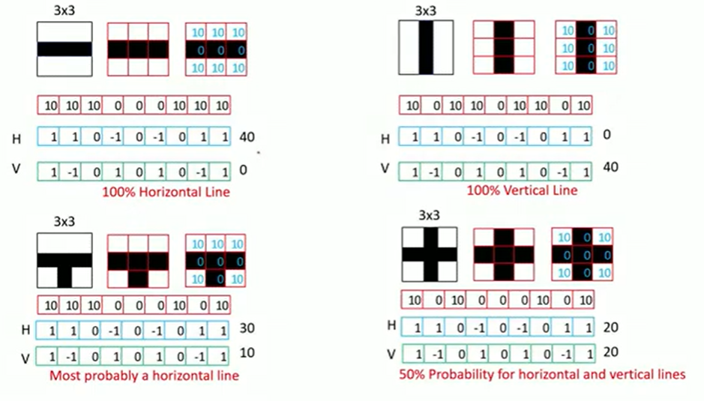

**Figure 7: Classification in Fully Connected Layer**

As shown in the figure 7 fully connected layers come after the convolutional and pooling layers. They take the flattened output from the final pooling layer and convert it into a single vector. This vector represents the high-level features extracted from the image by the convolutional layers.

In the above figure there are four examples, let us consider first example to understand the concept. Hear we have a small image of size 3*3, to classify this as horizontal and vertical image we need two filters one to identify horizontal image another for vertical image those are represented by H and V respectively. In the above figure the value 10 is assigned to white pixels and valve 0 for black pixels. And image 3*3 is converted to 1D vector, then dot product of 1D vector taken with both horizontal and vertical filters we get the value of 40 and 0 respectively then we can conclude it as the horizontal image as the dot product of 1D vector and horizontal filter is maximum that is probability is 100% and same applies for second example also. But in third example the probability of horizontal image is more but not 100%. In fourth example the value of both horizontal and vertical dot product is 50-50 we can’t conclude it as horizontal or vertical image to solve this problem we have to get confidential score that is what is probability that the prediction is correct. To get this we can apply softmax.

Softmax is an activation function often used in the output layer of a neural network for multi-class classification problems. It converts the raw output scores of the network into probabilities that sum to 100%. This makes it particularly suitable for classification tasks where the network needs to assign probabilities to each class, and the predicted class is typically the one with the highest probability.

The softmax function takes a vector of raw scores and transforms them into a probability distribution. The formula for the softmax function for an output vector *z* with *n* elements is:

**Softmax(*) =***

Where:

* ​ is the *i*-th element of the input vector *z.*
* *e* is the base of the natural logarithm.
* The denominator is the sum of the exponentials of all elements in the input vector.

**Table 1*:* Example of Softmax**

|  |  |  |
| --- | --- | --- |
|  |  | Softmax |
| 4 | 54.6 | 0.982 |
| 0 | 1 | 0.018 |
|  | 55.6 |  |

Consider the example: The output of the fully connected layer is 4 and 0 applying softmax formula we get the probability as 0.982 and 0.018 we can conclude that image is horizontal image as probability is close to one. We have seen that the softmax output will be between 0 – 1 and the sum should be equal to 1. Even though the fully connected layer output is negative the sofmax output will be always positive.

To get the probability close to one it is essential to have cascade of fully connected layer because for revolving around its ability to combine and interpret the features extracted by the convolutional and pooling layers.

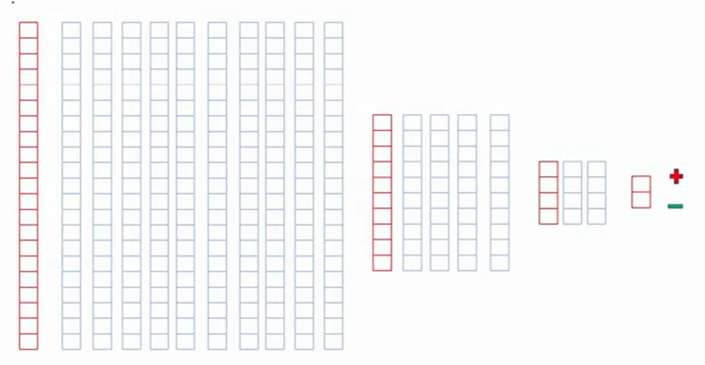

**Figure 8: Fully Connected layer Cascading**

As shown in the figure 8 consider the length of the output map of pooling is 21 now apply 10 different filters at the first stage then apply 4 different filters in second stage and then apply 2 filters in the last stage finally, we get the output then apply softmax to classify the image.

## **Conclusion**

**Why Cascade Convolutional Layers in CNN?**

Cascading is essential for effectively extracting and hierarchically representing features from input images.

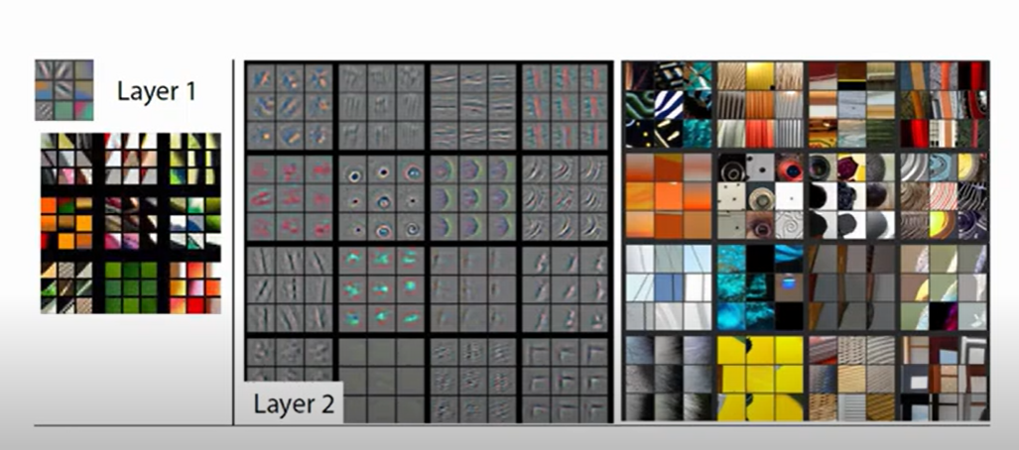

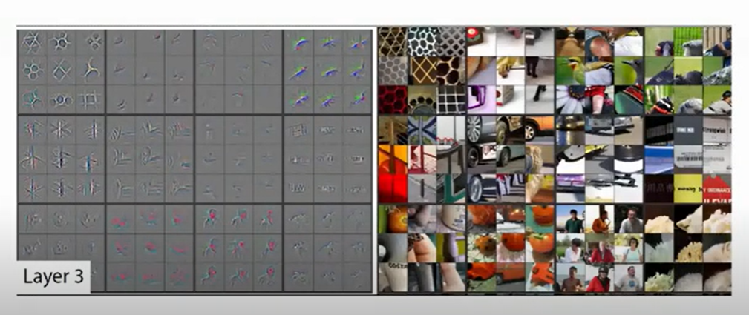

**Figure 9: Cascade Convolutional Layers**

Above figure 9 represents the how the cascading convolution works, in the first layer it detects the patterns standing line, sleeping line etc., in the second line it combines the patterns forms the shapes like triangle, square, circle etc. and the process continues to detect the object.

Here’s why these layers are used multiple times throughout the network:

1. **Hierarchical Feature Extraction:**

The early convolutional layers detect simple, low-level features such as edges, corners, and textures. As the network goes deeper, convolutional layers start to capture more complex, high-level features like shapes, parts of objects, and entire objects. This hierarchical feature extraction allows the network to build a comprehensive understanding of the input image.

Pooling layers reduce the spatial dimensions of the feature maps, which helps in managing computational complexity and memory usage. By down sampling the feature maps, pooling layers make the network more efficient and faster to train. Pooling layers help in summarizing the features by retaining the most significant information. This abstraction allows the network to become more robust to variations and distortions in the input image.

1. **Combating Overfitting:**

Using multiple layers helps in building a deeper model that can capture intricate patterns and nuances in the data. Pooling layers, in particular, help in reducing overfitting by providing a form of translational invariance. This means the network becomes less sensitive to the exact position of features in the image, improving its generalization ability.

1. **Complexity Management:**

By breaking down the feature extraction process into multiple layers, each layer focuses on a manageable subset of the overall task. This layered approach allows the network to efficiently handle complex patterns without overwhelming any single layer with too much complexity.

Pooling layers interspersed between convolutional layers help in progressively reducing the size of the feature maps. This step-by-step reduction ensures that the computational load remains manageable as the network depth increases.

1. **Improved Learning and Performance:** Stacking multiple convolutional and pooling layers enables the network to learn increasingly abstract and detailed representations of the input data. This depth is crucial for tasks such as object detection, where the network needs to identify and classify objects within varying contexts and environments. The combination of multiple convolutional and pooling layers ensures that the network has the capacity to learn rich and diverse features, leading to improved performance and accuracy in recognition tasks.

**Example:** Consider an image of a cat.

**Early Convolutional Layers:** Might detect edges and textures like fur patterns.

**Intermediate Convolutional Layers:** Could identify shapes such as the outline of the ears, eyes, and nose.

**Deep Convolutional Layers:** Would recognize the overall structure and identity of the cat as an object.

Pooling layers interspersed between these convolutional layers ensure that the network retains essential features while reducing spatial dimensions, contributing to the efficiency and robustness of the model.

In conclusion, the cascading of convolutional and pooling layers in CNNs is fundamental to their ability to effectively and efficiently extract, process, and understand complex features from input data, leading to high performance in tasks such as image classification, object detection, and more.

# RESULTS & PERFORMANCE ANALYSIS

## **Result**

**Complete CNN**

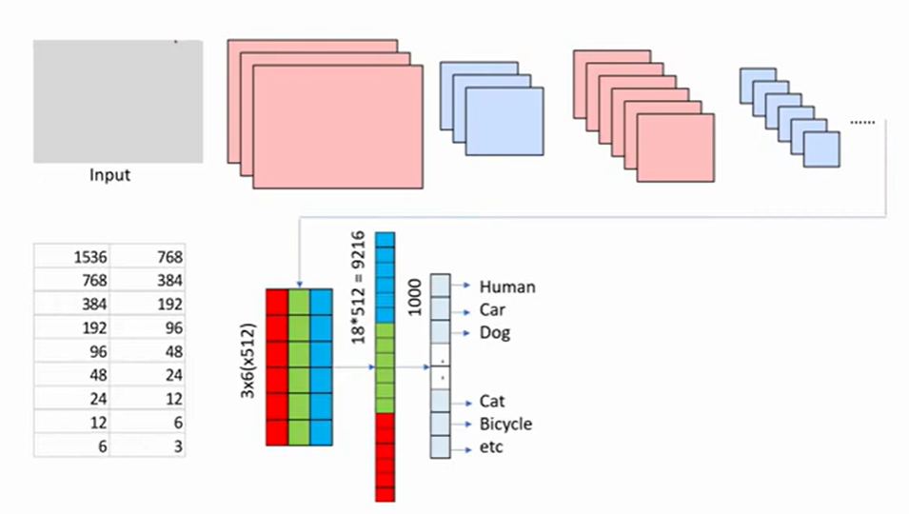

**Figure 10: Complete CNN Architecture**

As shown in the figure 10 take an input image cascading of Convolutional Layer and Pooling Layers is performed, we get the output feature map that is expanded to one dimensional vector then that one dimensional vector cascaded in fully connected layer to classify the image. In the table we can see that initially the size of image is 1536 after pooling size reduced to half that is 768. Then the process continues still the image size reduced to 3. The output map of this is converted into one dimensional vector in the fully connected layer there the size is 9216 by cascading of fully connected layer it is reduced to 1000.

The described process outlines the fundamental stages of a Convolutional Neural Network (CNN) architecture tailored for image classification tasks. Initially, the input image undergoes cascading convolutional and pooling layers, where convolutional layers extract essential features like edges and textures, while pooling layers reduce the spatial dimensions of the feature maps while retaining crucial information. This hierarchical feature extraction and dimensionality reduction process enables the network to progressively abstract and condense the input image's information into more manageable representations. Subsequently, the output feature map is flattened into a one-dimensional vector, preparing it for input into fully connected layers. Overall, this sequential progression through convolutional, pooling, and fully connected layers underscores the effectiveness of CNNs in extracting pertinent features and accurately classifying images.

# CONCLUSION

The case study underscores the pivotal role of convolutional and pooling layers in the success of CNNs for image classification tasks. Convolutional layers are instrumental in feature extraction, as they employ filters to detect various patterns, edges, textures, and shapes within the input image. These learned features are then passed through pooling layers, which help in reducing the spatial dimensions of the feature maps while retaining the essential information.

By cascading multiple convolutional and pooling layers, the network progressively abstracts and condenses the features, creating a hierarchical representation of the input image. This hierarchical representation captures increasingly complex and discriminative features, which are crucial for accurate classification.

Moreover, the dimensionality reduction achieved through pooling layers helps in mitigating the curse of dimensionality and reduces computational complexity. This makes CNNs computationally efficient and scalable for real-world applications, where processing large volumes of data in a timely manner is essential.

Overall, the successful classification results achieved in the case study highlight the effectiveness of CNNs in leveraging convolutional and pooling layers for feature extraction, dimensionality reduction, and ultimately, accurate and efficient classification of images across various domains and applications.

# FUTURE WORK

Future work for this study could explore optimization techniques to enhance CNN architecture, including investigating various activation functions, regularization methods, and optimization algorithms. Additionally, delving into advanced CNN architectures beyond traditional models, such as ResNet or Inception, could offer insights into their applicability and efficiency across different tasks. Another avenue for research involves conducting extensive hyperparameter tuning experiments to optimize settings like kernel sizes, layer depths, and learning rates, thereby improving model performance on specific tasks.

Further investigation could focus on transfer learning techniques, particularly in adapting pre-trained CNN models to specific domains with limited data. Fine-tuning strategies could be explored to tailor these models to new tasks effectively. Additionally, research into interpretability methods for CNNs would shed light on how features are learned and utilized for decision-making, enhancing the transparency and trustworthiness of these models.

Finally, the application of CNN architectures and techniques to other domains beyond computer vision, such as natural language processing, speech recognition, and medical image analysis, presents an intriguing area for exploration. Assessing the adaptability and effectiveness of CNNs in these domains could lead to groundbreaking advancements and innovative solutions in various fields.



# REFERENCES

1. Shaukat Hayat, She Kun, Zuo Tengtao, Yue Yu, Tianyi Tu, Yantong Du worked on A Deep Learning Framework Using Convolutional Neural Network for Multi-class Object Recognition paper released in 2018 3rd IEEE International Conference on Image, Vision and Computing <https://ieeexplore.ieee.org/document/8492777>
2. Zewen Li, FanLiu,Wenjie Yang, Shouheng,Peng and Jun Zhou worked on A Survey of Convolutional Neural Networks: Analysis, Applications, and Prospects paper released in IEEE TRANSACTIONS ON NEURAL NETWORKS AND LEARNING SYSTEMS, VOL. 33, NO. 12, DECEMBER 2022 <https://ieeexplore.ieee.org/document/9451544>
3. Rahul Chauhan, Kamal Kumar Ghanshala, R.C Joshi worked on Convolutional Neural Network (CNN) for Image Detection and Recognition paper released in 2018 First International Conference on Secure Cyber Computing and Communication (ICSCCC) <https://ieeexplore.ieee.org/document/8703316>
4. Prasoon Bharat Mishra1, Abdul Malik2, M.Safa,Saranaya G4,Arun D5 worked on Enhanced Object Detection with Deep Convolutional Neural Networks for Vehicle Detection paper released in 2022 International Conference on Power, Energy, Control and Transmission Systems (ICPECTS) <https://ieeexplore.ieee.org/document/10047323>
5. Xin Hu, Hua Ouyang and Yang Yin worked on Image Recognition based on Convolution Neural Network paper released in 2020 IEEE 9th Joint International Information Technology and Artificial Intelligence Conference (ITAIC) <https://ieeexplore.ieee.org/document/9339197>
6. Prof. Sujata Bhairnallykar, Aniket Prajapati, Anurag Rajbhar, Sahil Mujawar worked on Convolutional Neural Network (CNN) for Image Detection paper released in International Research Journal of Engineering and Technology (IRJET) 2020 <https://www.irjet.net/archives/V7/i11/IRJET-V7I11204.pdf>
7. Reagan L. Galvez, Ryan Rhay P. Vicerra, Elmer P. Dadios, Argel A. Bandala, Jose Martin Z. Maningo worked on Object Detection Using Convolutional Neural Networks Proceedings of TENCON 2018 - 2018 IEEE Region 10 Conference (Jeju, Korea, 28-31 October 2018) <https://ieeexplore.ieee.org/abstract/document/8650517>
8. Saad ALBAWI, Tareq Abed MOHAMMED and Saad AL-ZAWI worked on Understanding of a Convolutional Neural Network paper released in ICET2017, Antalya, Turkey <https://ieeexplore.ieee.org/document/8308186>