**What is a Convolutional Neural Network (CNN)?**

A Convolutional Neural Network (CNN), also known as a ConvNet, is a specialized deep learning model primarily used for tasks that require object recognition, such as image classification, detection, and segmentation. CNNs are widely utilized in real-world applications like autonomous vehicles and security camera systems.

**CNNs hold significant importance in today's world for several reasons:**

1. **Autonomous Feature Extraction:** Unlike traditional machine learning algorithms like SVMs and decision trees, CNNs can automatically extract features from data, eliminating the need for manual feature engineering and thus improving efficiency.
2. **Translation Invariance:** he convolutional layers in CNNs allow them to recognize and extract patterns regardless of variations in position, orientation, scale, or translation, making them robust to such changes.
3. **Pre-trained Architectures:** There are numerous pre-trained CNN models like VGG-16, ResNet50, Inceptionv3, and EfficientNet, which have shown high performance. These models can be fine-tuned for new tasks with relatively small amounts of data.
4. **Versatility:** Beyond image classification, CNNs are versatile and can be applied to various fields such as natural language processing, time series analysis, and speech recognition.

**Architecture of the CNN**

The number of layers in a Convolutional Neural Network (CNN) can vary widely depending on the architecture and the specific task it is designed for. Here are some general types of layers found in CNN

1. Convolutional Layers
2. Pooling Layers
3. Fully Connected Layers

Conv

 

Pool

Conv

 

Pool

Input Image

Conv + Pool

 

18*1

|  |  |  |  |  |  |  |  |  |  |  |  |  |  |  |  |  |  |
| --- | --- | --- | --- | --- | --- | --- | --- | --- | --- | --- | --- | --- | --- | --- | --- | --- | --- |
|  |  |  |  |  |  |  |  |  |  |  |  |  |  |  |  |  |  |

3*6

|  |  |  |  |  |  |
| --- | --- | --- | --- | --- | --- |
|  |  |  |  |  |  |
|  |  |  |  |  |  |
|  |  |  |  |  |  |

**Classifier**

**Out put**

**Figure 1:** **CNN Architecture**

As shown in figure1a typical CNN architecture consists of three main types of layers: convolutional layers, pooling layers, and fully connected layers.

Convolutional layers are the backbone of CNNs, responsible for extracting features from the input image. These layers utilize a set of filters, which are small, learnable matrices of weights. By sliding these filters across the input image and performing a convolution operation, the network generates feature maps, which are 2D arrays highlighting the presence and location of specific features like edges, textures, and patterns. Early convolutional layers might capture simple features such as edges and corners, while deeper layers can identify more complex structures like faces or objects. The filters' translation invariance allows the network to recognize features regardless of their position in the input image, enhancing the robustness and effectiveness of the model.

Pooling layers follow the convolutional layers to reduce the dimensionality of the feature maps, thus decreasing the computational load and helping to prevent overfitting. The most common type is max pooling, which down samples the feature map by taking the maximum value from small, non-overlapping regions of the input. This process not only reduces the spatial dimensions but also retains the most significant features, making the model more efficient. Other pooling methods, like average pooling, take the average value of these regions, but max pooling is more frequently used due to its effectiveness in highlighting dominant features.

Finally, fully connected layers are used towards the end of the CNN architecture. These layers resemble traditional neural network layers and are responsible for making predictions or classifications based on the extracted features. Each neuron in a fully connected layer is connected to every neuron in the previous layer, allowing the network to combine the features detected by the convolutional and pooling layers to make final decisions. Typically, the final fully connected layer has as many neurons as there are classes in the classification task, each producing a probability score for a specific class.

1. **Convolutional Layers**

Convolution is a mathematical operation where a filter (small matrix of numbers) slides over the input data (such as an image) to produce an output (feature map). This process involves the dot product of the filter and the sub-regions of the input.

|  |  |  |  |  |  |  |  |  |  |  |
| --- | --- | --- | --- | --- | --- | --- | --- | --- | --- | --- |
| 9 | 7 | 2 | 4 | 8 | 7 | 3 | 1 | 5 | 9 | Feature Vector 10*1 |

|  |  |
| --- | --- |
| 6 | Filter/ Weights 1*1 |

|  |  |  |  |  |  |  |  |  |  |  |
| --- | --- | --- | --- | --- | --- | --- | --- | --- | --- | --- |
| 54 | 42 | 12 | 24 | 48 | 42 | 18 | 6 | 30 | 54 | Feature Map 10*1 |

**Figure 2: 1D Convolutional**

As shown in the figure 2 input matrix is of size 10*1 is called as Feature Vector. The filter/weight is of size 1*1 is multiplied with feature vector to get the output map of size 10*1 is called as Feature Map. The weight is slide by 1 window at a time.

We can calculate the size of output map using the formula

***(W-F+2P)/S+1***

Where:

* **W** – size of Feature Vector
* **F -** Size of filter
* **P –** Padding size
* **S –** amount of slide of filter

In the above example filter is of size 1*1 there therefore the size of input and output vector remains same. If the size of the filter is other then 1*1 then the size of output vector will be reduced. To overcome this problem, we have to do padding to the input matrix as shown in the below figure 3.

**Figure 3: Example of Padding**

|  |  |  |  |  |  |  |  |  |  |  |
| --- | --- | --- | --- | --- | --- | --- | --- | --- | --- | --- |
| 9 | 7 | 2 | 4 | 8 | 7 | 3 | 1 | 5 | 9 | Feature Vector 10*1 |

|  |  |  |  |
| --- | --- | --- | --- |
| 1 | 3 | 6 | Filter/ Weights 3*1 |

|  |  |  |  |  |  |  |  |  |
| --- | --- | --- | --- | --- | --- | --- | --- | --- |
| 42 | 37 | 62 | 70 | 47 | 22 | 36 | 70 | Feature Map 8*1 |

**After padding**

|  |  |  |  |  |  |  |  |  |  |  |  |  |
| --- | --- | --- | --- | --- | --- | --- | --- | --- | --- | --- | --- | --- |
| 0 | 9 | 7 | 2 | 4 | 8 | 7 | 3 | 1 | 5 | 9 | 0 | Feature Vector 10*1 |

|  |  |  |  |
| --- | --- | --- | --- |
| 1 | 3 | 6 | Filter/ Weights 3*1 |

|  |  |  |  |  |  |  |  |  |  |  |
| --- | --- | --- | --- | --- | --- | --- | --- | --- | --- | --- |
| 69 | 42 | 37 | 62 | 70 | 47 | 22 | 36 | 70 | 80 | Feature Map 10*1 |

As shown in the figure 3 when the size of filter is 3*1 is applied to input vector of size 10*1 we get the output map of size 8*1. After padding that is appending zeros at both ends and performing convolutional, we get 10*1 output map.

1. **Pooling Layers**

Pooling layers are a crucial component in Convolutional Neural Networks (CNNs) that serve to downsample the feature maps produced by convolutional layers. They play a vital role in reducing the spatial dimensions of the input while retaining the most important features

|  |  |  |  |  |  |  |  |  |  |  |
| --- | --- | --- | --- | --- | --- | --- | --- | --- | --- | --- |
| 9 | 7 | 2 | 4 | 8 | 7 | 3 | 1 | 5 | 9 | Feature Vector 10*1 |

|  |  |  |
| --- | --- | --- |
| 1 | 1 | Filter/ Weights 2*2 |

|  |  |  |  |  |  |  |  |  |  |
| --- | --- | --- | --- | --- | --- | --- | --- | --- | --- |
| 9 |  | 4 |  | 8 |  | 3 |  | 9 | Feature Map 5*1 |

**Figure 4: Pooling**

As shown in the figure pooling reduces the size of input vector to half and provide the output map. In the above example size of input vector is 10*1 and size of filter is 2*1 and the size of output map is 5*1. Here the filter slides one window at a time, when 9 and 7 are multiplied by one the output with maximum number is retained in the output map that is max (9*1 and 7*1).

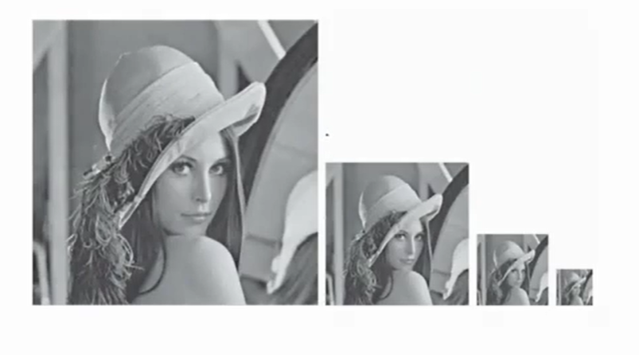

**Figure 5: Pooling cascading**

As shown in the figure we can see when pooling cascading is done it takes the important information of image and discard the unimported one and reduces the size of image to half of its original size.

1. **Fully Connected Layers**

Fully connected layers, also known as dense layers, are an essential component of neural networks, including Convolutional Neural Networks (CNNs).

**Purpose of Fully Connected Layers:**

**Classification and Regression:**

They take the high-level features extracted by the preceding convolutional and pooling layers and use them to make predictions. In the classification tasks, each neuron in the final fully connected layer corresponds to a class, and the output represents the probability of the input belonging to each class. In regression tasks, the fully connected layer predicts continuous values based on the extracted features.

**Complex Pattern Recognition**:

Fully connected layers allow the network to learn complex patterns and relationships between features. They perform non-linear transformations on the input data, enabling the network to capture intricate patterns that may not be discernible in the raw input.

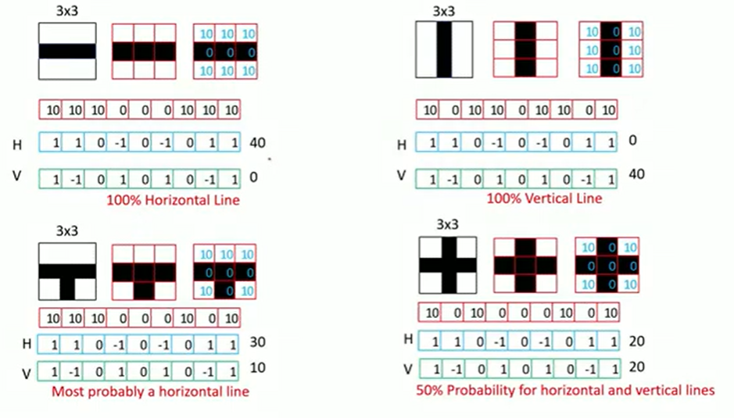

**Figure 6: Classification in Fully Connected Layer**

As shown in the figure fully connected layers come after the convolutional and pooling layers. They take the flattened output from the final pooling layer and convert it into a single vector. This vector represents the high-level features extracted from the image by the convolutional layers.

In the above figure there are four examples, let us consider first example to understand the concept. Hear we have a small image of size 3*3, to classify this as horizontal and vertical image we need two filters one to identify horizontal image another for vertical image those are represented by H and V respectively. In the above figure the value 10 is assigned to white pixels and valve 0 for black pixels. And image 3*3 is converted to 1D vector, then dot product of 1D vector taken with both horizontal and vertical filters we get the value of 40 and 0 respectively then we can conclude it as the horizontal image as the dot product of 1D vector and horizontal filter is maximum that is probability is 100% and same applies for second example also. But in third example the probability of horizontal image is more but not 100%. In fourth example the value of both horizontal and vertical dot product is 50-50 we can’t conclude it as horizontal or vertical image to solve this problem we have to get confidential score that is what is probability that the prediction is correct. To get this we can apply softmax.

Softmax is an activation function often used in the output layer of a neural network for multi-class classification problems. It converts the raw output scores of the network into probabilities that sum to 100%. This makes it particularly suitable for classification tasks where the network needs to assign probabilities to each class, and the predicted class is typically the one with the highest probability.

The softmax function takes a vector of raw scores (logits) and transforms them into a probability distribution. The formula for the softmax function for an output vector *z* with *n* elements is:

**Softmax(*) =***

Where:

* ​ is the *i*-th element of the input vector *z.*
* *e* is the base of the natural logarithm.
* The denominator is the sum of the exponentials of all elements in the input vector.

|  |  |  |
| --- | --- | --- |
|  |  | Softmax |
| 4 | 54.6 | 0.982 |
| 0 | 1 | 0.018 |
|  | 55.6 |  |

Consider the example: The output of the fully connected layer is 4 and 0 applying softmax formula we get the probability as 0.982 and 0.018 we can conclude that image is horizontal image as probability is close to one. We have seen that the softmax output will be between 0 – 1 and the sum should be equal to 1. Even though the fully connected layer output is negative the sofmax output will be always positive.

To get the probability close to one it is essential to have cascade of fully connected layer because for revolving around its ability to combine and interpret the features extracted by the convolutional and pooling layers.

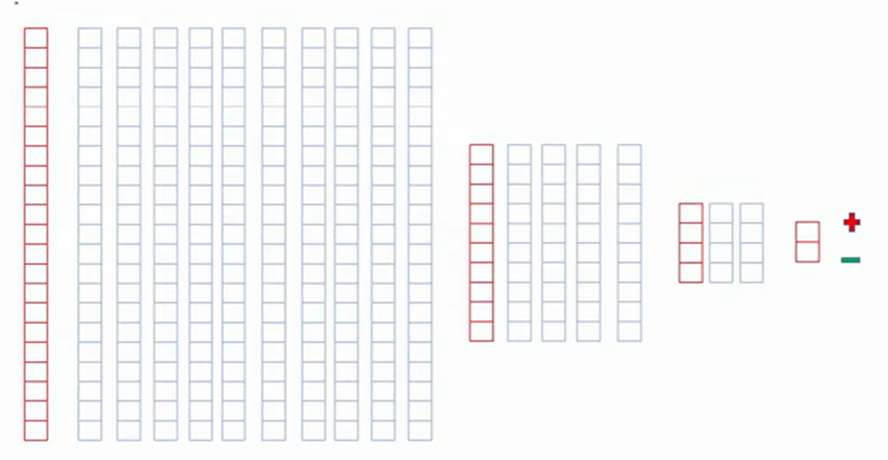

**Figure 7: Fully Connected layer Cascading**

As shown in the figure consider the length of the output map of pooling is 21 now apply 10 diffnet filters at the first stage then apply 4 different filters in second stage and then apply 2 filters in the last stage finally we get the output then apply softmax to classify the image.

**Complete CNN**

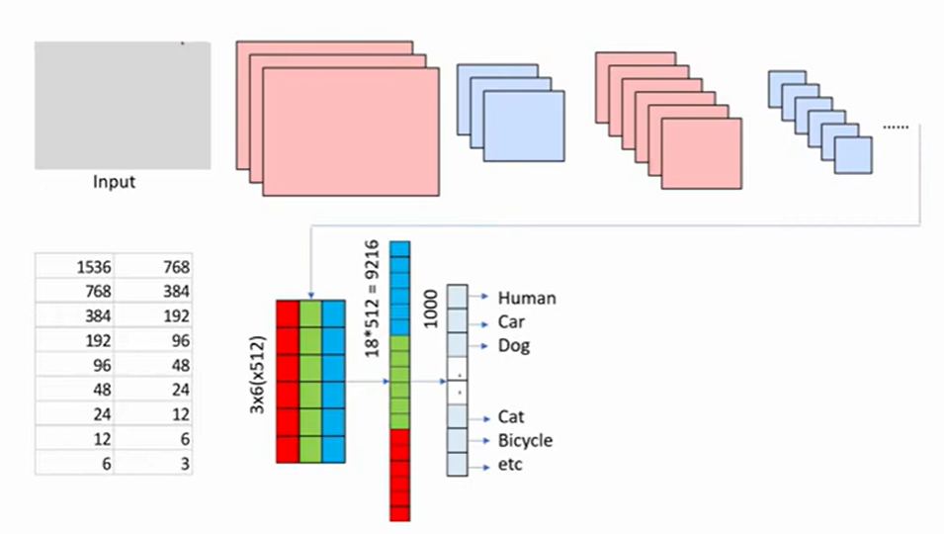

**Figure 8: Complete CNN Architecture**

As shown in the figure take an input image cascading of Convolutional Layer and Pooling Layers is performed, we get the output feature map that is expanded to one dimensional vector then that one dimensional vector cascaded in fully connected layer to classify the image. In the table we can see that initially the size of image is 1536 after pooling size reduced to half that is 768. Then the process continues still the image size reduced to 3. The output map of this is converted into one dimensional vector in the fully connected layer there the size is 9216 by cascading of fully connected layer it is reduced to 1000.

**Why Cascade Convolutional Layers in CNN?**

Cascading is essential for effectively extracting and hierarchically representing features from input images.

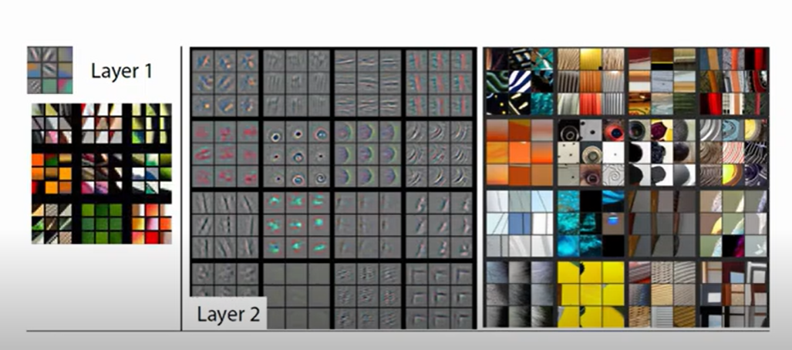

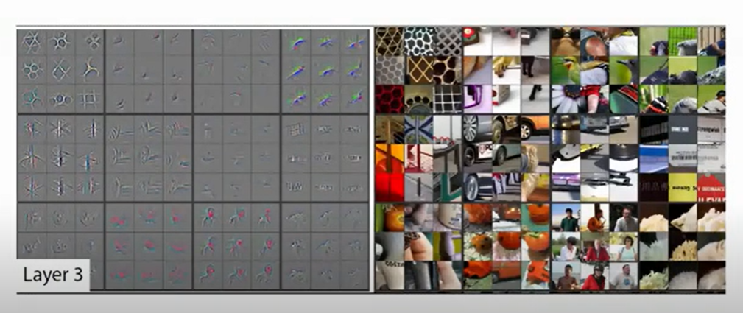

**Figure 9: Cascade Convolutional Layers**

Above figure represents the how the cascading convolution works, in the first layer it detects the patterns standing line, sleeping line etc, in the second line it combines the patterns forms the shapes like triangle, square, circle etc and the process continues to detect the object.

Here’s why these layers are used multiple times throughout the network:

1. **Hierarchical Feature Extraction:**

Convolutional Layers: The early convolutional layers detect simple, low-level features such as edges, corners, and textures. These features are foundational and provide the basic building blocks for more complex patterns. As the network goes deeper, convolutional layers start to capture more complex, high-level features like shapes, parts of objects, and entire objects. This hierarchical feature extraction allows the network to build a comprehensive understanding of the input image.

Pooling layers reduce the spatial dimensions of the feature maps, which helps in managing computational complexity and memory usage. By down sampling the feature maps, pooling layers make the network more efficient and faster to train. Pooling layers help in summarizing the features by retaining the most significant information (e.g., max pooling retains the most prominent features within a region). This abstraction allows the network to become more robust to variations and distortions in the input image.

1. **Combating Overfitting:** Using multiple layers helps in building a deeper model that can capture intricate patterns and nuances in the data. Pooling layers, in particular, help in reducing overfitting by providing a form of translational invariance. This means the network becomes less sensitive to the exact position of features in the image, improving its generalization ability.
2. **Complexity Management:**

Convolutional Layers: By breaking down the feature extraction process into multiple layers, each layer focuses on a manageable subset of the overall task. This layered approach allows the network to efficiently handle complex patterns without overwhelming any single layer with too much complexity.

Pooling Layers: Pooling layers interspersed between convolutional layers help in progressively reducing the size of the feature maps. This step-by-step reduction ensures that the computational load remains manageable as the network depth increases.

1. **Improved Learning and Performance:** Stacking multiple convolutional and pooling layers enables the network to learn increasingly abstract and detailed representations of the input data. This depth is crucial for tasks such as object detection, where the network needs to identify and classify objects within varying contexts and environments. The combination of multiple convolutional and pooling layers ensures that the network has the capacity to learn rich and diverse features, leading to improved performance and accuracy in recognition tasks.

**Example:** Consider an image of a cat.

**Early Convolutional Layers:** Might detect edges and textures like fur patterns.

**Intermediate Convolutional Layers:** Could identify shapes such as the outline of the ears, eyes, and nose.

**Deep Convolutional Layers:** Would recognize the overall structure and identity of the cat as an object.

Pooling layers interspersed between these convolutional layers ensure that the network retains essential features while reducing spatial dimensions, contributing to the efficiency and robustness of the model.

In conclusion, the cascading of convolutional and pooling layers in CNNs is fundamental to their ability to effectively and efficiently extract, process, and understand complex features from input data, leading to high performance in tasks such as image classification, object detection, and more.

1. **RESEARCH GAP ANALYSIS**
   1. **Comparative Study of different existing system**

Given the success of Convolutional Neural Networks (CNNs) in object recognition, there is a growing need to enhance the speed and efficiency of these models to enable real-time applications across various domains. One notable advancement in this direction is the introduction of YOLO. YOLO revolutionized real-time object detection by offering a streamlined approach that significantly improves processing speed while maintaining high accuracy levels. Unlike traditional object detection systems that rely on multiple passes through the image, YOLO processes the entire image in a single feedforward pass, resulting in faster inference times and improved efficiency.

Future enhancements in object detection technology are likely to focus on refining the implementation of existing systems like YOLO and optimizing their deployment in real-world scenarios. This includes addressing challenges related to scalability, reliability, and usability to ensure seamless integration and operation across different applications and industries.

Scalability is a critical consideration, especially as the volume and complexity of data continue to increase. Object detection systems must be capable of handling large-scale datasets and complex scenes without compromising performance or accuracy. This requires developing efficient algorithms and architectures that can scale effectively with the size of the input data and adapt to changing environmental conditions.

Reliability is another key aspect that needs to be addressed to ensure the robustness of object detection systems in real-world scenarios. This includes improving the robustness of models to variations in lighting, weather conditions, and occlusions, as well as minimizing false positives and false negatives.

Usability considerations are also crucial for the successful deployment of object detection technology across different applications and industries. This involves designing user-friendly interfaces, providing comprehensive documentation and support, and facilitating seamless integration with existing workflows and systems

Enhancements in object detection technology will likely focus on improving the speed, efficiency, scalability, reliability, and usability of existing systems to enable their widespread adoption and application in real-world scenarios.