

**SYNOPSIS ON**

**SmartFlow: Prioritize Emergency Vehicle and Traffic Rules Monitoring System**

Submitted to the

Department of Master of Computer Applications

in partial fulfilment of the requirements

for the Project Work (MCA41)

**by**

**Komal S Kallanagoudar**

**1MS22MC016**

**Under the guidance of**

**Abhishek K L**

**Assistant Professor**

**Department of Master of Computer Applications**

**RAMAIAH INSTITUTE OF TECHNOLOGY**

(Autonomous Institute, Affiliated to VTU)

Accredited by National Board of Accreditation & NAAC with ‘A+’ Grade

MSR Nagar, MSRIT Post, Bangalore-560054

www.msrit.edu

**2024**

**1.Title**

SmartFlow: Prioritized Emergency Vehicle Detection and Traffic Rules Monitoring System

**2.Project Overview**

SmartFlow is an innovative system designed to enhance road safety and traffic management by combining advanced technologies for emergency vehicle detection and real-time traffic rule monitoring. The project addresses the critical need for efficient emergency response and improved adherence to traffic regulations. Through the integration of cutting-edge sensors, computer vision, and artificial intelligence, SmartFlow aims to create a smarter and safer traffic environment.

**2.1 Introduction**

The traffic management system of a metropolitan city is a keystone for urban mobility. With the rise of the population, the demand for vehicles grows up and hence the requirement of transportation has also increased. Infrastructural development becomes an indispensable part of complementing the population growth to augment urban mobility. But the traditional traffic management system is shown not only ineffective for accompanying the increased number of vehicles with the use of police control and traffic light system but also incompetent enough to handle this growth of traffic on road systems. This traffic congestion consequentially consumes precious working time for being incapable of handling extensive traffic congestion and eventually leads to the environmental pollution for an extended period of vehicle emission. Adequate pre-measures and proper planning can help to reduce the number of traffic problems and manage an increased number of vehicles on the road. Traffic system utilize the concept of automation with IoT is called as “Smart Traffic”. Smart Traffic Management System is an advanced and integrated solution designed to optimize traffic flow, reduce congestion, enhance road safety, and improve overall transportation efficiency within urban or metropolitan areas. This system relies on various sensors placed strategically throughout the road network to monitor traffic conditions.

**Objectives:**

* Strengthen traffic monitoring efforts with camera technology.
* Controlling the traffic signals at intersections dynamically based on real-time traffic data.
* Adaptive traffic signal systems adjust signal timings to minimize waiting times and reduce idling.
* Reducing congestion and energy consumption at intersection.
* The emergency vehicle is detected, which gives ambulances priority to pass through traffic lights.

**2.2 Scope**

* Target Audience involves Traffic Management Authorities, Law Enforcement Agenesis, Emergency Services.
* Platform supported includes Traffic Signal Integration, IoT and Sensor Integration, Mobile Applications, Cloud-Based Infrastructure.

**2.2 Features**

Congestion control, Emergency vehicle Detection, Traffic rule violation monitoring system, Healthcare monitoring system

**3. Project Architecture**

**3.1 System component**

* Arduino MEGA
* Traffic LED’s
* Bluetooth
* RFID Tages
* Camera Module

**3.2 Technologies Used**

* Arduino Integrated Development Environment (IDE) and its Libraries.
* Python openCV, YOLO algorithm.

**3.2 Design Diagram:**

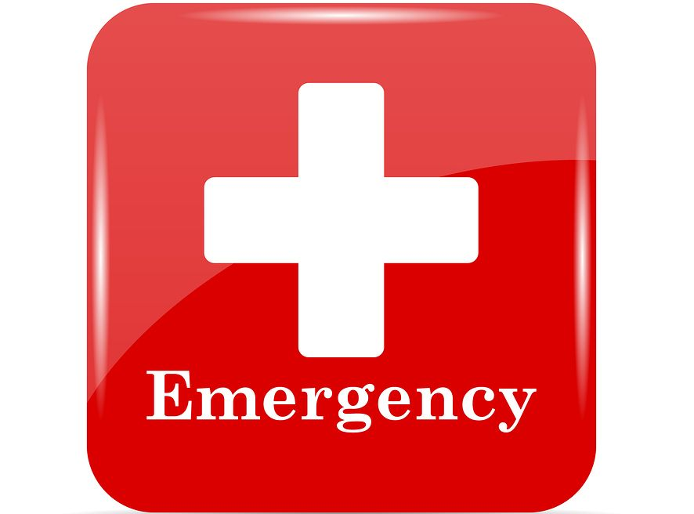

**Emergency vehicle detection**

**Capture Image**

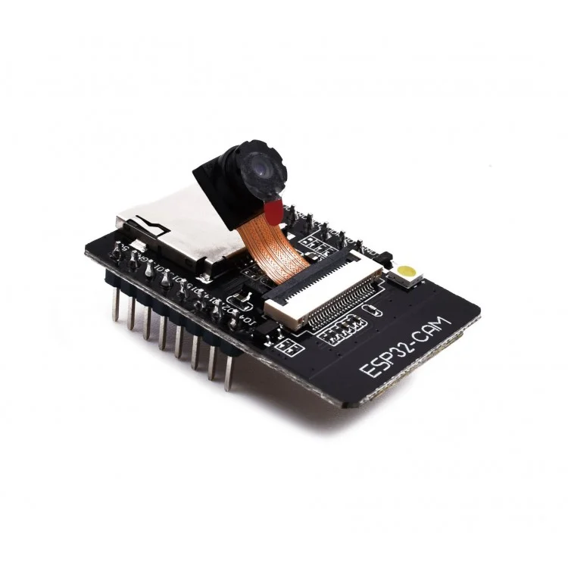

**Send to server to detect vehicle density**



**Updating the signal**



**Calculating the green signal Dealy**



**Figure 1:** **Behavioural Design**

The camera captures the image and store it in the server, then YOLO algorithm processes the image and detect the congestion and calculate the green signal timing, according that calculation the traffic signal is controlled. If there is any emergency vehicle is arriving towards the traffic junction then RFID tag detects the vehicle and green signal is turned on for the emergency vehicle.

**4.Functionalities**

* Congestion Control
* Emergency vehicle Detection
* Traffic rule violation monitoring system
* Voice Controlled Emergency Alert System

**References:**

1. Sunny Hossain and Farzana Shabnam researched on paper A Comparative Study of IoT Based Smart Traffic Management System published paper in IEEE International Women in Engineering (WIE) Conference on Electrical and Computer Engineering (2021) <https://ieeexplore.ieee.org/document/9829636>
2. Varsha Sahadev Nagmode and Prof.Dr.S.M.Rajbhoj researched on An IoT Platform for Vehicle Traffic Monitoring System and Controlling System Based on Priority published by IEEE in 2017 <https://ieeexplore.ieee.org/document/8463825>
3. Sabeen Javaid, Ali Sufian, Saima Pervaiz and Mehak Tanvee worked on Smart Traffic Management System Using Internet of Things published in International Conference on Advanced Communications Technology (2018)

<https://www.researchgate.net/publication/324464391_Smart_traffic_management_system_using_Internet_of_Things>

1. Dr. Vikram Bali, Ms. Sonali Mathur, Dr. Vishnu Sharma, Dev Gaur researched on Smart Traffic Management System using IoT Enabled Technology, 2020 2nd International Conference on Advances in Computing, Communication Control and Networking (ICACCCN). <https://ieeexplore.ieee.org/document/9362753>
2. Prof. Deepali Ahir, Saurabh Bharade, Pradnya Botre, Sayali Nagane, Mihir Shah worked on Intelligent Traffic Control System for Smart Ambulance paper released in International Research Journal of Engineering and Technology (IRJET) Volume: 05 Issue: 06 June-2018. <https://www.irjet.net/archives/V5/i6/IRJET-V5I675.pdf>