|  |  |
| --- | --- |
| Name: Komal Sharma  PG-DAC A | Saturday Assignment for Practice  Date: 24-09-2022  Concepts of Programming |

**Q 1: Wap to convert Fahrenheit to Celsius in Java using formula given below**  **°C = (°F – 32) / (9/5)**

**package** satAssign;

**import** java.util.Scanner;

**public** **class** Temperature {

**public** **static** **void** main(String[] args) {

Scanner sc=**new** Scanner(System.***in***);

System.***out***.print("enter temperature in Fahrenheit: ");

**float** fah=sc.nextFloat();

**float** cel = ((fah-32)*5)/9;

System.***out***.println("temperature in Celsius: "+ cel);

}

}

**Output:**

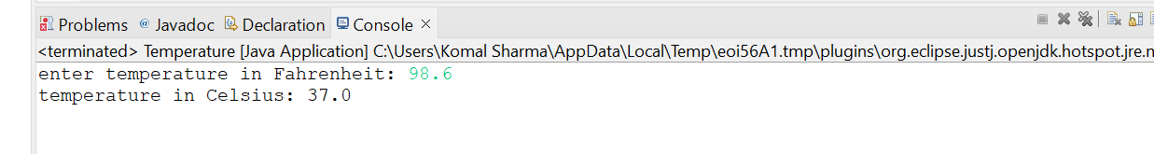

**Q 2 wap to check a given number is armstrong or not i.e. 153 = 1*1*1 + 5*5*5+3*3*3**

**package** satAssign;

**import** java.util.Scanner;

**public** **class** Armstrong {

**public** **static** **void** main(String[] args) {

Scanner sc=**new** Scanner(System.***in***);

System.***out***.print("enter the number to check armstrong: ");

**int** num=sc.nextInt();

**int** initial_num = num;

**int** res=0, rem=0;

**while**(num>0)

{

rem=num%10;

res=res+rem*rem*rem;

num=num/10;

}

J6

**if**(initial_num==res)

{

System.***out***.println("number is armstrong.");

}

**else** {System.***out***.println("number is not armstrong");}

}

}

**Output:**

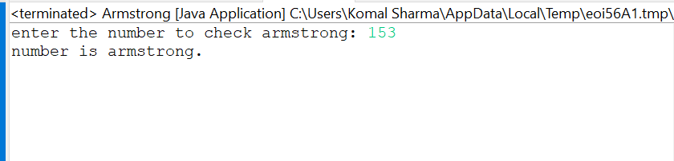

**Q 3 Rajan went to a movie with his friends in a multiplex theatre and during break time he bought pizzas, puffs, and cool drinks. Consider   the following prices:  
  
Rs.100/pizza  
Rs.20/puffs  
Rs.10/cooldrink  
Generate a bill for What Rajan has bought.**

**package** satAssign;

**import** java.util.Scanner;

**public** **class** Movie {

**public** **static** **void** main(String[] args) {

Scanner sc=**new** Scanner(System.***in***);

**char** ch='y';

**int** puff=0,pizza=0,cd=0,pz=0,pf=0,c=0;

System.***out***.print("-----MENU-----\nRs.100/pizza\nRs.20/puffs\nRs.10/cooldrink\n\n");

**do**

{

**if**(ch=='y') {

System.***out***.print("No. of pizza:");

pizza=pizza+sc.nextInt();

System.***out***.print("No. of Puff:");

puff=puff+sc.nextInt();

System.***out***.print("No. of Cold Drink:");

cd=cd+sc.nextInt();

System.***out***.println("do you want any more:Y or N");

ch=sc.next().charAt(0);}

**else**

**break**;

}**while**(ch=='y');

**if**(ch=='n')

{

pz=pizza*100;

pf=puff*20;

c=cd*10;

**int** total=pz+pf+c;

System.***out***.println("Your Bill:"+total);

}

}

}

**Output:**

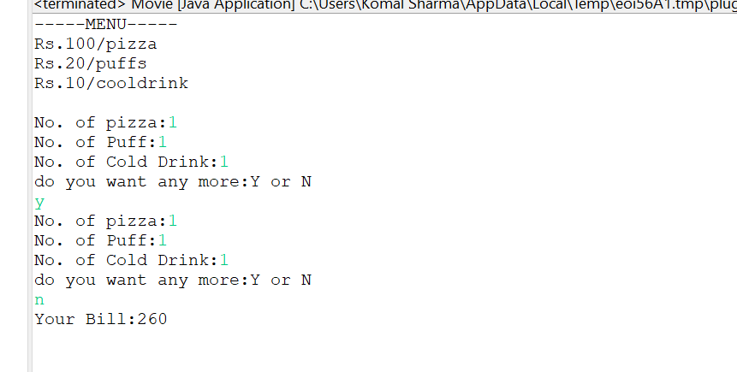

**Q 3 Given an integer U denoting the amount of KWh units of electricity consumed, the task is to calculate the electricity bill with the help of the below charges:  
   
  
1 to 100 units – Rs. 10/unit  
100 to 200 units – Rs. 15/unit  
200 to 300 units – Rs. 20/unit  
above 300 units – Rs. 25/unit**

**package** satAssign;

**import** java.util.Scanner;

**public** **class** Electricity {

**public** **static** **void** main(String[] args) {

Scanner sc=**new** Scanner(System.***in***);

System.***out***.println("-----ELECTRICITY CHARGES-----\n1 to 100 units – Rs. 10/unit\n100 to 200 units – Rs. 15/unit\nabove 300 units – Rs. 25/unit\n\n");

System.***out***.println("enter the units of electricity consumed:");

**int** U=sc.nextInt();

**int** bill=0;

**if**(U>=1 && U<=100)

{

bill=U*10;

System.***out***.println("electricity bill: "+ bill);

}

**else** **if**(U>100 && U<=200)

{

bill=100*10+(U-100)*15;

System.***out***.println("electricity bill: "+ bill);

}

**else** **if**(U>200 && U<=300)

{

bill=100*10+100*15+(U-200)*20;

System.***out***.println("electricity bill: "+ bill);

}

**else** {

bill=100*10+100*15+100*20+(U-300)*25;

System.***out***.println("electricity bill: "+ bill);

}

}

}

**Output:**

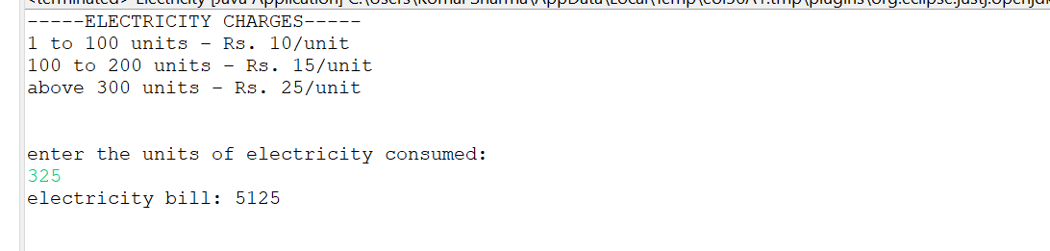

**Q 4 Write a java program that define a sorted array of size N and an integer K, find the position at which K is present in the array using binary search.  
  
Example 1:  
  
Input:  
N = 5  
arr[] = {1 2 3 4 5}  
K = 4**

**package** satAssign;

**import** java.util.Scanner;

**public** **class** SortAndFind {

**public** **static** **void** main(String[] args) {

Scanner sc=**new** Scanner(System.***in***);

System.***out***.println("Size of array:");

**int** size=sc.nextInt();

**int**[] ar=**new** **int**[size];

System.***out***.println("enter values:");

**for**(**int** i=0;i<size;i++)

{

ar[i]=sc.nextInt();

}

**for**(**int** j=0;j<size-1;j++)

{

**for**(**int** i=0;i<size-1;i++)

{

**if**(ar[i]>ar[i+1])

{

**int** temp=ar[i];

ar[i]=ar[i+1];

ar[i+1]=temp;

}

}}

System.***out***.println("sorted array:");

**for**(**int** i=0;i<size;i++)

{

System.***out***.println(" "+ar[i]);

}

System.***out***.println("enter the item to be found:");

**int** find=sc.nextInt();

**int** first=0;

**int** last=ar.length-1;

**int** mid=(first+last)/2;

**while**(first<=last)

{

**if**(ar[mid]<find)

{

first=mid+1;

}

**else** **if**(ar[mid]==find)

{

System.***out***.println(" record found at position: "+(mid+1));

**break**;

}

**else** **if**(ar[mid]>find)

{

last=mid-1;

}

mid=(first+last)/2;

} **if**(first>last)

System.***out***.println("record not found");

}}

**Output:**

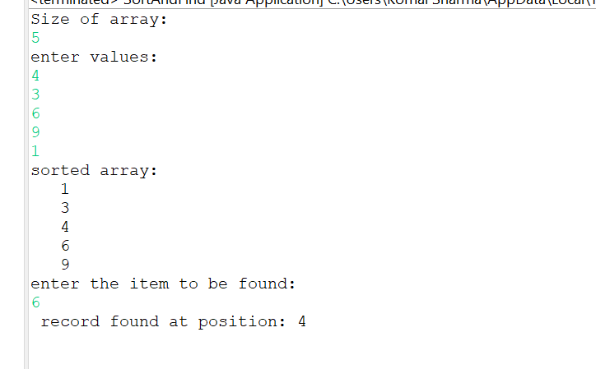

**Q 5 write a java program and define an array, print all the elements which are leaders. A Leader is an element that is greater than all the elements on its right side in the array.  
  
Example 1:  
Input:  
 arr = [4, 7, 1, 0]  
Output:  
 7 1 0**

**package** satAssign;

**import** java.util.Scanner;

**public** **class** Leader{

**public** **static** **void** main(String[] args) {

Scanner sc=**new** Scanner(System.***in***);

System.***out***.println("Size of array:");

**int** size=sc.nextInt();

**int**[] ar=**new** **int**[size];

System.***out***.println("enter values:");

**for**(**int** i=0;i<size;i++)

{

ar[i]=sc.nextInt();

}

System.***out***.println("Leader elements:");

**for** (**int** i = 0; i < size; i++)

{

**int** j;

**for** (j = i + 1; j < size; j++)

{

**if** (ar[i] <= ar[j])

**break**;

}

**if** (j == size)

System.***out***.print(ar[i] + " ");

}}}

**Output:**

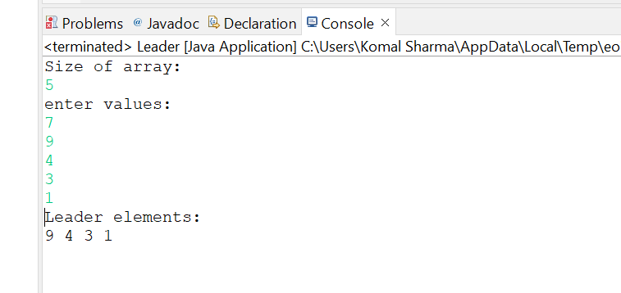

**Q 6 Given two strings a and b consisting of lowercase characters. The task is to check whether two given strings are an anagram of each other or not. An anagram of a string is another string that contains the same characters, only the order of characters can be different.**

**package** satAssign;

**import** java.util.Arrays;

**import** java.util.Scanner;

**public** **class** Anagrams {

**public** **static** **void** main(String[] args)

{

Scanner sc=**new** Scanner(System.***in***);

System.***out***.println("First string: ");

String str1=sc.next();

System.***out***.println("Second string:");

String str2=sc.next();

**boolean** flag=**true**;

**if** (str1.length() != str2.length())

{

flag=**false**;

}

**else**

{

**char**[] ArrayS1 = str1.toLowerCase().toCharArray();

**char**[] ArrayS2 = str2.toLowerCase().toCharArray();

Arrays.*sort*(ArrayS1);

Arrays.*sort*(ArrayS2);

flag = Arrays.*equals*(ArrayS1, ArrayS2);

}

**if** (flag==**true**)

{

System.***out***.println(str1 + " and " + str2 + " are anagrams");

} **else**

{

System.***out***.println(str1 + " and " + str2 + " are not anagrams");

}

}

}

**Output:**

