Part 2: Web Security Project
BookNest — Vulnerable Version vs Safe Version (Python / Flask / MySQL)

1. Project Overview
For Part 2, I built a small online bookstore website called BookNest. I made two copies of the exact same website: one copy has security bugs in it on purpose (the Vulnerable Version), and the other copy has those same bugs fixed (the Safe Version). Both copies look the same and work the same way, so it is easy to compare them and see exactly what changed to fix each bug.
I used Python (with a small web framework called Flask) for the backend, and MySQL as the database. Both versions run on my own computer at the same time, on two different addresses, so I can open them side by side in two browser tabs.
- Vulnerable Version: http://localhost:5000
- Safe Version: http://localhost:5001
Test accounts (same on both versions):
- alice / alice123
- bob / bob123
- admin / SuperSecretAdmin!2026

2. GitHub Repository
The full project (both versions, source code, and this report's payloads) is submitted on GitHub here:
[ TYPE HERE — paste your GitHub repository link here, e.g. https://github.com/your-username/booknest ]

3. Vulnerabilities — Vulnerable Version
This section shows every required bug actually working on the Vulnerable Version. For each one, I explain what the bug is in my own words, show the exact text (payload) I typed in, and I am pasting a screenshot proving it worked.

3.1. Reflected XSS
Reflected XSS happens when I type something into the search box, and the website puts my exact text back onto the page without checking what it is first. If I type in a small piece of JavaScript code instead of a normal search word, the website runs that code right inside my browser. I tested this using the search box on the Vulnerable Version's homepage.
Payload I typed into the search box:
<script>alert('reflected-xss')</script>
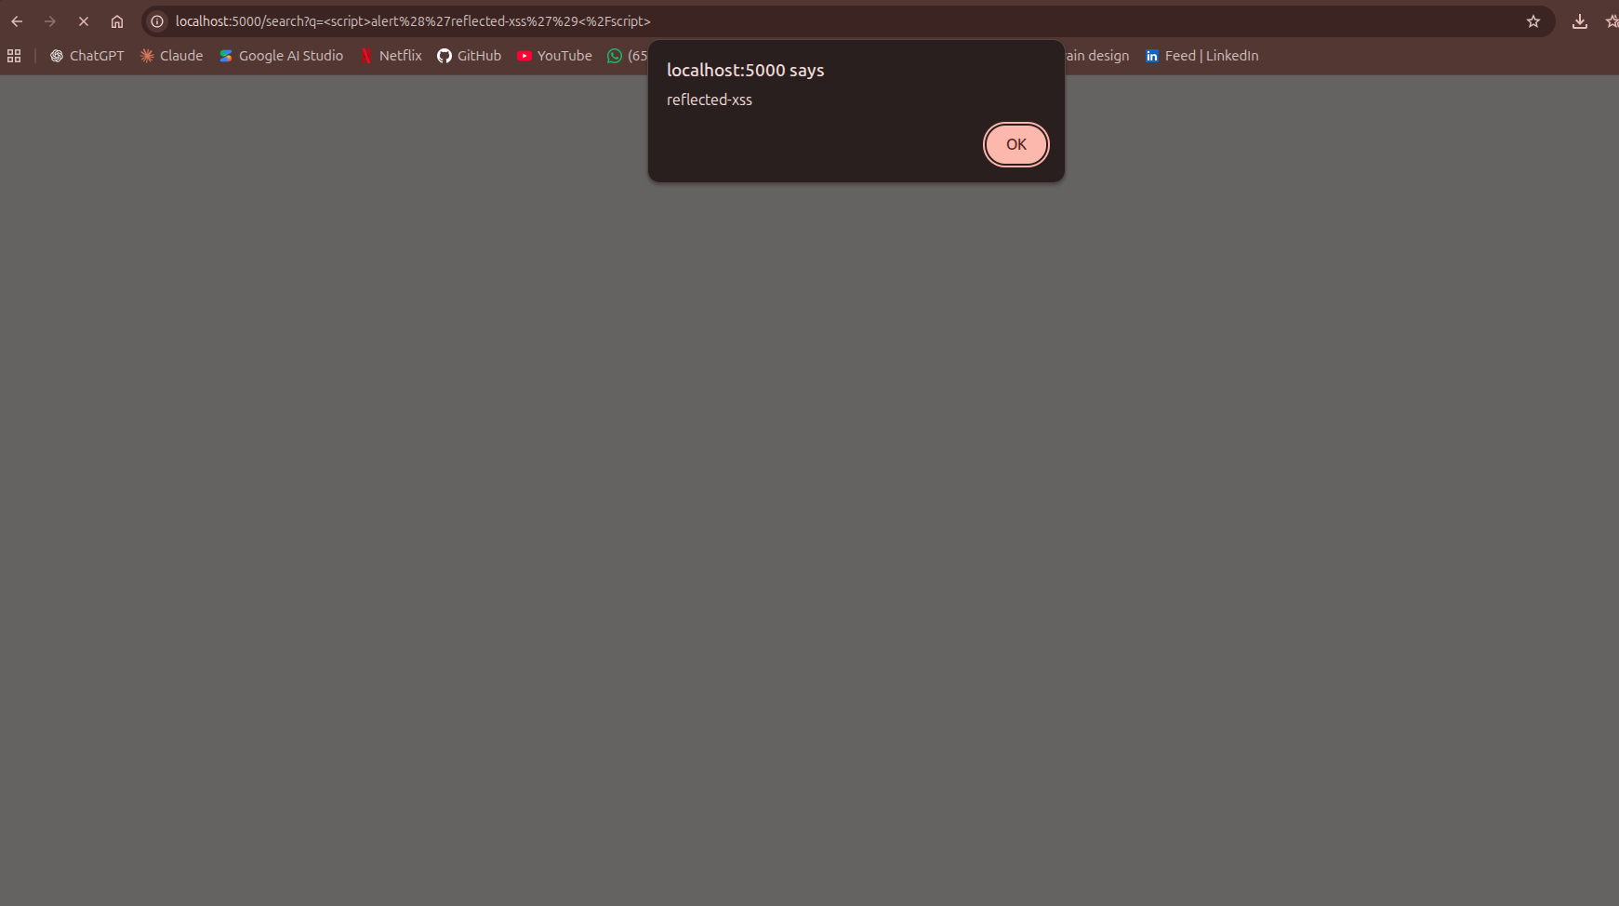

3.2. Stored XSS
Stored XSS is like reflected XSS, but worse: instead of my code only running for me, it gets saved into the database (as a book review). This means every single person who later opens that book's page also gets my code running in their browser automatically, even though they never typed anything themselves.
Payload I typed into the review box on a book page:
<script>alert('stored-xss')</script>
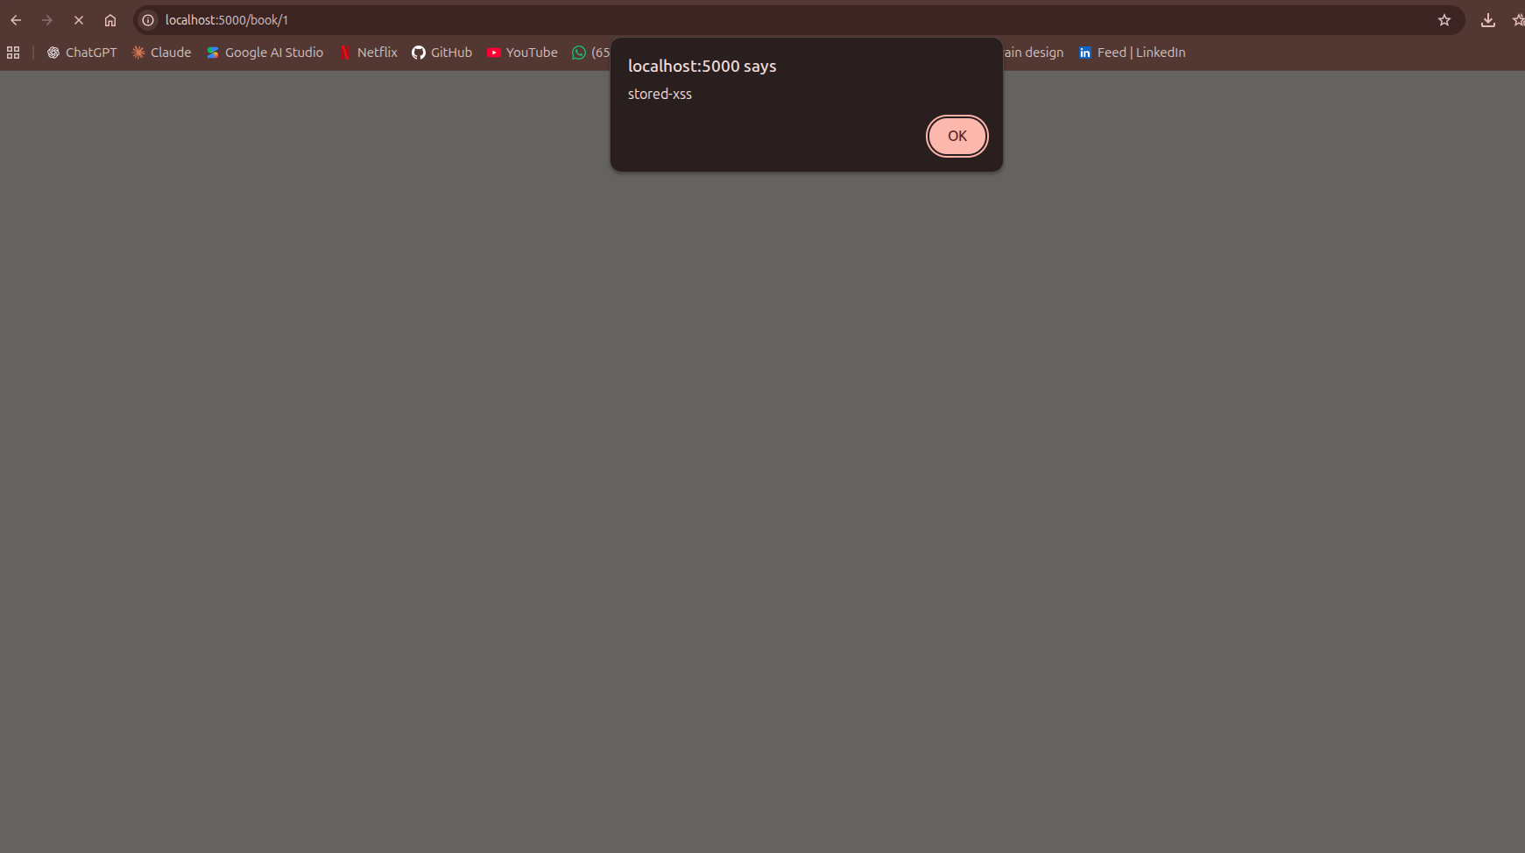

3.3. DOM-based XSS
DOM-based XSS happens completely inside the browser — the website's server never even sees this text. The page has a small feature at the top (a "quick note" banner) that reads a short note from the website's own address bar (the URL) and shows it on the page. If I put code instead of a normal note into the URL, the browser runs it directly, because the page's own JavaScript puts it on the screen the unsafe way.
Full URL I opened in the browser:
http://localhost:5000/#note=<img src=x onerror=alert('dom-xss')>
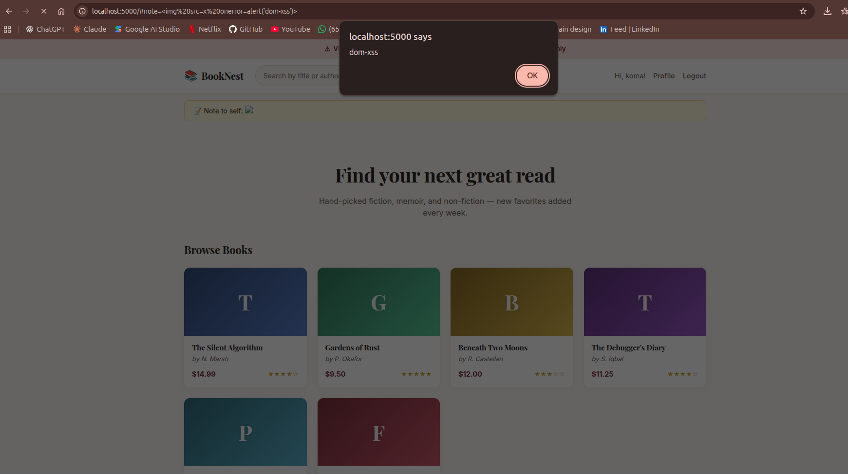

3.4. CSRF (Cross-Site Request Forgery)
CSRF means a completely different website can secretly make my browser send a request to BookNest, using my own login session, without me agreeing to it at all. I made a fake page called evil.html that looks like a "you won a prize" page. The instant someone who is already logged into BookNest opens this fake page, it secretly changes their email address on BookNest in the background — without them clicking anything on the fake page.
Attack setup: I logged into BookNest as alice, then opened evil.html (from the csrf_attack folder) in the same browser without logging out. evil.html automatically submits a hidden form to BookNest's "update email" page the moment it loads.
attacker-controlled@evil.com (the email alice's account gets silently changed to)
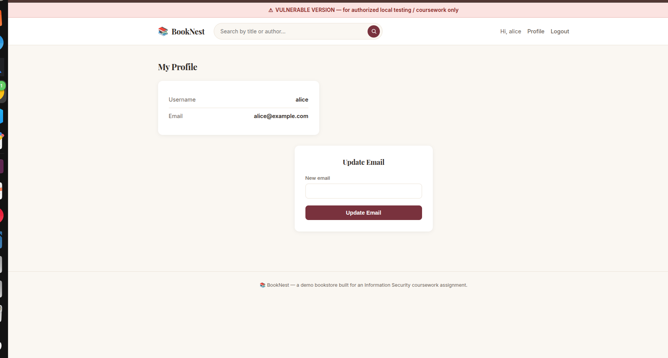
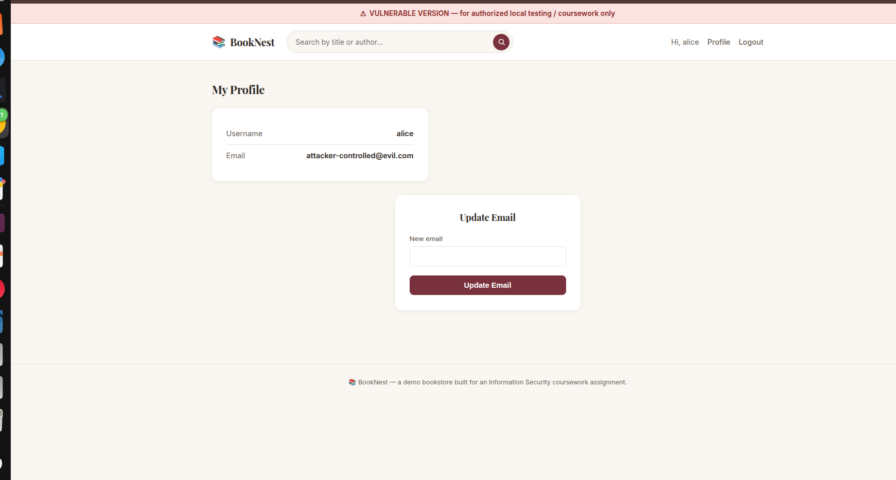

3.5. SQL Injection — Easy
SQL Injection means I can type special characters into a text box so that, instead of my text being treated as plain data, part of it gets treated as a command for the database. In this easy version, I used this trick on the login page to log straight into the admin account without knowing the real admin password at all.
Text I typed into the Username field (password field can be anything):
admin' --
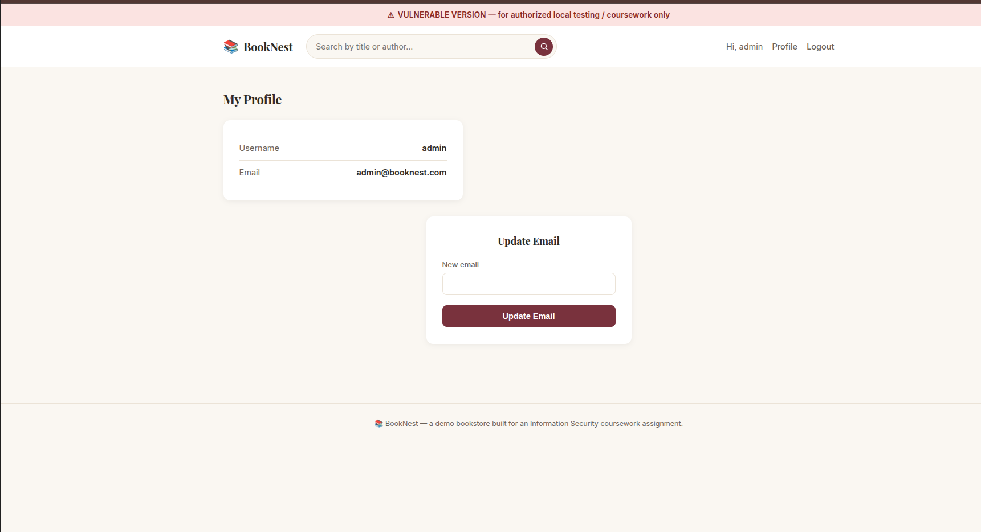

3.6. SQL Injection — Intermediate (Blind)
In this version, I could not see the database's data directly. The page only ever told me "taken" or "available" (from the email-check feature on the registration page). But by asking the right yes/no question each time, I could slowly figure out the admin's real password, one letter at a time, just from which answer I got back.
One example question (asks: "does admin's password start with the letter S?"):
x' OR (SELECT SUBSTRING(password,1,1) FROM users WHERE username='admin')='S'-- -
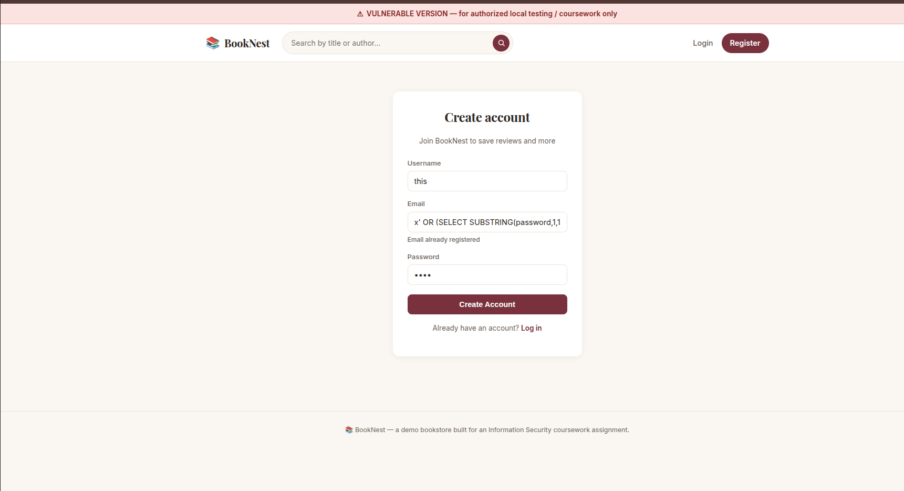

3.7. SQL Injection — Advanced (full chain)
In the hardest version, I worked step by step using the search box, the same way a real attacker would: first I found out how many columns the search results table has, then I found the names of every table in the database, then I found the names of every column inside the "users" table, and finally I pulled out the real usernames and passwords from that table — all without ever touching the database directly, just by typing into the search box.
The 5 payloads I used, one after another (typed into the search box):
Stage 1 (find column count):
zzz' ORDER BY 4-- -
Stage 2 (confirm columns show up):
zzz' UNION SELECT 1,2,3,4-- -
Stage 3 (list table names):
zzz' UNION SELECT 1,GROUP_CONCAT(table_name),3,4 FROM information_schema.tables WHERE table_schema=DATABASE()-- -
Stage 4 (list users table's columns):
zzz' UNION SELECT 1,GROUP_CONCAT(column_name),3,4 FROM information_schema.columns WHERE table_name='users' AND table_schema=DATABASE()-- -
Stage 5 (dump real usernames/passwords):
zzz' UNION SELECT 1,GROUP_CONCAT(username,0x3a,password SEPARATOR ' | '),3,4 FROM users-- -
Take ONE screenshot per stage (5 screenshots total), each showing that stage's result on the search results page:
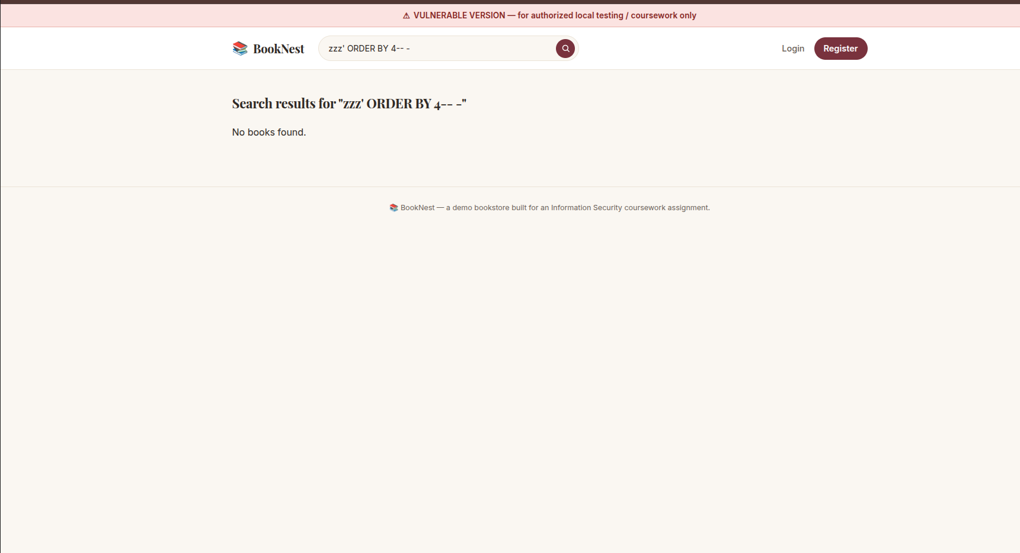
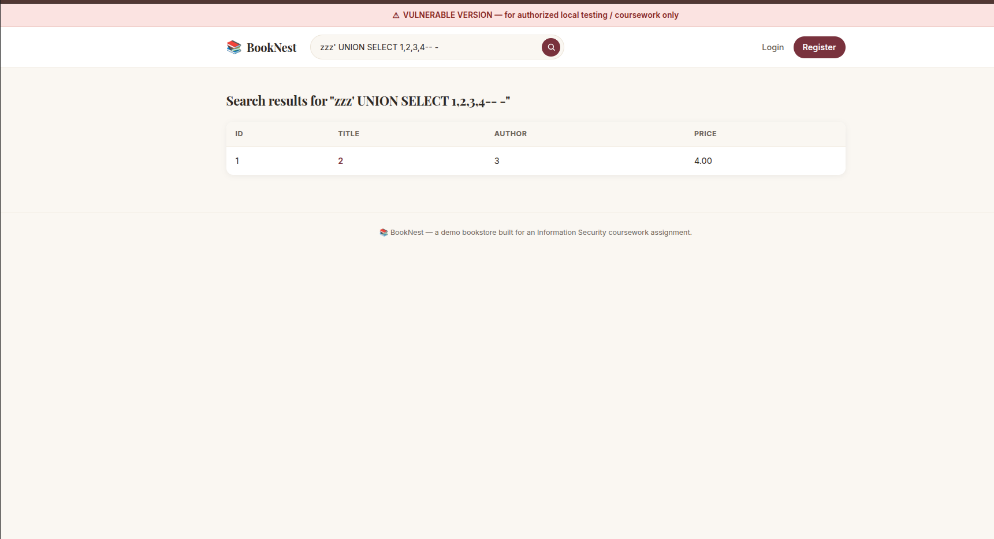
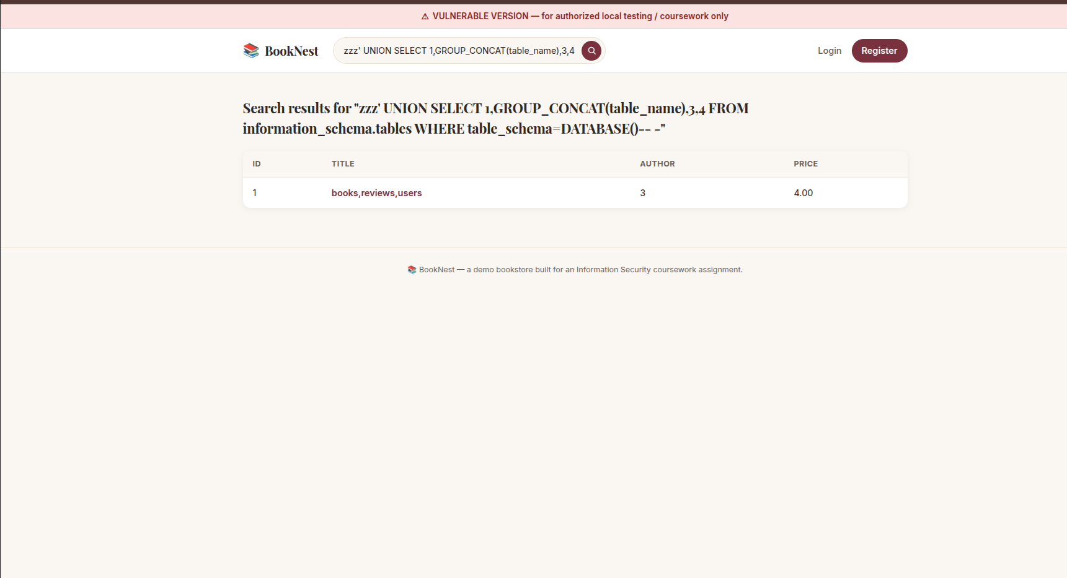
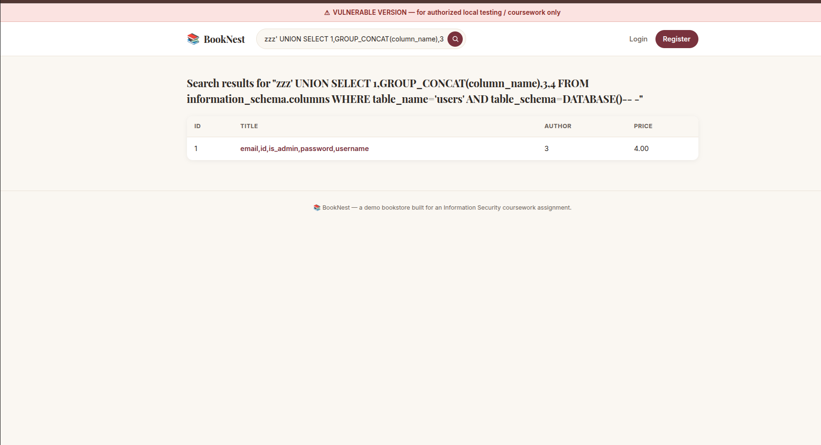
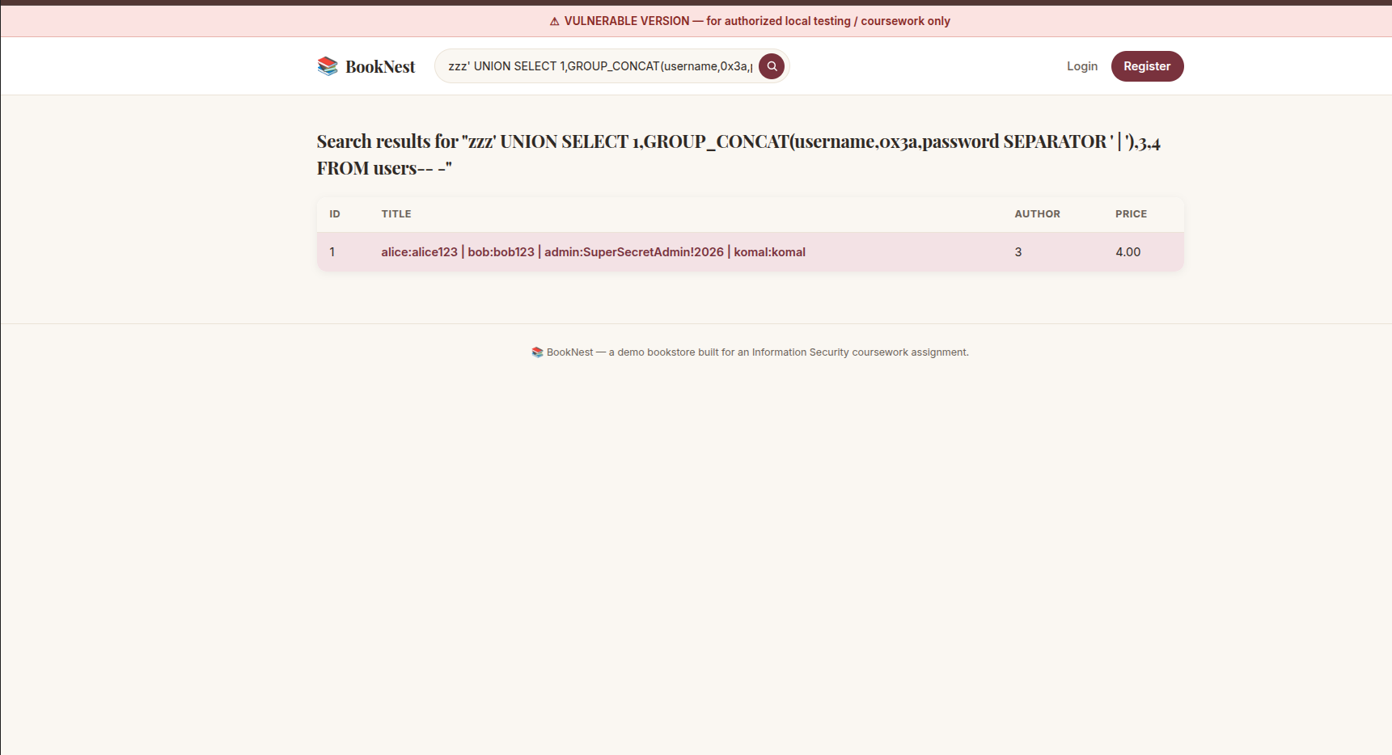

4. Safe Version — Proof Every Attack Now Fails
For every single attack above, I ran the exact same payload again, but this time against the Safe Version (http://localhost:5001) instead. Every one of them failed. This section is the proof: a screenshot for each attack, showing it no longer works, plus a very short note on what was changed in the code to fix it.

4.1 Reflected XSS — now fails
Fix: the search page no longer trusts my text as HTML — it shows it back as plain, harmless text instead.
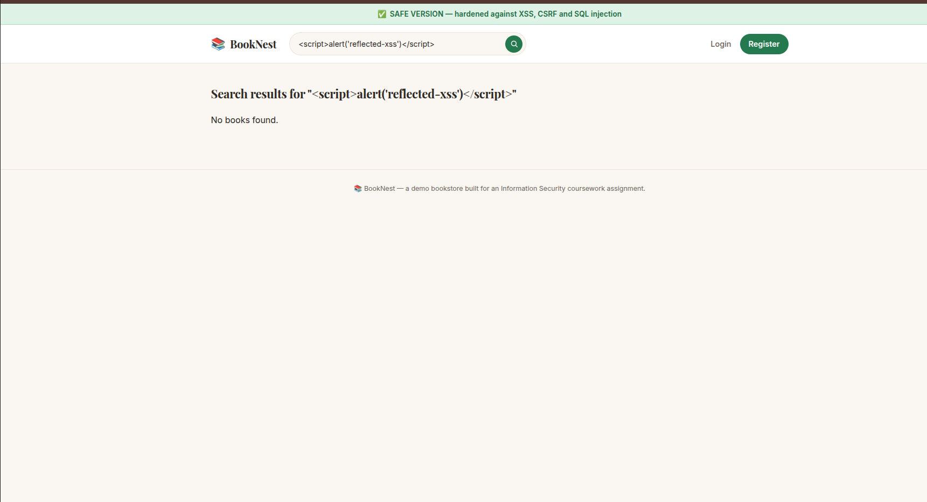

4.2 Stored XSS — now fails
Fix: the review box also shows saved text as plain text now, not as code.
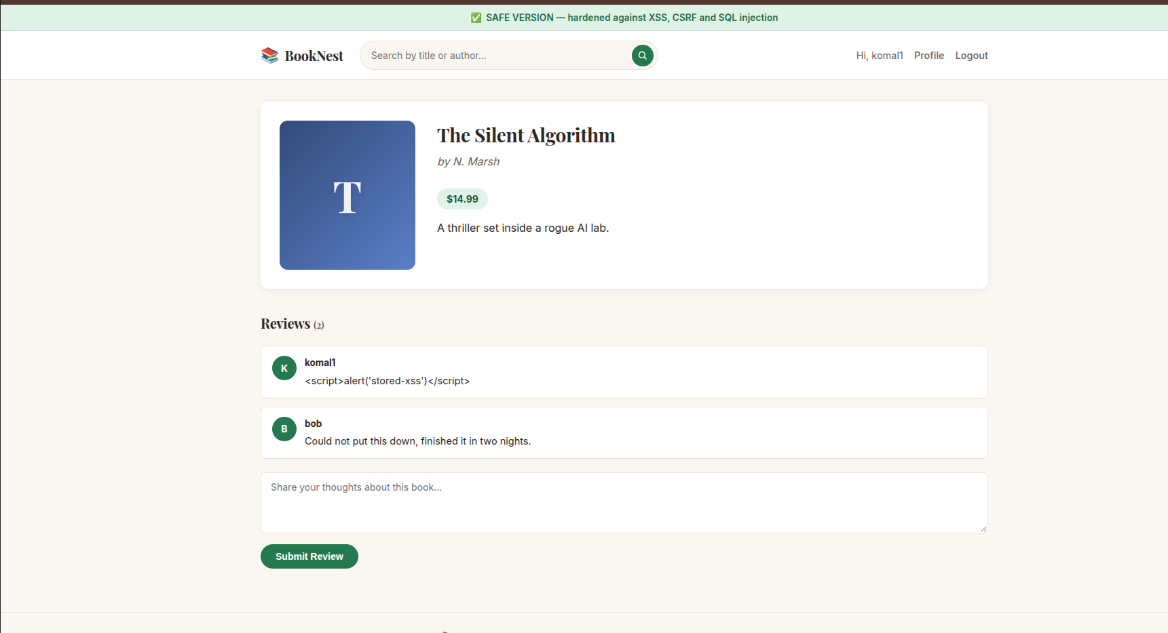

4.3 DOM-based XSS — now fails
Fix: the "quick note" banner now puts the note on the page as plain text, not as HTML.
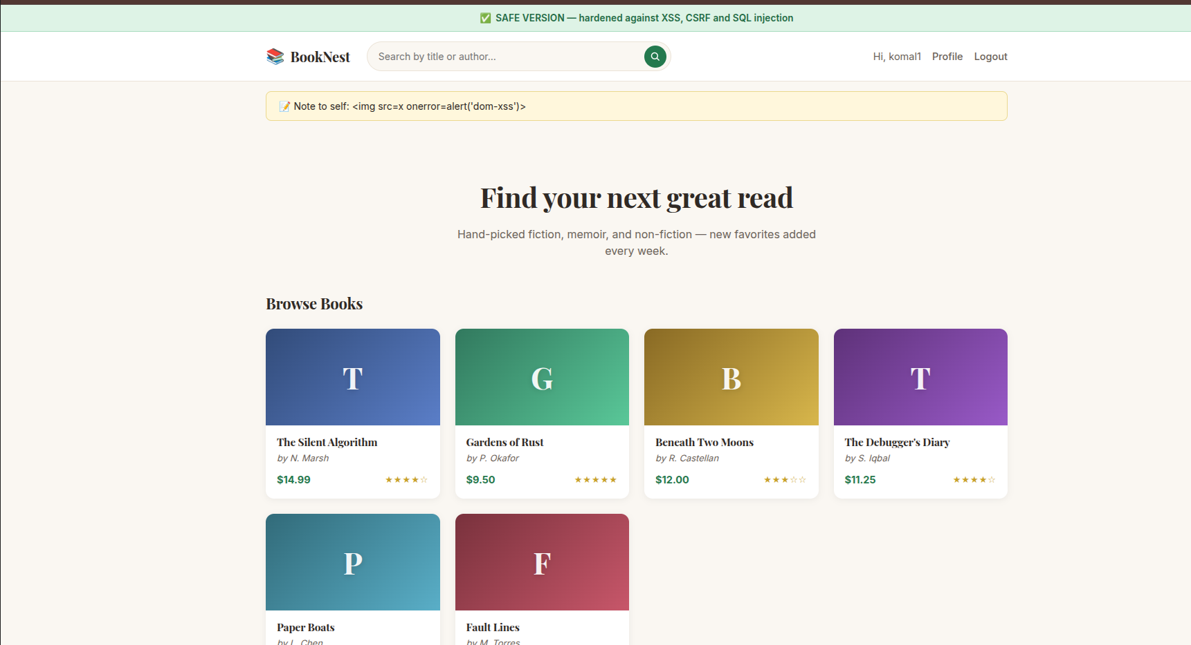

4.4 CSRF — now fails
Fix: changing the email now needs a secret one-time code that only BookNest's own page knows. evil.html has no way to know this code, so its attempt gets rejected.
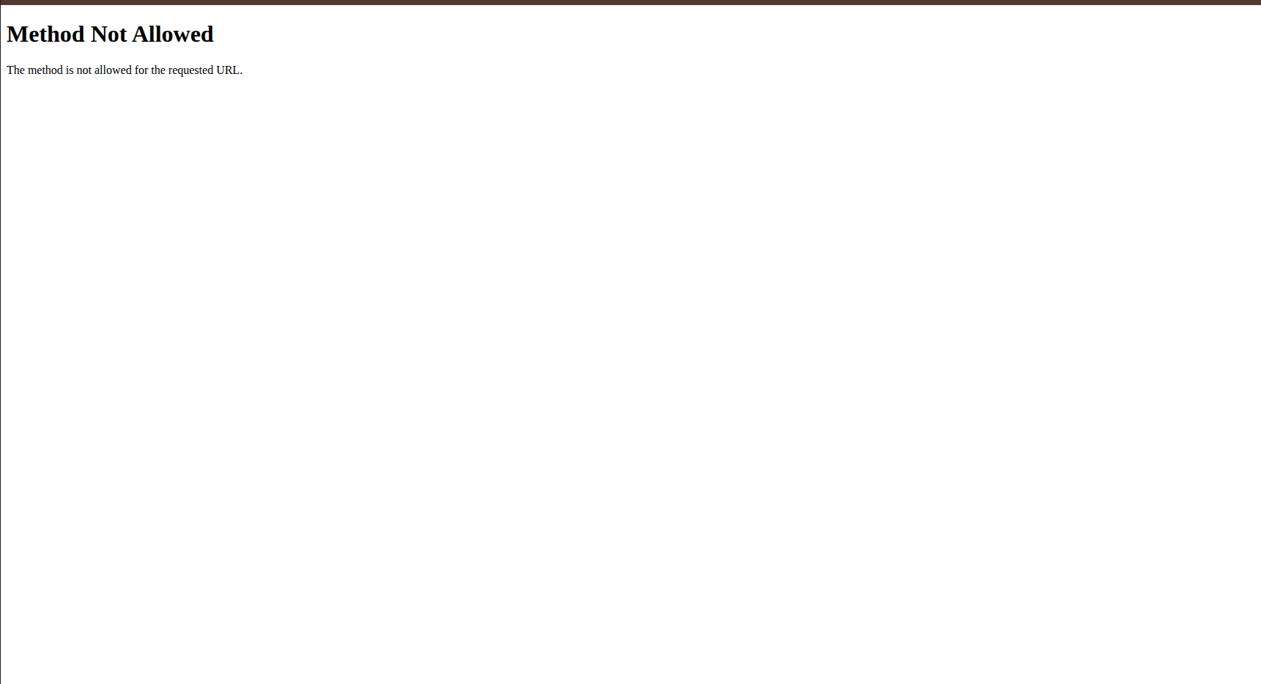

4.5 SQL Injection — Easy — now fails
Fix: the login page now checks the username and password the safe way, so typing SQL code into the box does not log me in as anyone.
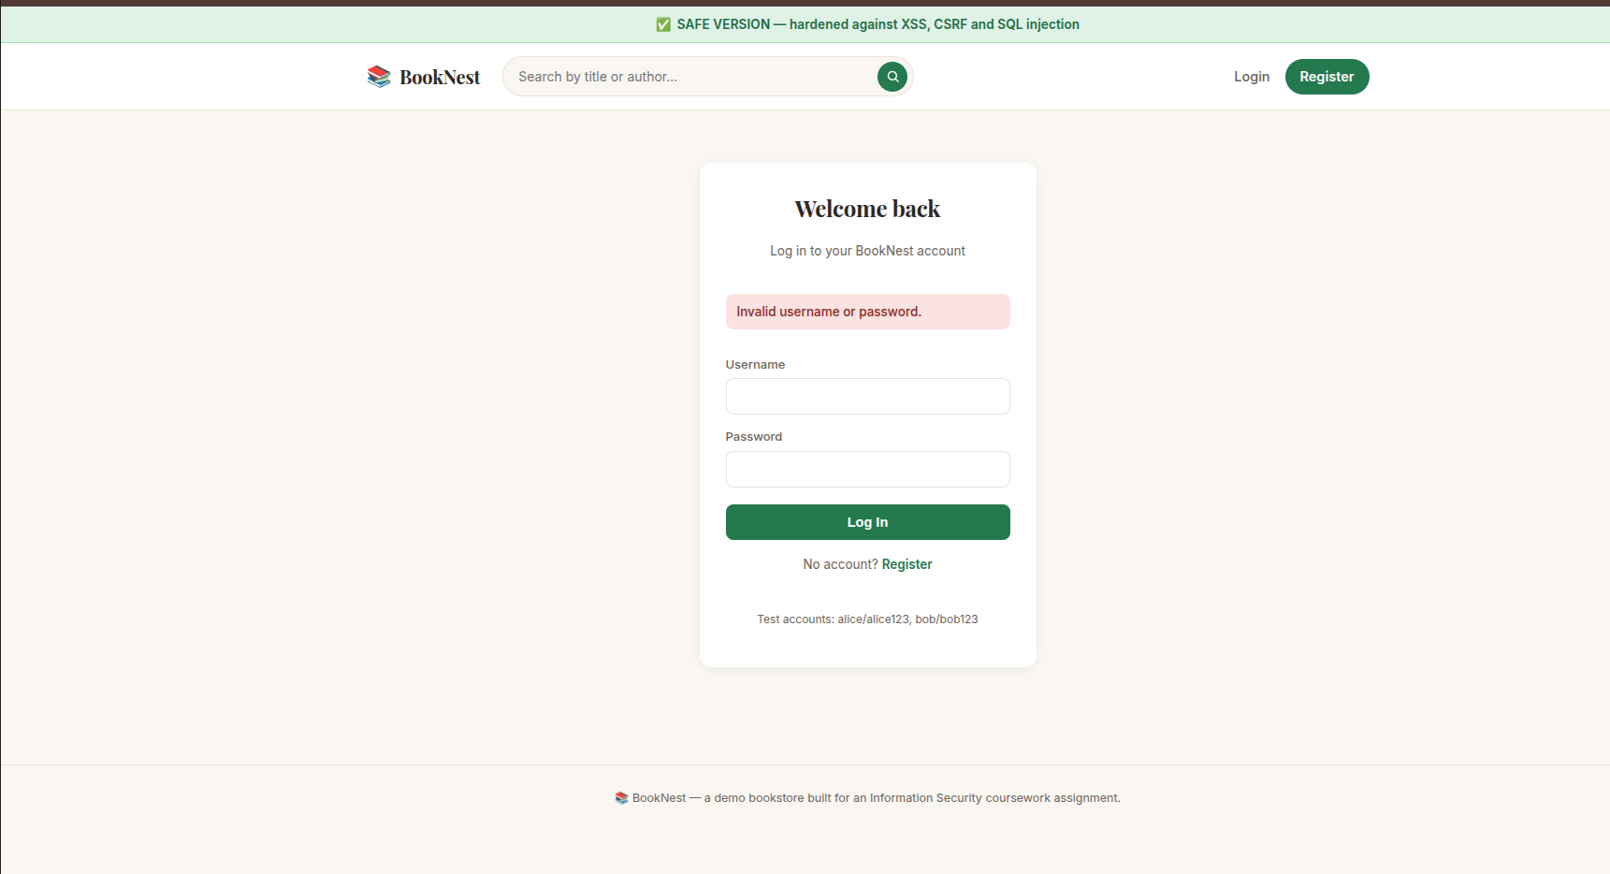

4.6 SQL Injection — Intermediate — now fails
Fix: the email-check feature now always gives a normal, honest answer, so my yes/no trick question no longer leaks anything about the password.
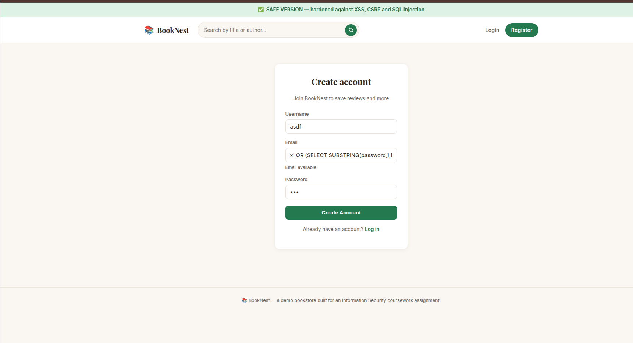

4.7 SQL Injection — Advanced — now fails
Fix: the search box on the Safe Version treats everything I type as plain search text, never as part of a database command, so none of the 5 stages work anymore.


