1. Mean (Average) :
is the value you get when you add all numbers
and divid by how may numbers thre are
mean(average) = total / number of values
example : 2,4,6-> (2+4+6)/3= 4

2. Mode : the number used most aften
from 3,5,5,7,7,7,9,9,12
7 comes 3 times(most)
so mode= 7

3. Median : middle value
arrange numbers in irders
take the middle one
Outlier: value that is verry diffrent from other far a way.
like a 3,2,4,5,61,100 100 is outlier
like a 6 num take middle 2 and divide by 2
ex: 2,4,6,8 middle = 4&6 (4+6)/2 = 5

4. Quartiles: dividing data into equal parts
they are split your data into sorting it
types:
Q0-> min
Q1-> 25% percentile lower
Q2-> 50% percentile midian
Q3-> 75% percentiles upper
Q4-> max 100 %
IQR: Interquartile Range: for mula
example: 1,2,3,4,5,6,7
Q1 = 2
Q3= 6
IQR = 6-2 = 4

5.Probability:
chance of something happening
coin toss -> Head or tell
1.P(A) = Favourable /total (basic chance)
how many chances you want / total chnace
2.Contional Probability (p(a|b) (chance with condition)
a happen given B alrady happed
3. Bayes Theorm (update chance using new info)
used update probability using new info

6. Quartiles :
a value that is verry different from others
it is number that is big or too small compared to the rest
Q0 : min
Q1 : 25%
Q2 : 50%(median)
Q3 : 76% , Q4 : Max :100%
7. Standard Deviation
How much data spreads from the average
for number are from the mean

8. Variance:
how much data spreads from the mean (average)
small variance : data is close to mean
Large variance : data is far from mean

9. Covariance :
it tells realtionship between X and Y
positive covariance (+) -> both increase togeher
Negative covariance (-) -> one increase other decreases
Zero -> no realtion

10. Correation :
strengh of relatinship between two variables
+1 = positive relation
-1 = negative relation
0 = no relation
How strongly two things are releted

11. Line Chart:
a line chart connects data points with a line
To show increse or decrease
to track time data (days ,months,year)
Line going Up = increse
Line going Down = decrese

12. Bar chart:
this graph using bars to compare data
compare different groups
categories (X-axis) -> age ,income,score, experince, education
values(Y-aixs)

11. Line Chart:
a line chart connects data points with a line To show increse or decrease
to track time data (days ,months,year)
Line going Up = increse
Line going Down = decrese
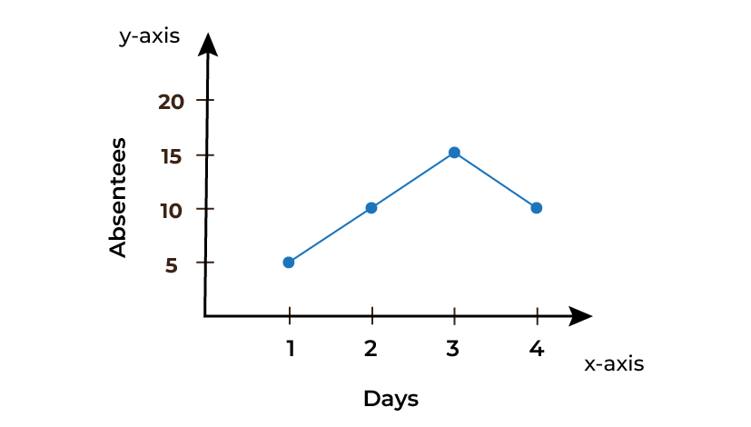

12. Bar chart:
this graph using bars to compare data
compare different groups
categories (X-axis) -> age ,income,score, experince, education
values(Y-aixs),income,score, experince, education
values(Y-aixs)
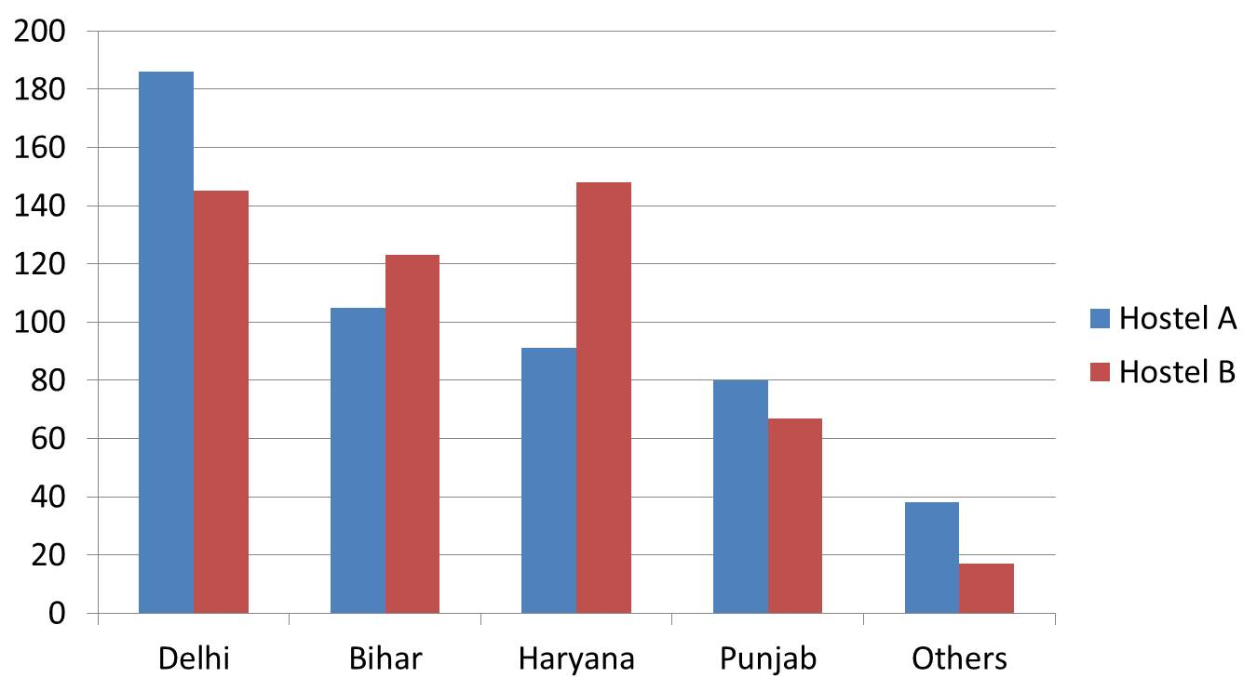

13.Histogram :
this bar graph for continuous data
it shows Frequency how many values in range
Bins: Groups ranges used in a histogram
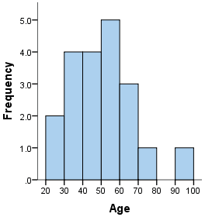

14. pie Chart:
show percentage / parts oh whole when total = 100%
like example : buget ,marks distribution, result

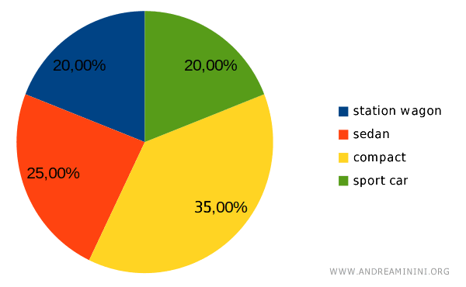
15. Donut Chart :
same use as pie chart (Percentage,difference)
plus center space extra info
slice (in pie/donut chart) = one part of the circle)

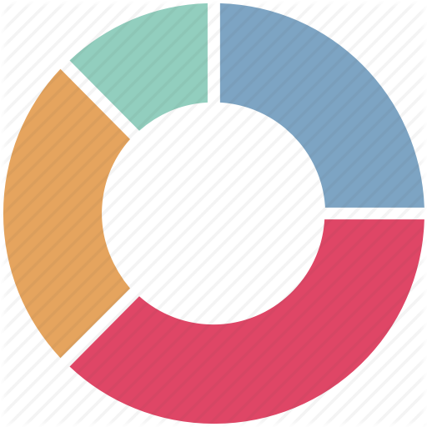

15 . Correlation Matrix Graph:
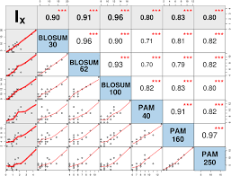

16.Scatter Plot:
graph that shows relatinship between between two variables
(points)
X - House size
y - house price
Used :
Regression
Clustering
Outlier detection

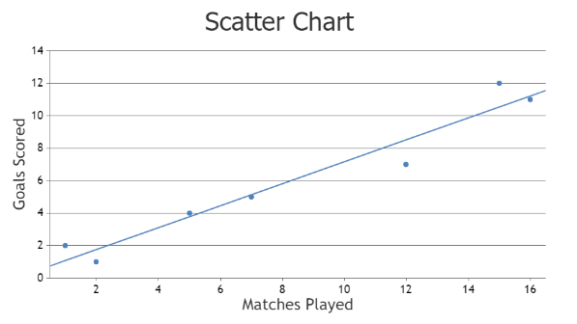

17. Stacked chart:
it is compare multiple features together
shows multiple series
shows: total simultaneously
100% stacked chart show proprtion
FP :false positive
FN : false negative
TP : true position
TN : true position
