1. INTRODUCTION
   1. OVERVIEW

The sentiment analysis of Indians after the extension of lockdown announcements to be analyzed with the relevant #tags on twitter and build a predictive analytics model to understand the behavior of people if the lockdown is further extended.

Also develop a dashboard with visualization of people reaction to the govt announcements on lockdown extension

* 1. PURPOSE

 After the measuring sentiment analysis, the graphical representation has been provided on the data. The data we have collected on twitter are based on two specified hashtag keywords, which are (“COVID-19, coronavirus”)

*1. Get to know people’s sentiment towards the epidemic*

*2. Understand the sentiments of people on govt. decision to extend the lockdown*

2. LITERATURE SURVEY

2.1 EXISTING PROBLEM

The aim of this analysis is to know how individuals in those countries reacting to the outbreaks of the disease.

There is no doubt that, there some necessary steps required while we are collected

and performing the operation, such as pre-processing and removing irrelevant

information from the tweets. The outcomes from these experiments shows that most

of the people from these societies are thinking positive and they are feeling good that

the situation will goes to be better, also it is worthy that there are also signs of fear

and sadness. However, four states especially from the Europe continent thinking that,

they cannot trust the situation because of the outbreaks and pandemic over large

scale of populations.

2.2 PROPOSED SOLUTION

1. From the tweets available in the dataset, we will pick the keywords and classify them as positive or negative words . this will be done by an ML classification algorithm, as the classification will be divided into two categories we use random forest classifier or could go with naive bayes algorithm
2. Further it would be categorized  based upon how they affected those people who tweeted.

3. THEORETICAL ANALYSIS

3. 1 BLOCK DIAGRAM

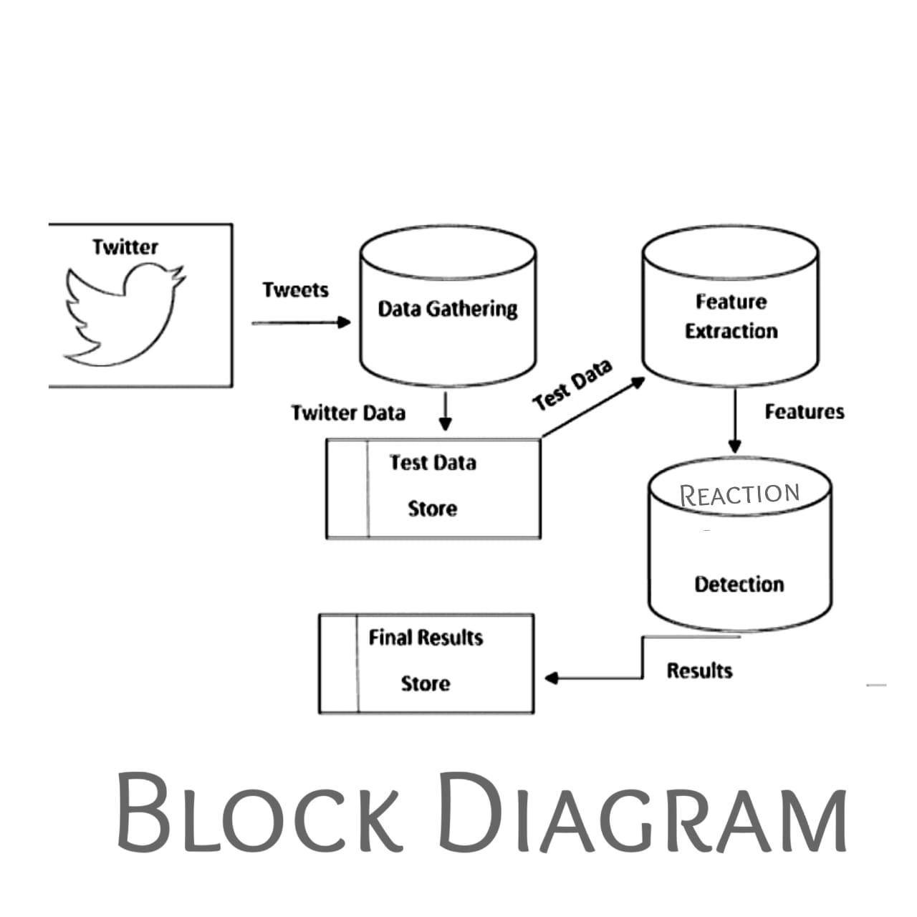

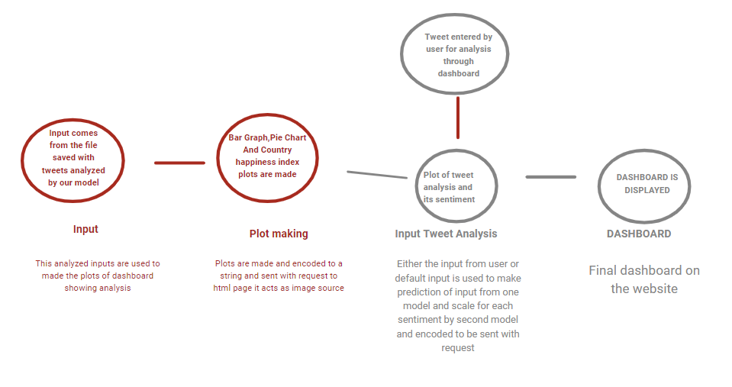

3.2 HARDWARE/SOFTWARE DESIGN

1. We'll be using natural language processing to extract words and classify them by using our own modified algorithm by simply changing either maths used behind or changing their output by other changes which we could analyse while studying regarding previous implemented algorithm's research papers. And it would be added advantage for us if we are provided with mentor for this new algorithm development task.
2. Rather than visualizing final outcome on jupyter notebook we will visualize that on our newly made website which would be either made using django framework or using react(will depend on time left while modifying the algorithm)

4. EXPERIMENTAL INVESTIGATION

We tried data augmentation by exploding the tweets of very long size to get uniform size input, then we used bidirectional LSTM layers after embedding layer instead of conventional RNN model as they have problem (vanishing and exploding gradient).By using bidirectional LSTM model can understand pattern and sequence after and before a particular word because in english a choice of words and there order both affect the meaning of sentence .it can be in passive,active voice and may convey different meaning in both

5. FLOWCHART

|  |  |
| --- | --- |
| Work to be done | Tentative time required |
| Research Paper Analysis for getting to know what sort of previous algorithms has been implemented regarding twitter sentiment analysis and try to modify it for our convenience and more optimised solution | 65% and would be in parallel to other work |
| Dataset preprocessing | 3% |
| Model selection | 3% |
| Model optimization | 3% |
| Dashboard creation | 10% |
| Content on dashboard(  psychological analysis  - economic analysis as per people thinking  - health analysis  - lifestyle analysis  -happiness analysis  ) | 3% |
| Integrating with backend and in turn with ibm cloud | 10% |
| Other Tasks | 3% |

6. RESULT

happy and joy has value is 1 denotes better-feeling, while the lower on the scale

which is and its value, is -1 depressed and fear denotes more negative emotional states, in

addition to the middle emotional state with 0 value represents neutral and relaxed state. Also,

the rest of the feelings cab be distributed evenly as spectrum between these three mentioned

scales.

Scale

Emotion

1

Happy and joy

0.8

Confident

0.6

Optimistic

0.4

Hopeful

0.2

Calm and content

0

Neutral and relaxed

-0.2

Relieved

-0.4

Pessimistic and impatient

-0.6

Worry and boredom

-0.8

Discouraged and difficulty

-1

Depressed and fear.

7. ADVANTAGES

Social Impact:

1. As its outcome would be  people's mental health analysis which would in turn help government to take further measures regarding lockdown

2. As Mental health would be known so it will help to to prepare people for post lockdown situations

Business Impact:

1. It will let people know potential of local brands

2. After knowing mindset of local people business could flourish accordingly post lockdown and government could plan economic strategies accordingly.

8. APPLICTION

This model can not only be used for analysis of coronavirus but also for any other sentiment analysis because it can be modified to give the desired outcome . This is a flexible model.

9. CONCLUSION

The present study applied sentiment analysis on twitter data related to worldwide COVID-19

outbreaks. The data has been collected during one of the most spread weeks of coronavirus

0,00% 10,00% 20,00% 30,00% 40,00% 50,00% 60,00% 70,00%

Depressed and fear

Worry and boredom

Relieved

Calm and content

Optimistic

Happy and joy

Average of sentiment analysis for one

week

COVID-19 % Coronavirus %

Kurdistan Journal of Applied Research | Special Issue on Coronavirus (COVID-19)| 62

which is 09-4-2020 to 15-04-2020 (According to https://coronavirus.jhu.edu/map.html

website) by using Twitter API and tweepy library of python. Two keywords are selected for

searching tweets which are #coronavirus and #COVID-19 for determining polarity and

subjectivity. TextBlob library of python Sentiment Analysis techniques applied for collected

tweets which are 530232 tweets. The results shown the neutral toll regarding both coronavirus

and covid-19 keywords for polarity was significantly high which is more than 50 percent and

the large portion of the records were objective which was approximately 64 percent. From this

study we can say that people's reactions vary day to day from posting their feelings on social

10. FUTURE SCOPE

1. The findings of the study might be helpful in identifying the knowledge and attitudes of Covid-19 among all age groups
2. The findings of the study might be helpful to future researchers.
3. The knowledge attitudes of youths about covid-19 will be assessed. The prevention measures followed by the people will be assessed.
4. Best part of this would be a new algorithm would be devised.

11. BIBLIOGRAPHY

1.https://www.kaggle.com/smid80/coronavirus-covid19-tweets

2. https://ieee-dataport.org/open-access/corona-virus-covid-19-tweets-dataset

3.https://www.ncbi.nlm.nih.gov/pmc/articles/PMC7152888/

APPENDIX