LAB ASSIGNMENT 5
Name: Komal Kakkar Roll No.: 1024030872
Section: 3C63 Date: 21-10-2026

Q1.
In Java, T extends Number is a bounded type parameter in generics. It means that T can be Number or any class that inherits from Number, such as Integer, Double, Float, and Long.
In Java, doubleValue() is a method of the Number class that converts a numeric value into the primitive data type double.

public class GenericArraySum {
public static <T extends Number> double sum(T[] numbers) {
double total = 0.0;
for (T number : numbers) {
total += number.doubleValue();
}
return total;
}
public static void main(String[] args) {
System.out.println("Komal Kakkar 1024030872 3C63");
Integer[] integers = {10, 20, 30};
Float[] floats = {1.5f, 2.5f, 3.0f};
Double[] doubles = {2.25, 4.75, 1.0};
System.out.println("Integer sum: " + sum(integers));
System.out.println("Float sum: " + sum(floats));
System.out.println("Double sum: " + sum(doubles));
}
}
Output:
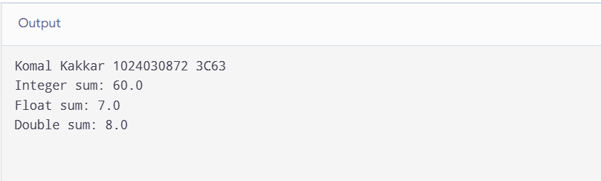

Q2.
Optional represents a value that may or may not be present. ifPresent() acts only when a value exists, orElse() supplies a fallback, and orElseThrow() throws an exception if the Optional is empty.
import java.util.Optional;
public class OptionalEmailDemo {
public static void main(String[] args) {
Optional<String> email = Optional.of("KK@wohoo.kom");
Optional<String> emptyEmail = Optional.empty();
email.ifPresent(value -> System.out.println("Email: " + value));
String emailToUse = emptyEmail.orElse("defaultKK@wohoo.kom");
System.out.println("Email to use: " + emailToUse);
try {
String requiredEmail = emptyEmail.orElseThrow(
() -> new IllegalStateException("Email address is missing")
);
System.out.println(requiredEmail);
} catch (IllegalStateException exception) {
System.out.println("Error: " + exception.getMessage());
}
}
}
Sample output:
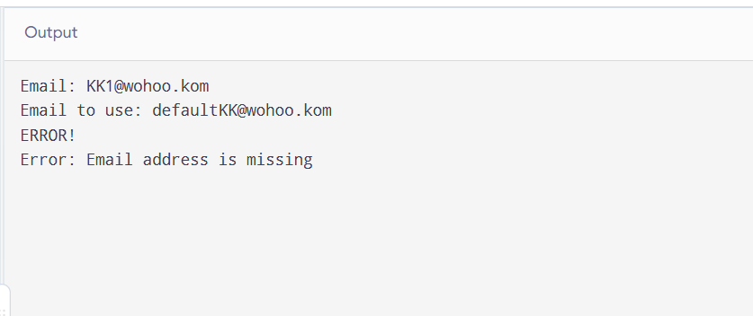

Q3.
Result<T extends Number> stores numeric marks, computes their average, checks the pass threshold, and exposes the marks through Optional. Objects.requireNonNull() validates the required marks input.

import java.util.*;
public class Result<T extends Number> {
private final List<T> marks;
private final double maxMarksPerSubject;
public Result(List<T> marks, double maxMarksPerSubject) {
Objects.requireNonNull(marks, "Marks cannot be null");
if (marks.isEmpty()) {
throw new IllegalArgumentException(
"Marks list cannot be empty"
);
}
if (maxMarksPerSubject <= 0) {
throw new IllegalArgumentException(
"Maximum marks must be positive"
);
}
for (T mark : marks) {
Objects.requireNonNull(mark, "Individual mark cannot be null");
double value = mark.doubleValue();
if (value < 0 || value > maxMarksPerSubject) {
throw new IllegalArgumentException(
"Marks must be between 0 and maximum marks"
);
}
}
this.marks = new ArrayList<>(marks);
this.maxMarksPerSubject = maxMarksPerSubject;
}
public double calculateTotal() {
double total = 0;
for (T mark : marks) {
total += mark.doubleValue();
}
return total;
}
public double calculateAverage() {
return calculateTotal() / marks.size();
}
public double calculatePercentage() {
return (calculateTotal() /
(marks.size() * maxMarksPerSubject)) * 100;
}
public boolean hasPassed(double threshold) {
return calculatePercentage() >= threshold;
}
public Optional<List<T>> getMarks() {
return Optional.of(Collections.unmodifiableList(marks));
}
public static void main(String[] args) {
List<Integer> studentMarks =
Arrays.asList(85, 78, 92, 66, 89);
Optional<Result<Integer>> result =
Optional.of(new Result<>(studentMarks, 100));
result.ifPresent(r -> {
r.getMarks().ifPresent(m ->|
System.out.println("Subject Marks: " + m)
);
System.out.println("Total Marks: " + r.calculateTotal());
System.out.println("Average Marks: " + r.calculateAverage());
System.out.printf("Percentage: %.2f%%%n",
r.calculatePercentage());
System.out.println(
"Result: " + (r.hasPassed(40) ? "Pass" : "Fail")
);
});
}
}
Sample output:
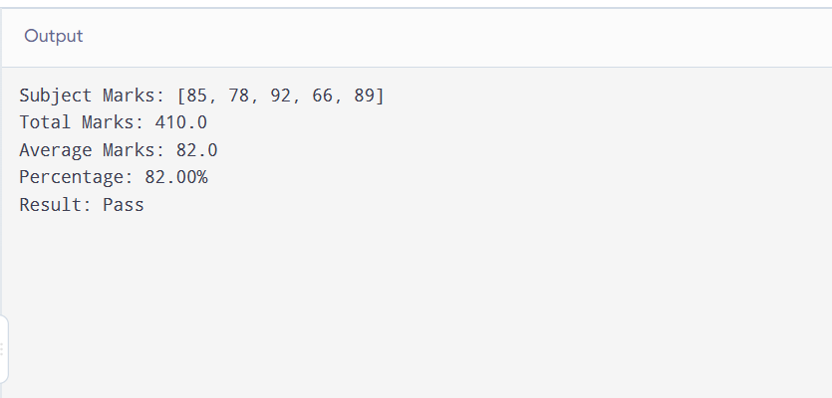

Q4.
This program reads the event name, date, start time, and an optional venue. It classifies the event date, computes days remaining, and calculates the end time after two hours.
import java.time.LocalDate;
import java.time.LocalTime;
import java.time.temporal.ChronoUnit;
import java.util.Optional;
import java.util.Scanner;
public class EventManager {
public static void main(String[] args) {
Scanner sc = new Scanner(System.in);
System.out.print("Event name: ");
String name = sc.nextLine();
System.out.print("Event date (YYYY-MM-DD): ");
LocalDate date = LocalDate.parse(sc.nextLine());
System.out.print("Start time (HH:MM, 24-hour): ");
LocalTime startTime = LocalTime.parse(sc.nextLine());
System.out.print("Venue (leave blank if not specified): ");
String venueInput = sc.nextLine().trim();
Optional<String> venue = venueInput.isEmpty()
? Optional.empty()
: Optional.of(venueInput);
LocalDate today = LocalDate.now();
System.out.println("\nEvent: " + name);
System.out.println("Date: " + date);
System.out.println("Start time: " + startTime);
System.out.println("Venue: " + venue.orElse("Venue not specified"));
if (date.isAfter(today)) {
System.out.println("Status: Future event");
} else if (date.isEqual(today)) {
System.out.println("Status: Event is today");
} else {
System.out.println("Status: Event is in the past");
}
long daysRemaining = ChronoUnit.DAYS.between(today, date);
System.out.println("Days until event: " + daysRemaining);
System.out.println("End time: " + startTime.plusHours(2));
sc.close();
}
}
Output:
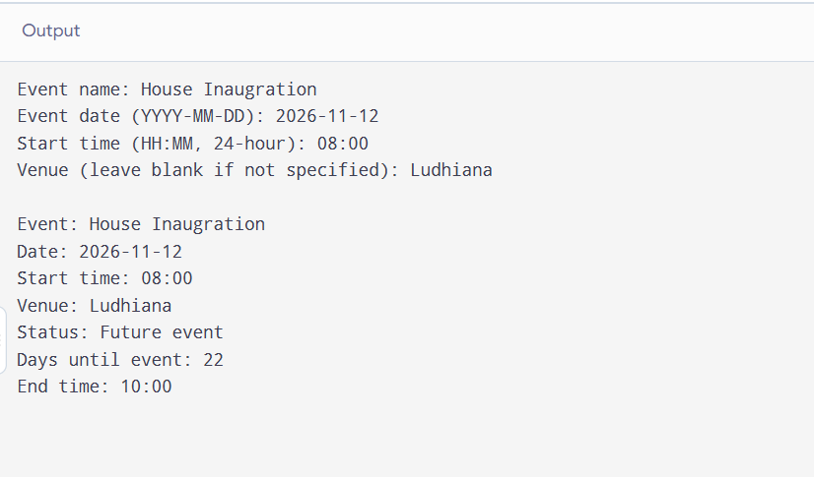

Q5.
The utility class uses Objects.equals() for null-safe equality, Optional.orElse() for a default value, Comparable<T> for finding the maximum, and Objects.isNull() for null checks.
import java.util.Optional;
import java.util.Objects;
public final class GenericUtils {
private GenericUtils() {
// Prevent instantiation of this utility class.
}
public static <T> boolean isEqual(T a, T b) {
return Objects.equals(a, b);
}
public static <T> T getDefault(Optional<T> value, T defaultValue) {
return Objects.requireNonNull(value, "Optional must not be null")
.orElse(defaultValue);
}
public static <T extends Comparable<? super T>> T max(T a, T b) {
Objects.requireNonNull(a, "First value must not be null");
Objects.requireNonNull(b, "Second value must not be null");
return a.compareTo(b) >= 0 ? a : b;
}
public static boolean isNull(Object obj) {
return Objects.isNull(obj);
}
public static void main(String[] args) {
System.out.println("Strings equal: " +
isEqual("Java", "Java"));
System.out.println("Integers equal: " +
isEqual(10, 20));
System.out.println("Default value: " +
getDefault(Optional.<String>empty(), "Guest"));
System.out.println("Maximum integer: " + max(12, 27));
System.out.println("Maximum string: " + max("Amandeep", "Komal"));
System.out.println("Is null: " + isNull(null));
System.out.println("Is null: " + isNull("hello"));
}
}
Output:
