**VPC**

**A Virtual Private Cloud (VPC) is a virtual network within a public cloud that allows an enterprise to establish its own private cloud-like computing environment, offering a secure and isolated space for resources and applications**

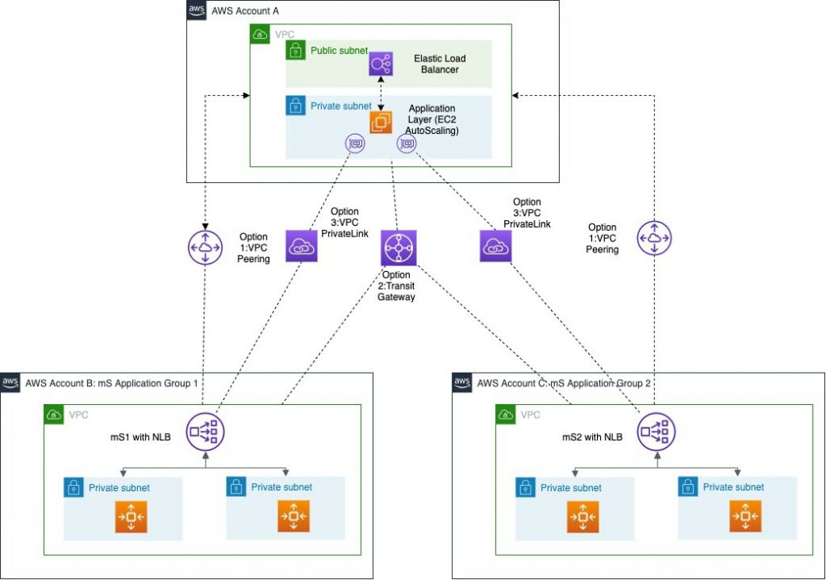

**Create VPC ( MyVPC ) - 10.0.0.0/16**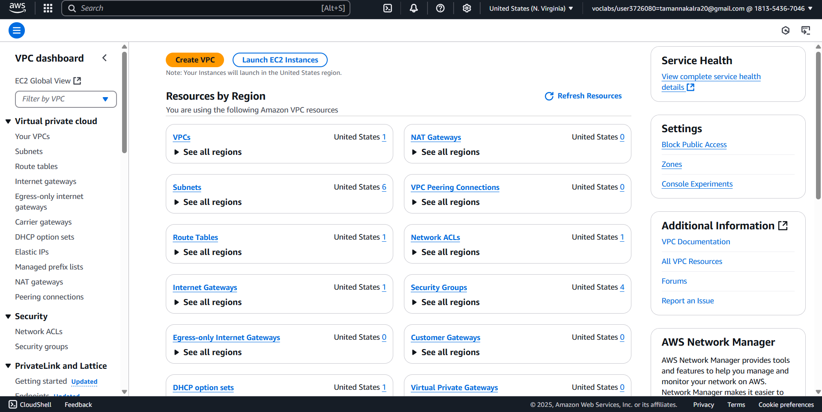

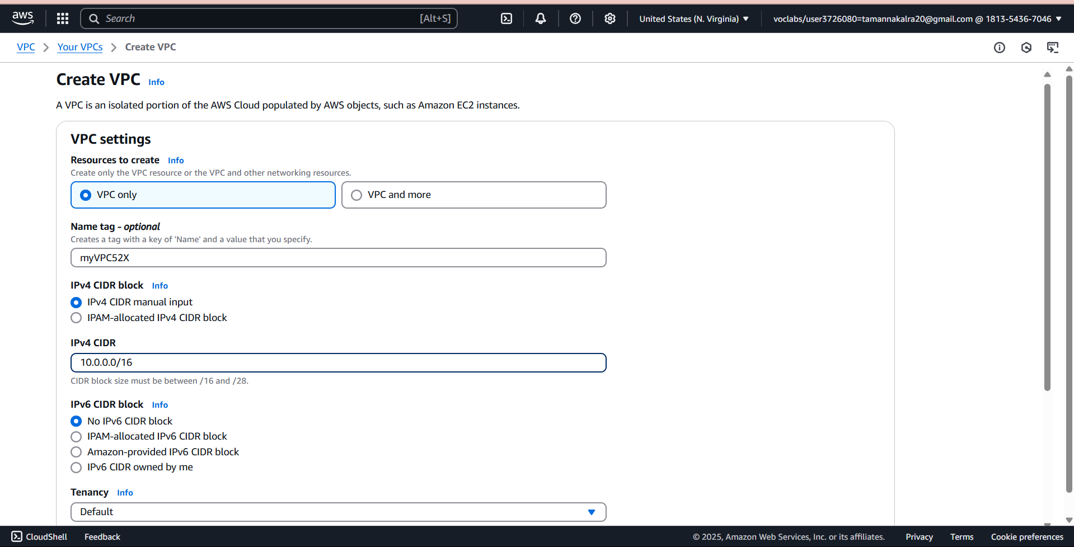

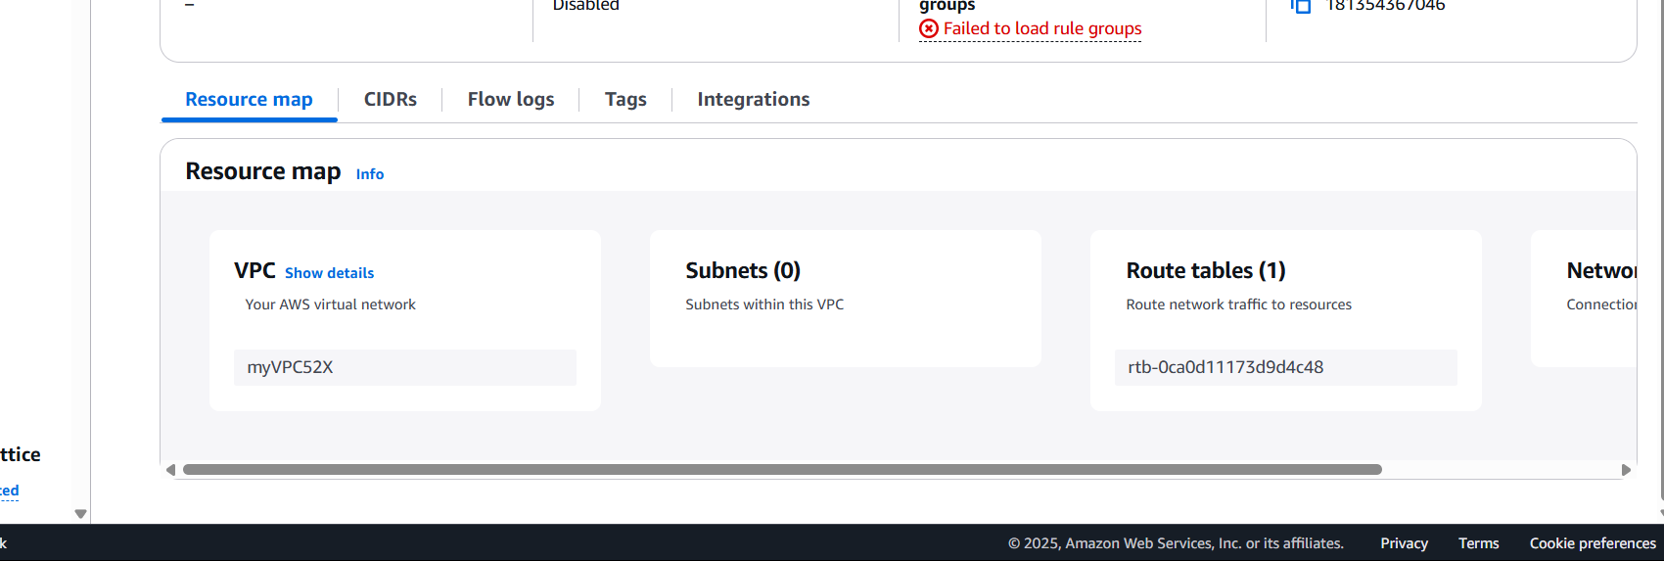

Create two subnets

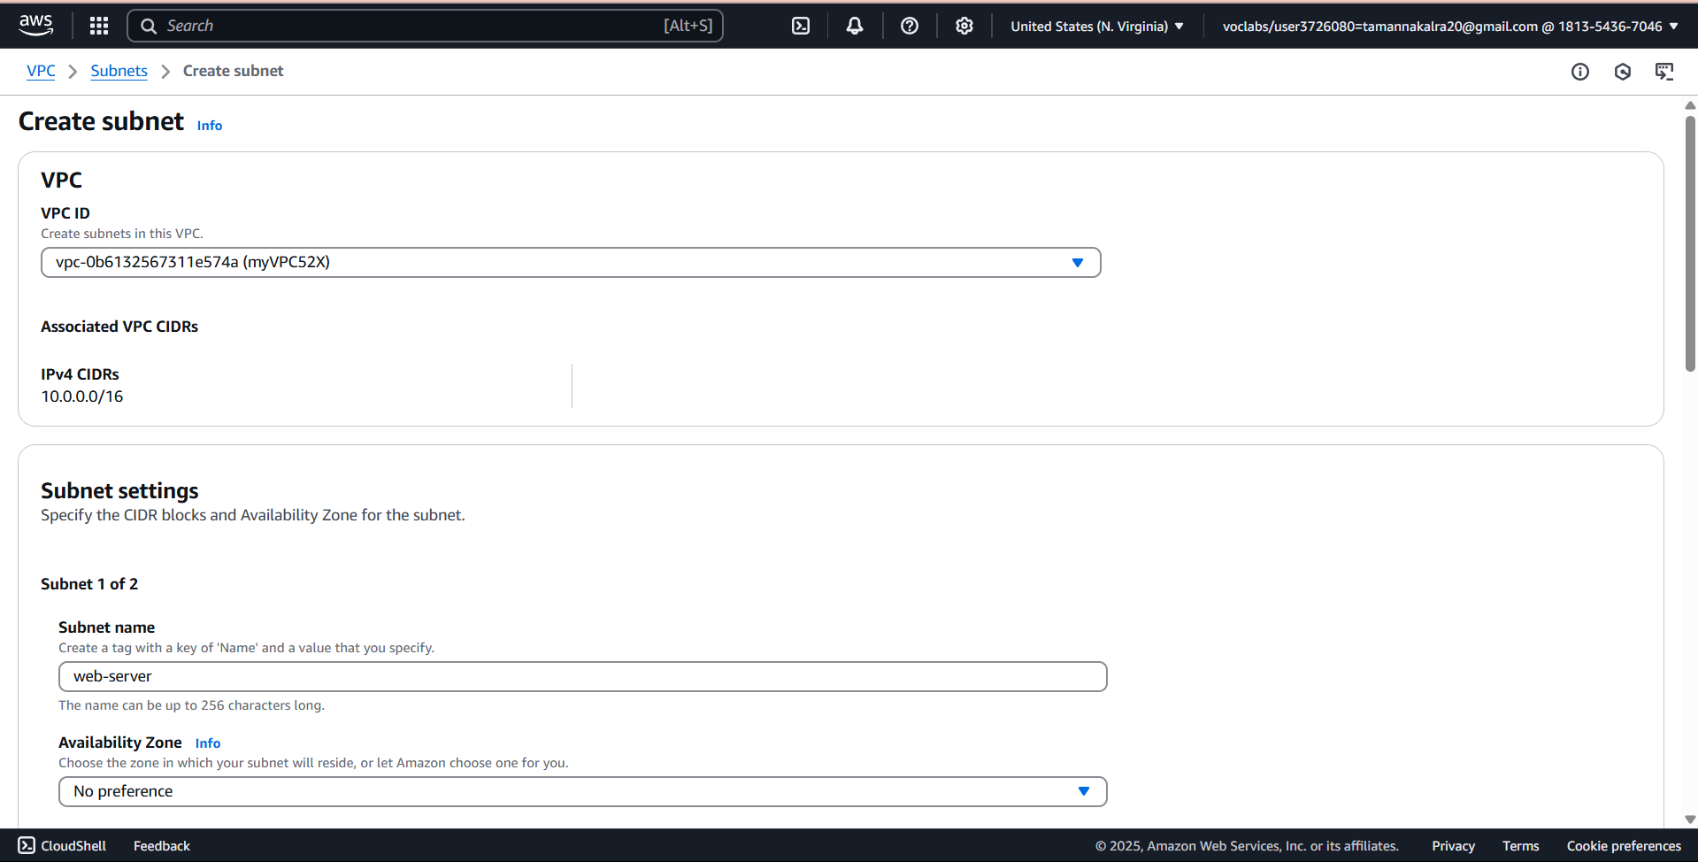

subnet1 - 10.0.1.0/24 - Web-Server

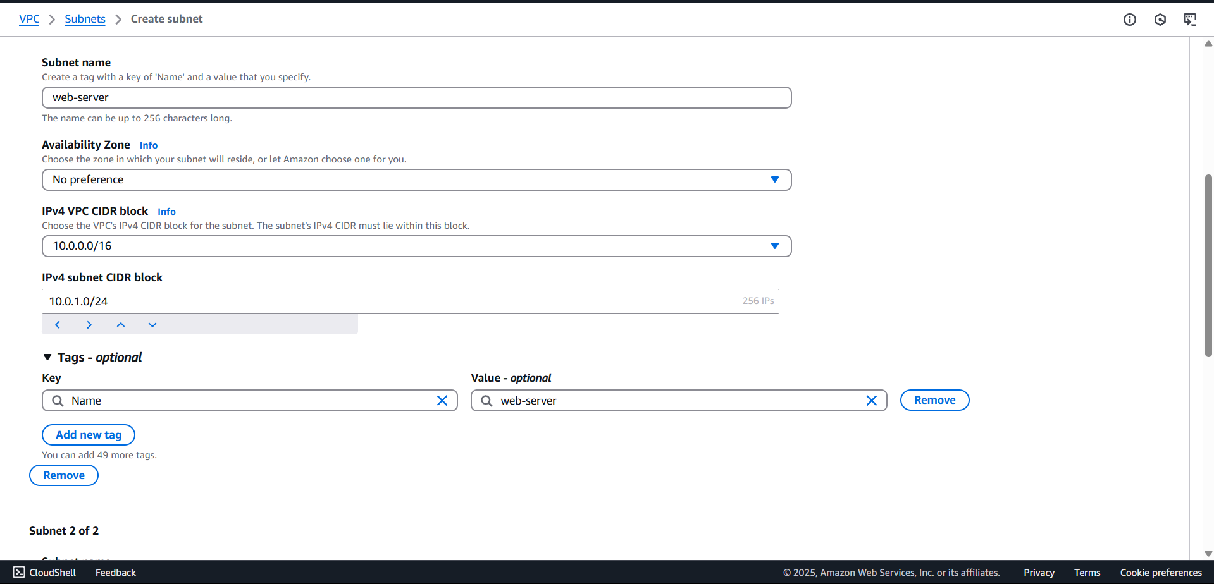

subnet2 - 10.0.2.0/24 - Db-Server

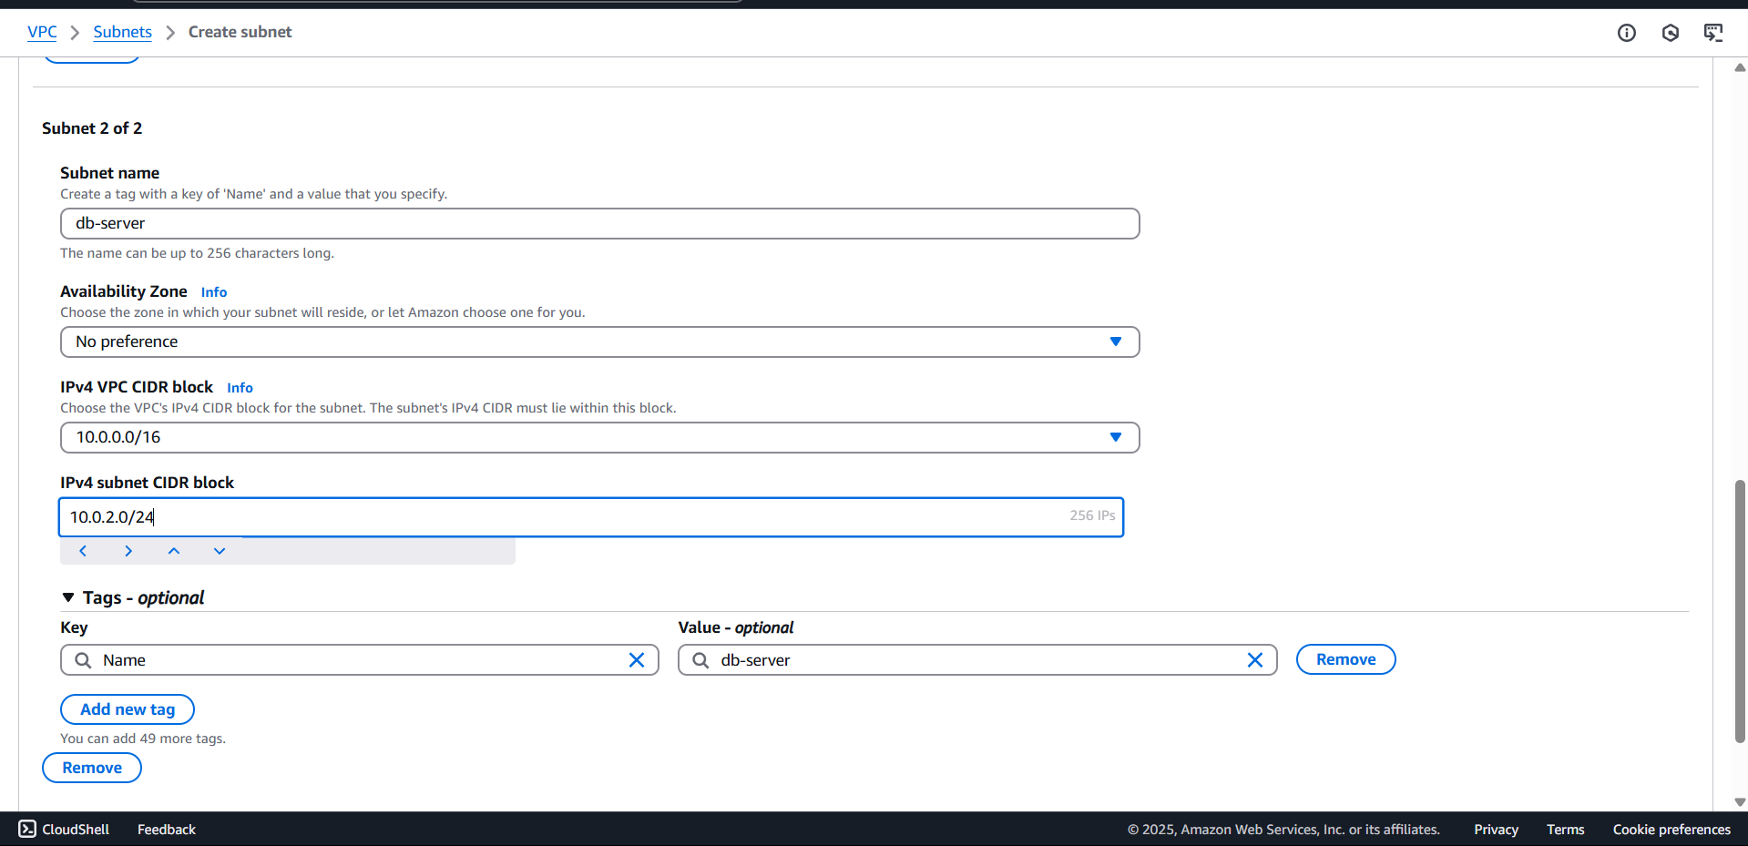

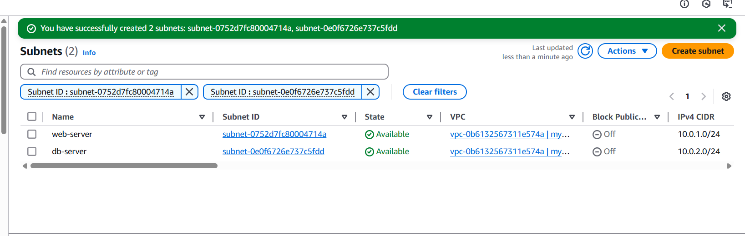

Enable public IP to subnet1

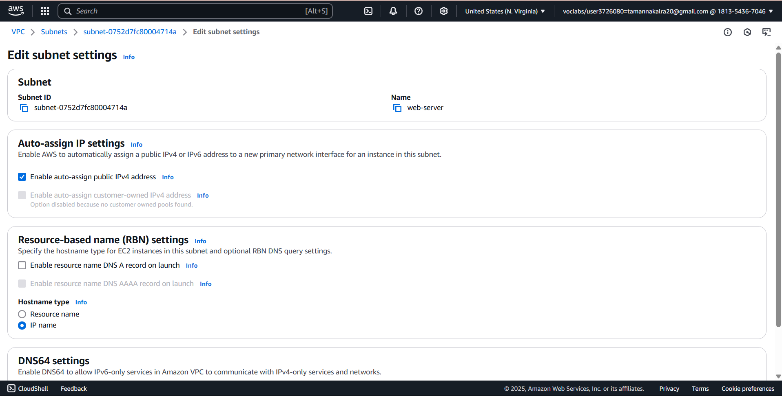

Create Internet Gateway

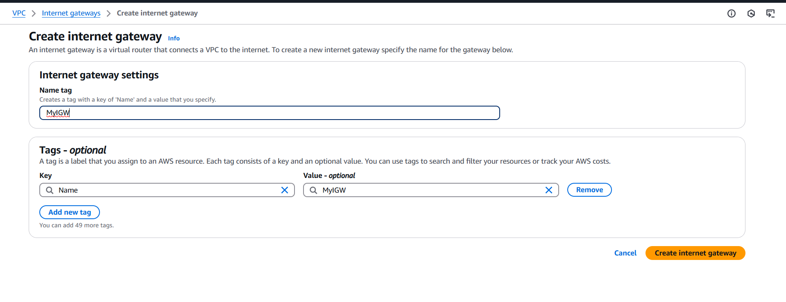

attach to VPC

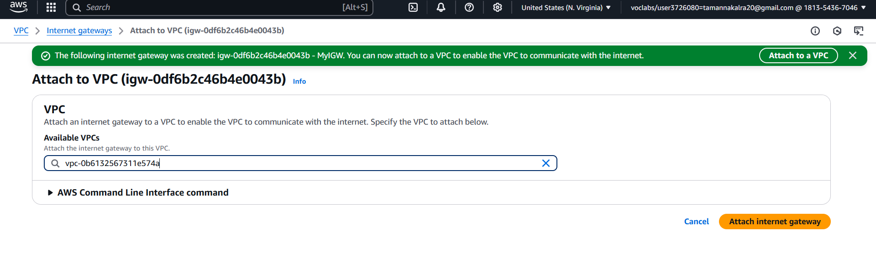

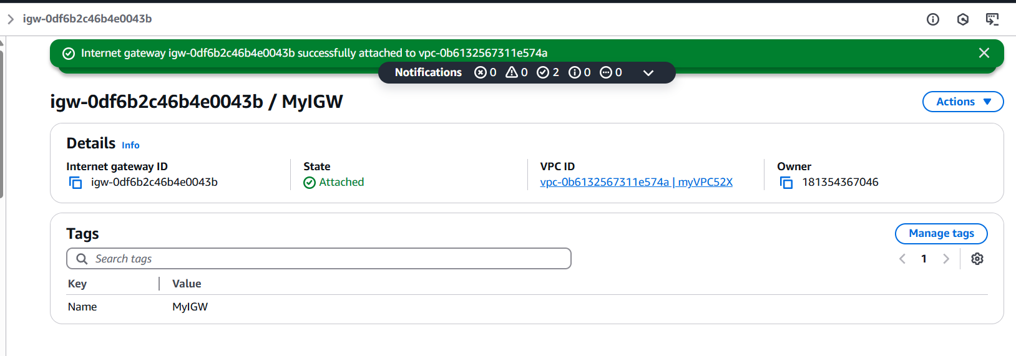

Create route table to subnet1

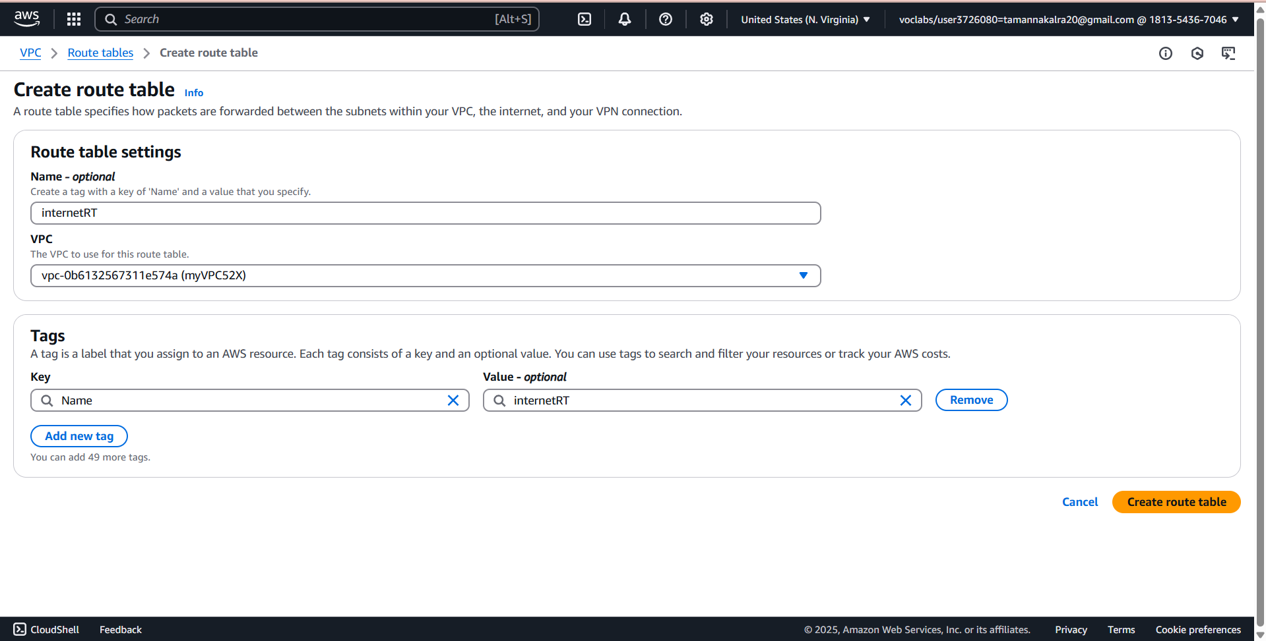

Attach Route table to subnet1

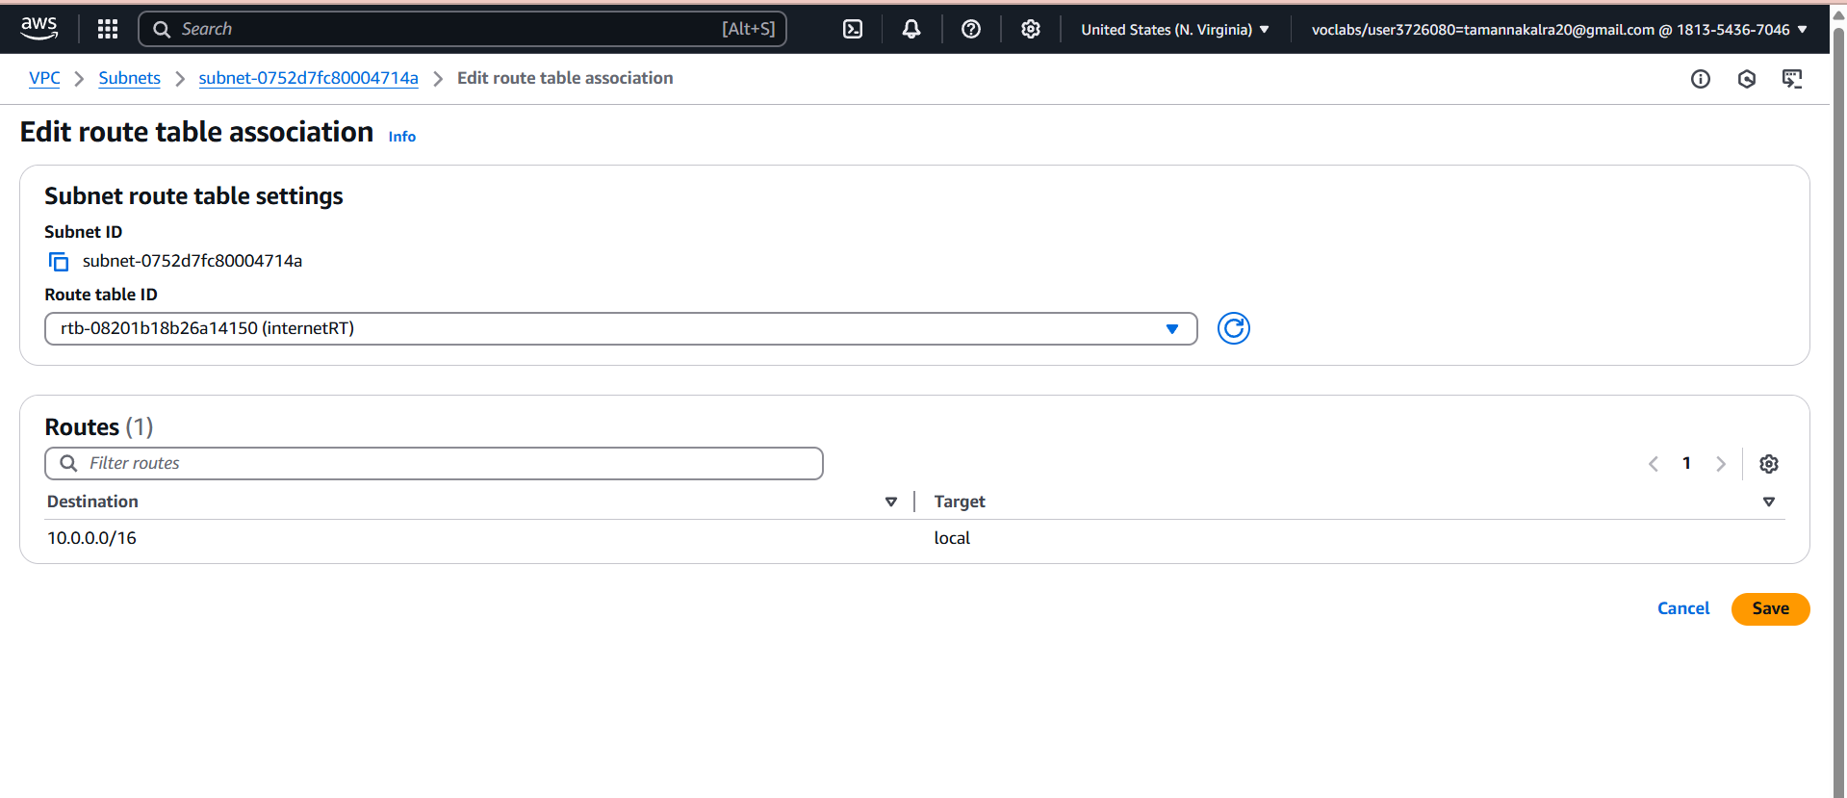

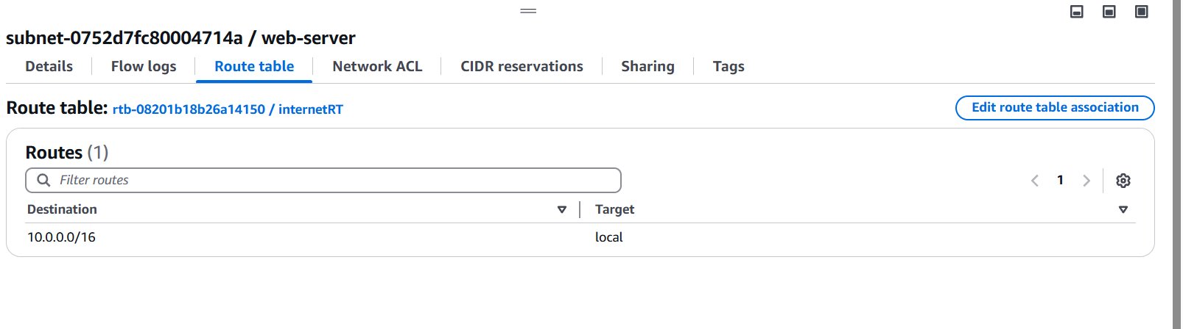

Create Instance

Now, Lets launch web-server in public subnet.

Network : MyVPC Subnet: 10.0.1.0/24

Security Group : Web-SG , Description: WebSG30

ADD RULE

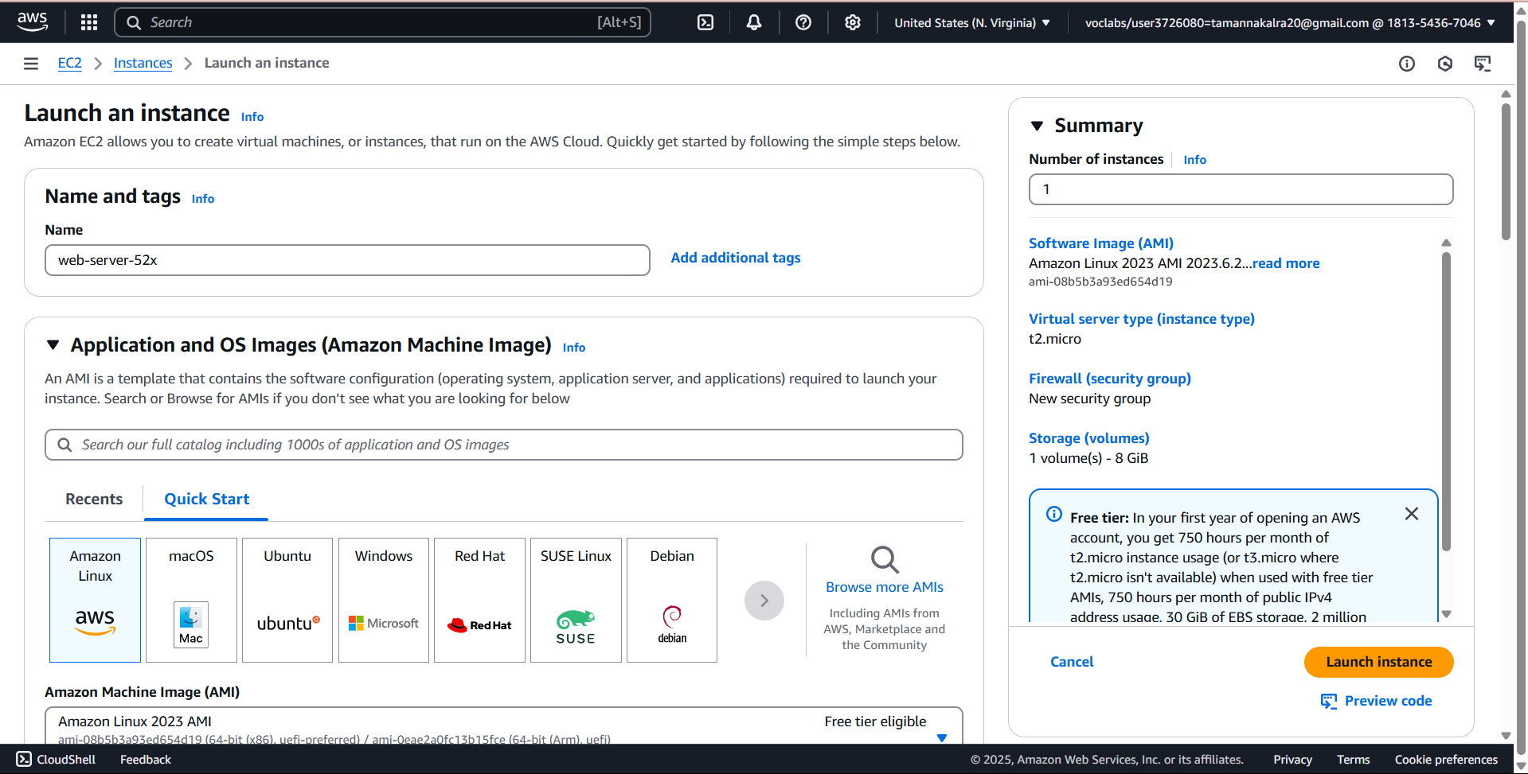

Select VPC

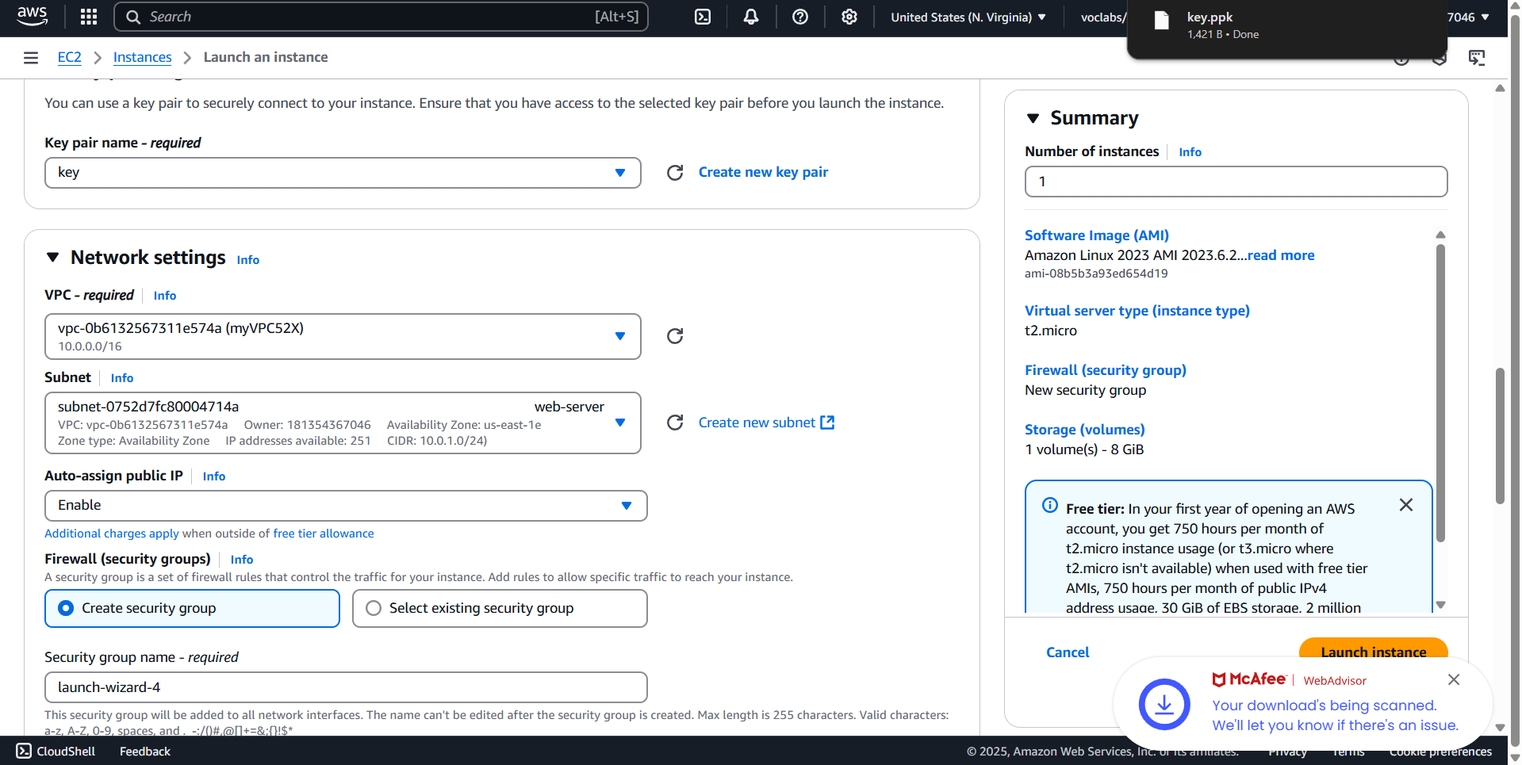

Edit subnet association

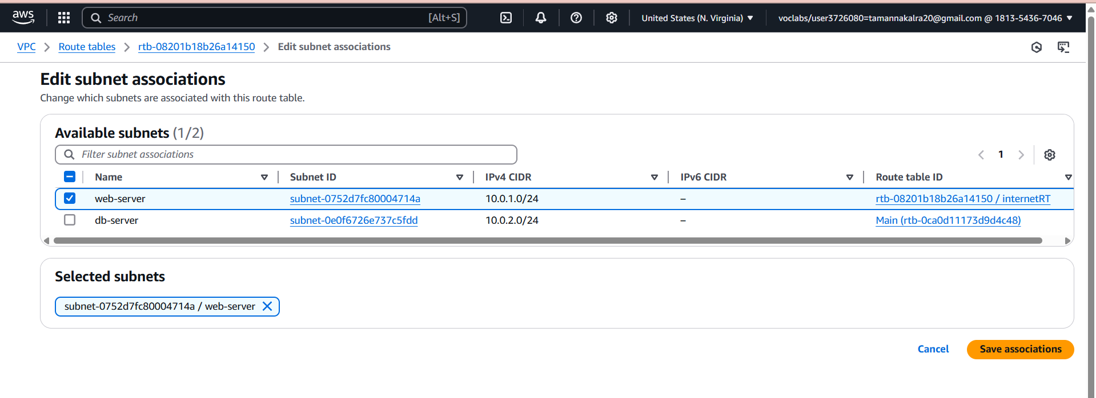

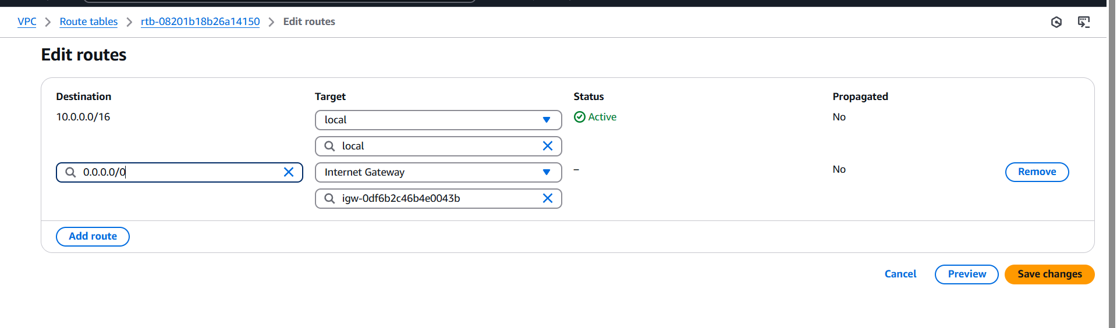

Launch another instance

Lets Launch Database Server in Private SUbnet.

Change Type from SSH to MYSQL/Auror

MYSQL/Aurora Custom 10.0.1.0/24

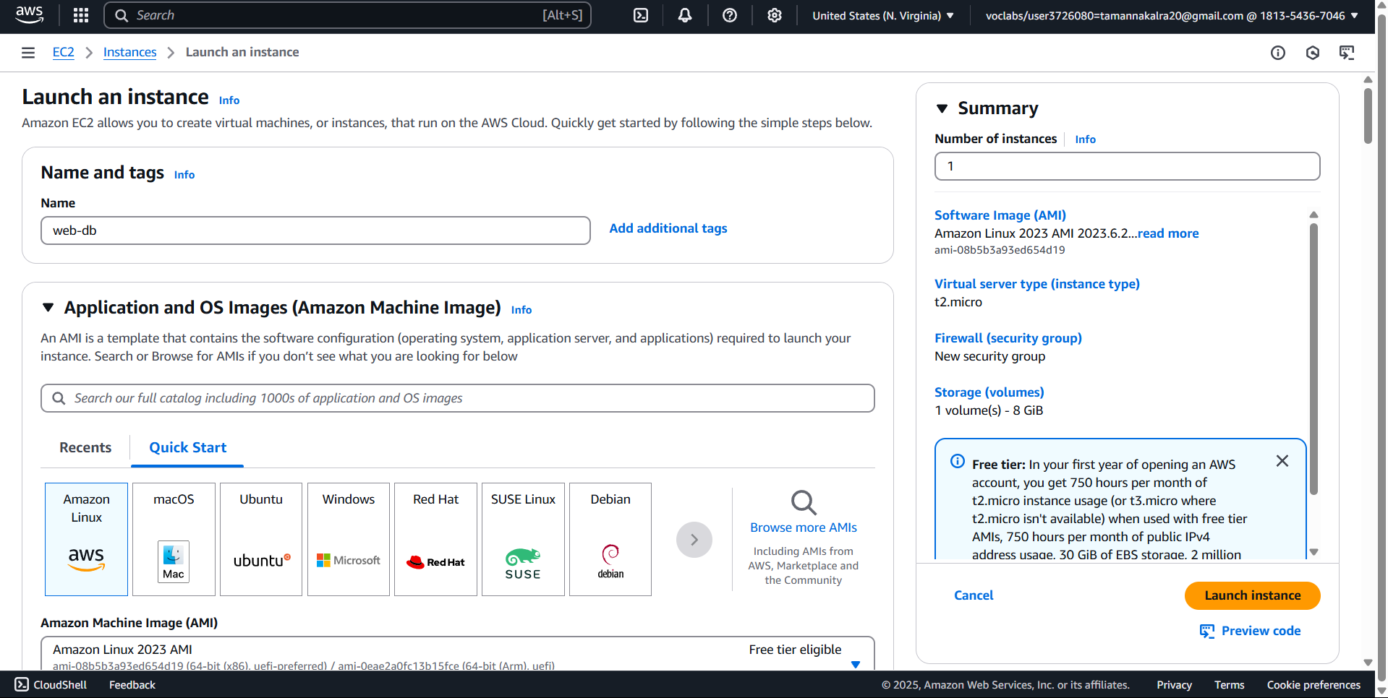

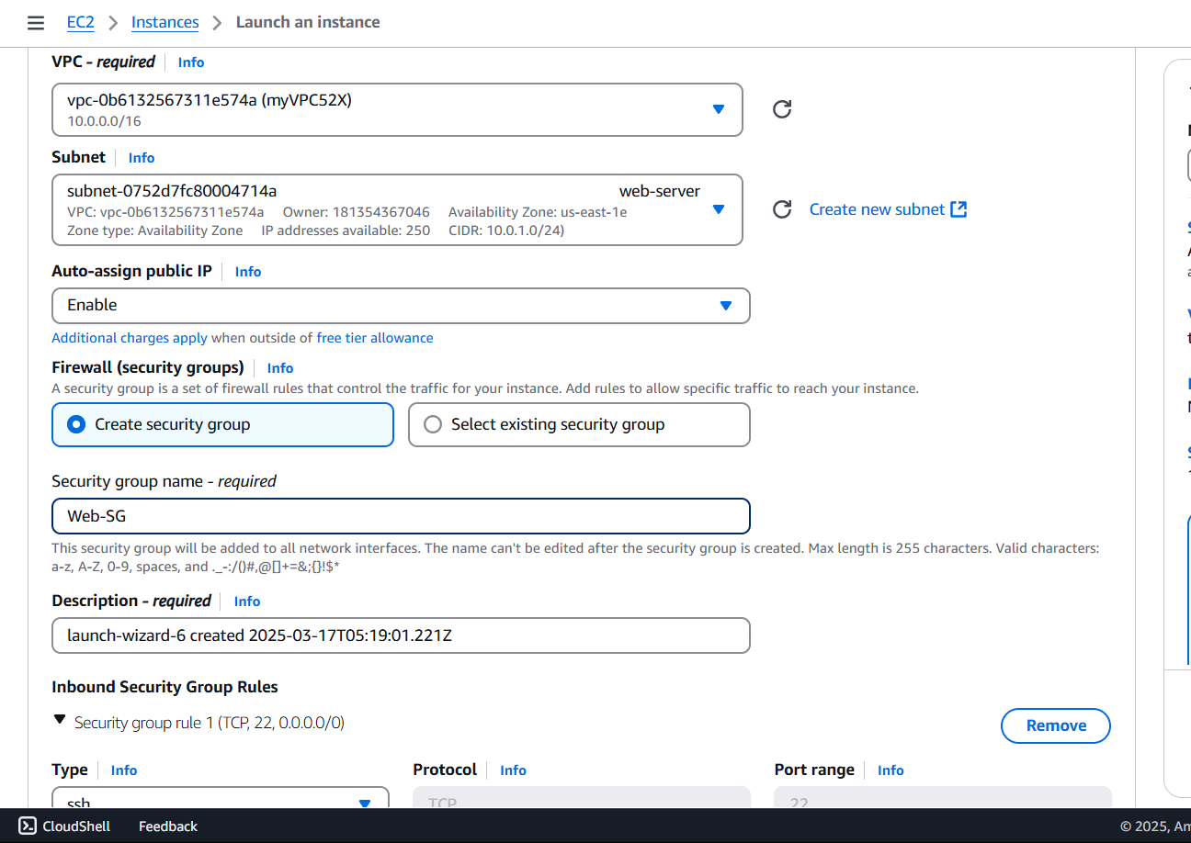

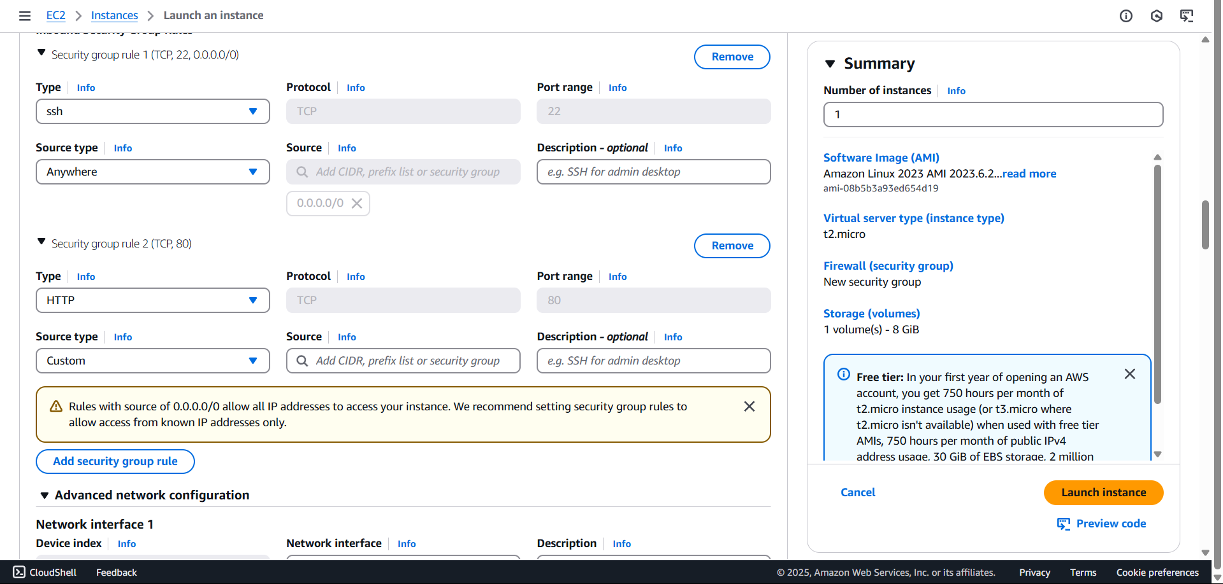

Copy this bootstrap code in the advanced settings to both instance

#!/bin/bash

Sudo su

Yum update -y

Yum install httpd -y

Cd var/www/html

Echo “22bd1a052x” >index.html

Service httpd start

Chkconfig httpd on

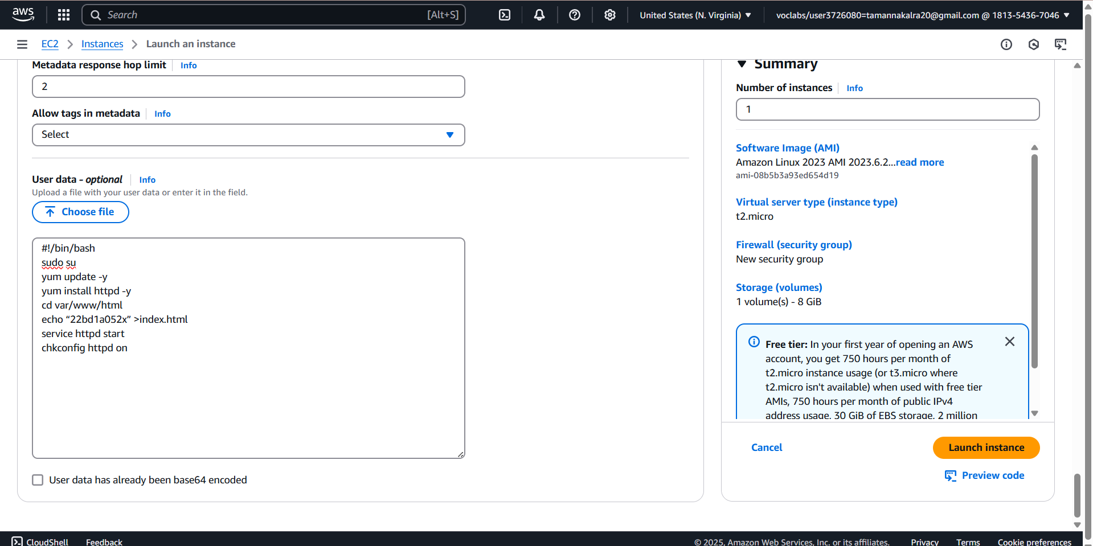

Add MySQL security rule

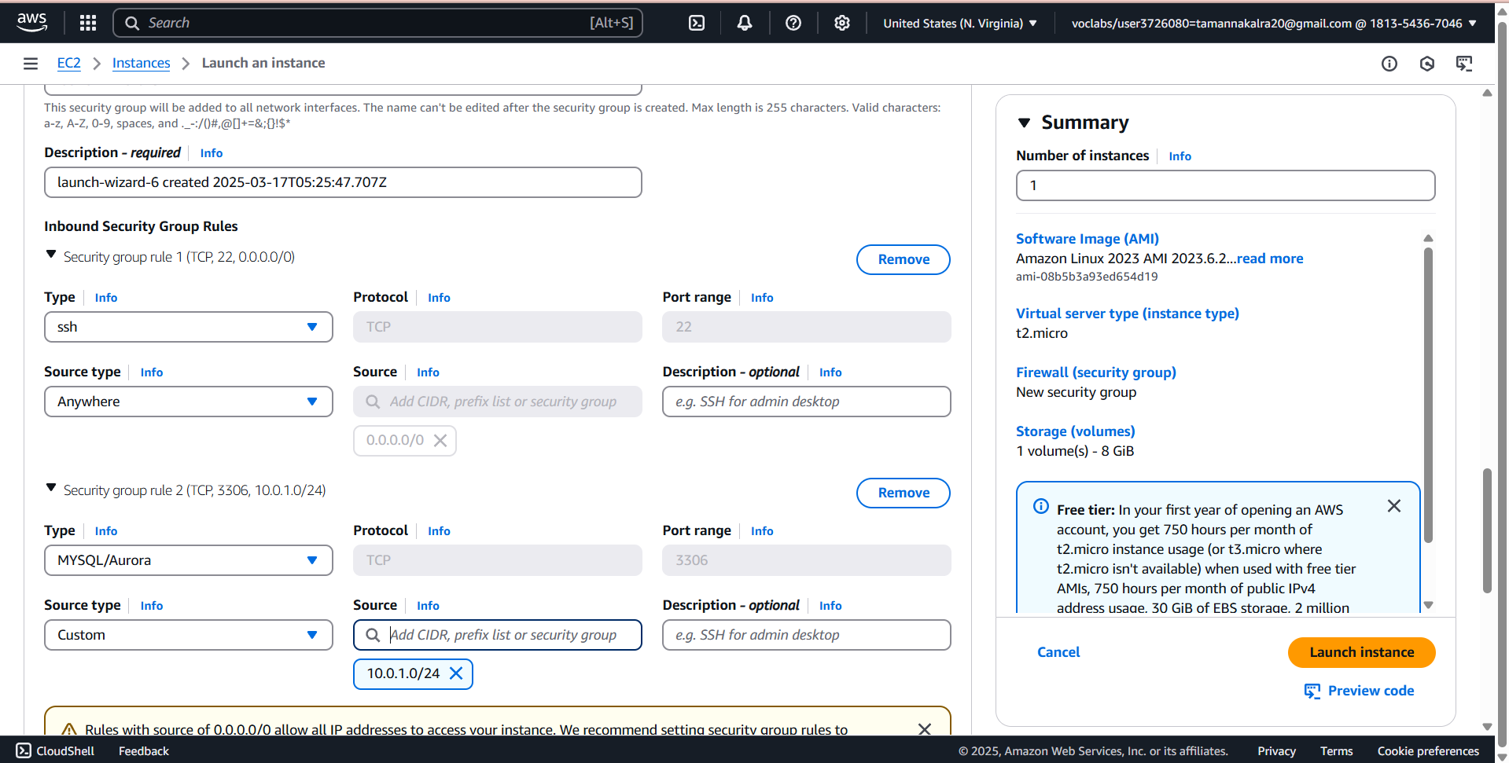

Go to the IP of the web-server



For the other instance you will not get public ip

