**ASSIGNMENT 1**

CREATE DATABASE

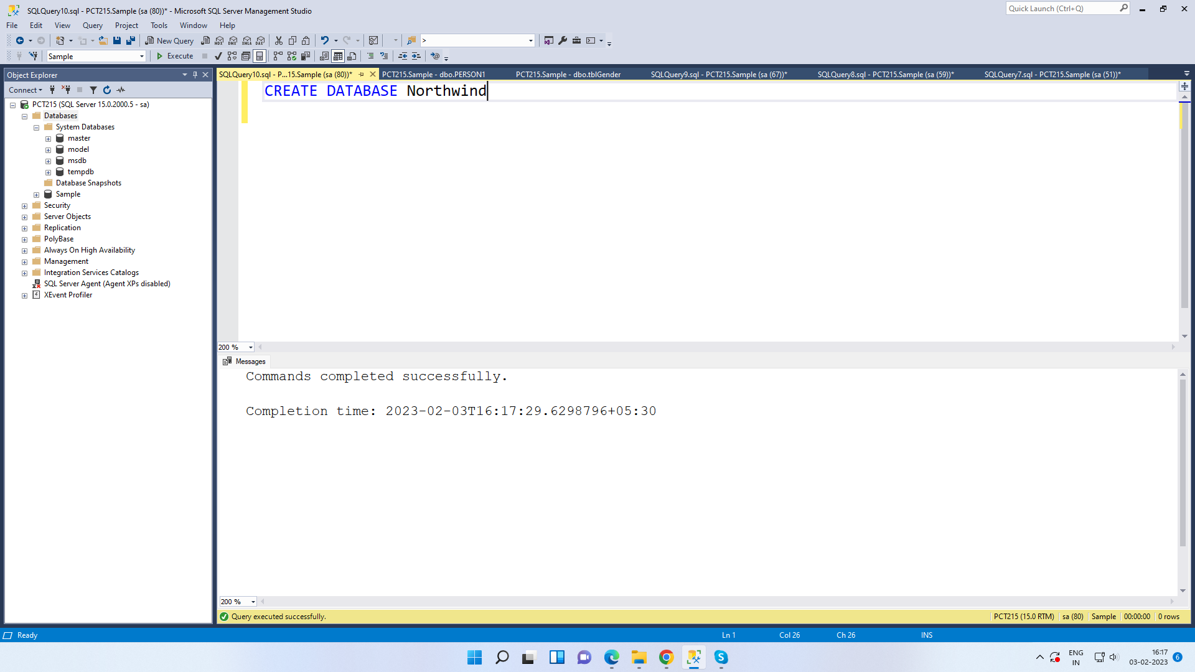

CRAETE TABLE

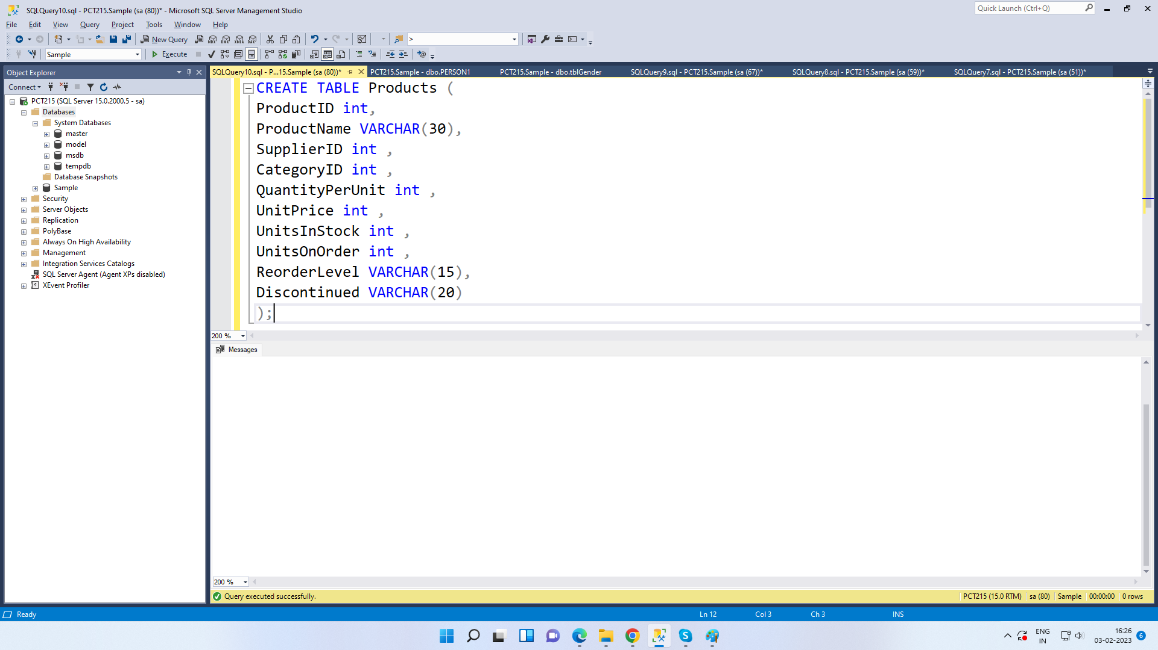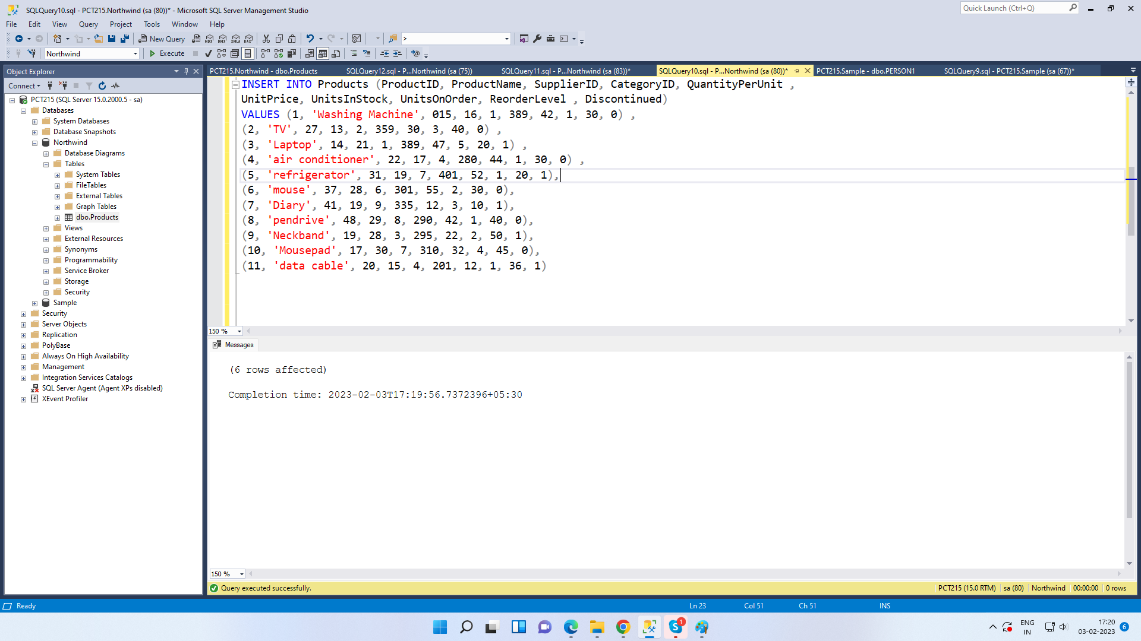

SELECT ALL THE DATA FROM TABLE

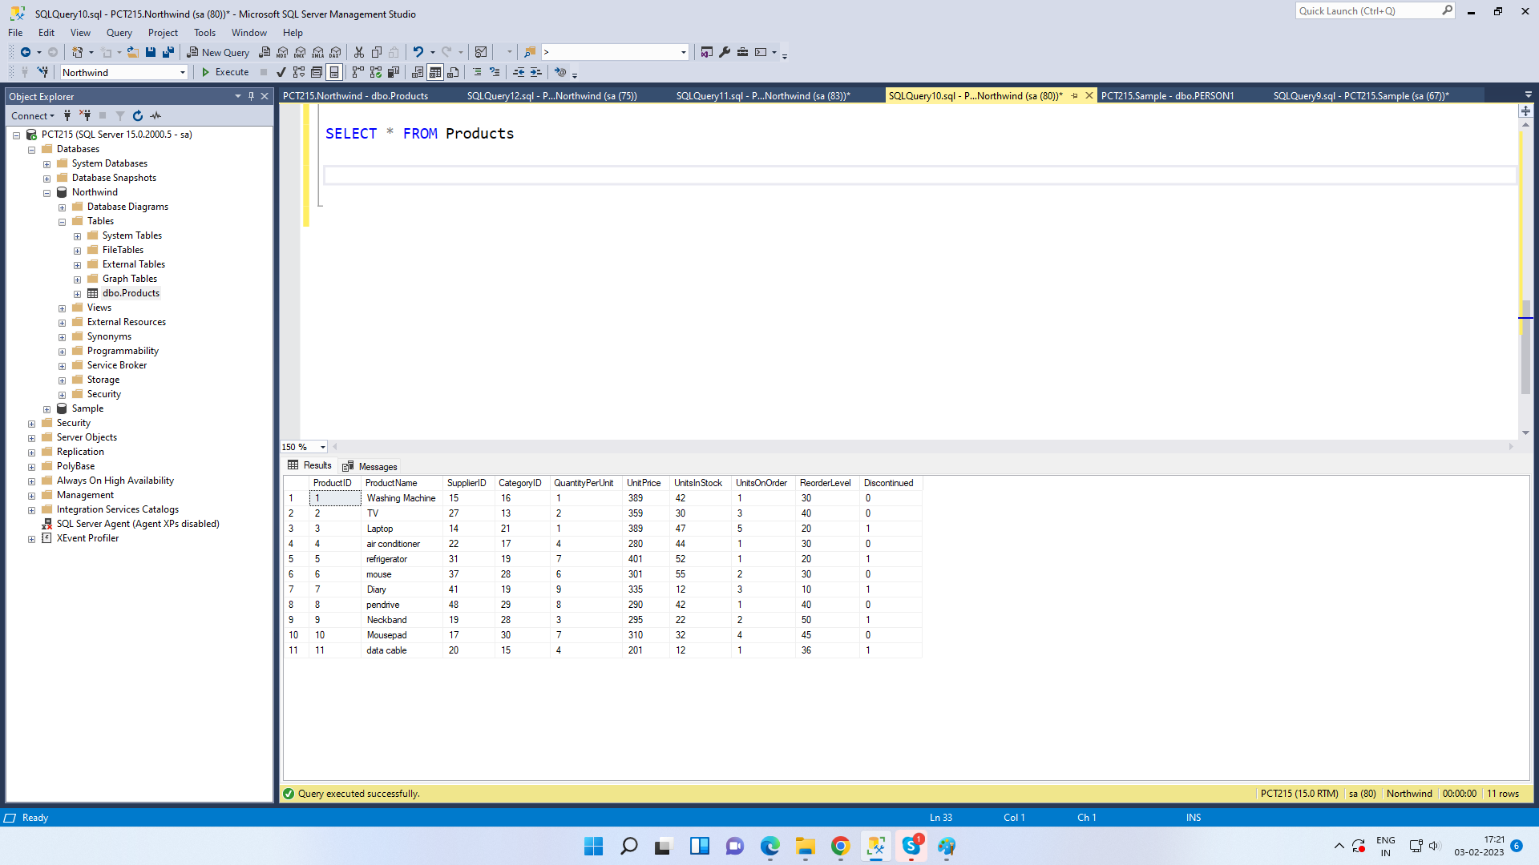

Write a query to get a Product list (id, name, unit price) where current products cost less than $20.

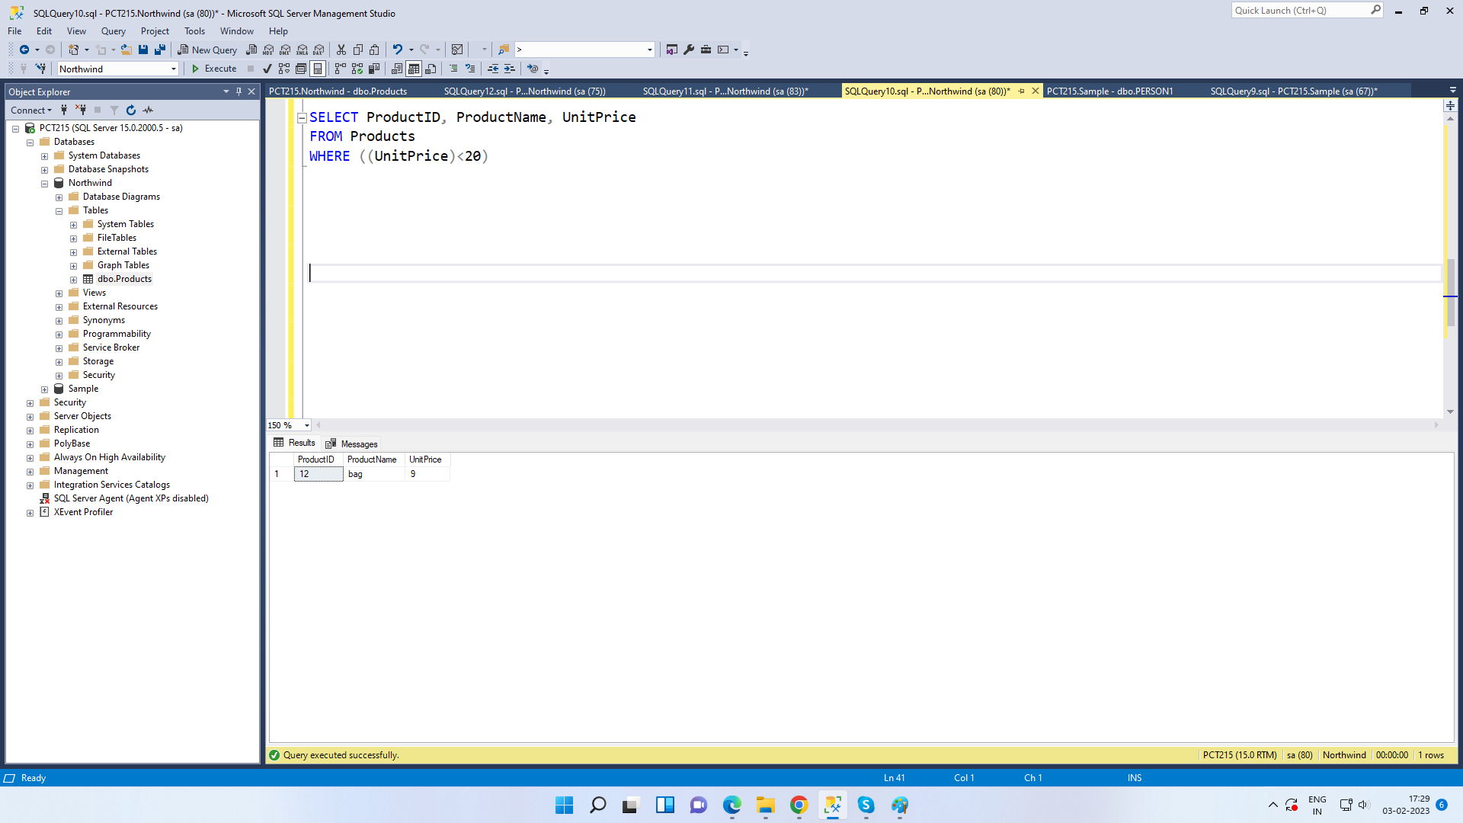

Write a query to get Product list (id, name, unit price) where products cost between $15 and $25

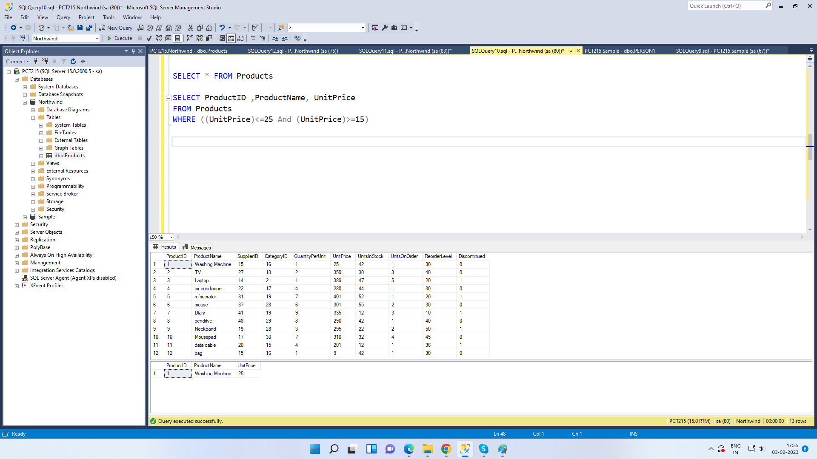

Write a query to get Product list (name, unit price) of above average price.

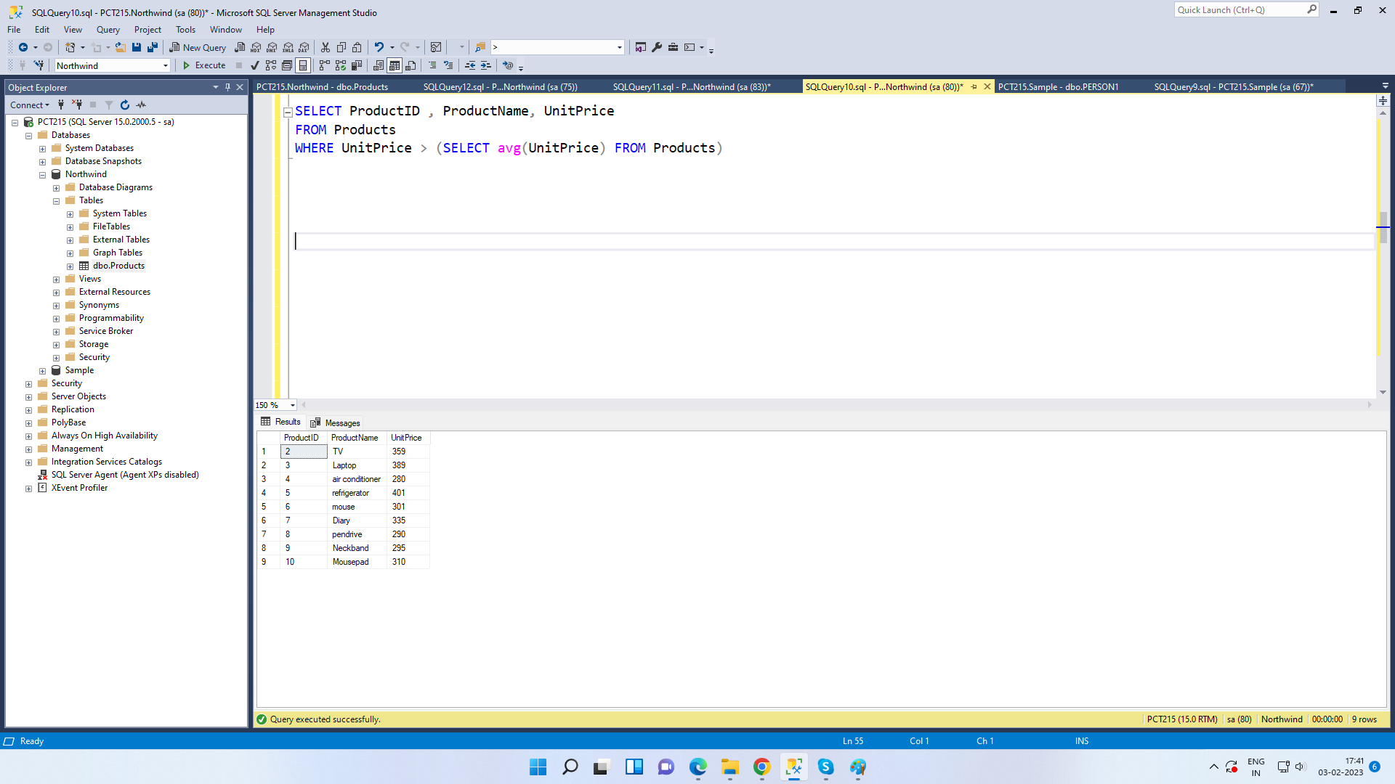

Write a query to get Product list (name, unit price) of ten most expensive products

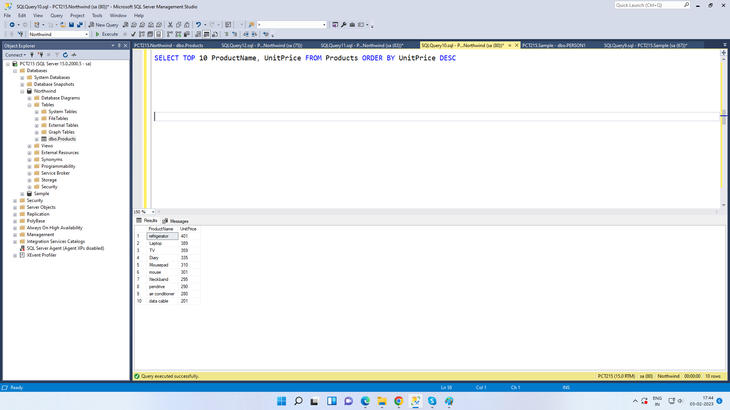

Write a query to count current and discontinued products

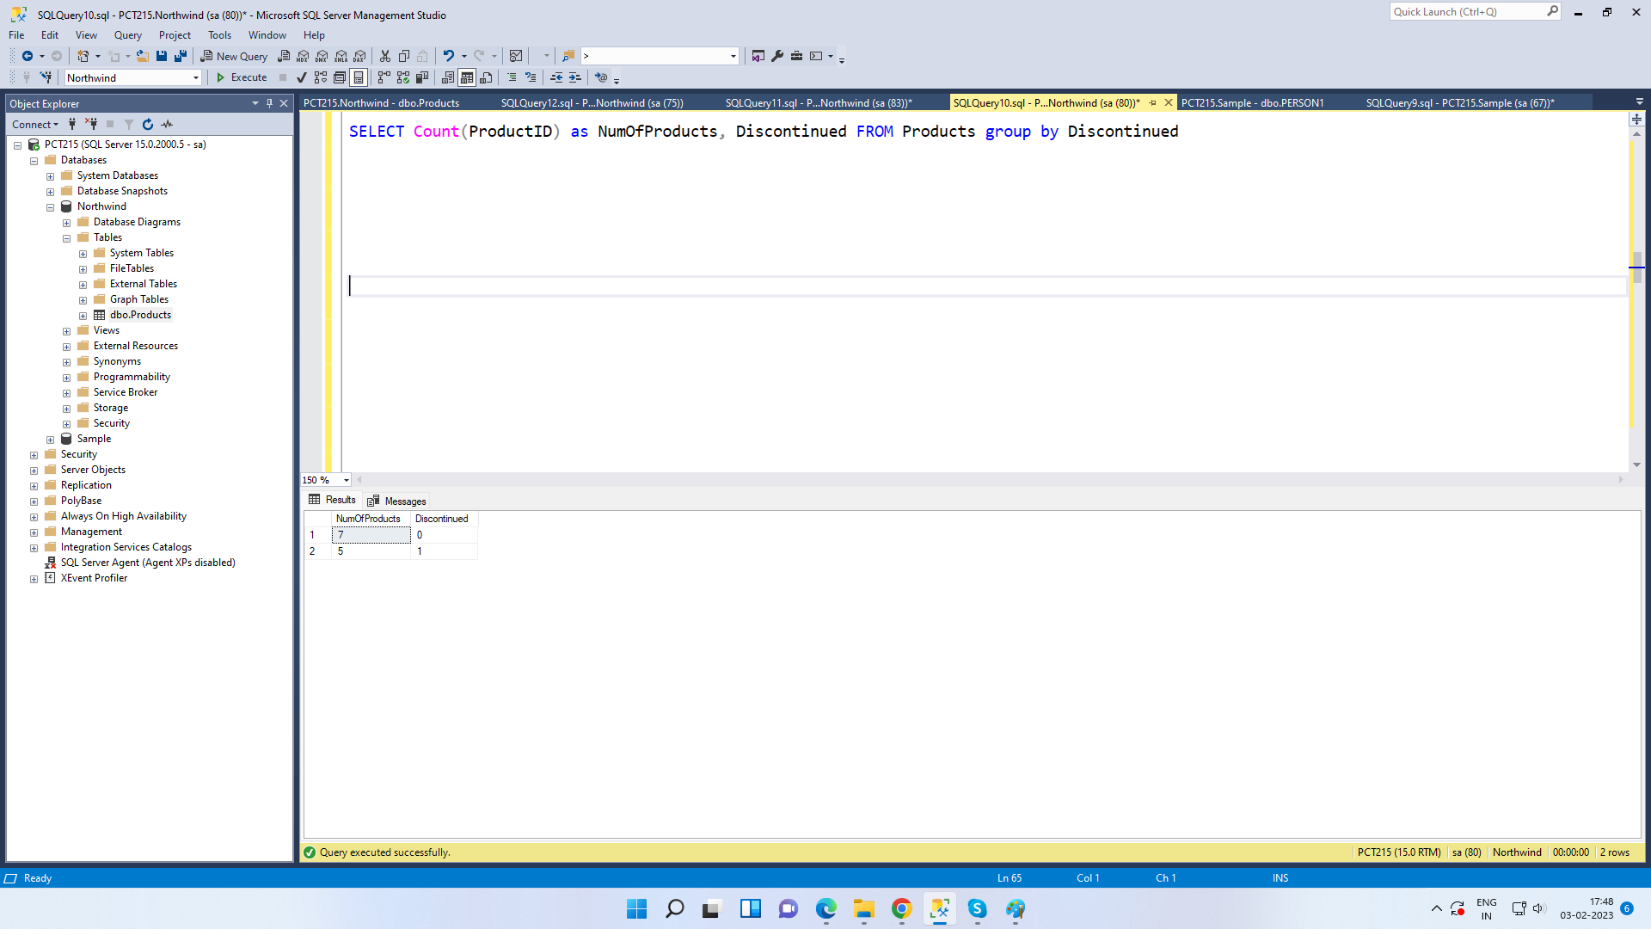

Write a query to get Product list (name, units on order , units in stock) of stock is less than the quantity on order

