**CONSUMERS**

* A Consumer is the basic unit of channels code. Consumers are like Django views.
* Consumers do following things in particular:
* Structures your code as a series of functions to be called whenever an event happens,rather than making you write an event loop.
* Allow you to write synchronous or async code and deals with handoffs and threading for you.

CREATING CONSUMERS:-

1. SyncConsumer
2. AsyncConsumer

CREATING SYNC CONSUMERS:

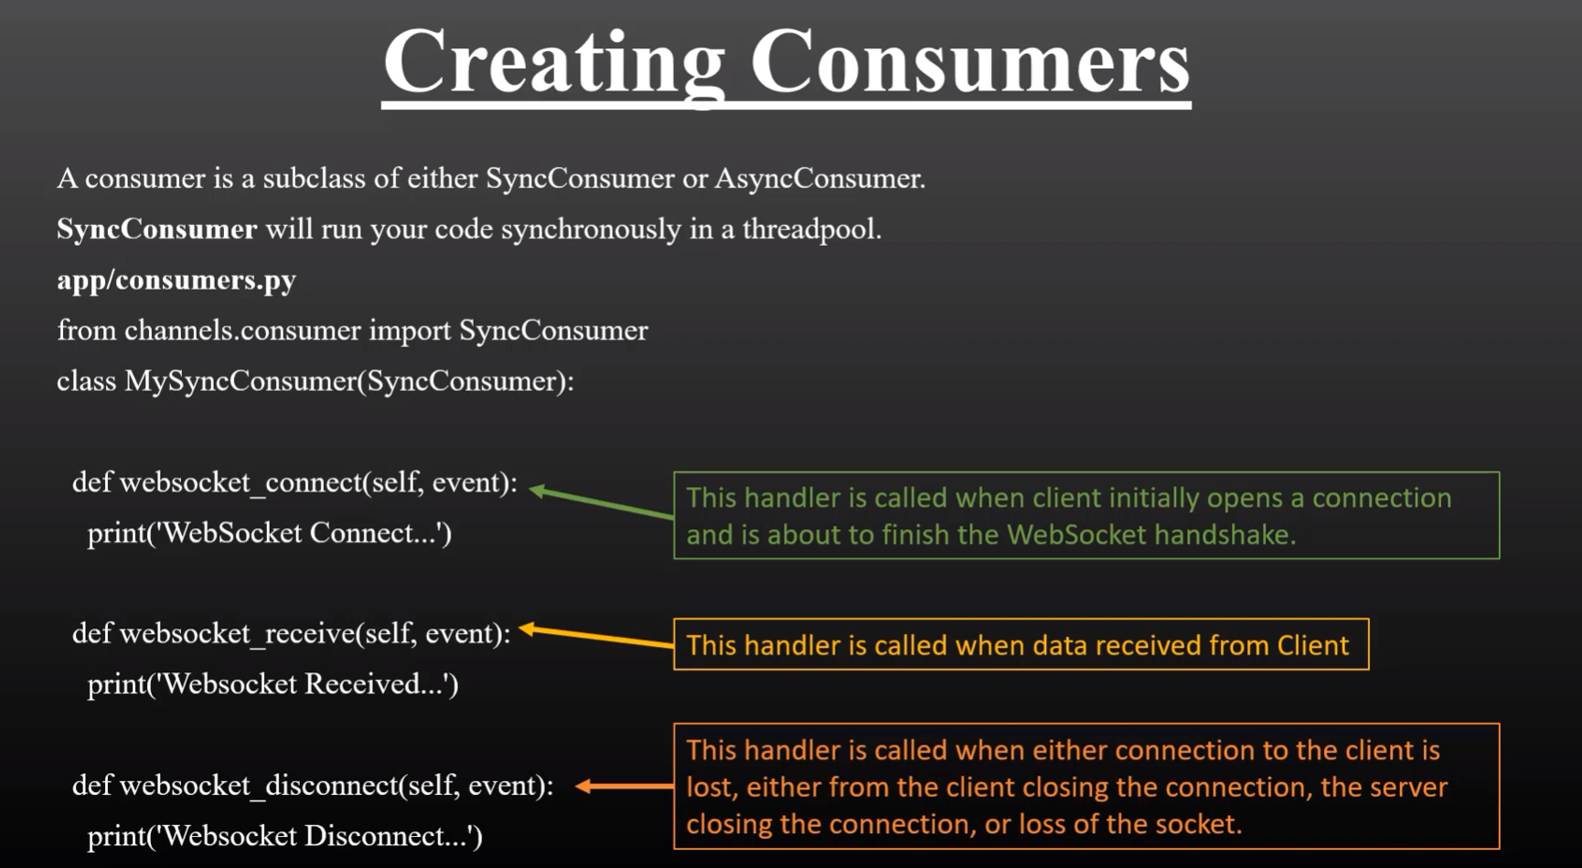

**CREATING ASYNC CONSUMER:**

