**ROUTING**

* Channels provides routing classes that allow you to combine and stack your consumers (and any other valid ASGI application) to dispatch based on what the connection is.
* We call the as_asgi() classmethod when routing our consumers.
* This returns an ASGI wrapper application that will instantiate a new consumer instance for each connection or scope.
* This is similar to Django’s as view(), which plays the same role for per-request instances of class-based views.
* Create routing.py File then write all websocket url patterns inside this file.
* Open asgi.py and mentioned your routing.py file.

**HOW TO CREATE**

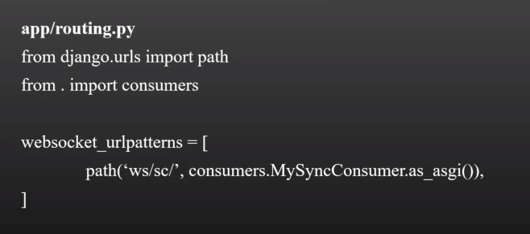

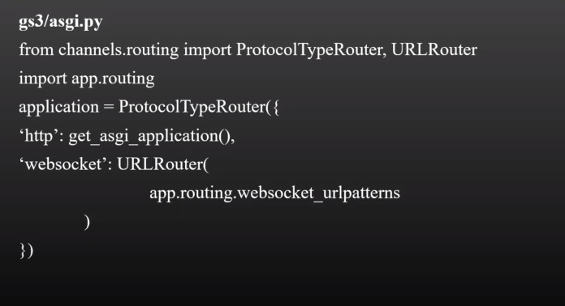

**STEPS**:

1.CREATE CONSUMERS IN consumers.py

2.CREATE ROUTING IN routers.py

3. ADD url patterns which is in routers.py in asgi.py

**Note:**

1. When I tried to run the websocket by runserver command it is not working then I use this command

**daphne -b 0.0.0.0 -p 8000 Routing.asgi:application (Routing is my project name)**

1. **And we need to write thid in connect function to connect with websocket in consumers.py**

**FOR SYNC CONSUMER**

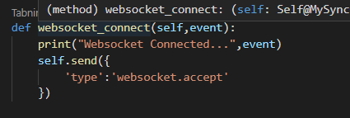

**FOR ASYNC CONSUMER**

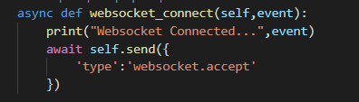

**Use await in async consumer**

**FOR RAISE EXCEPTION IN DISCONNECT WEBSOCKET**



