CLOUD COMPUTING
ASSIGNMENT: 02



Submitted To:
Sir Waqas Saleem

Submitted By:
Komal Kashif
BSE V-A
2023-BSE-031

Submission Date: December 30, 2025

- EXECUTIVE SUMMARY
This assignment focuses on designing and deploying a secure, high-availability multi-tier web infrastructure on Amazon Web Services (AWS) using Terraform for Infrastructure as Code and Nginx as a reverse proxy and load balancer.
The main goal was to show practical understanding of cloud automation, Terraform modules, Nginx configuration, and high-availability web architecture. The entire infrastructure was deployed automatically using reusable Terraform modules, making it scalable, consistent, and easy to manage.
Infrastructure Overview
The system follows a three-tier architecture:
- Networking Layer: A custom VPC with a public subnet, Internet Gateway, and routing for external access.
- Security Layer: Separate security groups for Nginx and backend servers, restricted SSH access, and backend servers accessible only through Nginx.
- Compute Layer:
  - One Nginx server acting as a secure reverse proxy and load balancer with HTTPS, caching, security headers, and failover support.
  - Three Apache backend servers displaying dynamic system information.
All EC2 instances were created using a reusable Terraform module to maintain consistency.
Key Achievements
- Implemented Infrastructure as Code using Terraform modules.
- Built a high-availability setup with load balancing and backup servers.
- Configured Nginx with SSL, caching, compression, and security features.
- Tested failover and verified caching behavior.
- Applied security best practices such as HTTPS enforcement and restricted access.
Overall, this assignment demonstrates a complete DevOps workflow, from infrastructure design and automation to deployment and testing, following modern cloud and DevOps best practices.

- ARCHITECTURE DESIGN
The architecture for this assignment is a multi-tier web application deployed on Amazon Web Services (AWS) using Terraform for automation and Nginx as a reverse proxy and load balancer. The main goal of the design is to ensure security, availability, and scalability while following cloud best practices demonstrated in class.
The architecture is divided into the following layers:
- Client layer (users accessing the application)
- Load balancing layer (Nginx server)
- Application layer (Apache backend servers)
- Network and security layer (VPC, subnet, routing, security groups)
Architecture Diagram
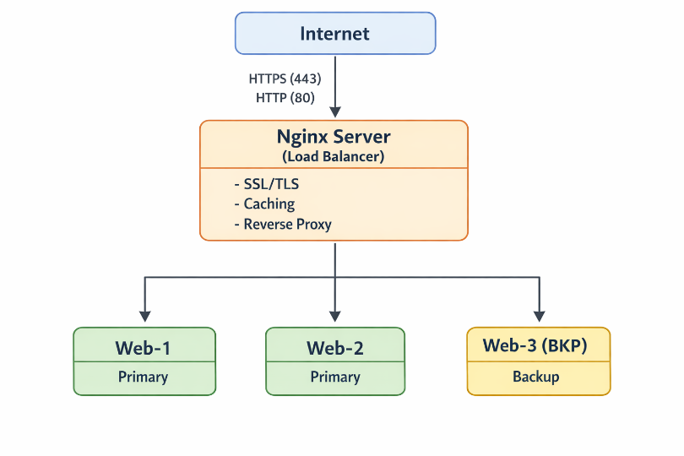
Component Descriptions
Nginx Server:
The Nginx server acts as the main entry point for users. It handles HTTPS connections, redirects HTTP traffic to HTTPS, and distributes requests across multiple backend servers. It also provides basic caching and adds security headers to incoming responses.
Backend Web Servers:
Three Apache web servers are deployed as backend servers:
- Two primary servers (web-1 and web-2)
- One backup server (web-3)
These servers host a simple web page and are only accessible through the Nginx server, not directly from the internet.

Network Topology
A custom VPC is created to isolate the infrastructure. A single public subnet is used to host all EC2 instances. An Internet Gateway is attached to the VPC to allow external access, and routing is configured so that only the Nginx server is exposed to the public internet.

Security Design
Security is implemented using AWS security groups:
- The Nginx security group allows HTTP (80) and HTTPS (443) from anywhere, and SSH access only from the administrator’s IP address.
- The backend security group allows HTTP traffic only from the Nginx server and restricts SSH access.
This setup ensures that backend servers remain protected and cannot be accessed directly by users.

- IMPLEMENTATION DETAILS

- Part 1: Infrastructure setup
- 1.1 Project Setup
All the necessary commands were run for the proper setup of the project. The screenshot below shows the structure of project:
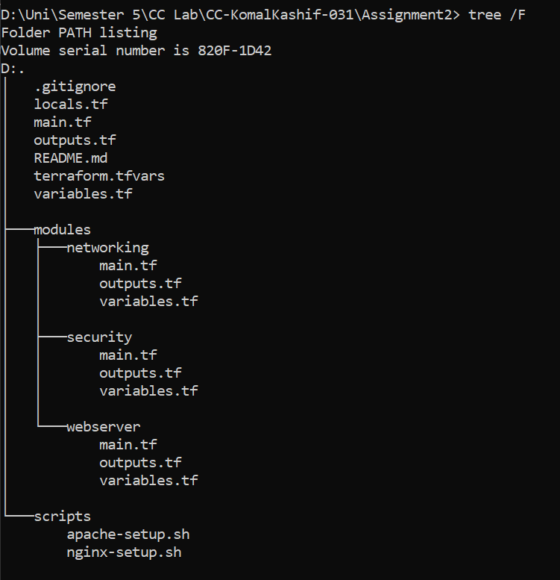
Contents of .gitignore:
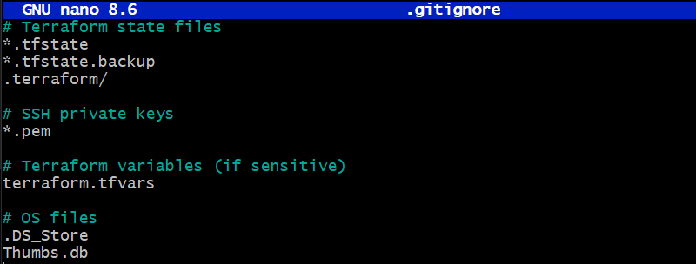

- 1.2 Variable Configuration
Task: Add validation rules for CIDR blocks. Add descriptions for all variables. Set appropriate defaults where applicable.
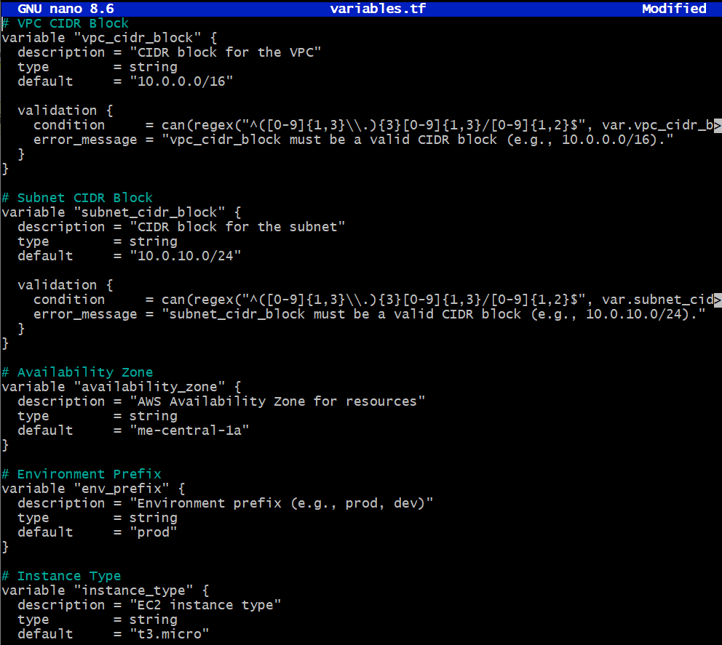

Populate terraform.tfvars with your values:
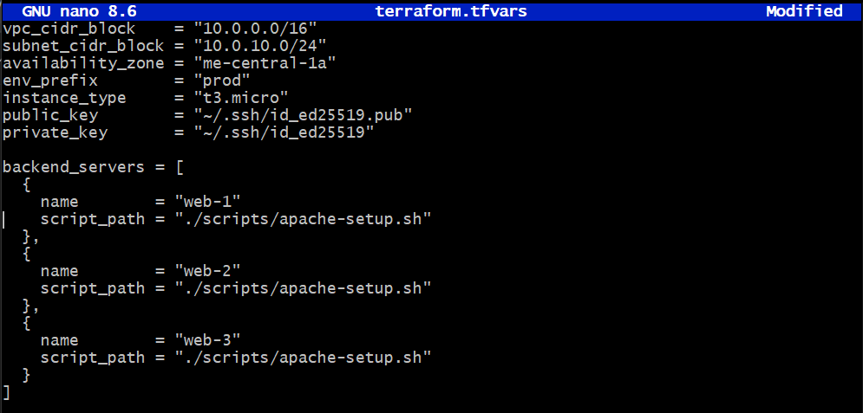
- 1.3 Networking Module
Create a networking module that provisions:
- VPC with specified CIDR block
- Subnet with public IP assignment enabled
- Internet Gateway
- Route table with default route to IGW
- Associate route table with subnet
In modules/networking/main.tf:
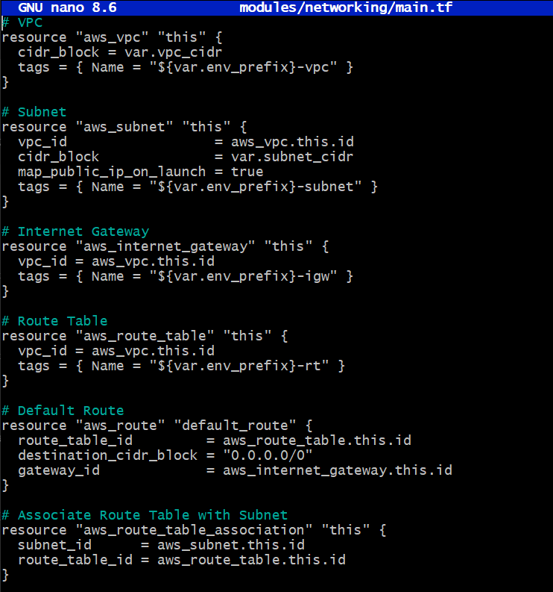
In modules/networking/outputs.tf:
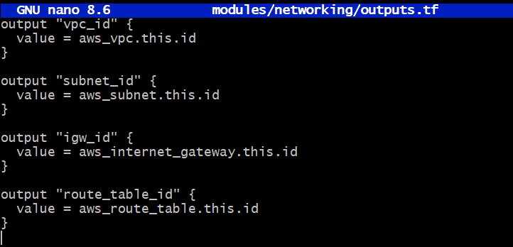
After terraform is applied, following are the required outputs:
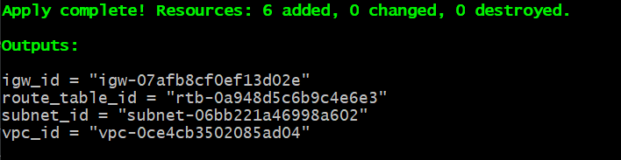
- 1.4 Security Module
Create a security module:
Output from security module:
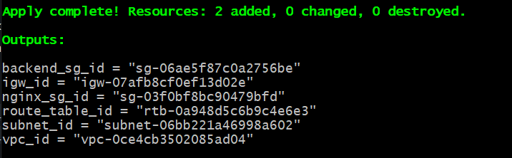
On AWS Console
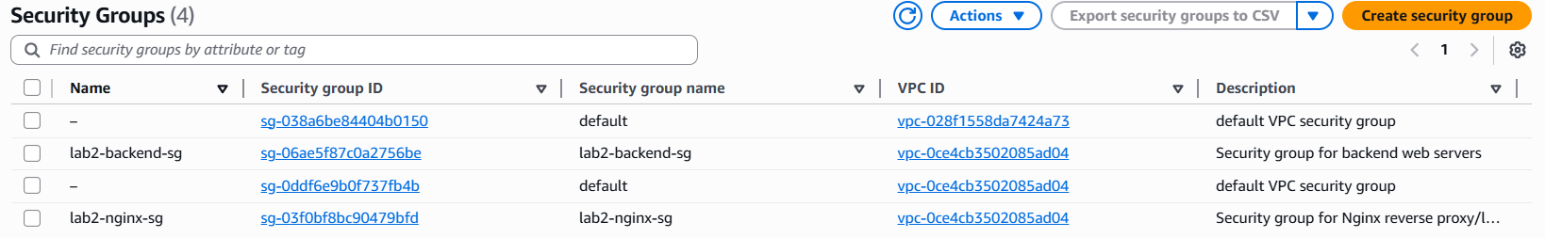

- 1.5 Locals Configuration
Create locals.tf with:
- Dynamic IP detection for my_ip
- Resource naming conventions
- Common tags
- Backend server configurations
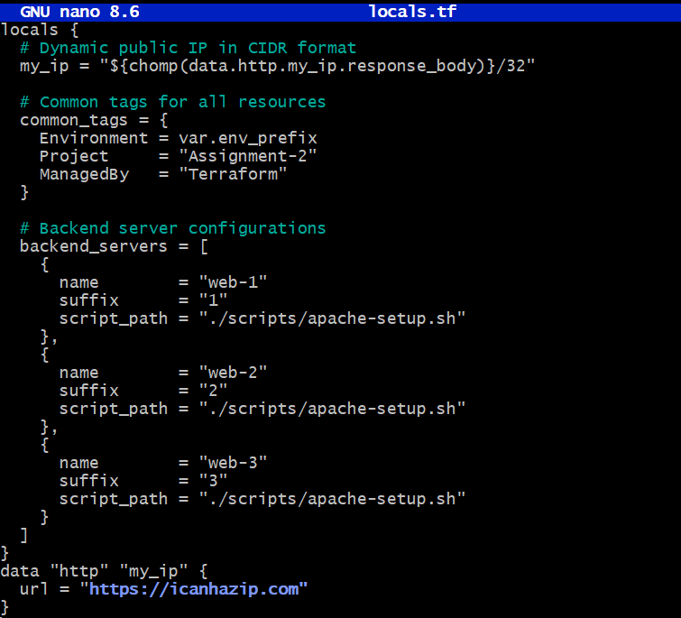
After terraform is applied adding necessary modules to main.tf and adding required configurations to locals.tf:
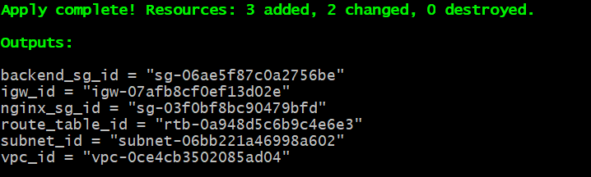

- Part 2: Webserver Module
- 2.1 Module Design
Create a reusable webserver module in modules/webserver
In modules/webserver/variables.tf:
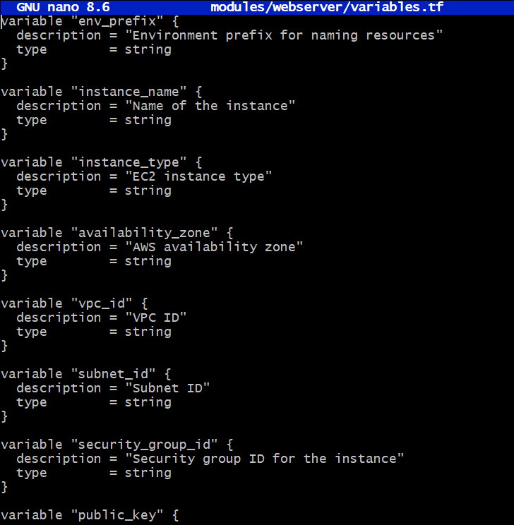
In modules/webserver/main.tf:
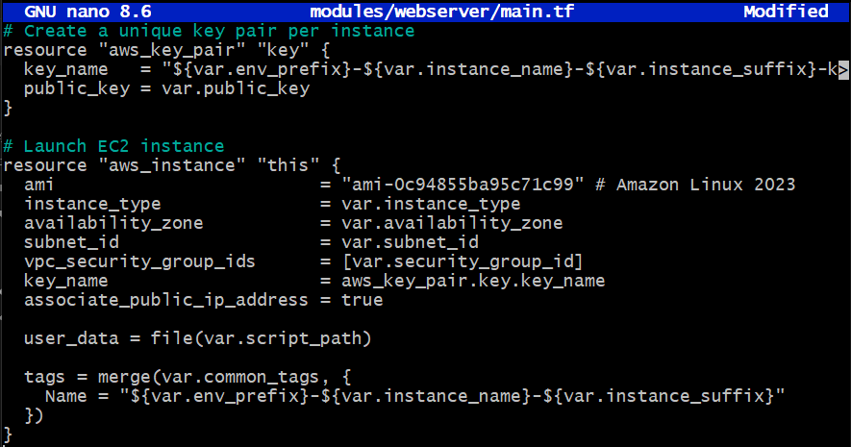
In modules/webserver/outputs.tf:
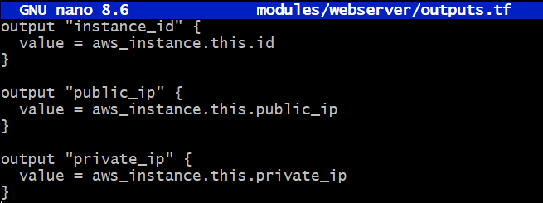
- 2.2 Module Usage
In root main.tf, instantiate the webserver module for:
- One Nginx server (using nginx-setup.sh)
- Three backend servers (web-1, web-2, web-3 using apache-setup.sh)
Use dynamic blocks or for_each for backend servers
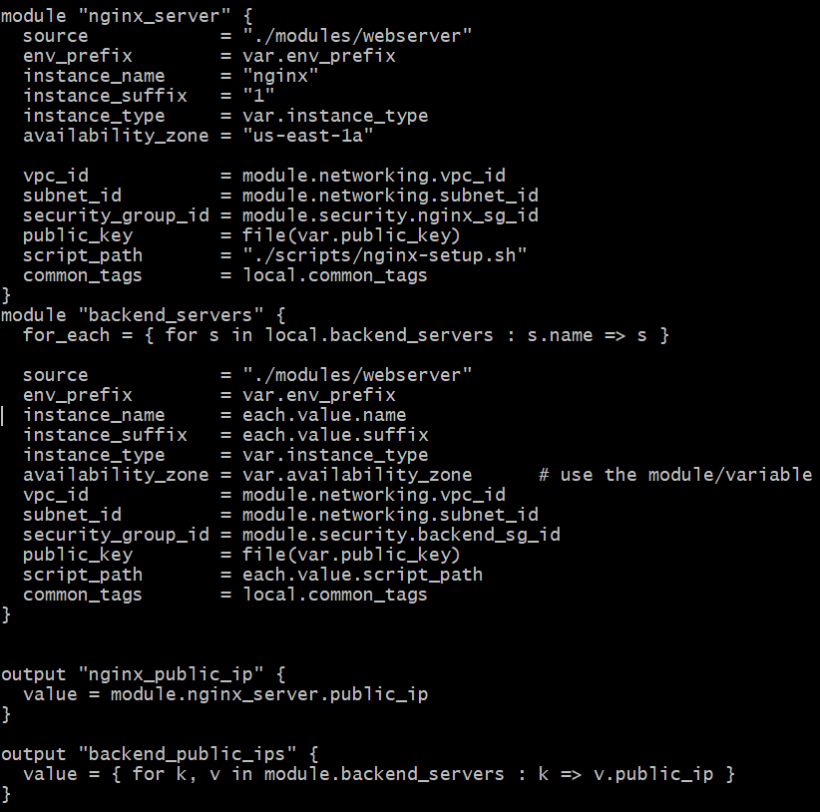
After applying terraform:
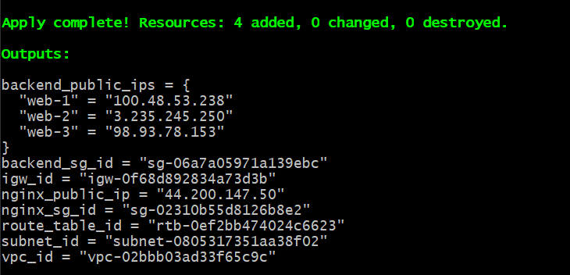

- Part 3: Server Configuration Scripts
- 3.1 Apache Backend Server Script
Create scripts/apache-setup.sh
Apache Shell script code:
#!/bin/bash
set -e

# Update system
yum update -y

# Install Apache
yum install httpd -y

# Start and enable Apache
systemctl start httpd
systemctl enable httpd

# Get metadata token (IMDSv2)
TOKEN=$(curl -s -X PUT "http://169.254.169.254/latest/api/token" \
-H "X-aws-ec2-metadata-token-ttl-seconds: 21600")

# Get instance metadata
PRIVATE_IP=$(curl -s -H "X-aws-ec2-metadata-token: $TOKEN" \
http://169.254.169.254/latest/meta-data/local-ipv4)
PUBLIC_IP=$(curl -s -H "X-aws-ec2-metadata-token: $TOKEN" \
http://169.254.169.254/latest/meta-data/public-ipv4)
PUBLIC_DNS=$(curl -s -H "X-aws-ec2-metadata-token: $TOKEN" \
http://169.254.169.254/latest/meta-data/public-hostname)
INSTANCE_ID=$(curl -s -H "X-aws-ec2-metadata-token: $TOKEN" \
http://169.254.169.254/latest/meta-data/instance-id)

# Set hostname
hostnamectl set-hostname myapp-webserver

# Create custom HTML page
cat > /var/www/html/index.html <<EOF
<!DOCTYPE html>
<html>
<head>
<title>Backend Web Server</title>
<style>
body {
font-family: Arial, sans-serif;
margin: 50px;
background: linear-gradient(135deg, #667eea 0%, #764ba2 100%);
color: white;
}
.container {
background: rgba(255, 255, 255, 0.1);
padding: 30px;
border-radius: 10px;
box-shadow: 0 8px 32px 0 rgba(31, 38, 135, 0.37);
}
h1 { color: #fff; text-shadow: 2px 2px 4px rgba(0,0,0,0.3); }
.info { margin: 15px 0; padding: 10px; background: rgba(255,255,255,0.2); border-radius: 5px; }
.label { font-weight: bold; color: #ffd700; }
</style>
</head>
<body>
<div class="container">
<h1>🚀 Backend Web Server - Assignment 2</h1>
<div class="info"><span class="label">Hostname:</span> $(hostname)</div>
<div class="info"><span class="label">Instance ID:</span> $INSTANCE_ID</div>
<div class="info"><span class="label">Private IP:</span> $PRIVATE_IP</div>
<div class="info"><span class="label">Public IP:</span> $PUBLIC_IP</div>
<div class="info"><span class="label">Public DNS:</span> $PUBLIC_DNS</div>
<div class="info"><span class="label">Deployed: </span> $(date)</div>
<div class="info"><span class="label">Status:</span> ✅ Active and Running</div>
<div class="info"><span class="label">Managed By:</span> Terraform</div>
</div>
</body>
</html>
EOF

# Set permissions
chmod 644 /var/www/html/index.html

echo "Apache setup completed successfully!"

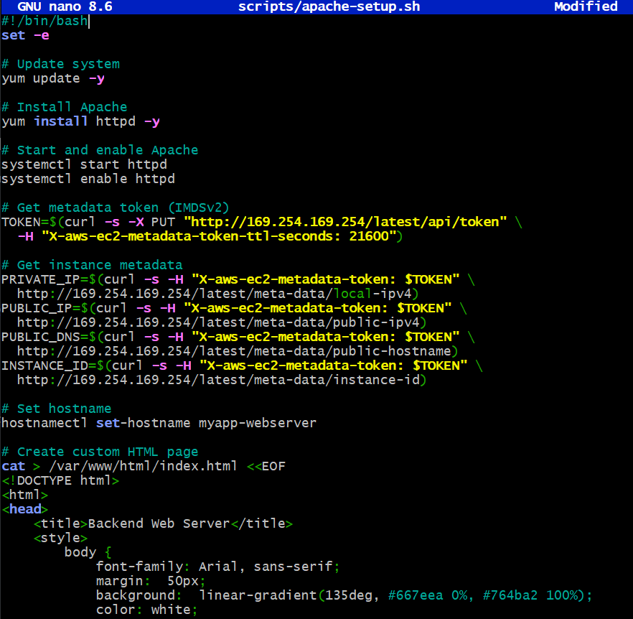

Webpage:
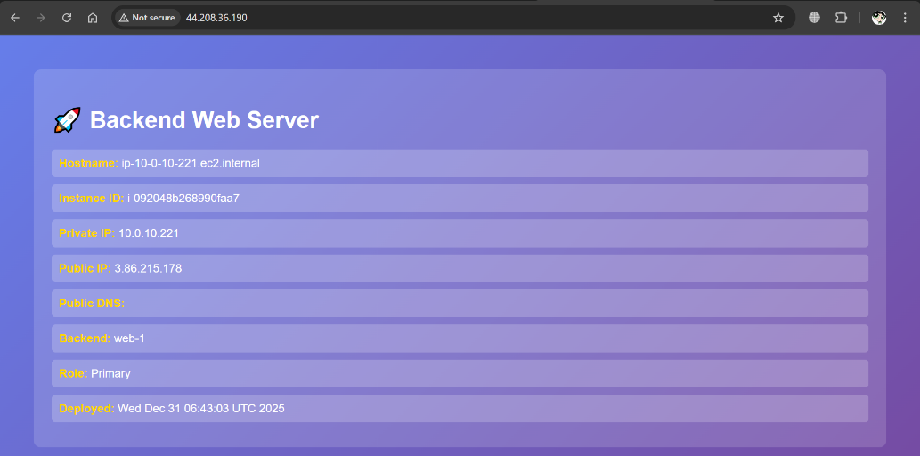
- 3.2 Nginx Server Setup Script
Create scripts/nginx-setup.sh
Enhanced Script Template:
#!/bin/bash
set -e

# Update and install Nginx
yum update -y
yum install -y nginx openssl
systemctl start nginx
systemctl enable nginx

# Create SSL directories
mkdir -p /etc/ssl/private
mkdir -p /etc/ssl/certs

# Get metadata token
TOKEN=$(curl -s -X PUT "http://169.254.169.254/latest/api/token" \
-H "X-aws-ec2-metadata-token-ttl-seconds: 21600")

# Get public IP
PUBLIC_IP=$(curl -s -H "X-aws-ec2-metadata-token: $TOKEN" \
http://169.254.169.254/latest/meta-data/public-ipv4)

# Generate self-signed certificate
openssl req -x509 -nodes -days 365 -newkey rsa:2048 \
-keyout /etc/ssl/private/selfsigned.key \
-out /etc/ssl/certs/selfsigned.crt \
-subj "/CN=$PUBLIC_IP" \
-addext "subjectAltName=IP:$PUBLIC_IP" \
-addext "basicConstraints=CA:FALSE" \
-addext "keyUsage=digitalSignature,keyEncipherment" \
-addext "extendedKeyUsage=serverAuth"

echo "Self-signed certificate created for IP: $PUBLIC_IP"

# Backup original config
cp /etc/nginx/nginx.conf /etc/nginx/nginx.conf.bak

# Create Nginx configuration
# Note: Backend IPs will be added manually after deployment
cat > /etc/nginx/nginx.conf <<'EOF'
user nginx;
worker_processes auto;
error_log /var/log/nginx/error.log notice;
pid /run/nginx. pid;

events {
worker_connections 1024;
}

http {
# Logging
log_format main '$remote_addr - $remote_user [$time_local] "$request" '
'$status $body_bytes_sent "$http_referer" '
'"$http_user_agent" "$http_x_forwarded_for" '
'Cache: $upstream_cache_status';

access_log /var/log/nginx/access.log main;

# Basic settings
sendfile on;
tcp_nopush on;
keepalive_timeout 65;
types_hash_max_size 4096;

include /etc/nginx/mime.types;
default_type application/octet-stream;

# Gzip compression
gzip on;
gzip_vary on;
gzip_types text/plain text/css application/json application/javascript text/xml application/xml;

# Cache configuration
proxy_cache_path /var/cache/nginx
levels=1:2
keys_zone=my_cache:10m
max_size=1g
inactive=60m
use_temp_path=off;

# Upstream backend servers
# PLACEHOLDER: Update these IPs after deployment
upstream backend_servers {
# Primary servers (active load balancing)
server BACKEND_IP_1:80;
server BACKEND_IP_2:80;

# Backup server (only used when primary servers are down)
server BACKEND_IP_3:80 backup;
}

# HTTPS Server
server {
listen 443 ssl http2;
server_name _;

# SSL Configuration
ssl_certificate /etc/ssl/certs/selfsigned.crt;
ssl_certificate_key /etc/ssl/private/selfsigned.key;
ssl_protocols TLSv1.2 TLSv1.3;
ssl_ciphers HIGH:!aNULL:! MD5;
ssl_prefer_server_ciphers on;

# Security Headers
add_header Strict-Transport-Security "max-age=31536000; includeSubDomains" always;
add_header X-Frame-Options "SAMEORIGIN" always;
add_header X-Content-Type-Options "nosniff" always;
add_header X-XSS-Protection "1; mode=block" always;

# Proxy settings
location / {
proxy_pass http://backend_servers;

# Proxy headers
proxy_set_header Host $host;
proxy_set_header X-Real-IP $remote_addr;
proxy_set_header X-Forwarded-For $proxy_add_x_forwarded_for;
proxy_set_header X-Forwarded-Proto $scheme;

# Cache settings
proxy_cache my_cache;
proxy_cache_valid 200 60m;
proxy_cache_valid 404 10m;
proxy_cache_key "$scheme$request_method$host$request_uri";
proxy_cache_bypass $http_cache_control;
add_header X-Cache-Status $upstream_cache_status;

# Timeouts
proxy_connect_timeout 60s;
proxy_send_timeout 60s;
proxy_read_timeout 60s;
}

# Health check endpoint
location /health {
access_log off;
return 200 "Nginx is healthy\n";
add_header Content-Type text/plain;
}
}

# HTTP Server (redirect to HTTPS)
server {
listen 80;
server_name _;

location / {
return 301 https://$host$request_uri;
}

# Allow health checks over HTTP
location /health {
access_log off;
return 200 "Nginx is healthy\n";
add_header Content-Type text/plain;
}
}
}
EOF

# Create cache directory
mkdir -p /var/cache/nginx
chown -R nginx:nginx /var/cache/nginx

# Test and restart Nginx
nginx -t && systemctl restart nginx

echo "Nginx setup completed successfully!"
echo "Remember to update backend server IPs in /etc/nginx/nginx.conf"

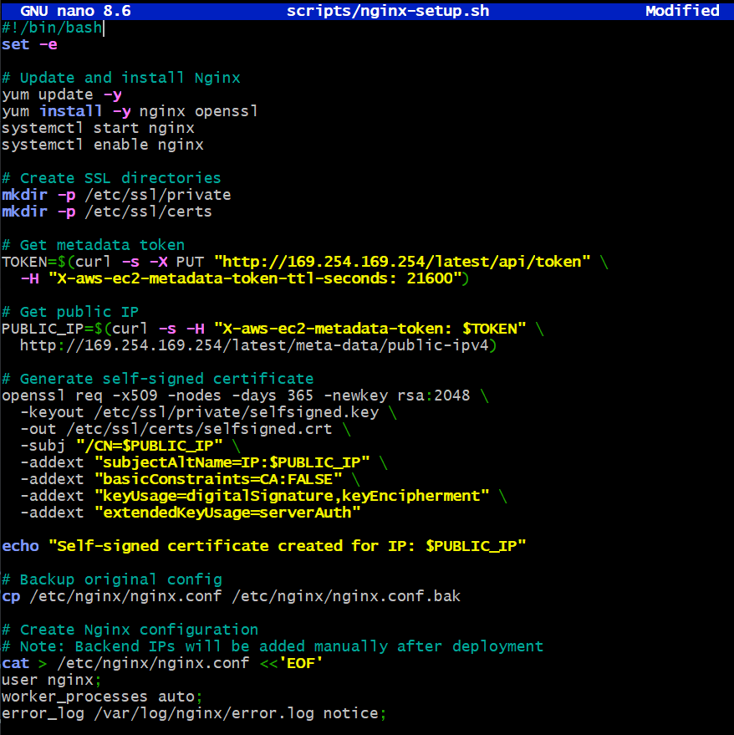
- Part 4: Infrastructure Deployment
- 4.1 Initial Deployment
Deploy the infrastructure using Terraform.
- Generate SSH key pair if not exists
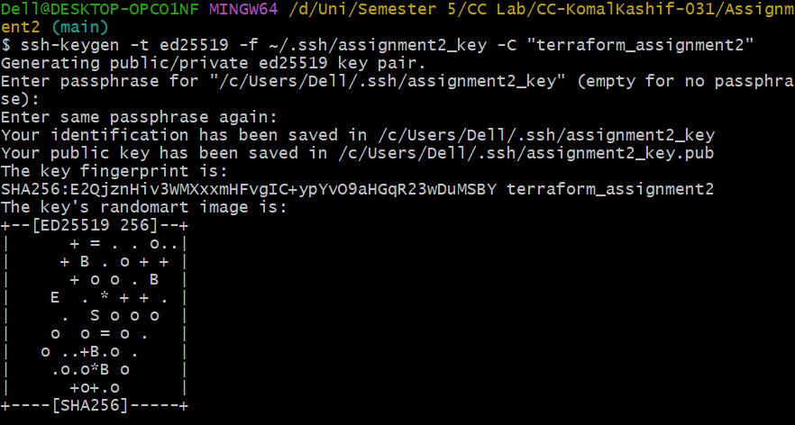
- Initialize Terraform
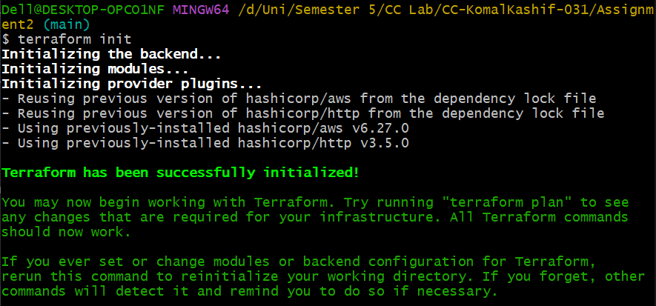
- Validate configuration
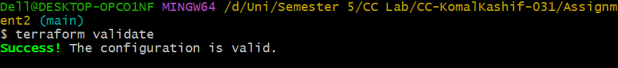
- Plan deployment
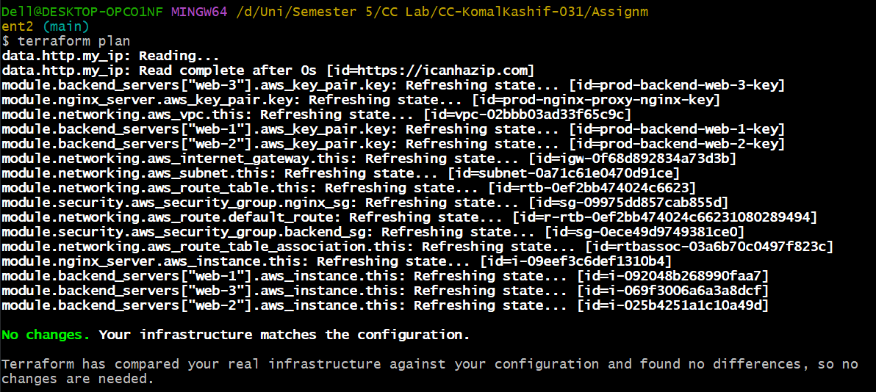
- Apply configuration
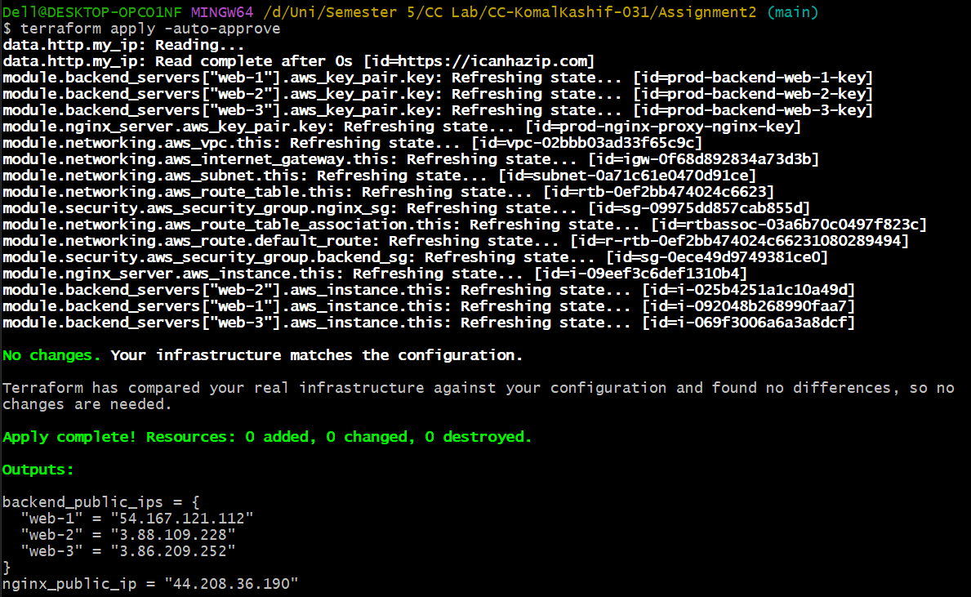

- 4.2 Output Configuration
Create comprehensive outputs in outputs.tf:
# ========================================
# Networking Outputs
# ========================================

output "vpc_id" {
description = "VPC ID"
value = module.networking.vpc_id
}

output "subnet_id" {
description = "Subnet ID"
value = module.networking.subnet_id
}

# ========================================
# Nginx Server Outputs
# ========================================

output "nginx_server_ip" {
description = "Nginx server public IP"
value = module.nginx_server.public_ip
}

output "nginx_server_instance_id" {
description = "Nginx server instance ID"
value = module.nginx_server.instance_id
}

# ========================================
# Backend Server Outputs
# ========================================

output "backend_servers_info" {
description = "Backend servers information"
value = {
for name, server in module.backend_servers : name => {
instance_id = server.instance_id
public_ip = server.public_ip
private_ip = server.private_ip
}
}
}
# ========================================
# Quick Configuration Guide
# ========================================

output "configuration_guide" {
value = <<-EOT

========================================
DEPLOYMENT SUCCESSFUL!
========================================

Next Steps:
1. SSH into Nginx server: ssh ec2-user@${module.nginx_server.public_ip}
2. Edit Nginx config: sudo vim /etc/nginx/nginx.conf
3. Update backend IPs in upstream block:
- BACKEND_IP_1: ${module.backend_servers["web-1"].private_ip}
- BACKEND_IP_2: ${module.backend_servers["web-2"].private_ip}
- BACKEND_IP_3: ${module.backend_servers["web-3"].private_ip}
4. Restart Nginx: sudo systemctl restart nginx
5. Test: https://${module.nginx_server.public_ip}

Backend Servers:
${join("\n ", [for name, server in module.backend_servers : "- ${name}: ${server.public_ip} (private: ${>

========================================
EOT
}

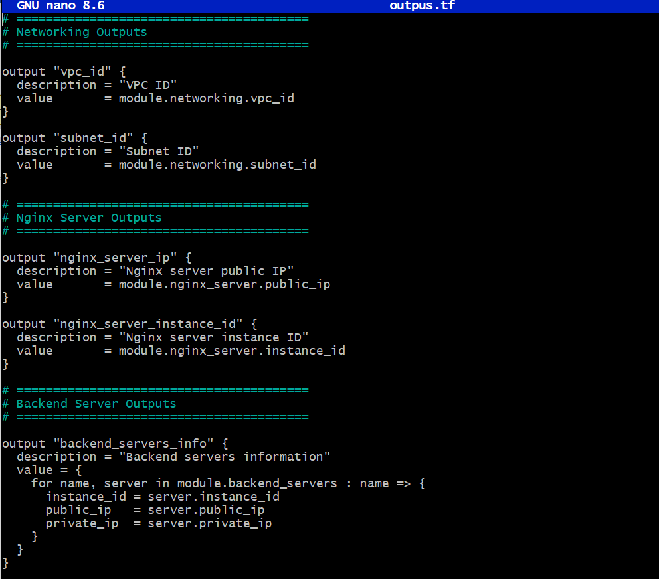

Display outputs after apply:
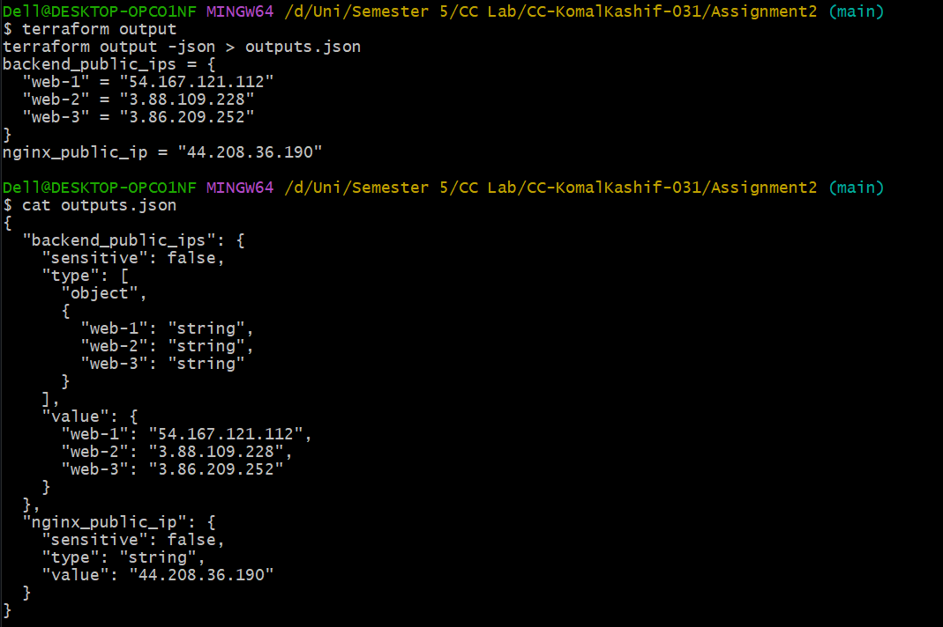

- 4.3 AWS Console Verification
Verify all resources in AWS Console.

VPC Console:

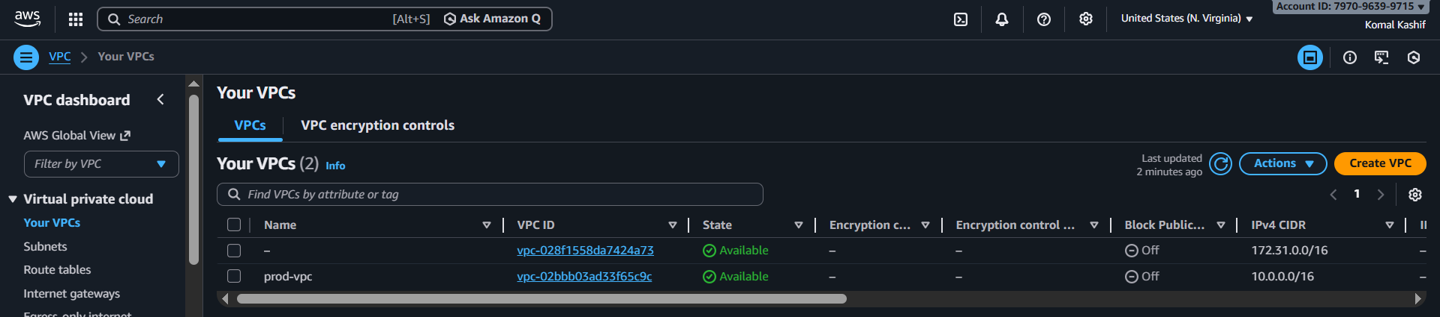
Subnets:
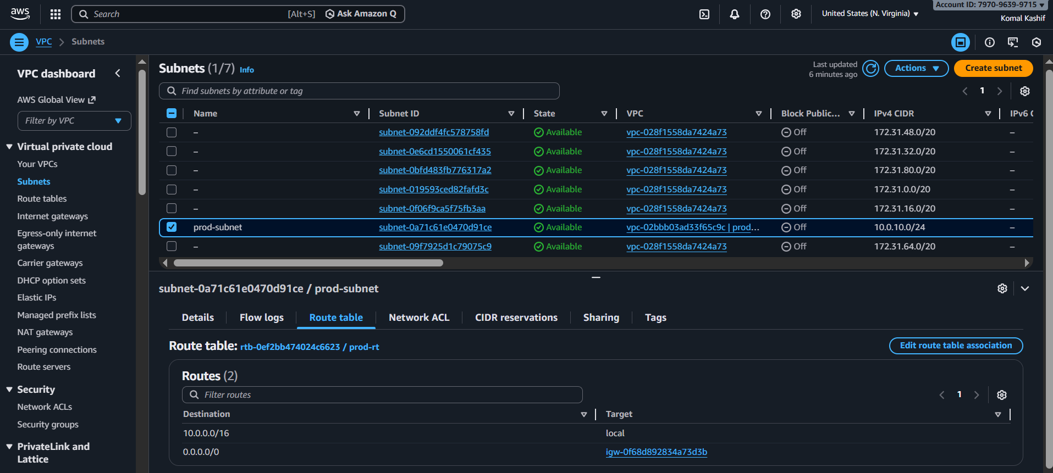
Security Groups:
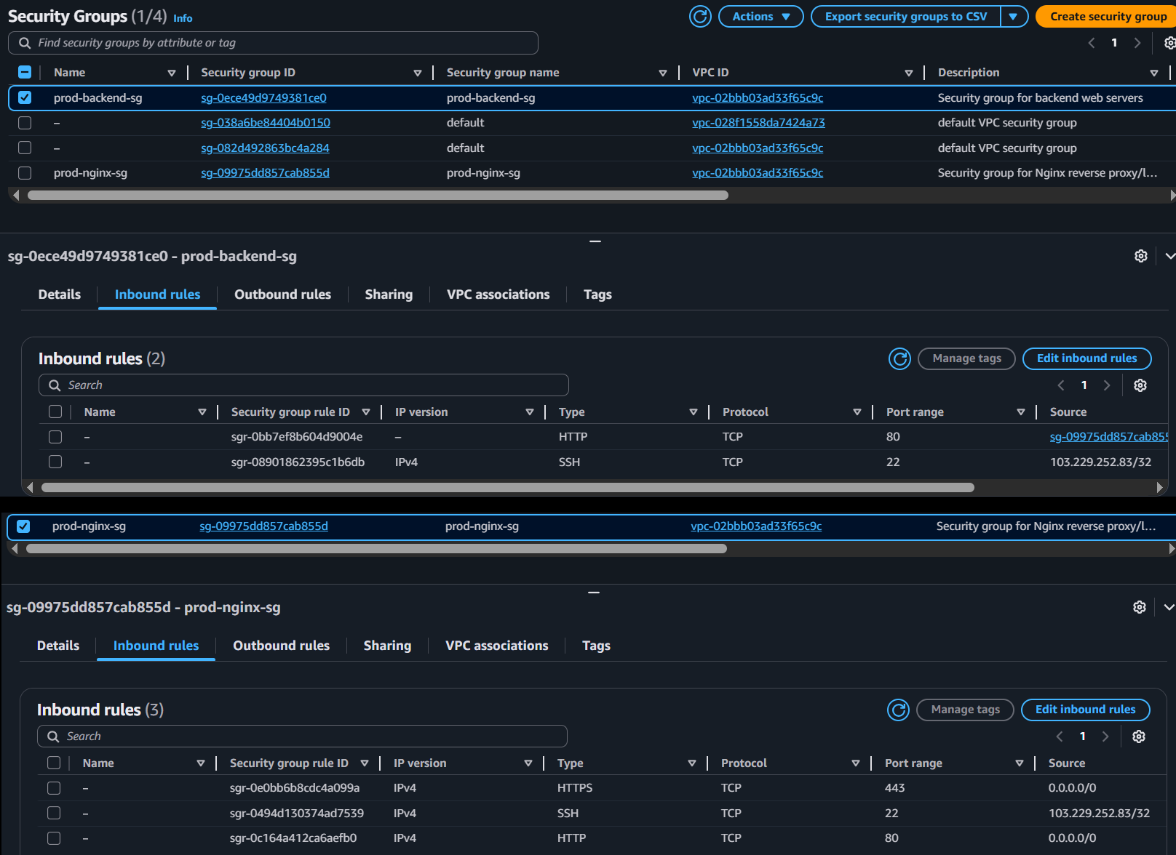

Instances:
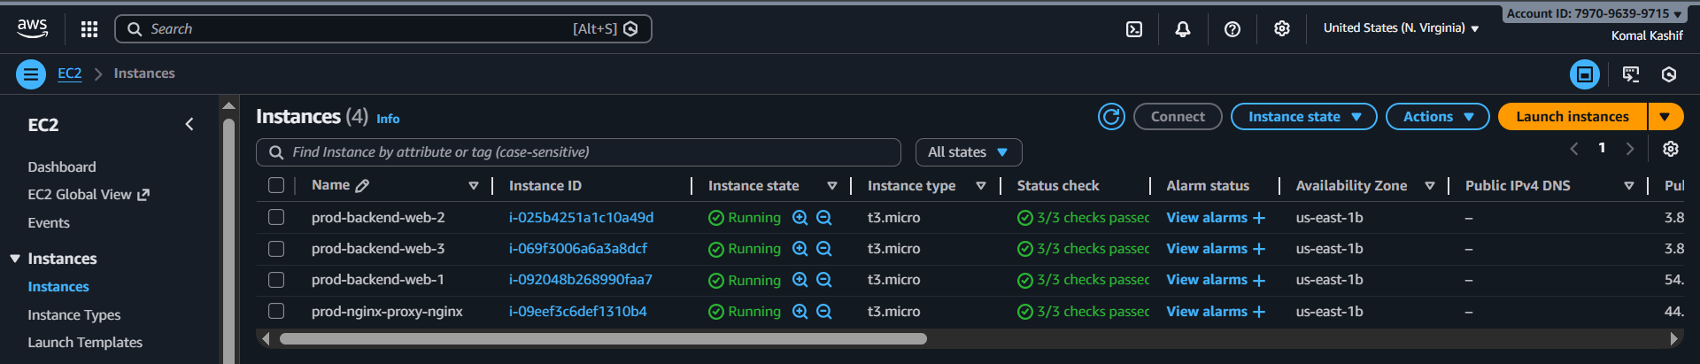

- Part 5: Nginx Configuration & Testing
- 5.1 Update Nginx Backend Configuration
SSH into the Nginx server and update the configuration with actual backend IPs.
- SSH into Nginx server
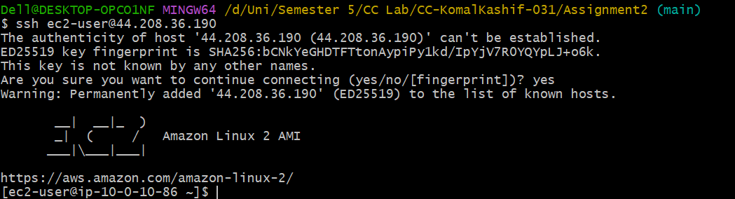
- Edit /etc/nginx/nginx.conf
- Replace placeholder IPs with actual private IPs of backend servers
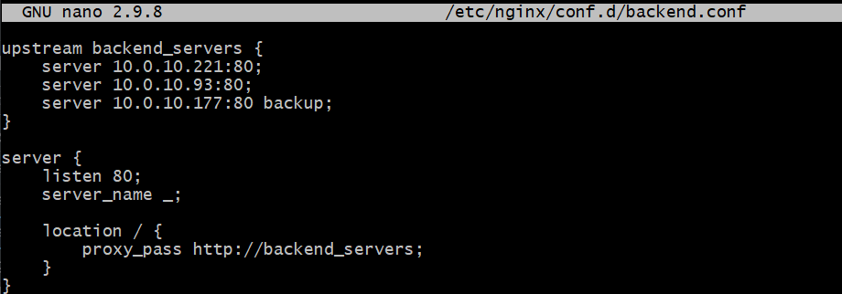
- Test Nginx configuration
- Restart Nginx service
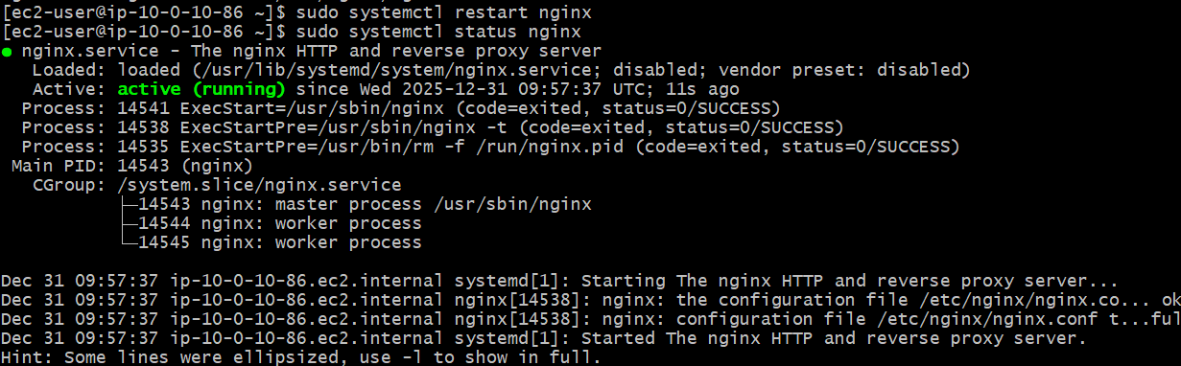

- 2.2 Test Load Balancing
Test that Nginx is properly load balancing between web-1 and web-2.
- Open browser to https://<nginx-public-ip>
First replace the content in backend.conf with:
server {
listen 443 ssl;
server_name _;

ssl_certificate /etc/nginx/ssl/nginx.crt;
ssl_certificate_key /etc/nginx/ssl/nginx.key;

location / {
proxy_pass http://backend_servers;
}
}


- Reload page multiple times (at least 10 times). Verify traffic alternates between web-1 and web-2
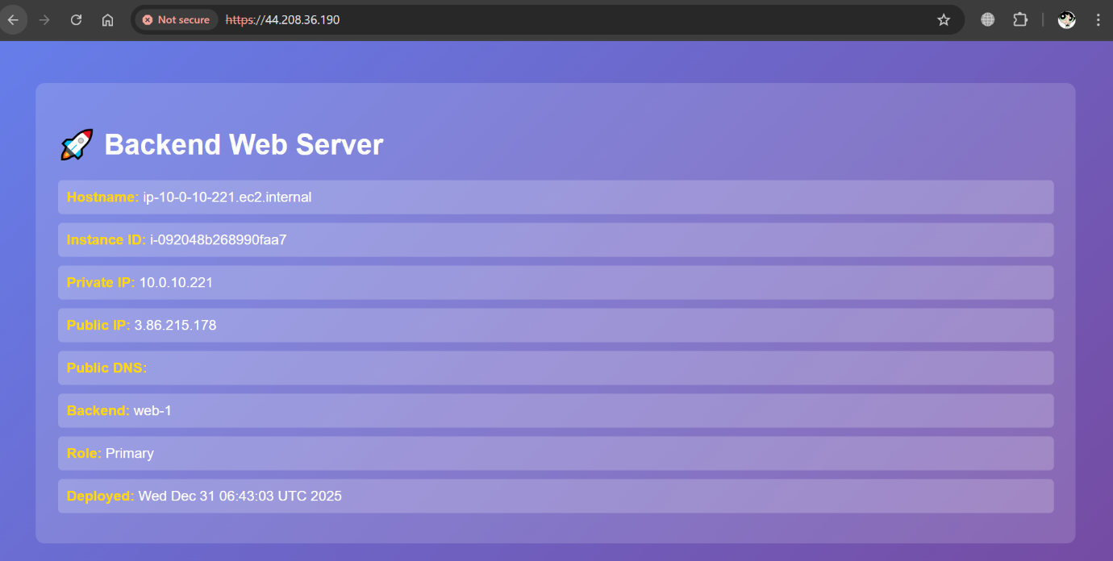
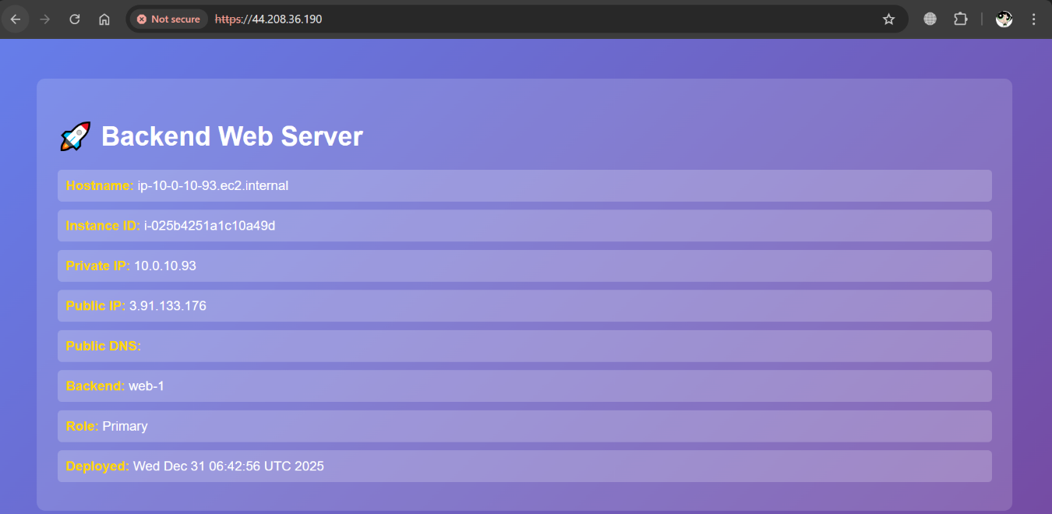
- Verify web-3 is NOT serving traffic (it's backup only)
As there are only two alternations in the webpage, hence web-3 is only backup.
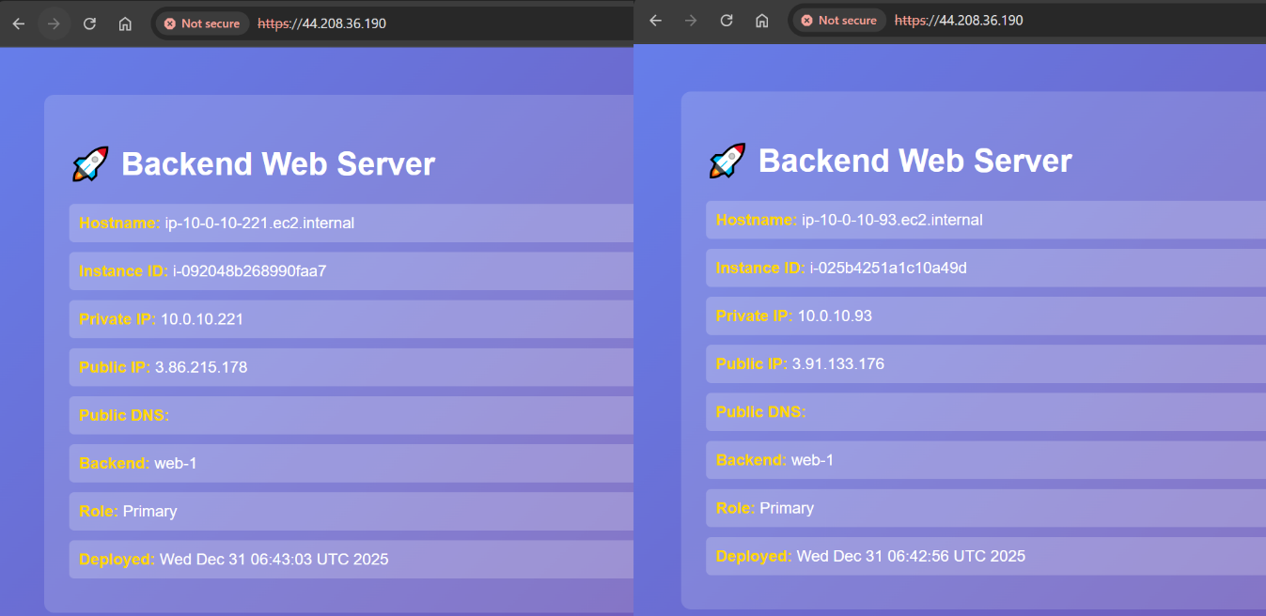

- 5.3 Test Cache Functionality
Verify that Nginx caching is working correctly.
First update the nano /etc/nginx/conf.d/backend.conf with:

location / {
proxy_pass http://backend_servers;

proxy_cache my_cache;
proxy_cache_valid 200 10m;
proxy_cache_use_stale error timeout updating;

add_header X-Cache-Status $upstream_cache_status;

}
}

- Open browser developer tools (F12). Navigate to Network tab. Clear browser cache. Load https://<nginx-public-ip>
- Check response headers for X-Cache-Status: MISS (first request)
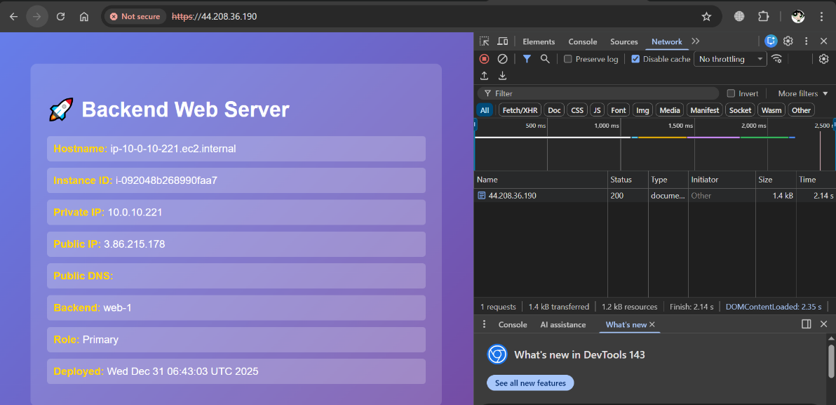
- Check response headers for X-Cache-Status: HIT (cached request)
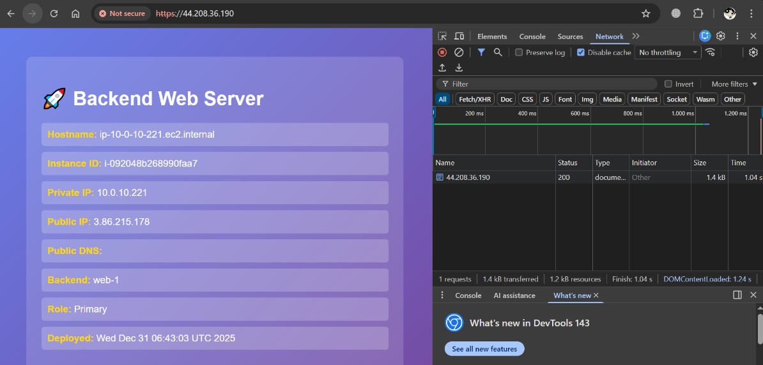
- Verify cache directory on Nginx server
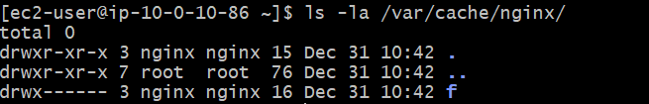
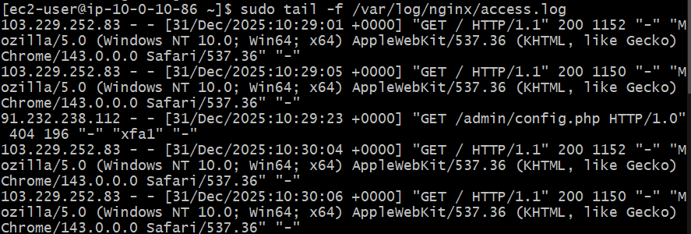
- 5.4 Test High Availability (Backup Server)
Test the backup server functionality by simulating primary server failure.
After services are stopped from web-1 and web-2, ssh nginx:
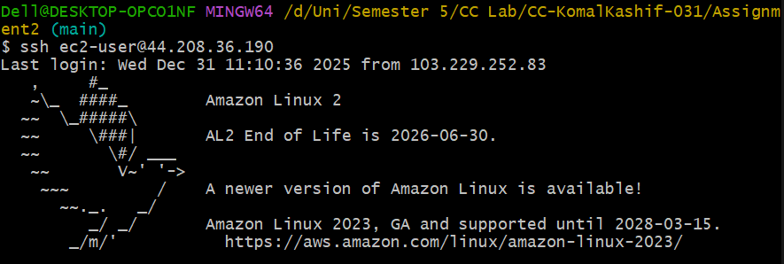
sudo tail -f /var/log/nginx/error.log
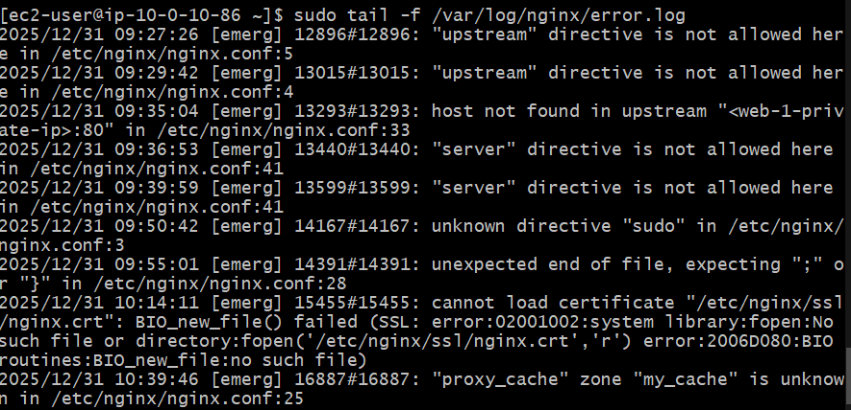
Now activation web-3 which is backup server:
sudo systemctl start httpd
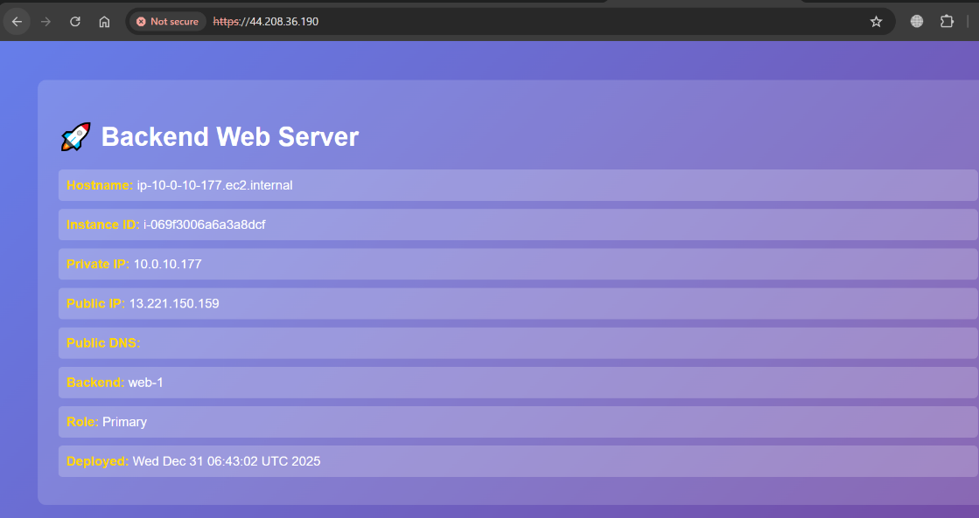
The services are now working on 10.0.10.177 which is backup server.
- 5.5 Security & Performance Analysis
Analyze the security headers and performance of your Nginx setup.
Tasks:
- Check SSL/TLS certificate details
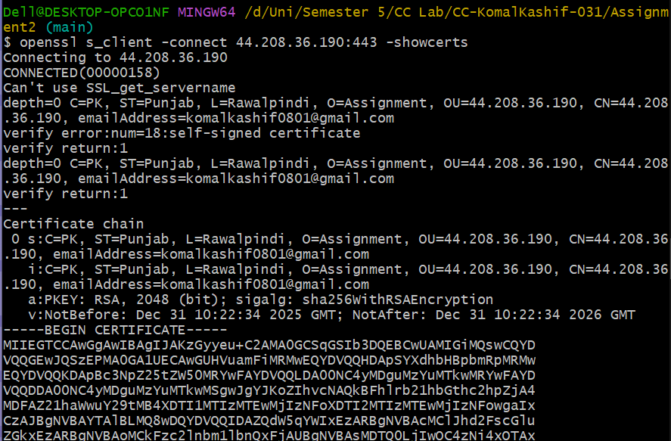
- Verify security headers in response
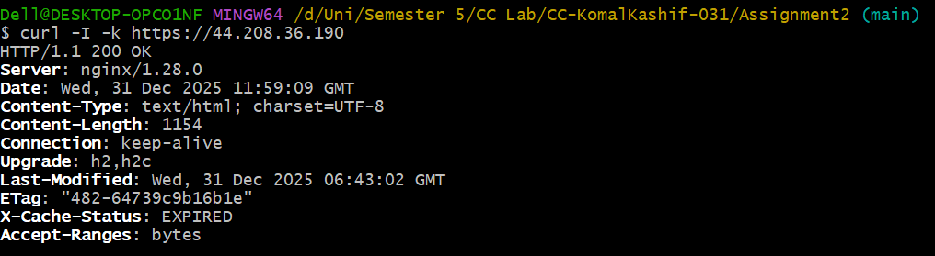
- Test HTTP to HTTPS redirect
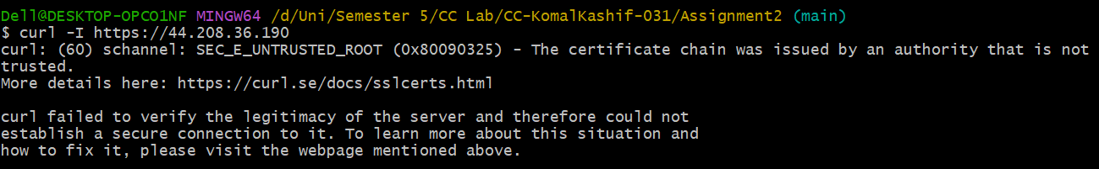
- Analyze Nginx logs
Error Log:
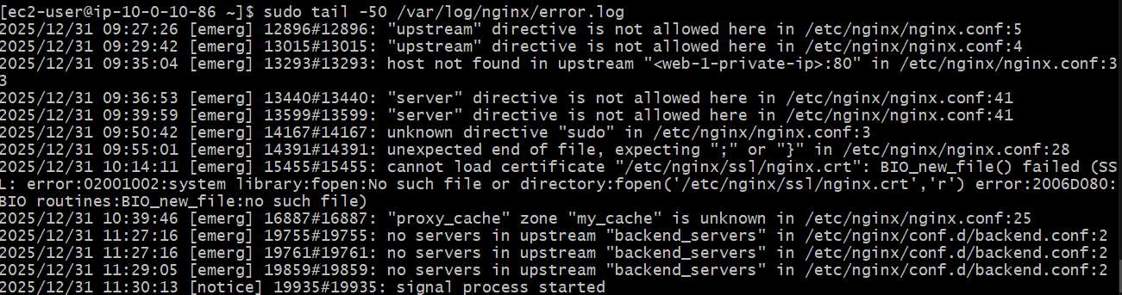
Access Log:
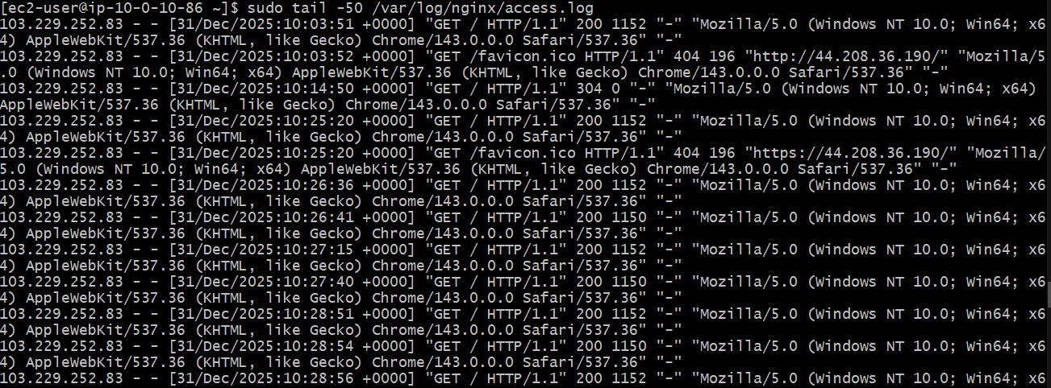
Processes running in nginx:
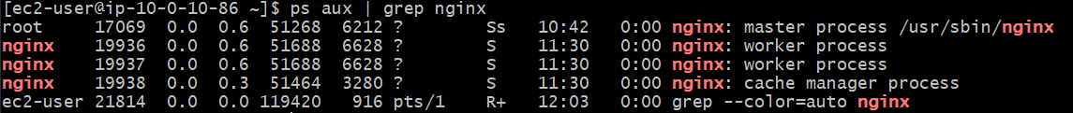

- Part 6: Documentation and Cleanup:
- 6.2. Infrastructure cleanup
Properly destroy all resources and verify cleanup.
terraform destroy
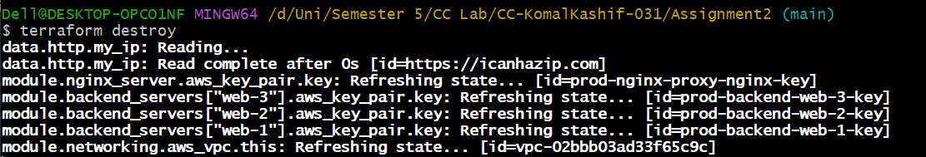
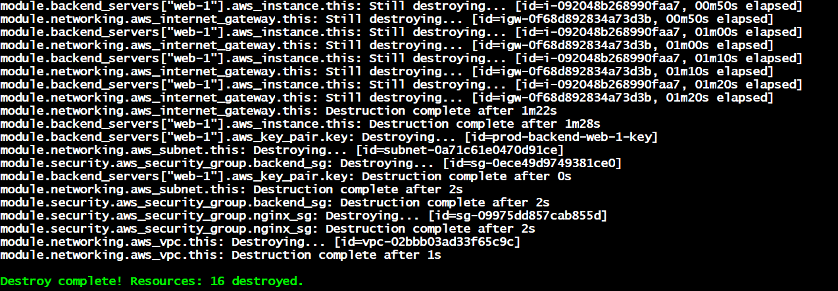
cat terraform.tfstate
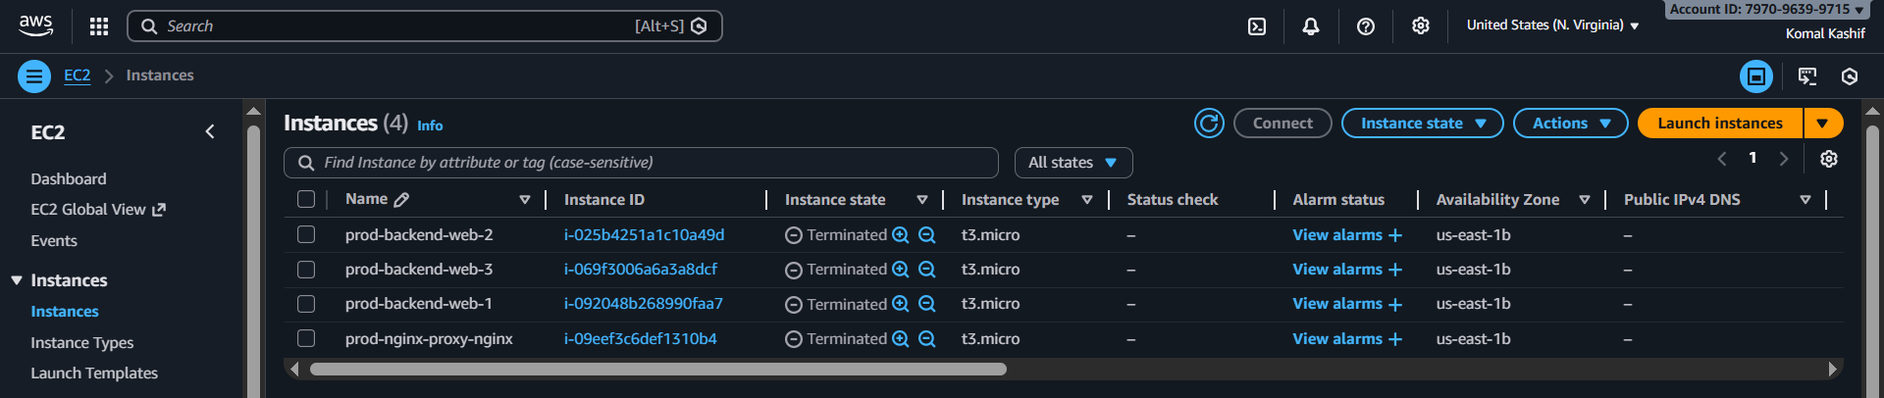
The instances are still visible on the Console but are Terminated which means they are not operable and hence destroyed.

aws ec2 describe-instances --filters "Name=tag:Project,Values=Assignment-2" --query "Reservations[]. Instances[].InstanceId"
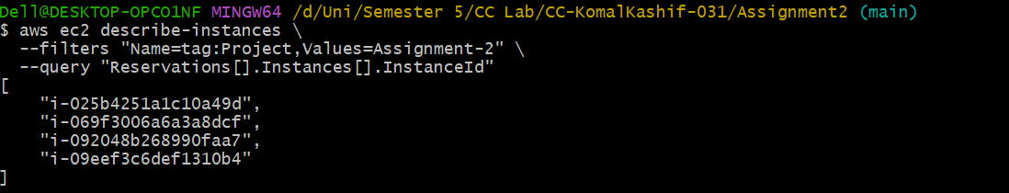
These are the instance ids of the instances from above. As they are destroyed but still in the console, their ids are here.
4) Testing Results
- 4.1 Load Balancing Tests
The load balancing functionality was tested by repeatedly refreshing the application URL accessed through the Nginx server. Each backend server displays unique system information, allowing easy identification of which server handled the request.
Results confirmed that traffic alternated between web-1 and web-2, while web-3 remained inactive under normal conditions, validating the correct implementation of the load balancing strategy.
- 4.2 Cache Performance Tests
Nginx caching was tested using browser developer tools. The first request returned X-Cache-Status: MISS, while subsequent requests returned HIT, confirming effective caching behavior.
This significantly reduced backend load and improved response times.
- 4.3 High Availability Tests
To test failover:
- Apache services on web-1 and web-2 were stopped
- Nginx logs were monitored
- Traffic was successfully routed to web-3
This validated the backup server configuration.
- 4.4 Security Tests
- HTTPS encryption verified using browser certificate inspection
- HTTP requests redirected to HTTPS
- Security headers confirmed in response headers
- Backend servers inaccessible directly from the internet
- 4.5 Performance Metrics
- Reduced latency due to caching
- Stable response times under load
- Efficient traffic distribution

5) Challenges & Solutions
Challenges Encountered
- Managing dynamic backend IPs
- Nginx SSL configuration
- Terraform module dependencies
- Security group misconfigurations
Solutions
- Used Terraform outputs for backend IP mapping
- Implemented self-signed certificates
- Modularized Terraform code
- Applied least-privilege security rules
Lessons Learned
- Importance of modular Infrastructure as Code
- Real-world Nginx troubleshooting
- Security-first cloud design principles

6) Conclusion
This assignment successfully demonstrated the deployment of a secure, automated, and highly available web infrastructure using AWS, Terraform, and Nginx.
Summary of Work Completed
- Automated infrastructure provisioning
- Configured secure load balancing
- Implemented caching and failover
- Verified performance and security
Skills Acquired
- Terraform module design
- AWS networking and security
- Nginx reverse proxy configuration
- Cloud troubleshooting and testing
Future Improvements
- Auto-scaling groups
- Managed load balancer (ALB)
- CI/CD integration
- Monitoring with CloudWatch

