Komal Khan
CST- 315 (Operating System)
Dr. Citro
February 1, 2026
Assignment 1- Producer and Consumer
Description:
Program demonstrates the Producer and Consumer problem in C language by using pthread library. Multiple producer threads generate data item and place them into a shared buffer of sized which is fixed and consumers remove those threads to process them.
Problem:
The problem is how to safely share a limited buffer between multiple producers and consumer threads without the data corruption. Producers might not add items when the buffer is full and the consumer must not remove items when the buffer is empty. Without this coordination race conditions can happen which lead to system crash.
Solution:
A shared buffer is used, it tracks how many item have been produced and also how many have been consumed. One thread at a time modifies the shared buffer and counter. Producers wait when buffer is full and the consumer wait when the buffer is empty. It also uses sleep intervals to reduce the usage of the CPU.
Code:
The buffer is used circularly meaning that the index is calculated using modulo arithmetic. Consumer items are removed in the same order that they were produced in. Mutex provides synchronization so that race condition does not occur.
Screenshot:
The output shows 5 producer threads each producing an item and placing it into different buffer slots which fill up the buffer completely. Then after that 5 consumer threads remove so it makes the buffer count 0. It ensures the items are produced and consumed in correct order.
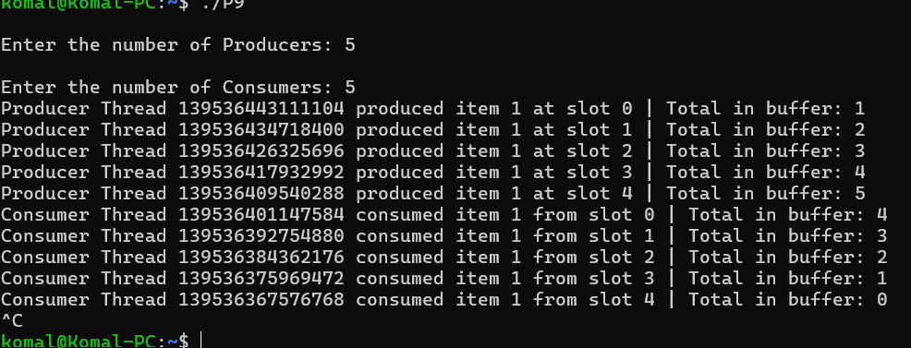

References:

https://github.com/KomalKhan776/CST-315-A1

