Project -4
Virtual Memory Manager
Komal Khan
CST – 315 Operating Systems
Dr. Citro
March 22, 2026

Description:
This project implements a VMM as a component of LopeShell from Project 2. Shell supports basic commands like ls, cd, pwd and background process execution (batch mode). Now the shell is extended in this project, VMM simulates how a real OS manages memory from multiple processes. Each process is given a virtual address that is larger than the physical memory. Demand paging is used to load pages, FIFO replacement is also used to evict old pages when the physical memory is full. VMM built in commands makes shell accessible.
Methodology:
Physical memory is divided into 16 frames with 4096 for each byte. Processes are assigned a virtual address space which is then divided into virtual pages. Global frames keep track of frames which are free or are currently occupied. Dirty bit shows if the page has been modified since it was uploaded. VMM first checks is the page is valid or not, if the page is not in RAM a page fault is triggered and page is loaded from data buffer or swap file. Swap file is created using I/O system call. FIFO algorithms select old loaded frame and evicts it.
Algorithm:
Page replacement algorithm is used in this scenario, FIFO (first in first out – queue). So basically, in FIFO if a page had been in the physical memory the longest is always selected first for eviction when a new page needs to be loaded and there are no free frames available at that time. Queue of frame indices is used. If the frame index is pushed back of queue the frame at the front queue is popped and after eviction it is re-pushed. FIFO is easy to implement and also there is no need for any other tracking for access time or reference bits.
When a process accesses a virtual address, the page number is calculated by dividing the virtual address by the page size and the offset is calculated using the remainder. Also the page table is checked for that page number. If the valid bit is true the physical address is computed as frame number multiplied by page size plus offset and the memory access completes. If the valid bit is false a page fault occurs.
Segmentation faults and page faults:
Page fault occurs when a process tries to access virtual address whose page is not currently loaded in physical memory. In this implementation, every page starts with its valid bit set to false. The first time a process reads or writes any address within a page, the VMM detects that valid is false and calls the page Fault function. This function increments the page fault counter, finds or evicts a frame, then copies the page data into that frame, and updates the page table entry to mark the page as valid. This is known as demand paging because pages are only loaded on demand when they are actually needed rather than all at once when the process starts.
Code snippets:

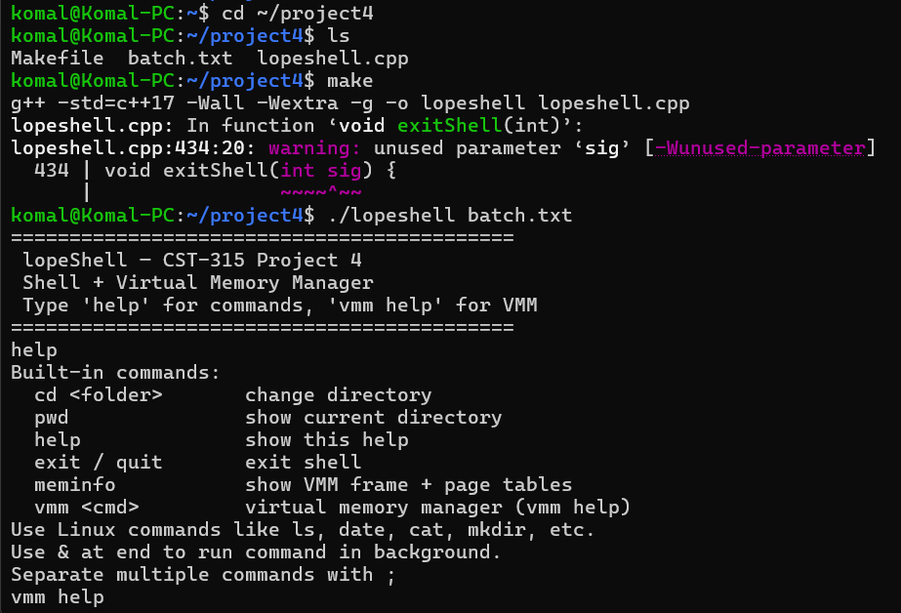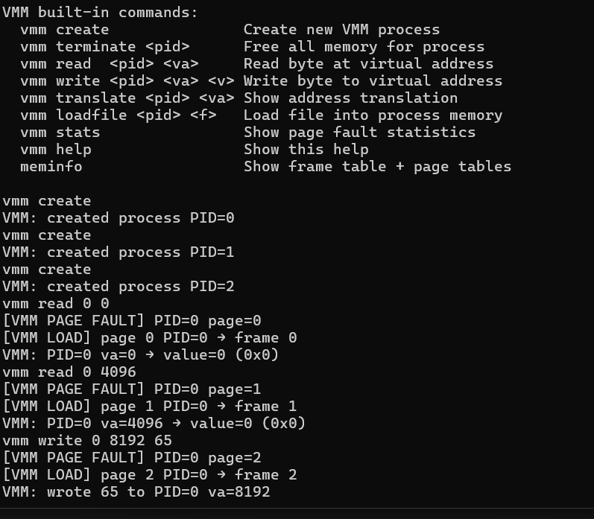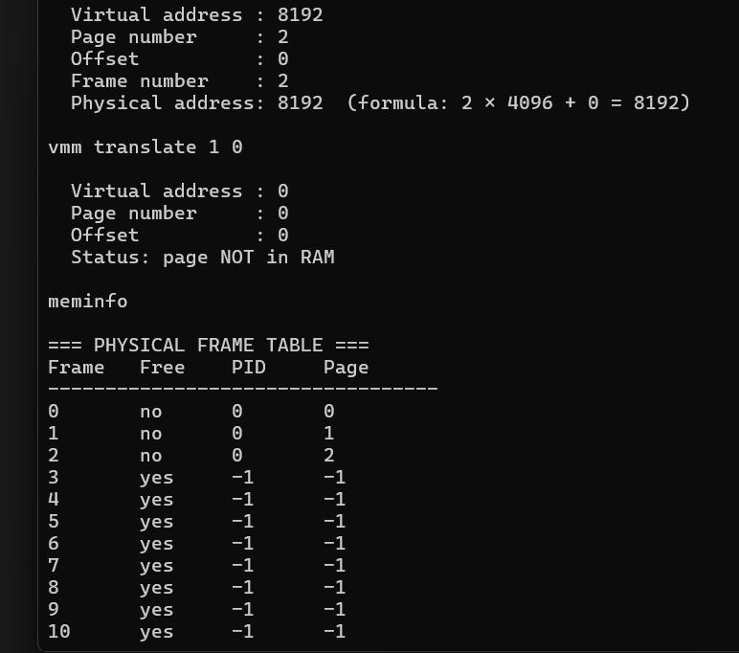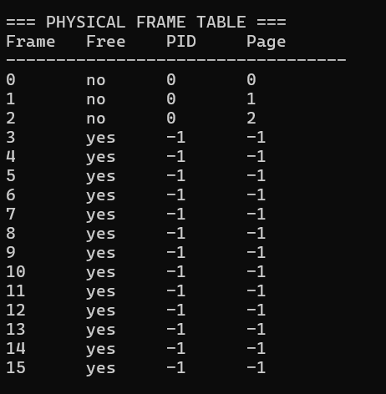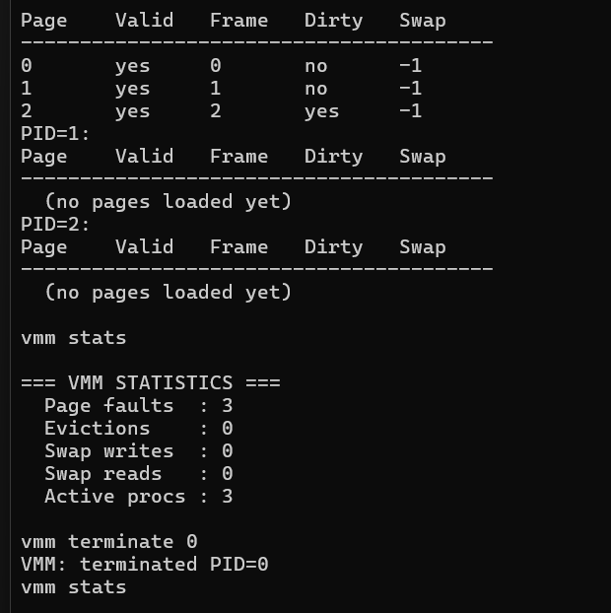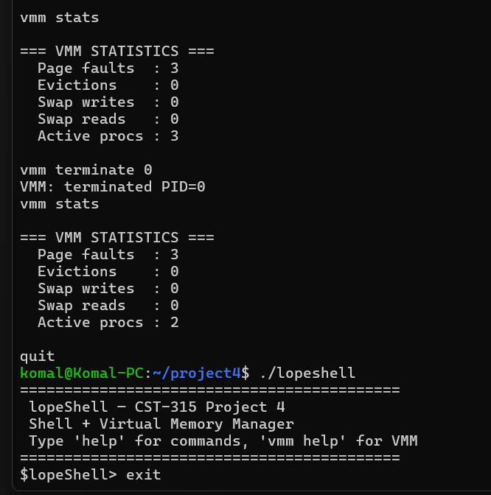

Github link:
https://github.com/KomalKhan776/CST-315-P4

References:
https://stackoverflow.com/questions/6950549/segmentation-fault-vs-page-fault
https://pages.cs.wisc.edu/~remzi/OSTEP/vm-segmentation.pdf
https://www.scaler.com/topics/fifo-page-replacement-algorithm/
https://workat.tech/core-cs/tutorial/page-replacement-algorithms-in-operating-system-os-q0pioxh7iym5

