Komal Khan
CST-315 Operating Systems
Dr Citro
April 12, 2026
Project 6: File System Manager
Description:
In this project a Linux shell is implemented by file system manager. The system basically allows user to create, delete, and navigate directories, as well as create and remove files. The shell has basic Linux commands such as mkdir, cd, ls, touch, rm, and rmdir. Moreover, it also uses an internal hierarchical structure to manage directories and files. It allows user to interact with a simulated file system through command line operations. Any operation performed by the user will update any internal structure currently present in shell, which also reflects the current state of file system.
Methodology:
The file system implemented here uses a tree structure. So that each directory contains subdirectories and files. The shell then keeps track of current working directory and updates it whenever user navigates it using cd. All operations modify the internal structure directly. So when the user enters a command the input is parsed into tokens which means that the command is identified. Then the function is executed and it updates the internal structure.
Commands to run:
mkdir <dir> - Create a directory
ls - List contents
cd <dir> - Change directory
cd .. - Move to parent
touch <file> - Create file
rm <file> - Delete file
rmdir <dir> - Remove empty directory
pwd - Show current path
help - Show commands
exit - Exit shell
Assumptions:
Each directory has unique names for files and subdirectories which means that any duplicate file name is not allowed in the same directory. The system is simulated and does not affect any real OS files. Only the empty directories can be deleted, or the directories must be cleared before performing rmdir command. Lastly, all the commands must follow exact syntax otherwise it will not run and show an error.
Description of Commands:
- Create and rename directories.
Directory is added to a node in a tree structure. Mkdir is used to create new directories in the current working directory. The names of the directory are unique so that there are no conflicts within the same parent directory.
Directory* newdir = new directory{name, current, {}, {}}
- Delete directories, with special handling of non-empty directories (e.g., special flag to delete command).
Rmdir command is used to delete the directory only if there are no files inside it.
To ensure there is no accidental loss of data the directory must be empty. If there is a file the directory it will show an error message.

If(!dir- >files.empty() || !dir- >subdirs.empty())cout <,”directory not empty”;

- Create, rename, edit, and delete files.
Touch command is used to create files. The files are then stored in the current working directory. If user wants to rename a file then it must be updated in the tree structure also. Deletion of files is done with rm command which will remove the directory and its internal file system.

File* newfile = newfile{name};

- When a file is created, a special flag will indicate the amount of data (bytes) to (randomly) generate for it (in order to eliminate the need to open and edit each file).
A special flag like -b could be used to generate a specified number of bytes of data automatically. It means that there is no need for manual editing. Size of the file is stored and recorded internally.

File- >size = bytes;

- Move files across directories.
Files can be moved from one directory to another with the help of move operation. So then a file can be removed from current directory and put into the target directory. Path of the file is updated accordingly to display the new location in the tree structure.

Destdir- >files.push_back(file);

- Duplicate files.
The system supports duplicating files by creating a copy of an existing file. Then the duplicate file retains same content and size but it is assigned new name and stored as a separate entity.

File* copy = new file{original- >name};

- Duplicate directories.
Directories can be duplicated by recursively copying all of its contents which include files and subdirectories. This creates a new directory with the same internal structure as the original. Each element copied is treated as a new object within the file system.

Newdir- >subdirs.push_back(copysubdir);

- Search for a file in a directory tree.
The system allow user to search for file starting from a specified directory. This is implemented using recursive traversal of the directory tree. If the file is found its full path is displayed to the user.

Findfilerecursive(current, filename);

- Display a directory tree given a starting node.
Structure of the directory is displayed using a tree command, which prints all directories and files starting from a given node. Indentation is used to represent hierarchy levels which makes it easy to visualize the structure of the file system.

Printtree(current, 0);

- Get basic information about a file.
Basic file information can be retrieved using a command like stat. It includes file name, location and size. This helps user to quickly understand file properties without any detailed metadata.

Cout << file- >name;

- Get detailed information about a file (e.g., using a special flag).
Detailed file information can be accessed using a special flag like -1. This includes additional metadata such as file ID, creation time, last modification time and content size. This provides a deeper understanding of the attributes of a file.

Cout << file- >createdat;

- Get basic information about a directory.
Users can retrieve basic information about a directory including its name, path, number of files and subdirectories it contains. This gives a quick overview of directory contents.

Cout << dir- >subdirs.size();

- Get detailed information about a directory (e.g., using a flag)
With a special flag, users can view detailed directory information such as creation time, last modification time, parent directory, and full structure details. This provides a comprehensive view of the directory’s properties and relationships.

Cout << dir- >createdAt;
Testing:
Tested using sequences of commands such as mkdir, cd, touch, ls, rm, and rmdir. The output matches expected behavior of the Linux shell. The output shows directories and file names that were created. Navigation between directories. Files are deleted using rm. Directories are only removed once they are empty.
Diagram (tree structure):
Root directory contains run1, run2, run3. Each directory maintains a reference to its parent, subdirectories and files (path is traceable back to the root).

Code snippets:
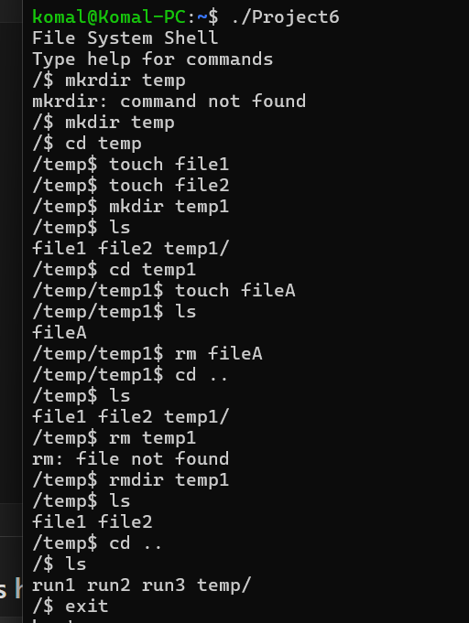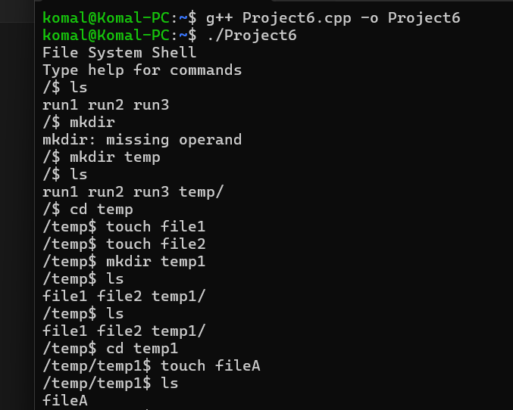

Github link:
https://github.com/KomalKhan776/CST-315-P6

References:
https://docs.redhat.com/en/documentation/red_hat_enterprise_linux/6/html/storage_administration_guide/ch-filesystem
https://www.scaler.com/topics/file-management-in-operating-system/
https://www.cs.uic.edu/~jbell/CourseNotes/OperatingSystems/12_FileSystemImplementation.html
https://www.ibm.com/docs/en/aix/7.3.0?topic=tree-file-system-structure

