**SOFTWARE REQUIREMENT SPECIFICATION DOCUMENT**

**FURIOUS CODERS**

**Komal Kumra- 1511981135**

**Arjun Sharma- 1511981057**

**CONTENTS:**

1. INTRODUCTION

* PROBLEM STATEMENT
* OBJECTIVE
* SCOPE
* ADVANTAGES AND DISSADVANTAGES

1. ARCHITECTURE DSIGN
2. DATABASE DESIGN
3. DFD
4. SECURITY REQUIREMENTS

**INTRODUCTION:**

**PROBLEM STATEMENT:**

* In the future, the world's population is expected to peak, after which it will decline due to economic reasons, health concerns, land exhaustion and environmental hazards .There are many examples where big population is considered an undesirable phenomenon for developing nations. Such as traffic, road blockage, long banking queues etc .This ensures that the daily.

**OBJECTIVE:**

The main objectives that our paramount application is meant to be conquered are as follows:

1. In highly populated countries, roads get blocked by traffic in very common situations. And, this problem turns very bad for cab availing apps. So our application helps in finding out best available path.
2. It is not seldom to see long queues of people waiting outside the banks for their turns. In order to automate these banking transactions, our application consists a sub-application to provide online platform for transactions between people.
3. The most popular thing that common people look for is where they can get their wished products at reasonable rates. To provide this facility, our application involves a sub-application that displays the different comparing rates of input product.

**SCOPE:**

* This application named ‘Paramount’ contains further 3 sub-applications optimum, banking and economy respectively. These 3 sub-applications are meant to provide road traffic solutions, online platform for transactions and to display best affordable prices of products.
* The main triggering application ‘Paramount’ can be easily accessed and doesn’t require any credentials. Paramount provides service sub-applications which would require login/signup credentials because of building connection to existing services.

**ADVANTAGES**

* Login: – User will not need to register/login on main application ‘paramount’ but instead of that he/she has their wish to use which of the sub-application’s service and further login to that sub-application to connect to its database.
* User Interface:- The application provides interface comprising 3 applications and user not need to move to different location to access its features.
* Efficient Services:-The sub-applications are capable of executing their particular operations defined to their designated areas.
* Combination of various services:- Paramount is meant to solve different problems at the same platform .Paramount is the collaboration of path-finding, banking and availing economical-prices.

**ARCHITECTURE DESIGN:**

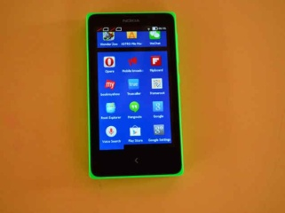

Application of User Interface

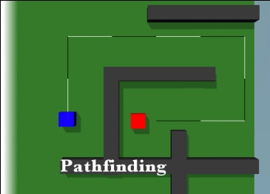

User access the paramount through his mobile phone as an android application.

The above diagram shows the basic architectural design of the User Interface which further goes to access the different sub-application stages.

Various steps in process are:

* Login Account
* User Interface
* Selection Of Sub-application
* Choose query for various services

**DATABASE DESIGN:**

Firebase, Sqlite database using android.

**DFD:**

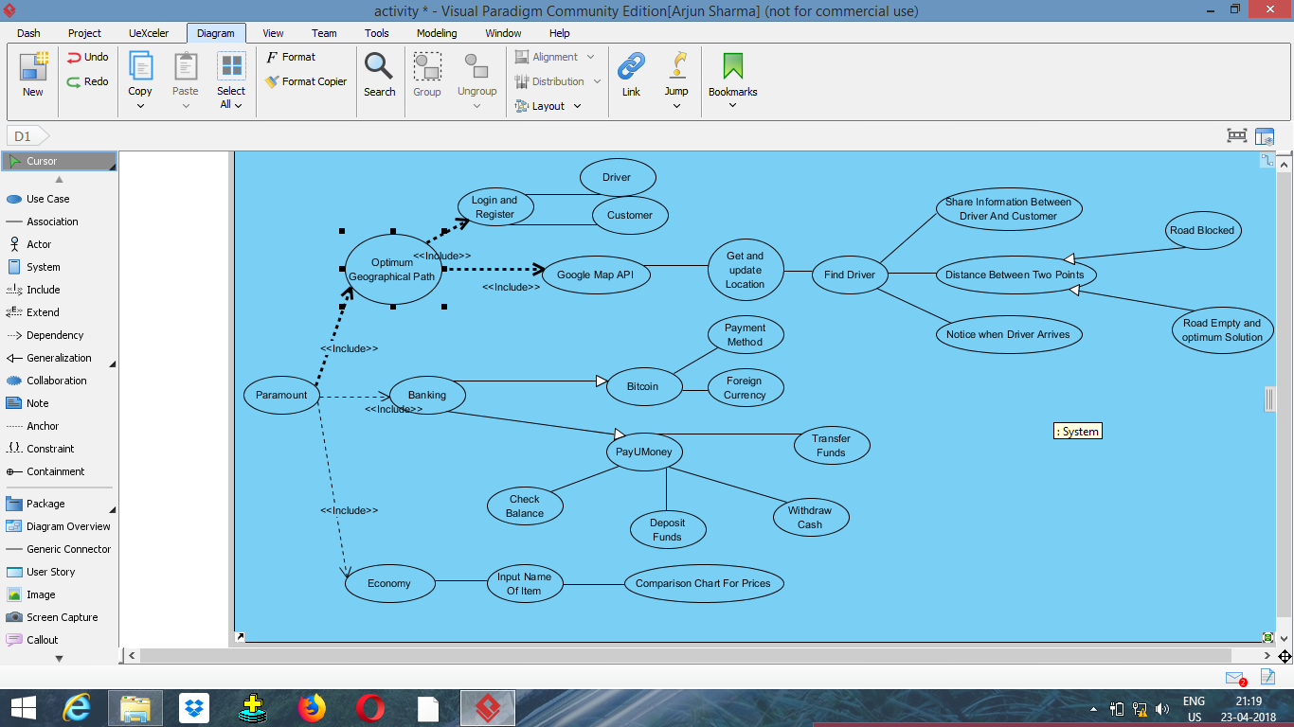

Account Database

Invalid Account

Not allowed to access

Administrator

First Name

Last Name

Email-id

User not recognised

Standard User

Account Database

**User Checks In Interface**

**SECURITY REQUIREMENTS:**

* Security systems need database storage just like many other applications. However, the special requirements of the security access mean that the users who are selected or assumed eligible to have the access to the particular hall must be evaluated carefully so there could not be possibility of any jeopardy in future.