Problem Statement: There can be multiple customers, who can place multiple orders on the site. Now a sales person can handle these orders will distribute into multiple sales persons (One order will be assign to one salesperson only). So a sales person can have multiple orders of multiple customers
- Create Database
create database komaldb;
use komaldb;
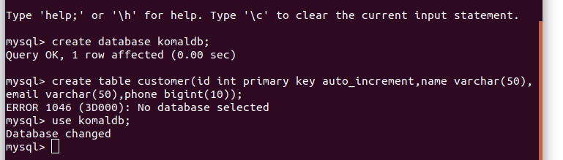
2.Design Schema
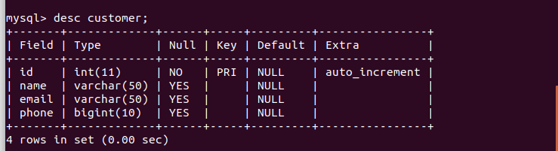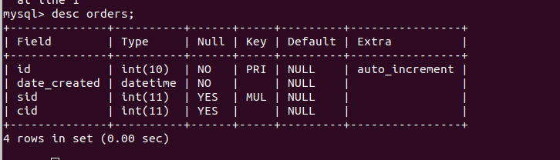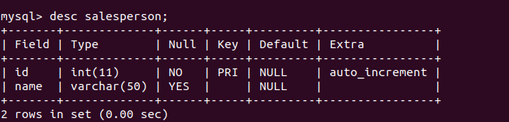
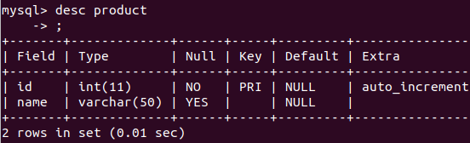
3.Create tables
create table customer(id int primary key auto_increment,name varchar(50),email varchar(50),phone bigint(10));
create table salesperson (id int primary key auto_increment,name varchar(50));
create table product (id int primary key auto_increment,name varchar(50));
create table orders(id int(10) auto_increment primary key,date_created datetime not null,sid int,cid int,foreign key order_salesperson(sid) references salesperson(id),foreign key order_customer(id) references customer(id));
create table orderproduct(id int,pid int,qty int,foreign key orderproduct(id) references product(id));
- Insert sample data
insert into customer(id,name,email,phone) values (1,'rajiv','rajiv@abc.com',1234567890);
insert into customer(id,name,email,phone) values (2,'sanjiv','sanjiv@abc.com',1234567890);

5.Find the sales person have multiple orders.
select count(*),s.name from salesperson s inner join orders o on s.id=o.sid group by s.id having count(*)>1;
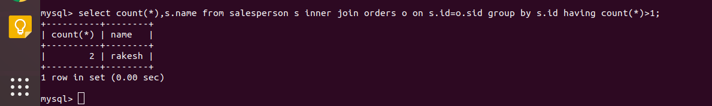6.Find the all sales person details along with order details
select s.*,o.* from salesperson s inner join orders o on s.id=o.sid;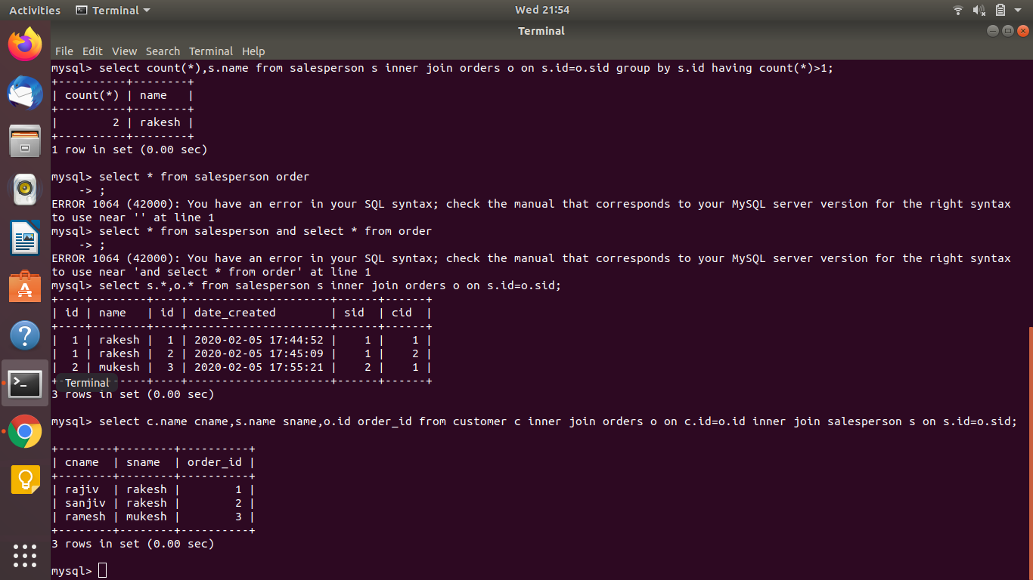7.Create index
create index myindex on customer(email);
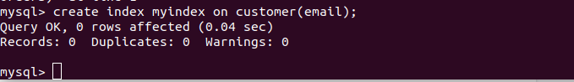
- How to show index on a table
show index from customer;
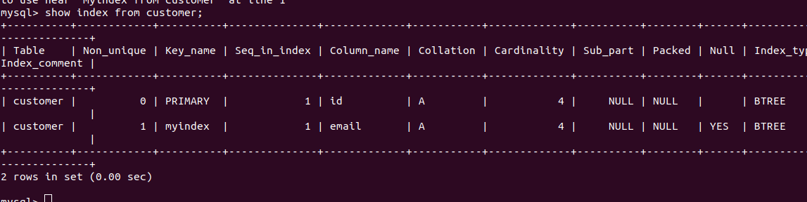99.Find the order number, sale person name, along with the customer to whom that order belongs to
select c.name cname,s.name sname,o.id order_id from customer c inner join orders o on c.id=o.id inner join salesperson s on s.id=o.sid;

