1.How are inline and block elements different from each other?
Block elements:Contains all the space available in their parent.Eg:<p></p>tag
Inline elements:Contains only the space required by the content.Eg><span></span>
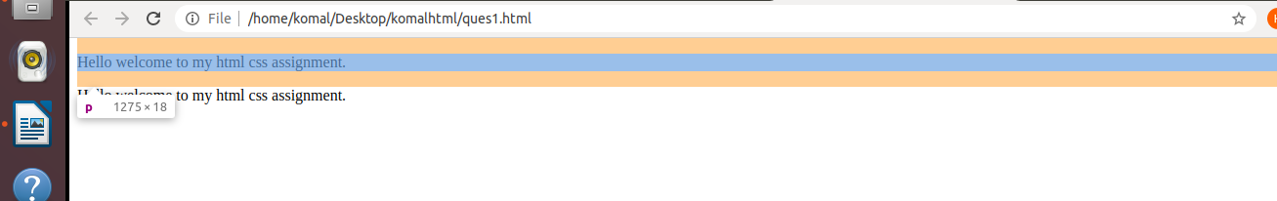
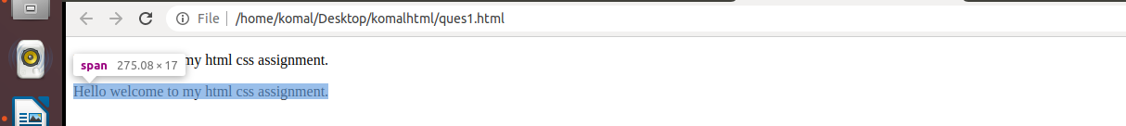
as we can see above the entire parent space is occupied in block element and in inline element only the space required by the text is occupied.
2.Explain the difference between visibility:hidden and display:none
visibility:hidden->it leaves tracking element in the normal flow of the control in the page but element still occupies space on the page.
display:none->it neither tracks the element on the page nor does occupy space on the page and space is given to the other elements on the page.
3. Explain the clear and float properties.
Float:The float property is used for positioning and formatting content e.g. let an image float left to the text in a container.The float property can have one of the following values:
- left - The element floats to the left of its container
- right - The element floats to the right of its container
- none - The element does not float (will be displayed just where it occurs in the text). This is default
- inherit - The element inherits the float value of its parent
Clear:The clear property specifies what elements can float beside the cleared element and on which side.The clear property can have one of the following values:
- none - Allows floating elements on both sides. This is default
- left - No floating elements allowed on the left side
- right- No floating elements allowed on the right side
- both - No floating elements allowed on either the left or the right side
- inherit - The element inherits the clear value of its parent
4. explain difference between absolute, relative,fixed.
Relative:Making an HTML element relative, gives you the privilege to move the element from its current position. It does not refer to a different element’s position.
Absolute: Absolute positioning an HTML element positions the element to its nearest positioned parent. Thus it refers to the nearest parent’s position
Fixed: An HTML element positioned fixed is relative to the viewport and not to any other element.
5. Write the HTML code to create a table in which there are 4 columns( ID , Employee Name, Designation, Department) and at least 6 rows. Also do some styling to it.
<html>
<head></head>
<body>
<table border="1">
<thead>
<th>ID</th>
<th>Employee Name</th>
<th>Designation</th>
<th>Department</th>
</thead>
<tr><td>1</td><td>Ramesh</td><td>Manager</td><td>Administration</td></tr>
<tr><td>2</td><td>Suresh</td><td>Professor</td><td>Science</td></tr>
<tr><td>3</td><td>Mahesh</td><td>Professor</td><td>Arts</td></tr>
<tr><td>4</td><td>Rakesh</td><td>Professor</td><td>Science</td></tr>
<tr><td>5</td><td>Surbhi</td><td>Professor</td><td>English</td></tr>
<tr><td>6</td><td>Surinder</td><td>Professor</td><td>Mathematics</td></tr>
</table>
</body>
</html>
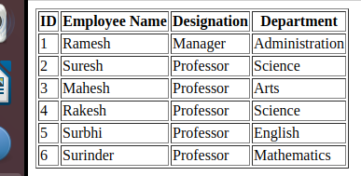

6. Why do we use meta tags?
The meta tag are used to tell the information about data in html page.In HTML 5 the meta tags are used to specify the height and width of the page also.The <meta> tag provides metadata about the HTML document. Metadata will not be displayed on the page, but will be machine parsable.
Meta elements are typically used to specify page description, keywords, author of the document, last modified, and other metadata.
The metadata can be used by browsers (how to display content or reload page), search engines (keywords), or other web services.

7. Explain box model.
The CSS box model is essentially a box that wraps around every HTML element. It consists of: margins, borders, padding, and the actual content.
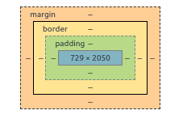
8. What are the different types of CSS Selectors?
CSS selectors are used to select the content you want to style. Selectors are the part of CSS rule set. CSS selectors select HTML elements according to its id, class, type, attribute etc.
There are several different types of selectors in CSS.
- CSS Element Selector
- CSS Id Selector
- CSS Class Selector
- CSS Universal Selector
- CSS Group Selector

9. Define Doctype.
HTML <!DOCTYPE> tag is used to inform the browser about the version of HTML used in the document. It is called as the document type declaration (DTD).Technically <!DOCTYPE > is not a tag/element, it just an instruction to the browser about the document type. It is a null element which does not contain the closing tag, and must not include any content within it.

10. Explain 5 HTML5 semantic tags.
Semantic Tags:These tags are used for special task.They have predefined tasks defined in the browser and they do only their specific task
<header></header>:This is used to define the content that is to be present at the top of the page.
<footer></footer>:This is used to define the content that is to be present at the bottom of the page.
<nav></nav>:This is used to define the navigation bar content on the page.This is used to redirect the control.
<article></article>:This tag is used to write the content of page i.e. it contains the text written in the blog post,etc.
<section></section>:This tag is used to define the content defined in the block that are to be considered as a single unit.
11. Create HTML for web-page.jpg (check resources, highest weightage for answers)
Index.html
<!DOCTYPE html>
<html>
<head>
<link rel="stylesheet" type="text/css" href="style.css">

</head>
<body style="background-color: grey;">
<div class="main">
<div class="header" style="color: white;margin-top: 10px;margin-left: 150px;font-size: 20px">
TO THE NEW
<div class="nav">
<ul >
<li><a href="#">TEST LINK</a></li>
<li><a href="#">TEST LINK</a></li>
<li><a href="#">TEST LINK</a></li>
<li><a href="#">TEST LINK</a></li>
</ul>
</div>

</div>
<div class="container" style="margin-left: 150px;margin-top: 20px;background-color: white;height: 850px;width: 950px;position:absolute;z-index: 5" >
<div class="lower"><p></p></div>
<div class="texts"><p style="background-color: #D2CCCB; color: #000000;display: inline-block;">lor sit amet, no vero omnes nullam nec, duo harum aliquid ut. Vis inimicus reformidans in, in sea vivendum tractatos. Cum ex meis semper philosophia, duo ex denique vituperata, iuvaret accusamus imperdiet ne ius. Vix vidit aeterno quaestio ex.
</div>
<div>
<div class="flex-container"><p></p>
</div>
<div class="flex-container">
<p></p>
</div>
<div class="flex-container">
<p></p>
</div>
</div>
</div>
<div class="footer">
<p> Copyright &copy; All rights reserved</p>
</div>
<div class="names" style="float:right;margin-right: 250px;margin-top: -20px;" >TO THE NEW</div>

</body>
</html>
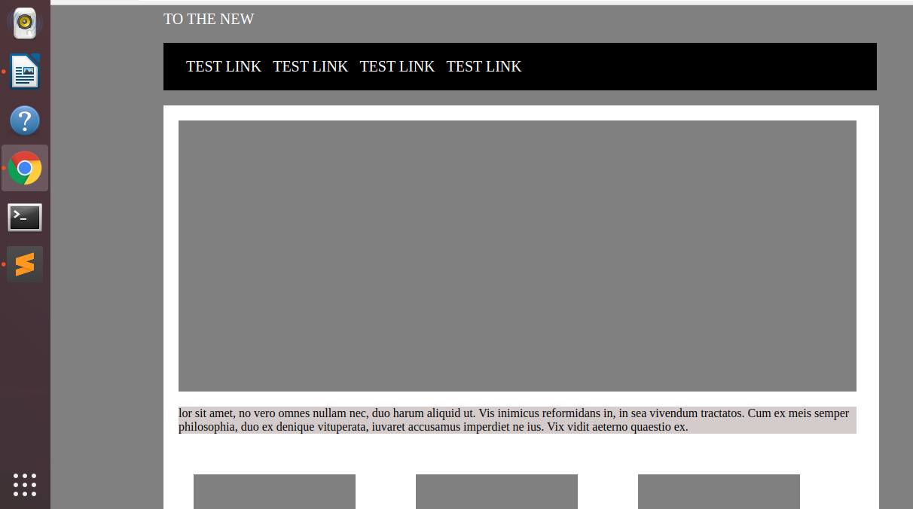

12. Create HTML for form.png (check resources, highest weightage for answers)

Form.html
<!DOCTYPE html>
<html lang="en">
<head>
<meta charset="UTF-8">
<meta name="viewport" content="width=device-width, initial-scale=1.0">
<title>Form Question</title>
<link rel="stylesheet" href="formstyle.css">
</head>
<body>
<div class="container">
<header>
<nav>
<div class="left font">
<a href="">TO THE NEW</a>
</div>
<div class="right">
<a href="">Home</a>
<a href="">Quick Help</a>
</div>
</nav>
</header>
<hr class="clear">
<section class="clear border">
<header class="header">
<p class="content">Bug Report</p>
</header>
<form action="#" >
<table >
<div class="title padding ">
<label class="lmargin display" for="">Title:<sup>*</sup></label>
<input class="display width iborder " type="text">
</div>
<div class="desc padding">
<label class="lmargin display" for="">Description:<sup>*</sup></label>
<textarea name="" id="" cols="30" rows="5" class="display width textarea "></textarea>
</div>
<div class="os padding">
<label class="display lmargin" for="">Operating System:<sup>*</sup></label>
<select name="os" id="" class="display select width iborder ">
<option value="">Windows XP</option>
<option value="">Ubuntu</option>
<option value="">MAC</option>
<option value="">Windows 8</option>
</select>
</div>
<div class="product padding">
<label class="lmargin display" for="">Product:<sup>*</sup></label>
<select name="product" id="" class="display select width iborder ">
<option value="">Formoid</option>
<option value="">Vegetable</option>
<option value="">Mobiles</option>
<option value="">Laptop</option>
</select>
</div>
<div class="version padding">
<label class="display width lmargin" for="">Version:<sup>*</sup></label>
<input class="display version iborder " type="text">
</div>
<div class="license padding">
<label class="display width lmargin" for="">License:<sup>*</sup></label>
<div>
<input type="radio" name="license" >Free

<input type="radio" name="license" >Business

</div>
</div>
<div class="severity padding">
<label class="display lmargin" for="">Severity:<sup>*</sup></label>
<select name="severity" id="" class="display select width iborder ">
<option value="">Critical</option>
<option value="">Low</option>
<option value="">High</option>
<option value="">Medium</option>
</select>
</div>
<div class="attachment padding ">
<label class="lmargin display" for="">Attachments:</label><br/>
<label class="file">
<input type="file" id="file" aria-label="File browser example">
<span class="file-custom"></span>
</label>
<footer class="footer">
<input class="button " type="submit">
</footer>
</table>
</form>
</section>

</div>
</body>
</html>

formstyle.css

a{
text-decoration: none;
color:seagreen;
}
.font{
font-size: 30px;
}
.left{
float:left;
}
.right{
float:right;
}
.width{
width: 100%;
}
.clear{
clear:both;
}
.width{
widows: 100px;
}
.display{
display:inline-block;
}
.border{
border: 0.5px solid lightgray;
padding: 0px 30px 30px 30px;
margin: 50px 20% 0px 20%;
}
.header{
margin: 0px -29px 10px;
padding: 0px;
background-color:silver;
height:50px;
}
.content{
padding: 15px 20px 10px;
margin:0px;
color:honeydew;
font-size: 22px;
}
.footer{
margin: 10px -29px -29px -29px;
background-color: lightgray;
height:50px;
}
.button{
margin:8px 35px 5px 5px;
padding:6px;
float:right;
background-color: mediumseagreen;
border: 1px solid mediumseagreen;
border-radius: 1.5mm;
}
.version{
width:50%
}
.padding{
padding:5px;
}
.iborder{
border-radius: 1.5mm;
border: 0.5px solid lightgrey;
height:20px;
}
.textarea{
border-radius: 1.5mm;
border: 0.5px solid lightgrey;
}
.margin{
margin:5px;
}
.lmargin{
margin:0px 0px 5px 0px;
}
.select{
background-color:mediumseagreen;
}

