Name = Komal Vijendra Vadak
PRN=250843420020
## **Assignment: Git Hands-on Practice**

### **Task 1: Configure Git**

1. Set your username and email in Git.
2. Verify the configuration.
$ git config --global user.name "komal"
$ git config --global email.name komalvadak926@gmail.com
$ git config list
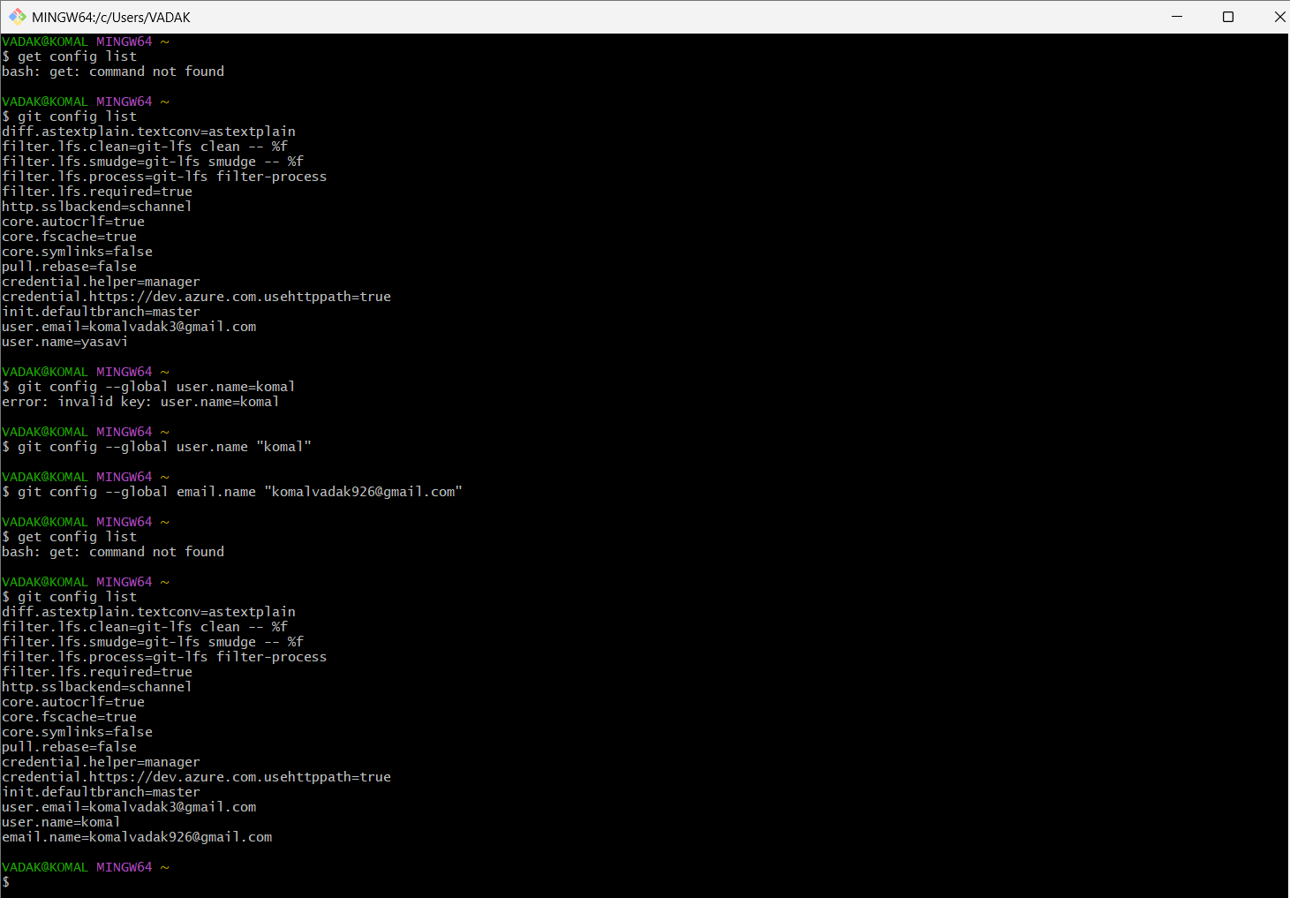
### **Task 2: Initialize a Local Repository**

1. Create a new folder named `git-hands-on`.
2. Initialize it as a Git repository.
3. Check the repository status.

$ git init
$ git status
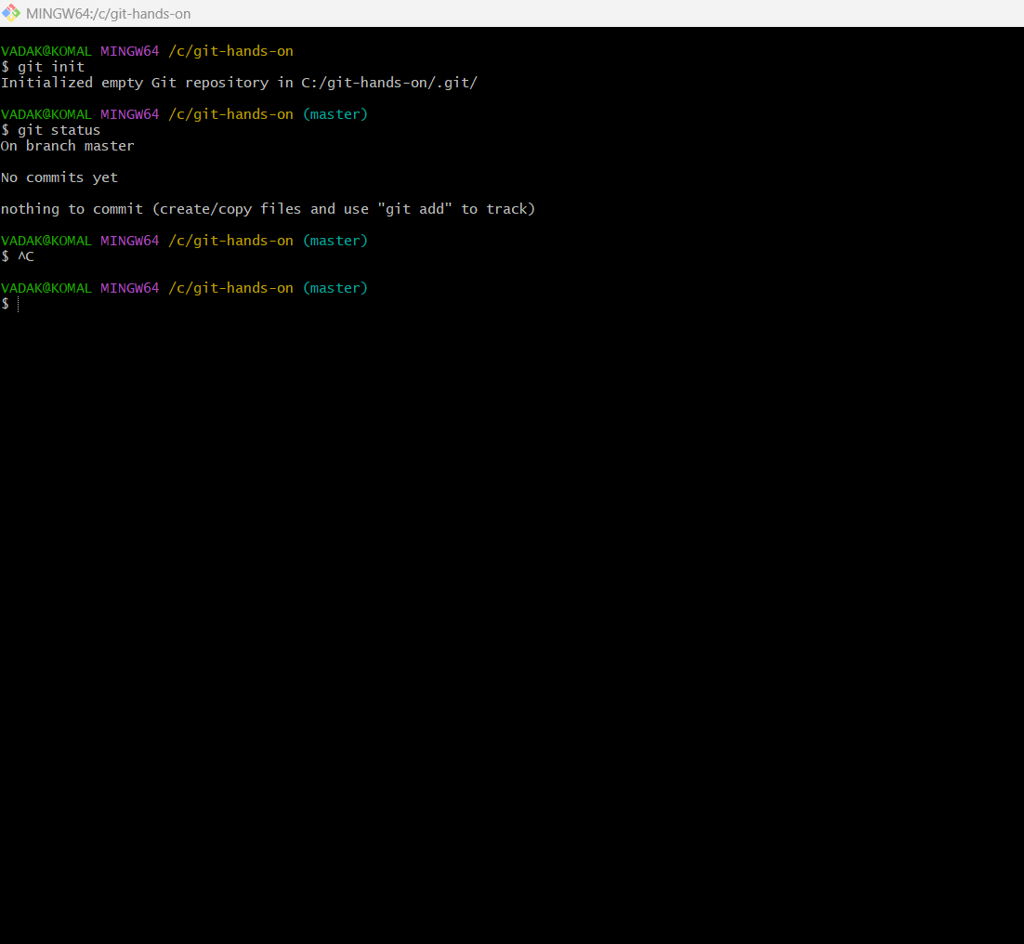

### **Task 3: Create and Track Files**

1. Create a file named `documentation.txt`.
2. Add a short project description inside it.
3. Check file status.
4. Stage the file.
5. Commit the changes with an appropriate message.

$ git status
$ git add documentation.txt
$ git commit -m "documentation version 1.0"
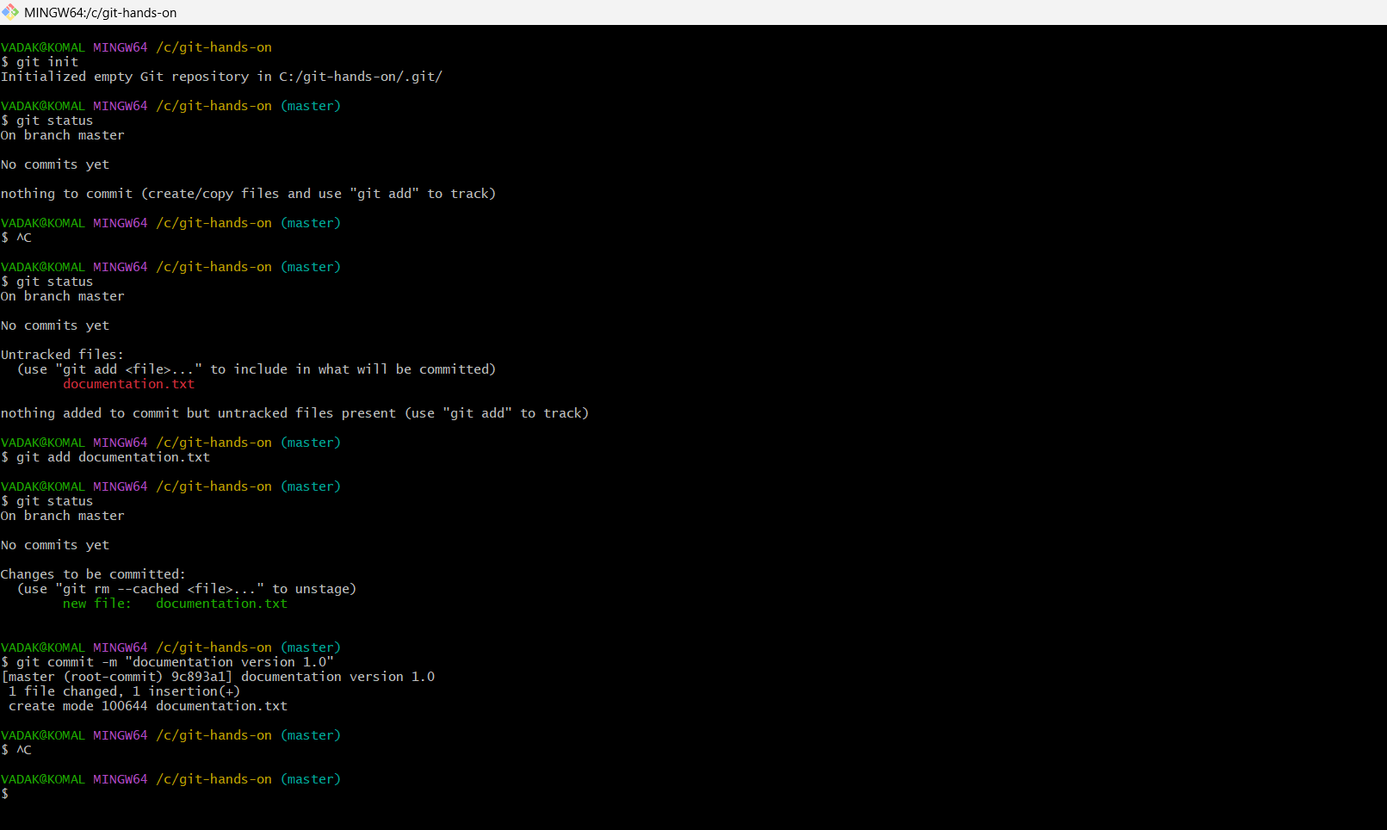
### **Task 4: Modify and Commit Changes**

1. Edit `documentation.txt` and add one more line.
2. View the differences between working directory and staging area.
3. Stage and commit the changes.
$ git diff
$ git add documentation.txt
$ git commit -m "documentation version 2.0"
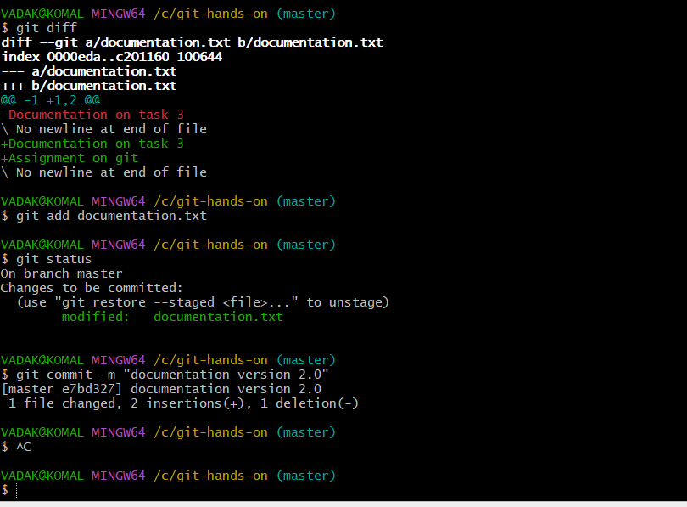
### **Task 5: View Commit History**
1. View the complete commit history.
2. View commit history in one-line format.
$ git log --pretty=fuller
$ git log --pretty=oneline
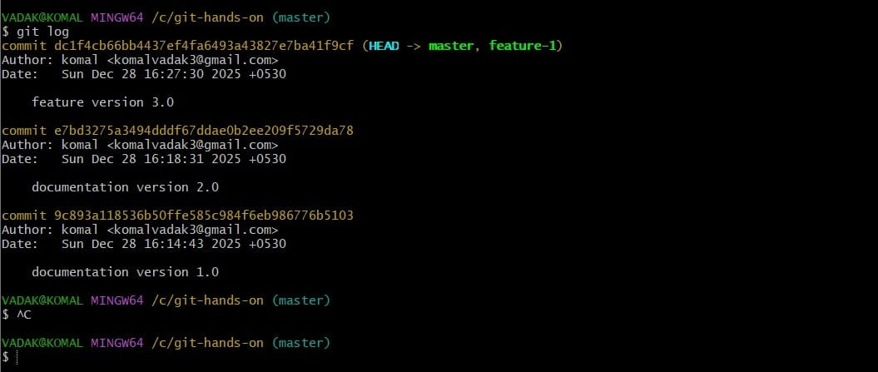

### **Task 6: Create and Work with Branches**
1. Create a new branch named `feature-1`.
2. Switch to the new branch.
3. Create a new file `feature.txt`.
4. Commit the changes.
5. Switch back to the main branch.
$ git branch feature-1
$ git checkout feature-1
$ git status
$ git add -A
$ git status
$ git commit -m "feature version 3.0"
$ git checkout master
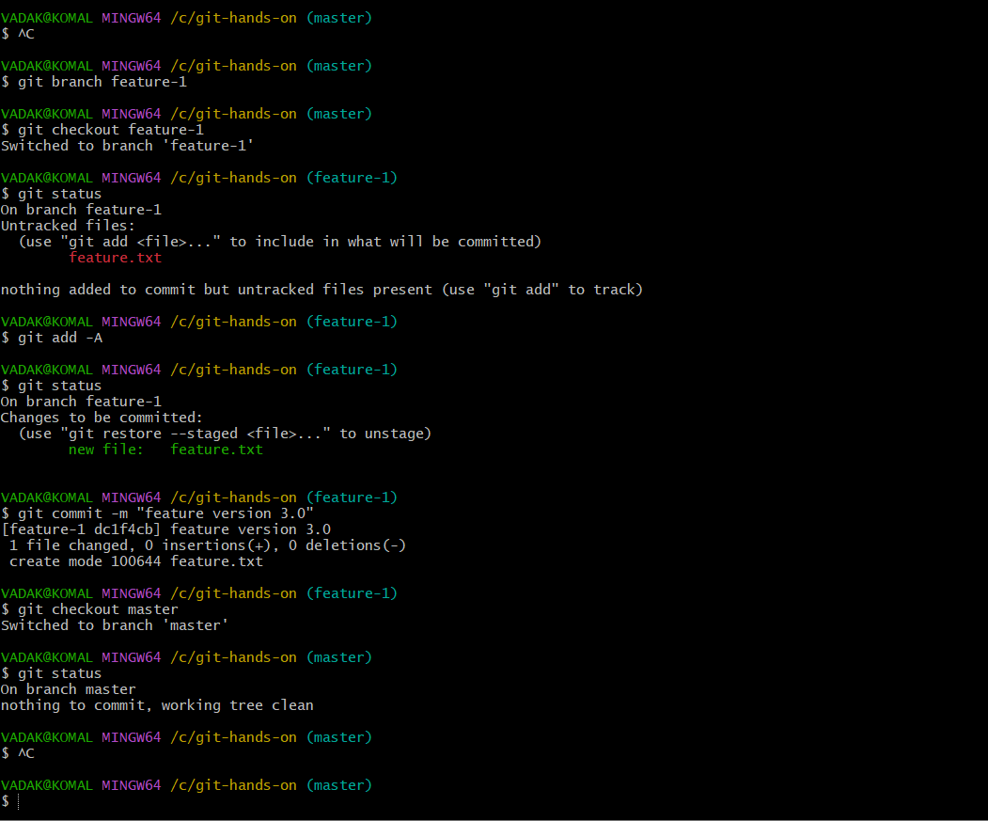

### **Task 7: Merge Branches**
1. Merge `feature-1` branch into `main`.
2. Verify the merge using commit history.
$ git merge feature-1
$ git log
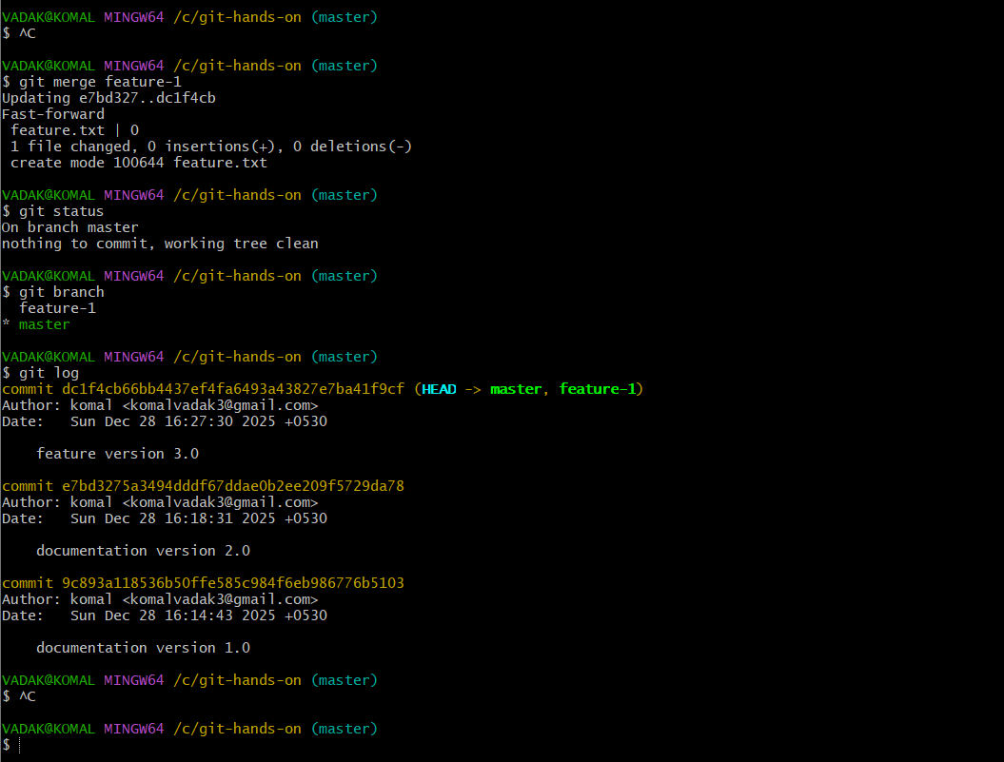
### **Task 8: Connect to a Remote Repository**
1. Create a new repository on GitHub.
2. Add the remote repository URL to your local repo.
3. Verify the remote connection.
$ git remote add origin https://github.com/KomalVadak/Assign.git
$ git remote -v
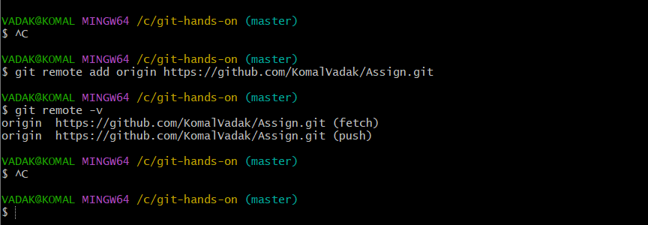

### **Task 9: Push Code to GitHub**
1. Push the `main` branch to GitHub.
2. Verify files on GitHub.
$ git remote add origin https://github.com/KomalVadak/Assign.git
$ git push -u origin master

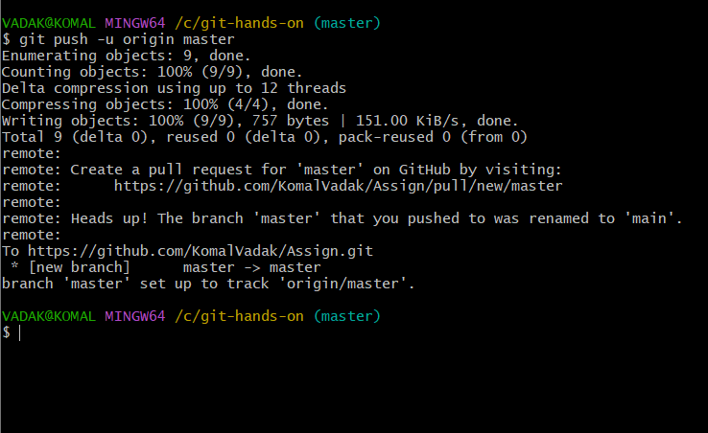

### **Task 10: Clone a Repository**
1. Clone the same GitHub repository into a different folder.
2. Verify the cloned content.
$ git clone https://github.com/KomalVadak/Assign.git
$ cd Assign
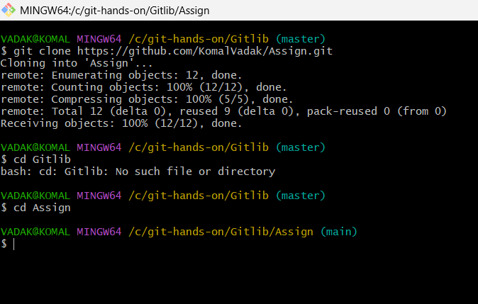

### **Task 11: Undo Changes**
1. Make a change in `documentation.txt` but do not commit.
2. Discard the changes.
3. Verify the file status.
$ git checkout master
$ cd -
$ git status
$ git add -A
$ git status

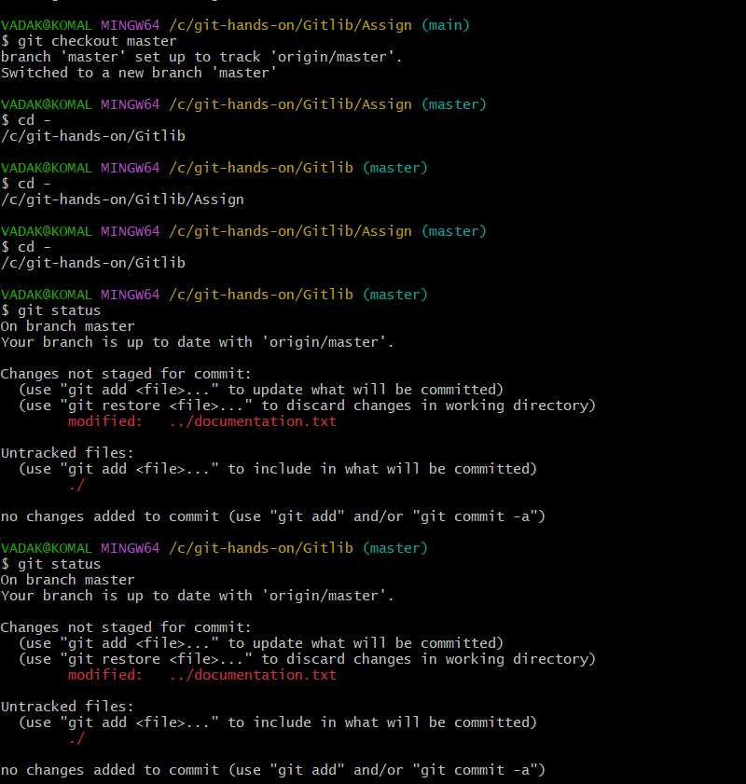
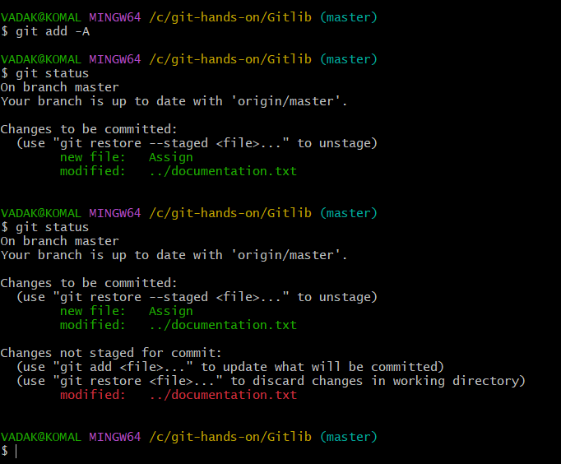
### **Task 12: Remove Files**9

1. Delete `feature.txt` using Git.
2. Commit the deletion.
$ git rm feature.txt
$ git commit -m "feature file delete"

