K L UNIVERSITY
FRESHMAN ENGINEERING DEPARTMENT

A Project Based Lab Report On
DYNAMIC TRANSPORT LOGISTICS & ROUTE OPTIMIZATION
TOOL (DTL-RO)

SUBMITTED BY:
ID NUMBER NAME
2500032609 D.Komala Hasini
2500032622 P.Raj Siddharth
2500032445 Thulasinatha Reddy
2500032455 Mallikharjuna Rao
2500032614 Gnana Kumar

UNDER THE ESTEEMED GUIDANCE OF
Mrs.Alapati Smitha Kranthi

ASSISTANT PROFESSOR



KL UNIVERSITY
Green fields, Vaddeswaram – 522 502 Guntur Dt., AP, India.

DEPARTMENT OF BASIC ENGINEERING SCIENCES



CERTIFICATE

This is to certify that the project based laboratory report entitled “DYNAMIC TRANSPORT LOGISTICS & ROUTE OPTIMIZATION TOOL (DTL-RO)” submitted by D.Komala Hasini, P.Raj Siddharth , Gnana Kumar, Thulasinatha Reddy, Mallikharjuna Rao bearing Regd. No. 2500032609, 2500032622, 24500032614, 2500032445, 2500032455 to the KL University in partial fulfillment of the requirements for the completion of a project based Laboratory in “Computational Thinking for Problem Solving (24SC1102)” course in I B Tech I Semester, is a Bonafede record of the work carried out by him/her under my supervision during the academic year 2024 – 2025.

PROJECT SUPERVISOR HEAD OF THE DEPARTMENT Dr. Mrs.Alapati Smitha Kranthi Dr. D. HARITHA

ACKNOWLEDGEMENTS

It is great pleasure for me to express my gratitude to our honorable President.

Sri. Koneru Satyanarayana, for giving the opportunity and platform with facilities in accomplishing the project-based laboratory report.
I express sincere gratitude to our Director Dr. A. Jagdeesh for his administration towards our academic growth.
I express sincere gratitude to our Coordinator and HOD-BES for her leadership and constant motivation provided in successful completion of our academic semester. I record it as my privilege to deeply thank you for providing us with the efficient faculty and facilities to make our ideas into reality.
I express my sincere thanks to our project supervisor Dr. Sireesha Gundu for her novel association of ideas, encouragement, appreciation, and intellectual zeal which motivated us to venture this project successfully.
Finally, we are pleased to acknowledge our indebtedness to all those who devoted themselves directly or indirectly to making this project a success.

ID NUMBER NAME
2500032609 D.Komala Hasini
2500032622 P.Raj Siddharth
2500032445 Thulasinatha Reddy
2500032455 Mallikharjuna Rao
2500032614 Gnana Kumar

ABSTRACT

The Dynamic Transport Logistics & Route Optimization Tool (DTL-RO) is designed to optimize transportation and delivery systems for small to medium-scale businesses. The system integrates inventory management with logistics planning to efficiently assign delivery routes based on constraints like vehicle capacity, time windows, and traffic conditions.
It supports both static route planning and dynamic re-routing when new orders or unexpected events occur. The system uses algorithms such as Vehicle Routing Problem (VRP), Greedy methods, and OR-Tools optimization to minimize distance, time, and cost.
This tool improves delivery efficiency, reduces operational costs, and enhances customer satisfaction.

INDEX

S.NO | TITLE | PAGE NO
1 | Introduction | 6
2 | Aim of the Project | 7
2.1 | Advantages & Disadvantages | 8
2.2 | Future Implementation | 8
3 | Software & Hardware Details | 9
4 | Data Flow Diagram | 10-11
5 | Algorithm for each module | 12
6 | Implementation | 13-15
7 | Integration and System Testing | 16-18
8 | Conclusion | 19
INTRODUCTION

In today’s fast-paced world, efficient logistics management is essential for businesses like food delivery, grocery services, and e-commerce. Traditional delivery systems often face problems like increased fuel costs, delayed deliveries, and inefficient routing.
The DTL-RO system solves these problems by:
- Automating route planning
- Optimizing delivery schedules
- Handling real-time changes
It uses advanced algorithms and data structures to ensure efficient transportation.

AIM

To design and develop a Dynamic Transport Logistics and Route Optimization Tool that:
- Minimizes travel distance and cost
- Optimizes vehicle routes
- Handles real-time order updates
- Improves delivery efficiency

ADVANTAGES
. • Reduces delivery cost
• Saves time
• Improves efficiency
• Handles real-time changes
• Scalable system

DISADVANTAGES
• Complex implementation
• Requires accurate data
• High computation for large data

FUTURE IMPLEMENTATION

Real-Time Traffic Integration

Artificial Intelligence & Machine Learning

Mobile Application for Drivers

Multi-Modal Transportation

SYSTEM REQUIREMENTS

SOFTWARE REQUIREMENTS:
• Python (3.x)
• FastAPI
• OR-Tools
• PostgreSQL
• Folium / Leaflet (for maps)

HARDWARE REQUIREMENTS:
- Minimum 4GB RAM
- Processor: Intel i3 or above
- Storage: 20GB free space
DATA FLOW DIAGRAM

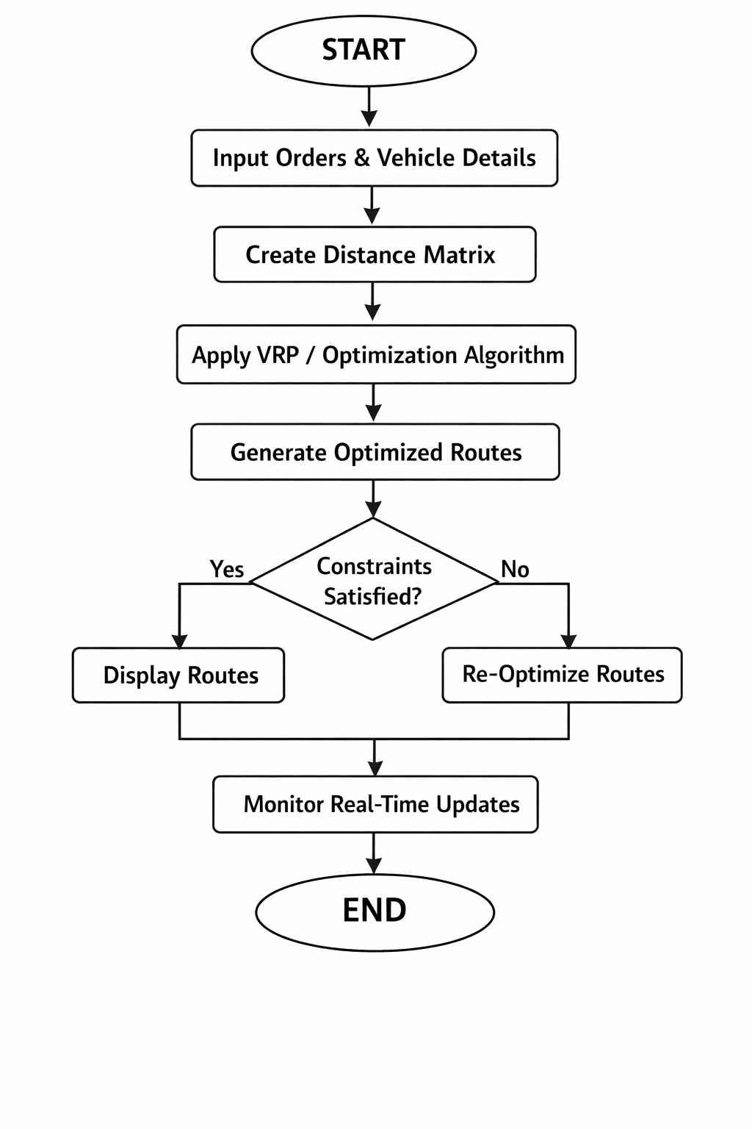

ALGORITHM

Step 1: Input Data
Get orders and vehicle details

Step 2: Create Distance Matrix
Calculate distance between locations

Step 3: Apply VRP Algorithm
Assign orders to vehicles
Optimize route

Step 4: Route Optimization
Use 2-opt or Greedy method

Step 5: Output
Display optimized routes

IMPLEMENTATION

# Dynamic Transport Logistics & Route Optimization Tool (DTL-RO)

import math

# Sample locations (x, y coordinates)

locations = {

"Warehouse": (0, 0),

"Order1": (2, 3),

"Order2": (5, 2),

"Order3": (6, 6),

"Order4": (8, 3)

}

# Vehicle details

vehicle_capacity = 2

vehicles = {

"Vehicle1": [],

"Vehicle2": []

}

# Function to calculate distance

def distance(a, b):

x1, y1 = locations[a]

x2, y2 = locations[b]

return round(math.sqrt((x2 - x1)**2 + (y2 - y1)**2), 2)

# Step 1: Input Orders

orders = ["Order1", "Order2", "Order3", "Order4"]

# Step 2: Assign orders to vehicles

i = 0

for order in orders:

vehicle_name = list(vehicles.keys())[i % len(vehicles)]

if len(vehicles[vehicle_name]) < vehicle_capacity:

vehicles[vehicle_name].append(order)

flowchart.edge('F', 'H', label='N

i += 1

# Step 3: Optimize route (Nearest Neighbor)

def optimize_route(vehicle_orders):

route = ["Warehouse"]

remaining = vehicle_orders[:]

current = "Warehouse"

while remaining:

nearest = min(remaining, key=lambda x: distance(current, x))

route.append(nearest)

remaining.remove(nearest)

current = nearest

route.append("Warehouse")

return route

# Step 4: Display routes

print("Optimized Delivery Routes:\n")

for vehicle, assigned_orders in vehicles.items():

route = optimize_route(assigned_orders)

total_distance = 0

for j in range(len(route)-1):

total_distance += distance(route[j], route[j+1])

print(vehicle)

print("Assigned Orders:", assigned_orders)

print("Route:", " -> ".join(route))

print("Total Distance:", round(total_distance, 2), "km")

print("-" * 40)

INTEGRATION AND SYSTEM TESTING
OUTPUTS

Screen Shots:

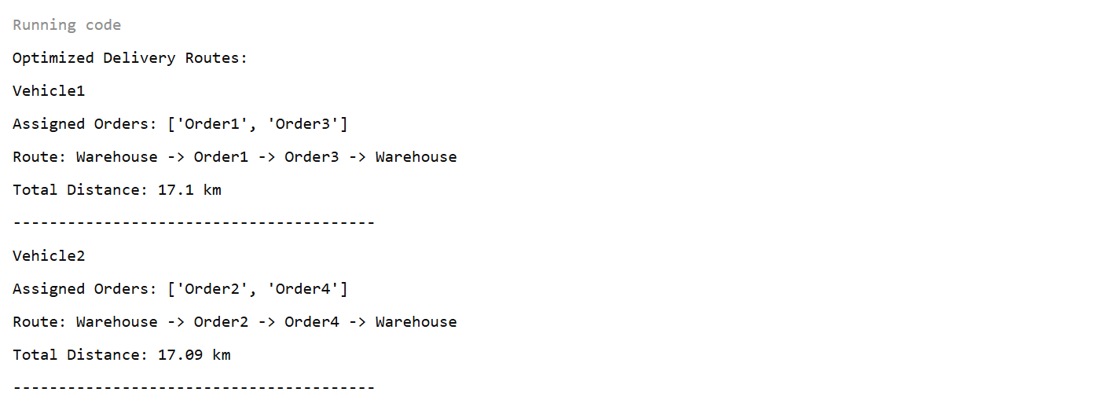

CONCLUSION
The DTL-RO system provides an efficient solution for modern logistics challenges. By using optimization algorithms and real-time data, it enhances delivery performance and reduces operational costs. It is highly useful for businesses aiming for smart and automated logistics systems.

19

