**1.Write a java program for Addition of 2number.**

import java.util.*;

class Main{

public static void main(String args [])

{

int a,b,add;

Scanner sc=new Scanner(System.in);

System.out.println("Enter Frist Number:");

a=sc.nextInt();

System.out.println("Enter the second number:");

b=sc.nextInt();

add=a+b;

System.out.println("Addition of two number is:" +add);

}

}

Output-

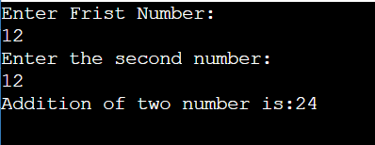

**2.Write a java program for Multiplication of 4 number.**

import java.util.*;

class Main{

public static void main(String args [])

{

int a,b,c,d,mult;

Scanner sc=new Scanner(System.in);

System.out.println("Enter Frist Number:");

a=sc.nextInt();

System.out.println("Enter the second number:");

b=sc.nextInt();

System.out.println("Enter the third number:");

c=sc.nextInt();

System.out.println("Enter the second number:");

b=sc.nextInt();

System.out.println("Enter the fourth number:");

d=sc.nextInt();

mult=a*b*c*d;

System.out.println("multiplication of four number is:" +mult);

}

}

**Output=**

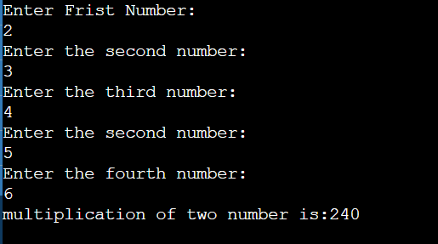

**3.Write a java program for Addition of 4 number.**

import java.util.*;

class Main{

public static void main(String args [])

{

int a,b,c,d,add;

Scanner sc=new Scanner(System.in);

System.out.println("Enter Frist Number:");

a=sc.nextInt();

System.out.println("Enter the second number:");

b=sc.nextInt();

System.out.println("Enter the third number:");

c=sc.nextInt();

System.out.println("Enter the second number:");

b=sc.nextInt();

System.out.println("Enter the fourth number:");

d=sc.nextInt();

add=a+b+c+d;

System.out.println(“Addition of four number is:" +add);

}

}

Output-

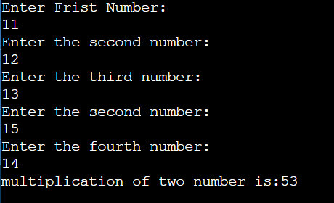

**4.Write a java program for Division of 2 number.**

import java.util.*;

class Main{

public static void main(String args [])

{

int a,b,c;

Scanner sc=new Scanner(System.in);

System.out.println("Enter Frist Number:");

a=sc.nextInt();

System.out.println("Enter the second number:");

b=sc.nextInt();

c=a/b;

System.out.println("division of two number is:" +c);

}

}

Output-

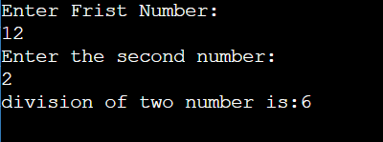

}

**5.Write a java program for Arithmetic mean & Harmonic mean.**

import java.util.*;

class Main{

public static void main(String args [])

{

int a,b,AM,HM;

Scanner sc=new Scanner(System.in);

System.out.println("Enter the value of a:");

a=sc.nextInt();

System.out.println("Enter the value of :b");

b=sc.nextInt();

AM=(a+b)/2;

HM=(a-b)/2;

System.out.println("Arithmetic mean is"+AM+"\n Harmonic mean is "+HM);

}

}

Output-

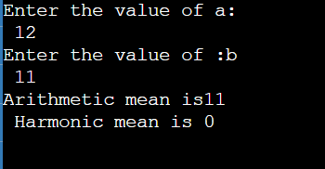

**6.Accept basic salary from user and calculate HRA,TA,DA also calculate GS.**

import java.util.*;

class Main{

public static void main(String args [])

{

int BS,HRA,TA,DA,GS;

Scanner sc=new Scanner(System.in);

System.out.println("Enter the bASIC salary:");

BS=sc.nextInt();

HRA=BS*40/100;

TA=BS*50/100;

DA=BS*35/100;

GS=HRA+TA+DA;

System.out.println("The HRA is"+HRA);

System.out.println("The HRA is"+TA);

System.out.println("The HRA is"+DA);

System.out.println("The HRA is"+GS);

}

}

Output-

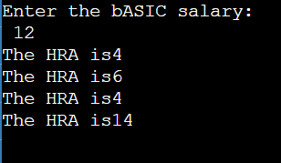

**7.Write a java program for Area of rectangle.**

import java.util.*;

public class Rectangle{

public static void main(String args[])

{

float l,b,a;

Scanner sc=new Scanner(System.in);

System.out.println("enter the length");

l=sc.nextFloat();

System.out.println("enter the breath");

b=sc.nextFloat();

a=l*b;

System.out.println("area of rectangle:"+a);

}

}

Output-

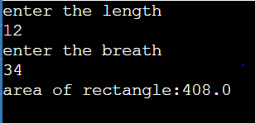

**8.Write a java program Kinetic energy.**

import java.util.*;

public class Kinetic{

public static void main(String args[])

{

double m,v,KE;

Scanner sc=new Scanner(System.in);

System.out.println("enter the mass");

m=sc.nextDouble();

System.out.println("enter the velocity");

v=sc.nextDouble();

KE=0.5*m*v*v;

System.out.println("The kinetic energy is:"+KE);

}

}

Output-

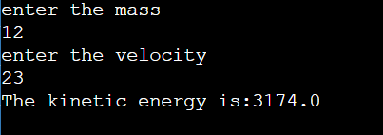

**9.Write a java program Potential energy.**

import java.util.*;

public class Potential{

public static void main(String args[])

{

double m,g,h,PE;

Scanner sc=new Scanner(System.in);

System.out.println("enter the m");

m=sc.nextDouble();

System.out.println("enter the g");

g=sc.nextDouble();

System.out.println("enter the h");

h=sc.nextDouble();

PE=m*g*h;

System.out.println("The kinetic energy is:"+PE);

}

}

Output-

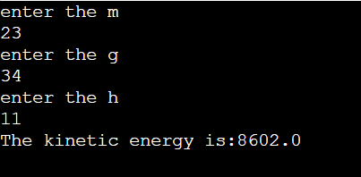

**10.Write a java program for swaping two numbers using third varriable.**

import java.util.*;

public class Swapping{

public static void main(String args[])

{

int a,b,c;

Scanner sc=new Scanner(System.in);

System.out.println("enter the a");

a=sc.nextInt();

System.out.println("enter the b");

b=sc.nextInt();

c=a;

a=b;

b=c;

System.out.println("Numbers after swapping :"+a+"\t"+b);

}

}

Output

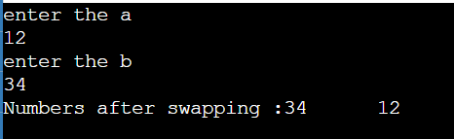

**11.Write a java program to convert kilometers to meters.**

import java.util.*;

public class KM{

public static void main(String args[])

{

float km,m;

Scanner sc=new Scanner(System.in);

System.out.println("enter kilomiter");

km=sc.nextFloat();

m=km*1000;

System.out.println("kilomiter="+m +"m");

}

}

Output-

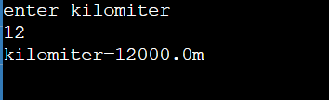

**12.Write a java program for swaping two numbers Without using third varriable.**

import java.util.*;

public class Swapping{

public static void main(String args[])

{

int a,b;

Scanner sc=new Scanner(System.in);

System.out.println("enter the no");

a=sc.nextInt();

System.out.println("enter the no");

b=sc.nextInt();

a=a*b;

b=a/b;

a=a/b;

System.out.println("Numbers after swapping :"+a+"\t"+b);

}

}

Output-

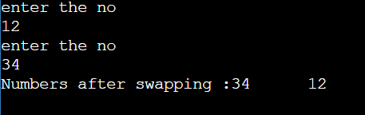

**13.Write a java program to liter to mililiter.**

import java.util.*;

public class Liter{

public static void main(String args[])

{

float l,ml;

Scanner sc=new Scanner(System.in);

System.out.println("enter the value of liter");

l=sc.nextFloat();

ml=l*1000;

System.out.println("l="+ml +"mililiter");

}

}

Output-

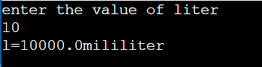

**14.Write a java program to convert H:M:S to seconds..**

import java.util.*;

public class Meter{

public static void main(String args[])

{

float H,M,S;

Scanner sc=new Scanner(System.in);

System.out.println("enter the value of hours");

H=sc.nextFloat();

System.out.println("enter the value of minutes");

M=sc.nextFloat();

System.out.println("enter the value of seconds");

S=sc.nextFloat();

S=(H*3600)+(M*60)+(S);

System.out.println("H:M:S to seconds is :"+S);

}

}

Output-

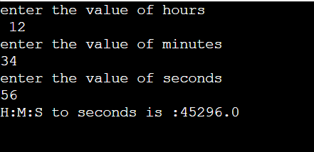

**15.Write a java program to accept meter from user and convert it into kilomer and miter..**

import java.util.*;

public class Meter{

public static void main(String args[])

{

int M,KM;

Scanner sc=new Scanner(System.in);

System.out.println("enter the value of Meter");

M=sc.nextInt();

KM=M/1000;

M=M%1000;

System.out.println("the kilomiter is "+KM+" and meter is"+M);

}

}

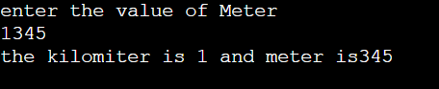

**16.Write a java program to convert seconds to H:M:S.**

import java.util.*;

public class Second{

public static void main(String args[])

{

int H,M,S;

Scanner sc=new Scanner(System.in);

System.out.println("enter the Second");

S=sc.nextInt();

H=S/3600;

S=S%3600;

M=S/60;

S=S%60;

System.out.println("the conversion is "+H+" and Hours "+M+" Minutes and" +S+" Second");

}

}

Output-

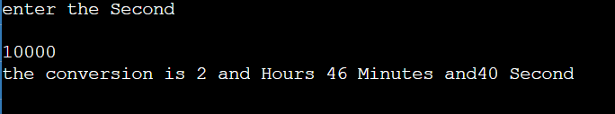

**17.Write a java program to Accept ruppes from user and display how many numbers of 500.200.100.50.20.10.5.2.1.notes gives to user.**

import java.util.*;

public class Rupees{

public static void main(String args[])

{

int RS,FH,TWOH,H,F,T,TEN,FIVE,TWO,ONE;

Scanner sc=new Scanner(System.in);

System.out.println("enter the Rupees");

RS=sc.nextInt();

FH=RS/500; RS=RS%500;

TWOH=RS/200; RS=RS%200;

H=RS/100; RS=RS%100;

F=RS/50; RS=RS%50;

T=RS/20; RS=RS%20;

TEN=RS/10; RS=RS%10;

FIVE=RS/5; RS=RS%5;

TWO=RS/2; RS=RS%2;

ONE=RS/1; RS=RS%1;

System.out.println("500 * "+FH+"="+(FH*500));

System.out.println("200 * "+TWOH+"="+(TWOH*200));

System.out.println("500 * "+H+"="+(H*100));

System.out.println("500 * "+F+"="+(F*50));

System.out.println("500 * "+T+"="+(T*20));

System.out.println("500 * "+TEN+"="+(TEN*10));

System.out.println("500 * "+FIVE+"="+(FIVE*5));

System.out.println("500 * "+TWO+"="+(TWO*2));

System.out.println("500 * "+ONE+"="+(ONE*10));

}

}

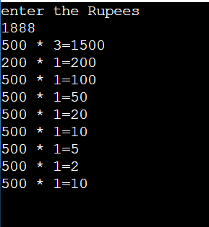

**18.Write a java program to add & subtract two numbers.**

import java.util.*;

public class Rupees{

public static void main(String args[])

{

int a,b,add,sub;

Scanner sc=new Scanner(System.in);

System.out.println("Enter the value of a");

a=sc.nextInt();

System.out.println("Enter the value of b");

b=sc.nextInt();

add=a+b;

sub=a-b;

System.out.println("The addition of two no is:"+add);

System.out.println("The subtraction of two no is:"+sub);

}

}

Output-

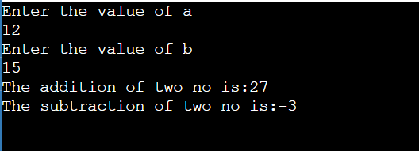

**19.Write a java program to multiply & divide two numbers.**

import java.util.*;

public class MulDiv{

public static void main(String args[])

{

int a,b,Mul,Div;

Scanner sc=new Scanner(System.in);

System.out.println("Enter the value of a");

a=sc.nextInt();

System.out.println("Enter the value of b");

b=sc.nextInt();

Mul=a*b;

Div=a/b;

System.out.println("The addition of two no is:"+Mul);

System.out.println("The subtraction of two no is:"+Div);

}

}

Output-

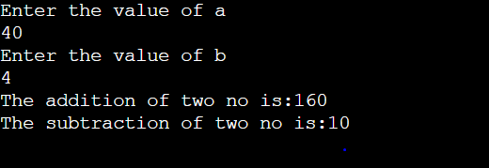

**20.Write a java program to find the square and cube of a given number.**

import java.util.*;

public class Square{

public static void main(String args[])

{

int num,Square,cube;

Scanner sc=new Scanner(System.in);

System.out.println("Enter the no");

num=sc.nextInt();

Square=num*num;

cube=num*num*num;

System.out.println("The Square of"+num+" is:"+Square);

System.out.println("The cube of "+num+"is:"+cube);

}

}

Output-

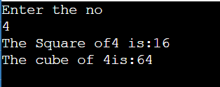

**21.Write a java program to find the area and perimiter of a given number.**

import java.util.*;

public class Square{

public static void main(String args[])

{

int A,P,Side;

Scanner sc=new Scanner(System.in);

System.out.println("Enter the side lenght of square");

Side=sc.nextInt();

A=Side*Side;

P=4*Side;

System.out.println("The area of Square is:"+A);

System.out.println("The Perimiter of Square is:"+P);

}

**Output-**

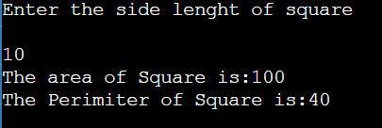

**22.Write a java program to find the squre root of a given number(use Sqrt() function.**

import java.util.*;

public class Sqrt{

public static void main(String args[])

{

Double num,sqr;

Scanner sc=new Scanner(System.in);

System.out.println("Enter the no");

num=sc.nextDouble();

sqr=Math.sqrt(num);

System.out.println("The Square root of given number is:"+sqr);

}

}

Output-

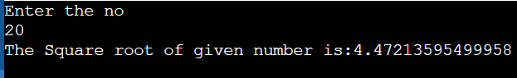

**23.Write a Java program to find the area and circumference of a circle.**

import java.util.*;

public class Circumference{

public static void main(String args[])

{

Double A,R,C;

Scanner sc=new Scanner(System.in);

System.out.println("Enter the radius");

R=sc.nextDouble();

A=3.14*R*R;

C=2*3.14*R;

System.out.println("The area of square is:"+A);

System.out.println("The Perimiter of square is:"+C);

}

}

Output=

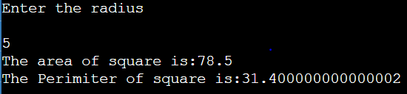

**24.Write a Java program to find the area of a sphere.**

import java.util.*;

public class AreaSphere{

public static void main(String args[])

{

Double A,R;

Scanner sc=new Scanner(System.in);

System.out.println("Enter the radius");

R=sc.nextDouble();

A=4*3.14*R*R;

System.out.println("The area of sphere is:"+A);

}

}

Output=

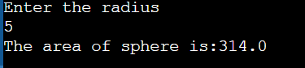

**25.Write a Java program to find the volume of a cylinder.**

import java.util.*;

public class Volume{

public static void main(String args[])

{

Double R,H,V;

Scanner sc=new Scanner(System.in);

System.out.println("Enter the radius");

R=sc.nextDouble();

System.out.println("Enter the height");

H=sc.nextDouble();

V=3.14*R*R*H;

System.out.println("Volume of cylinder:"+V);

}

}

Output=

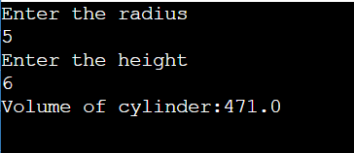

**26.The Tempreture of the city is input through the keyboard in Fahrenheit.write a java Programto convert into Celsius .**

import java.util.*;

public class Fahrenheit{

public static void main(String args[])

{

Double F,C;

Scanner sc=new Scanner(System.in);

System.out.println("Enter the value of Fahrenheit:");

F=sc.nextDouble();

C=(F-32)*5/9;

System.out.println("Fahrenheit to celsius conversion:"+C);

}

}

Output=

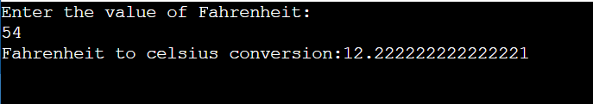

**27.The distance between two cities in KM. Is input through the keyboard.write a java program to convert abd print the result in meters and centimiters.**

import java.util.*;

public class City{

public static void main(String args[])

{

int KM,M,CM;

Scanner sc=new Scanner(System.in);

System.out.println("Enter distance between two Cities :");

KM=sc.nextInt();

M=KM*1000;

CM=KM*100000;

System.out.println("The meter is:"+M);

System.out.println("The kilometermeter is:"+CM);

}

}

Output=

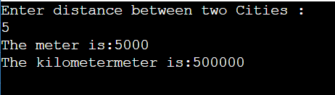

**28.Write a java program which accepts the amount in dollars and converts into rupees.**

import java.util.*;

public class Doller{

public static void main(String args[])

{

double Doller,Rs;

Scanner sc=new Scanner(System.in);

System.out.println("Enter the value of Dollers:");

Doller=sc.nextDouble();

Rs=Doller*83.30;

System.out.println("The" +Doller+ "Doller to rupees conversion is :"+Rs);

}

}

Output=

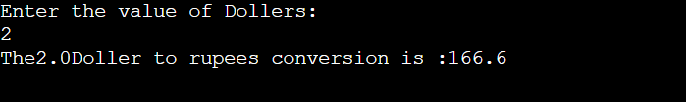

**29.Write a java program to read your address and print it.**

import java.util.*;

public class Address{

public static void main(String args[])

{

String Address;

Scanner sc=new Scanner(System.in);

System.out.println("Enter the value of Address:");

Address=sc.nextLine();

System.out.println("your address is:"+Address);

}

}

Output=

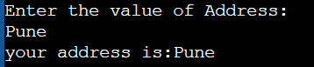

**30.Write a java program to print the area og triangle if base and height value are given.**

import java.util.*;

public class Triangle{

public static void main(String args[])

{

double A,B,H;

Scanner sc=new Scanner(System.in);

System.out.println("Enter the value of base:");

B=sc.nextDouble();

System.out.println("Enter the value of height:");

H=sc.nextDouble();

A=0.5*B*H;

System.out.println("the area of Triangle is:"+A);

}

}

Output=

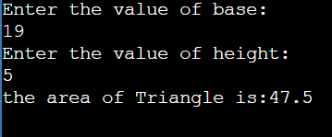

**31.Write a java program to read marks of 3 subject and display the total,avg.**

import java.util.*;

public class Marks{

public static void main(String args[])

{

int m1,m2,m3,total,avg;

Scanner sc=new Scanner(System.in);

System.out.println("Enter the frist subject marks:");

m1=sc.nextInt();

System.out.println("Enter the second sunject marks:");

m2=sc.nextInt();

System.out.println("Enter the third subject marks:");

m3=sc.nextInt();

total=m1+m2+m3;

avg=total/3;

System.out.println("the total marks is:"+total);

System.out.println("the average marks is:"+avg);

}

}

Output=

