Task 5 - SQL Practice

Department Table
Create Table Query:
CREATE TABLE Department (dept_id INT PRIMARY KEY, dept_name VARCHAR(50));

Insert Query:
INSERT INTO Department VALUES (1,'HR'), (2,'IT'), (3,'Finance'), (4,'Marketing');

Department table:
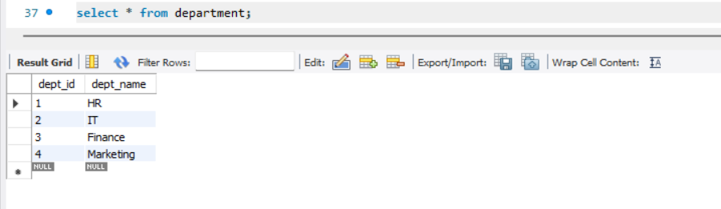

Employee Table
Create Table Query:
CREATE TABLE Employee (
emp_id INT PRIMARY KEY,
emp_name VARCHAR(50),
salary DECIMAL(10,2),
hire_date DATE,
dept_id INT,
FOREIGN KEY (dept_id) REFERENCES Department(dept_id)
);

Insert Query:
INSERT INTO Employee VALUES
(101,'Amit',50000,'2025-08-15',1),
(102,'Priya',70000,'2026-02-10',2),
(103,'Rahul',60000,'2025-11-20',2),
(104,'Sneha',90000,'2026-04-05',3),
(105,'Vikas',80000,'2026-05-15',2),
(106,'Neha',70000,'2025-10-01',1),
(107,'Amit',55000,'2026-06-10',1),
(108,'Rohan',45000,'2024-12-10',4);

Employee Table:
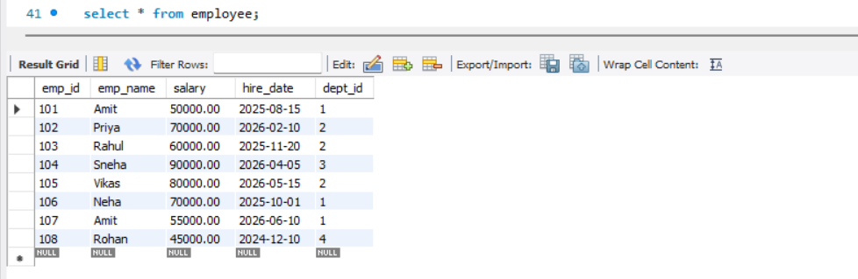

Q1: Top 5 Highest Salary Employees
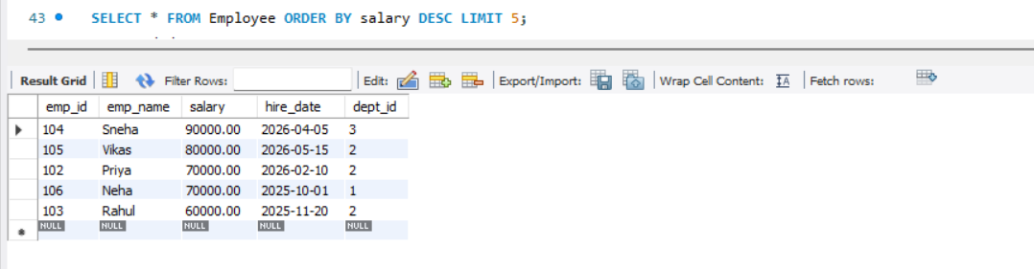

Q2: Department Wise Employee Count
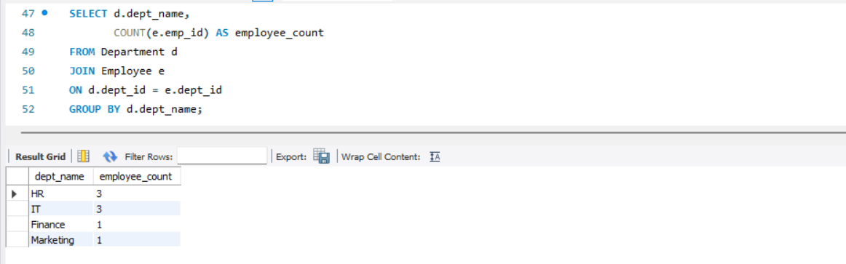

Q3: Find Second Highest Salary
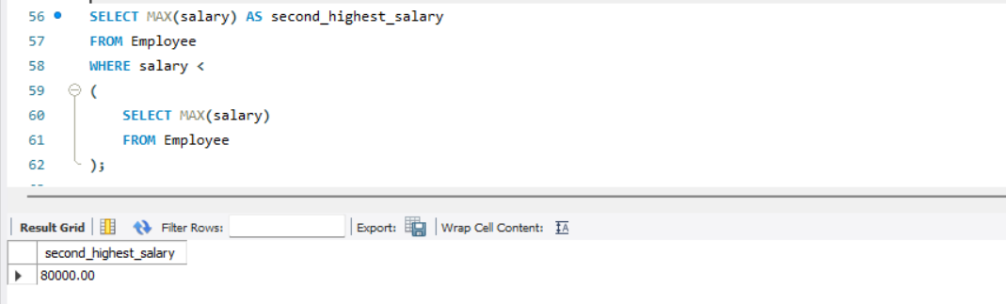

Q4: Employees Whose Salary is Greater Than Department Average Salary
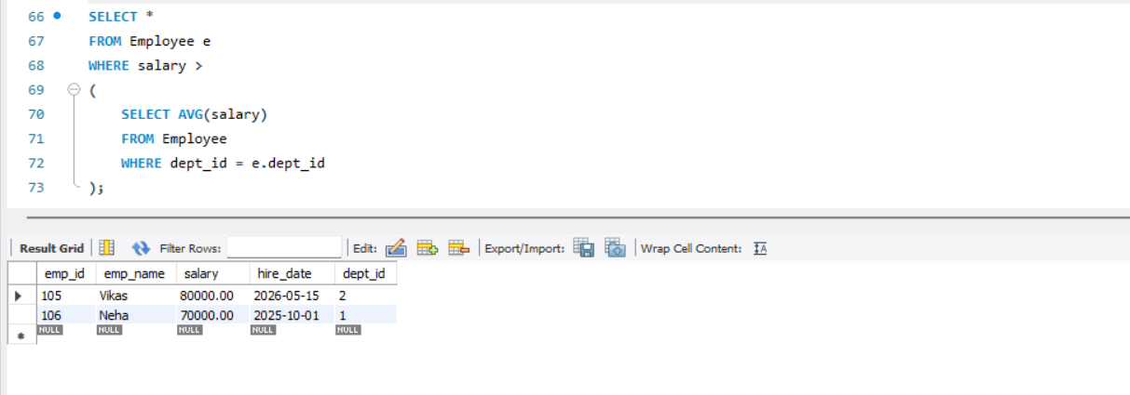

Q5: Inner Join
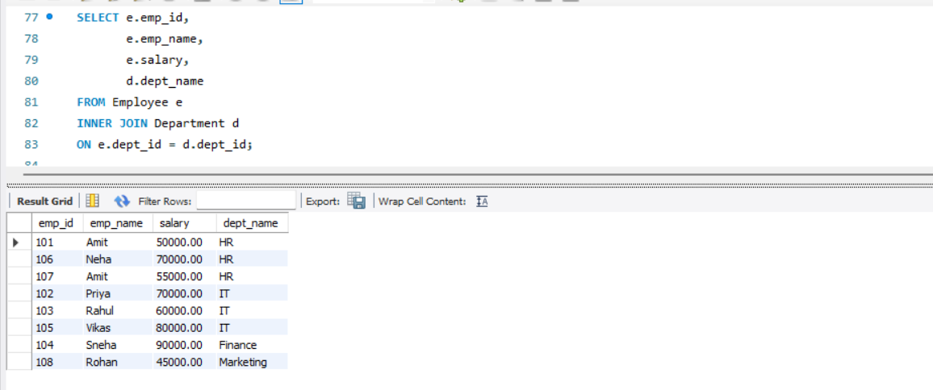

6: Left Join
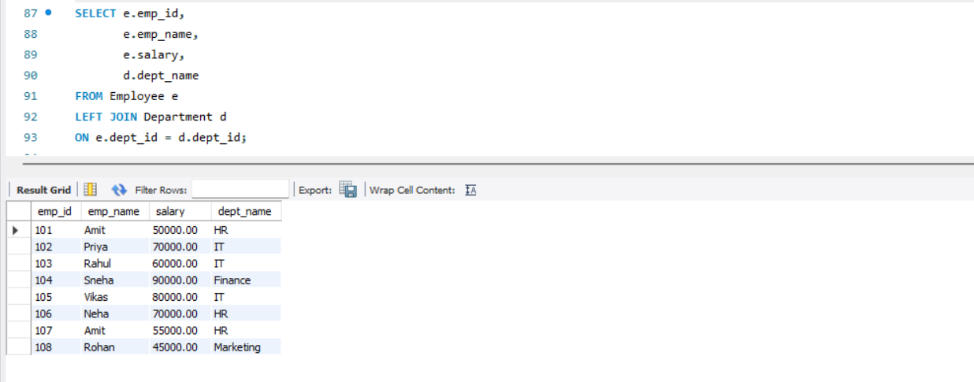

Q7: Group By with Having
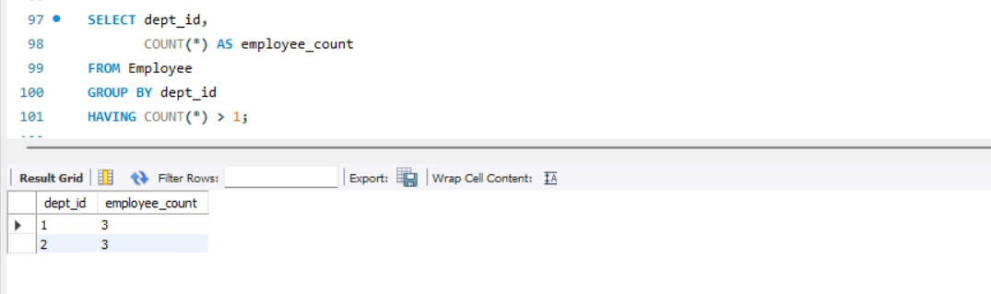

Q8: Employees Hired in Last 6 Months
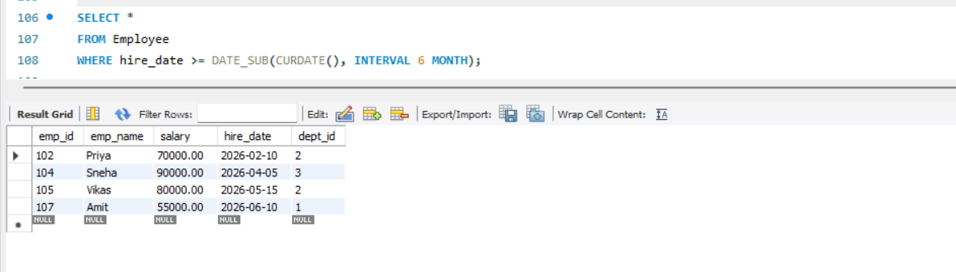

Q9: Find Duplicate Records
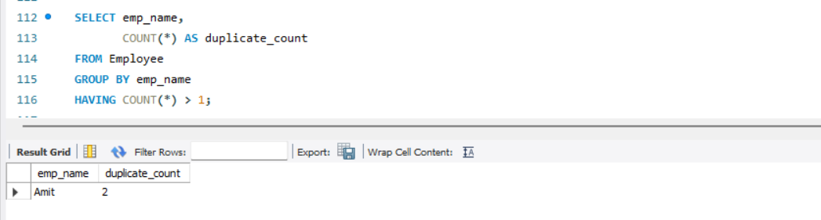

Q10: Remove Duplicate Records
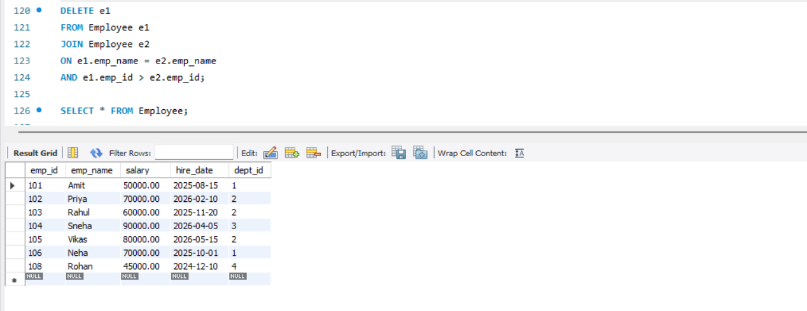

Records after duplicates deletion: