Assignment 02

Moses Oduwole

ScreenShot #1: MENU

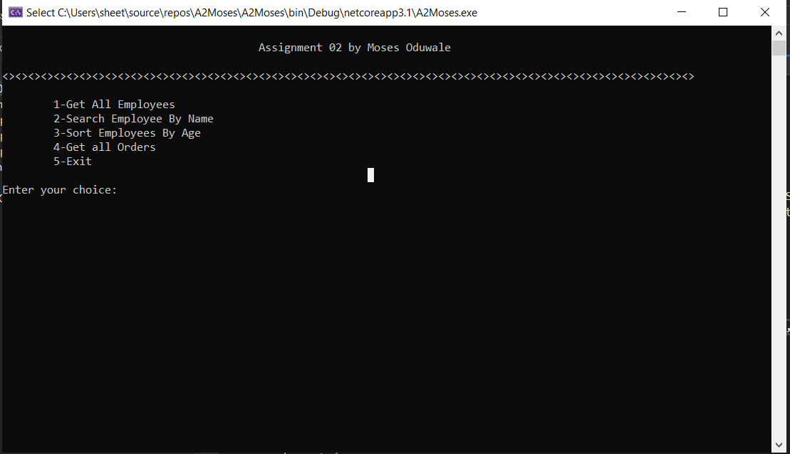

ScreenShot #2: Selecting 1

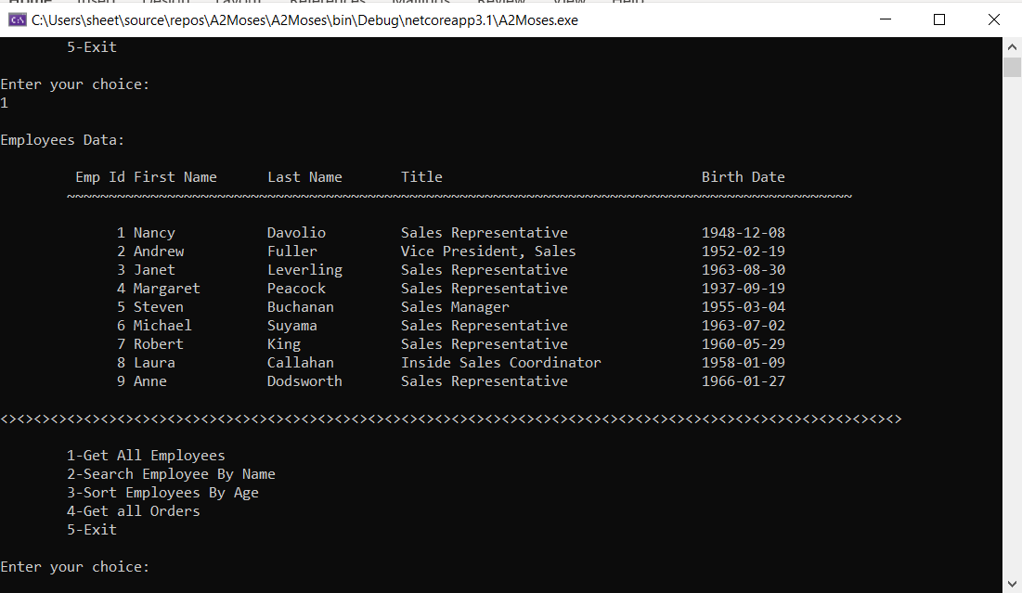

ScreenShot #3: Selecting 2 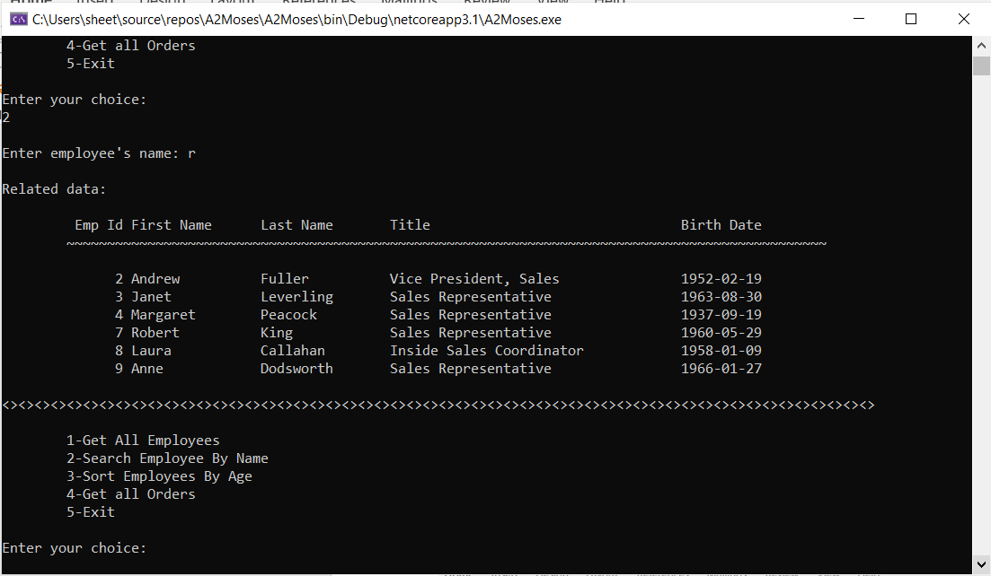

ScreenShot #4: Selecting 3

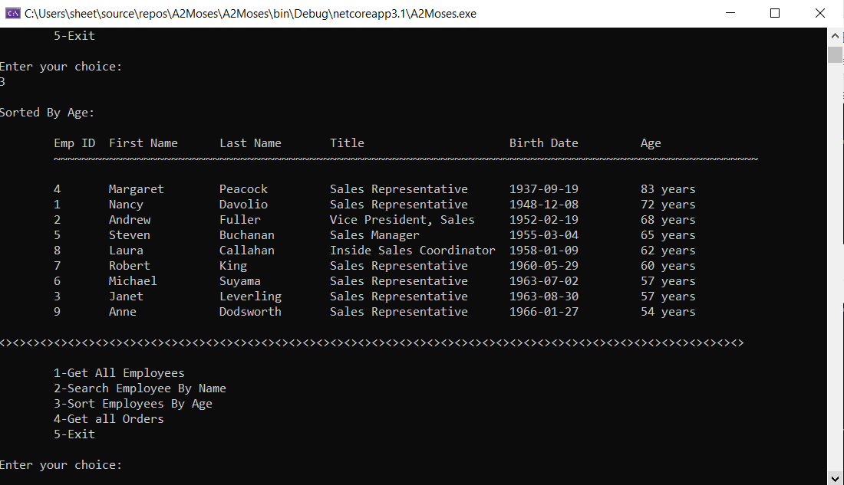

ScreenShot #5: Selecting 4 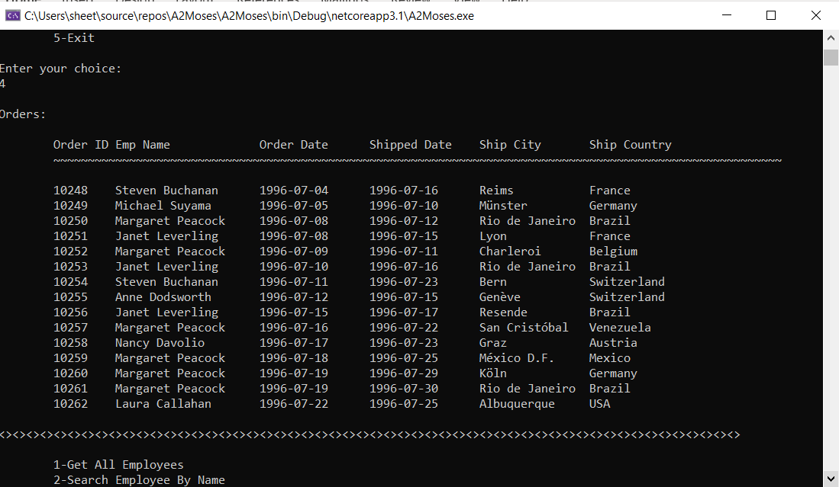

ScreenShot #6: Selecting any other key 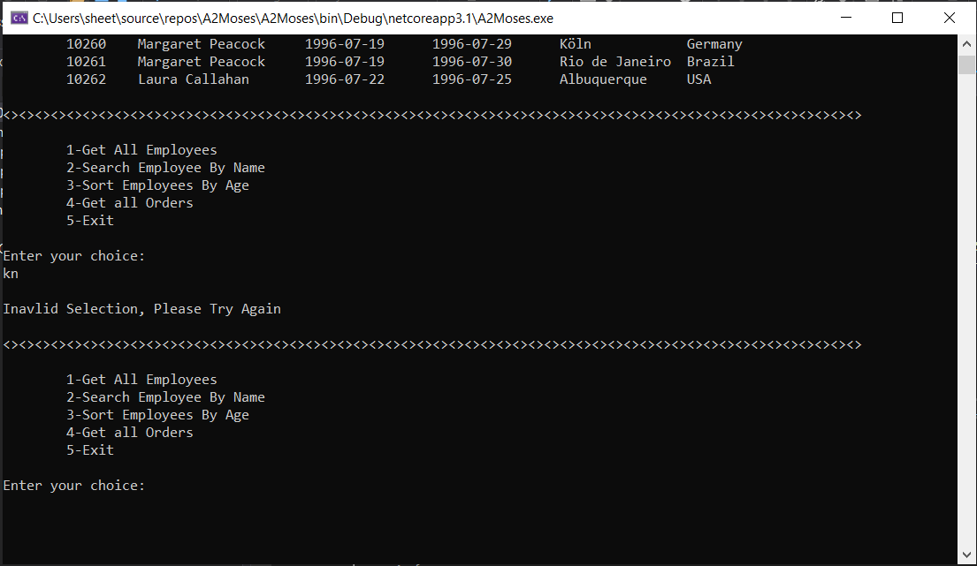ScreenShot #7: Selecting 5 