

Project proposal

Management Information System (Lambton College)



December 8, 2019

Aperture labs

[Company address]

Executive Summary

This report is basically a research on some particular changes required to improve the functions of Management Information System (MIS) of Lambton College. Project will solve a major problem of going to front desk to sign-up for any volunteer work, academic events, tournaments or any other kind of activity. Additionally, mylambton account login option will be available in the Moodle as a more convenient side.

Different areas related to the project like project charter, deliverables, risks, WBS, resource scheduling, conclusion etc. will be included. Related completed projects will be compared, so that better understanding and reducing failure risk can be achieved.

Introduction:

The main purpose of the project is to upgrade the operations of Management Information System. Number of improvements are needed like online library system, gym for students, sign-up problems, individual printers for all groups and mylambton embedded in Moodle. For now, we will work only on sign-up problems and sperate link to accounts of students.

Currently, Lambton college has different links to the Moodle and mylambton account which creates a lot of problems for the students, as sometimes logging in to the Moodle through browser, wastes a lot of time to find the correct link. Also, for the college events and activities, students have to visit the front desk to apply for the opportunities. Most of the time, when students go for sign-up, spaces became full or events are due.

This project will fix both of these problems which will help students in saving their time and will help staff also by decreasing their work.

The whole project is related to web design and develop field and will be handled by Aperture labs. Aperture labs, a famous creative company, works on School or College projects with accurate and affordable plans.

Scope, Vision & mission, background, objectives and deliverables of the project are listed as follows:

Scope

Scope of the project is to improve the functionality of the Moodle in the two particular aspects, which will solve some major problems of the students. By the completion of the project, students will be able to access two new features i.e., having mylambton in Moodle and events sign-up facility through Moodle.

Vision and Mission

**Vision:** The vision of the Aperture labs is to be one of the best web designing firm of the Ontario.

**Mission:** The mission of the project is to upgrade the Moodle with some new features which will be convenient to the students of Lambton College.

Objectives

The main objectives or purposes of this project are as follows:

* Combining work of both Moodle and My Lambton together in one.
* Enable a sign-up option for every student in Moodle to apply for different activities or events without visiting front desk.

Deliverables

The following are the deliverables of the project:

* Upgraded Moodle with new features.
* Upgraded mylambton passwords of students.
* A video to help the students to guide the use of new features of Moodle.

Project Leadership and Governance

In this project, contractor of project is Aperture labs, and it is holding by project manager, Michael. Each task and duties are assigned to team or group equally by Michael. Even though, each group has its own team leader also, which directly contact with Mr. Michael when there is anything required in the project. Aperture labs has daily links with Mr. Michael for daily reports and analysis. Also, Mr. Michael communicate directly with upper level management of Aperture labs in case when any tools are required in project or for any demand of project. Every week team meetings are held to study latest status of project, in which project manager and project leader take participation.

Each group that are assigned to the project has its own responsibilities and duties towards project. However, as a group leader it is duty of him/her to lead the project and finish tasks on the given time period. As, him/her must manage group properly. If, in some case one of the groups are lacking behind, where other groups are going well, in that case it is responsibility of group leader to help that group to pick up speed.

The above mentioned is the perfect example of how Aperture labs are governing the project. Now, it is time to compare project governance and leadership’s theory with above points. As, given above Mr. Michael is enable to and lack behind to share information with other groups. He has assigned the duties and tasks to each team properly. Mr. Michael are putting them all on many team members to move forward in project. He depends on his teams, team leaders (functional managers), top management and the contractor. It depicts that it is duty of project leader to understand the stakeholder requirements, which can affect project in many ways and should build a method in place of trying different things.

List of Stakeholders

Stakeholders are the persons who can affect the project and who are affected by the project.

Here, we listed stakeholders that involve in our project.

Stakeholders

* Management and director of Lambton College
* Teachers and students of Lambton college
* Project Executive
* Project Manager
* Team leader
* Team members
* Investors

Requirement Breakdown Structure:

Requirements are sub-divided so that every requirement can be fulfilled with surety. RBS will help to complete the requirements as every requirement is further divided into the parts and working on parts will be easier than the whole.

Here is the designed Requirement Breakdown Structure of the project:

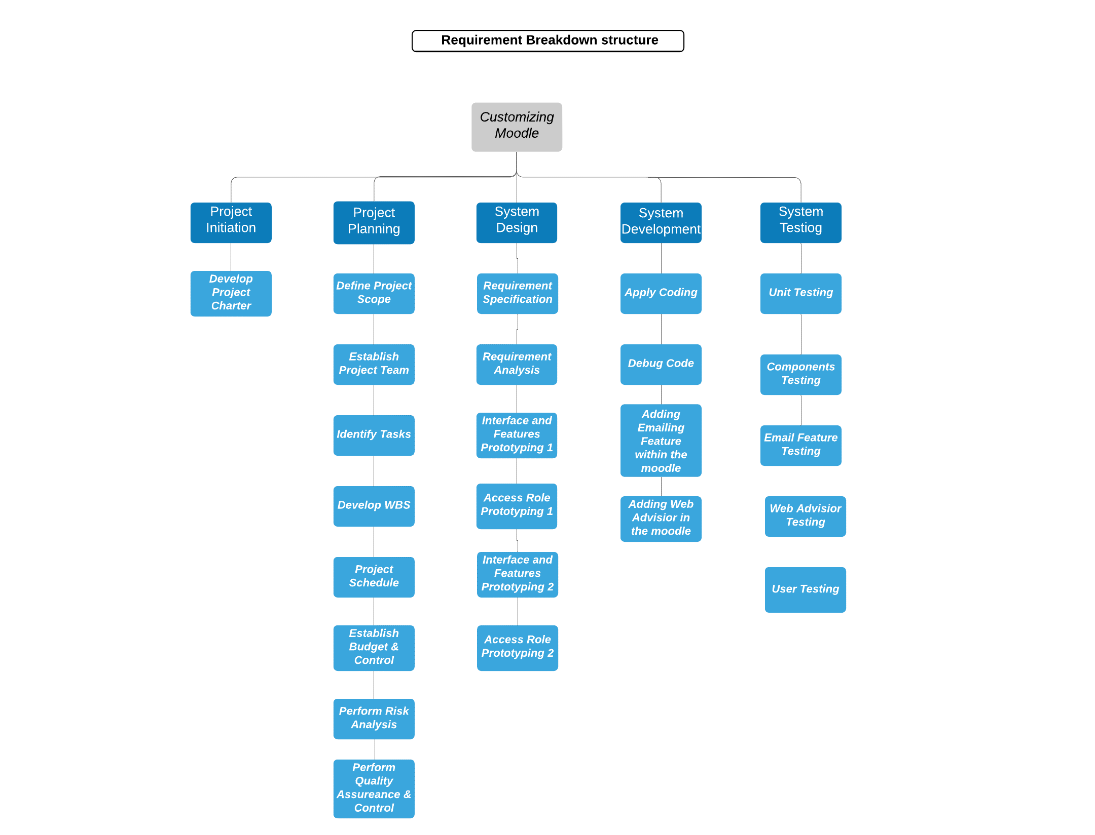

Work Breakdown Structure

Michael, project manager, divided the work into smaller parts by looking over all the requirements in the Required Breakdown Structure. Using this WBS, Michael can keep the track of work rate of the project. Michael does resource scheduling and estimation of duration using this WBS. He also figured out the estimated time required to complete every work by adding estimated time of divided work in WBS.

This is the Work Breakdown structure which Michael created for the project.

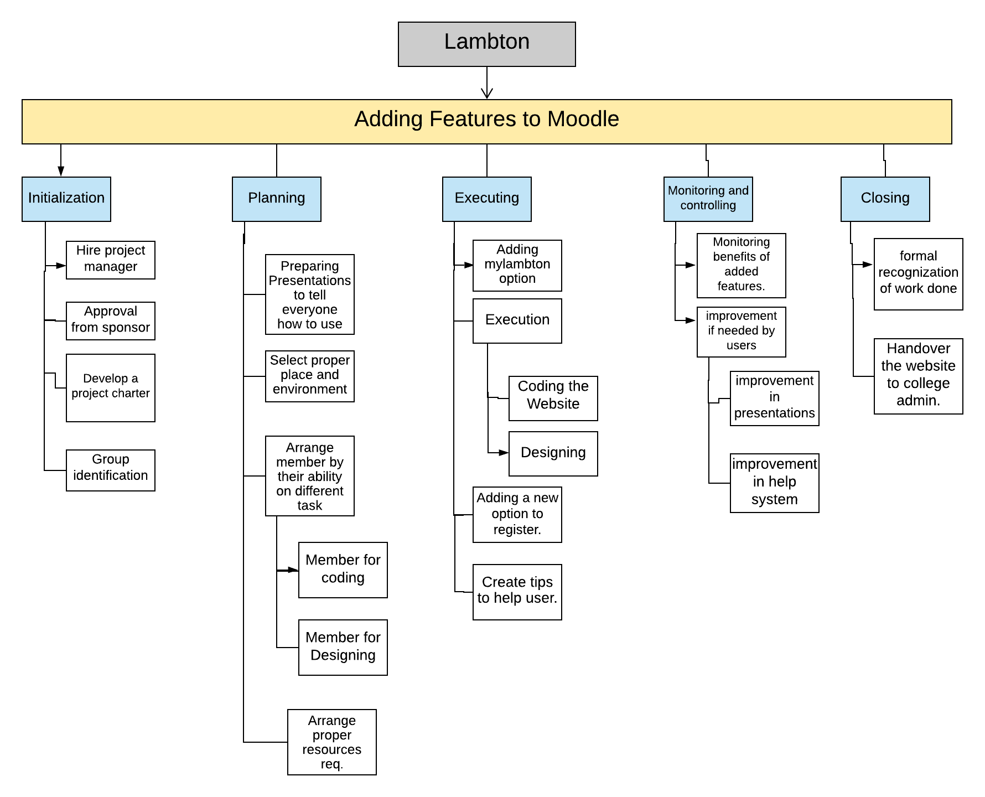

Resource Scheduling

According to the work to be done throughout the project, Michael recognized all the resources that are mandatory to do the different works. He figured out the required experts and their working number of hours, physical resources such as computers. Michael decided to acquire all the resources at affordable rate so that project can be completed within the budget. He allocated certain limited resources to every phase of the project and if any further resources are required, team can have a meeting and can discuss about the requirement of resource.

Michael also compared the project with the previous similar projects, and come to a conclusion of required resources and budget for these resources. He also got the idea that from where and which resource have to arrange.

Some of the necessary resources for the project are as follows:

* Team with expert designers
* Notepad++
* Meeting and work place
* Computers
* Server

Resources

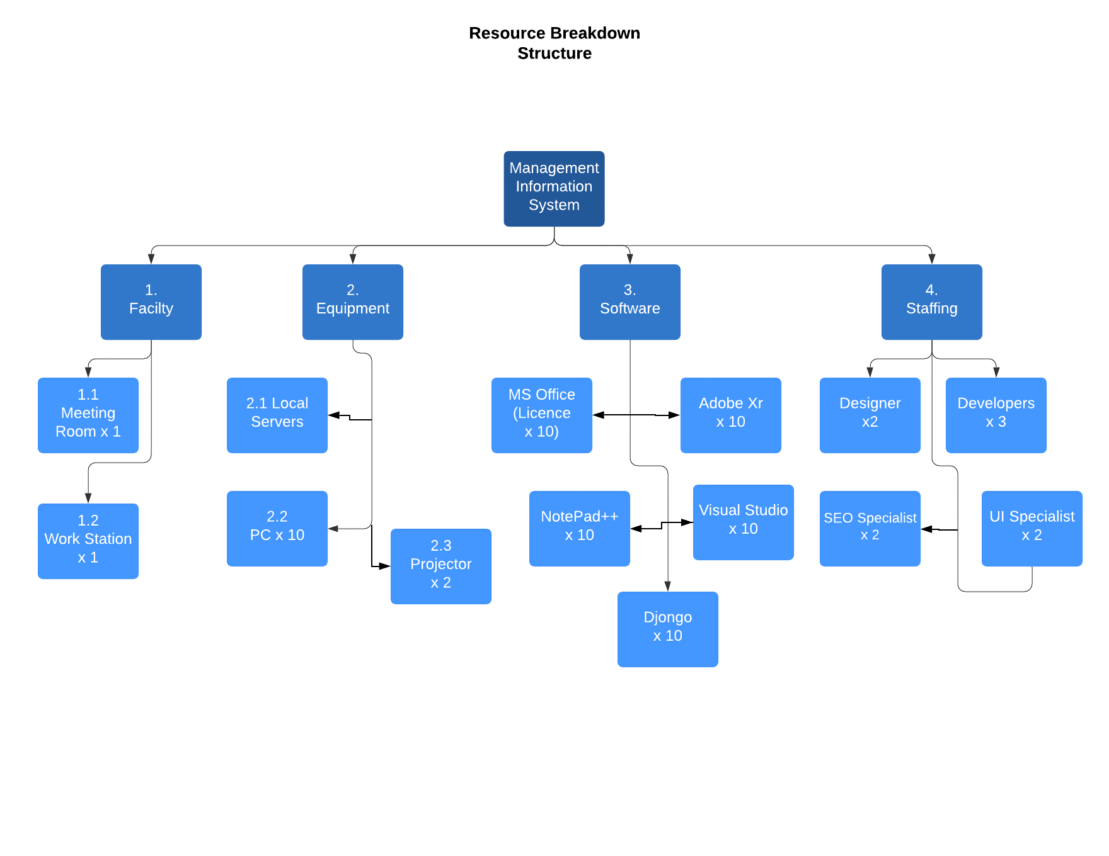

Cost and Duration estimation

Planning is not complete without estimating cost and time. So, Michael does the estimation of cost as well as time on the basis of resources and work respectively. Michael compared the resources with the other projects done in the past with almost similar resources, and estimated the budget required for the different resources. Also, for the time estimation, he compared project with similar projects done in past and gets an idea of time within which different divided parts of the work supposed to be completed.

The resources that depends upon cost in our project are:

1. Material Required.
2. Labour Expenses.

**Material Expenses:**

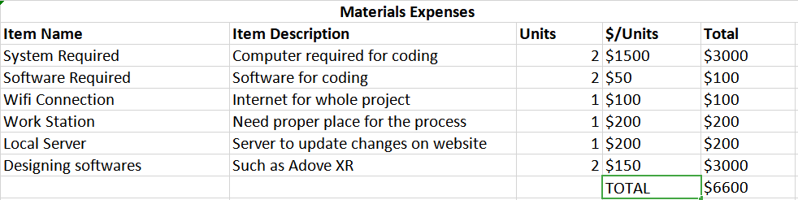

**Labor Expenses:**

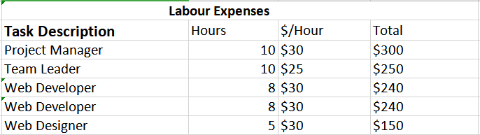

**Duration Estimate**

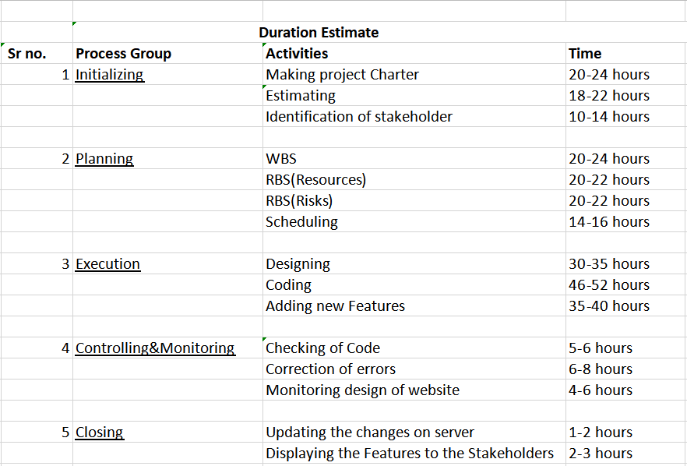

SWOT Analysis

SWOT Analysis is also done by Michael, project manager. He checked the previous status of the current Moodle and website of the college and found some strengths, weaknesses, opportunities and threats regarding college Moodle and mylambton site.

Strengths and weaknesses recognized by the Michael will help to achieve the objective of project and could cause trouble to achieve the objective of project.

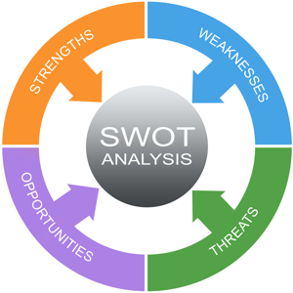

|  |  |
| --- | --- |
| **Strengths** | **Weaknesses** |
| 1. Whole code of Website is already made, we are just adding new feature. 2. Skilled team members. 3. New computers. 4. Popular software for coding. | 1. Less time. 2. Less budget. 3. Lots of Competing projects. 4. Addition of new feature may affect the functioning of native website. |
| **Opportunities** | **Threats** |
| 1. Technology development. 2. New innovation. 3. Reduce the time of users. 4. It may affect the demand of user. | 1. Changing customer needs. 2. Competitors copying the same features. 3. Instead of increasing, it may reduce the number of users. 4. Customer may find it more Confusing to use. |

Project Overview Statement (POS)

|  |  |  |  |
| --- | --- | --- | --- |
| **Project Name:**  Customising Moodle | **Project Manager:**  Mr. Komalpreet Singh | **Project Sponsor:**  Lambton College | **Team members:**  Abhishek Sharma Jaskaran Singh  Shahnawaz Singh |
| **Problem/Opportunity:**  Our testing team reports that there were some errors in the final product code which can lead to exceeded expenses and budget by an average of 4% by the end of the project. Also, to increase the profit by 10% by make more bug fixes and adding new features. | | | |
| **Goal:**  To implement all the new goals including adding email functionality in the Moodle with Web advisor and without exceeding already exceeded budget by the end of the project. | | | |
| **Objectives:**   1. Creating a new department to manage budgeting and expenses. 2. Including more developers in the already coding team to do project in time. 3. Fixing all the bug in the Moodle to take advantage of exceeded time. 4. Increasing quality control to make sure nothing goes wrong. | | | |
| **Success Criteria:**   1. The total project cost is just increased by 4% but the profit is increased by 10% to make sure there is no loss but profit. 2. At least 98% of the project will by ready before the dead line. 3. All the changes will be in the budget. 4. No expenses will be increased by more then 4% because of the planning. | | | |
| **Assumptions/Risks/Obstacles:**   1. User will be sensitive if time will be exceeded without adding new features. 2. Management will be supportive and consistent. 3. Every step will be noted by the department. | | | |

Risk Assessment and mitigation

Michael used the previous project’s data and identified those risks which can occur during this project. He finds some acceptable risks and some critical risks that might can occur. Michael decided to do a meeting with the team members and team leader regarding these risks. A conclusion of risk assessment and mitigation is also done.

**Risks that are typical for each phase of the project are as follows:**

**Initialization process:** At the beginning of the project, most of the risks are unknown. Identification of these risks is very important in order to decide if project should be chosen or not.

**Risk Identification:**

1. **Software:** Finding a proper software for the coding is difficult task which have more risks.

**Risk Assessment:**

* In this situation, probability of occurrence is low, but impact of the risk is high. Finding a proper software for coding is most important task. Because having a bad software take more time due to lack of proper features.
* As the risk is considerable, so cost of losses should not be too much.

**Risk Mitigation:**

* We can use a software which is already used in some previous projects.

1. **Team:** Not having proper team for each specific task is also a big risk.

**Risk Assessment:**

* For this circumstance, probability of occurrence is medium, but impact of the risk is very high. So, the risk is noteworthy and a particular action is needed here.
* As risk can make the situation critical, so cost can be also very high, or we can say that budget limit can be crossed.

**Risk Mitigation:**

* Teams should be assigned by looking their work and experience.

**Planning Process:** After the approval of the project, project moves to the planning phase. To identify risks in this process group, Risk Breakdown Structure (RBS) can be very helpful.

**Risk Identification:**

1. **Supply of material:** Materials could lead to short supply, which result in delay of the project.

**Risk Assessment:**

* For this condition, the probability of occurrence is low but impact of the risk is high. So, the risk is under considerable category and can be mitigated to a large extent by using a proper methodology.
* For this, cost of losses should also be considerable or might be very high depending on the situation.

**Risk Mitigation:**

* Order should be made from a reputed and known firm who are known for their best for products and deliveries. They should be given earlier time than required time of delivery so that if there are any chances of getting late, it will not be too much late in this way.

1. **Inappropriate tasks to volunteers:** During planning the structure of work to be done in the project, roles provided to different memebers might be wrong according to their capabilities.

**Risk Assessment:**

* For this condition, the probability of occurrence is low but impact of the risk is high. So, the risk is under considerable category and can be mitigated to a large extent by using a proper methodology.
* For this, cost of losses should also be considerable or might be very high depending on the situation.

**Risk Mitigation:**

* A survey for testing abilities of members should be conducted and record of their previous done works should be checked so that perfect role for the members can be concluded.

**Executing Process:** In this process, execution of the whole planning occurs. Because of advanced planning and risk mitigation attempts in advance according to the probability of their happening, risks and losses reduces in this phase.

**Risk Identification**

1. **Bad network:** Bad network conditions can create a risk of delay in completion.

**Risk Assessment:**

* In this situation, probability of occurrence is low, but impact of the risk is high, as internet is necessary for the coding work.
* Cost of losses cannot be affordable as their will be a great effect on the schedule of the project.

**Risk Mitigation:**

* Internet of two different companies should be arranges, so that in case if one stops working then we can use the other one and can call technician to look over the first one, which stops working.

1. **Design of website:** There could be design problems related to the structure of the website.

**Risk Assessment:**

* For this circumstance, both probability of occurrence and impact are medium, as we have hired experts who know how to design but still there are some possibilities of having problems in this matter.
* Cost of losses are negligible because these design is not a requirement and if design is not good in looking, still project will be successful with completeing all the requirements.

**Risk mitigation:**

* Design should be created by following some coding rules and following the previous pattern of colors, margins and padding.

**Monitoring & Controlling Process:** In this phase, whole project is reviewed and changes requested by the clients are handled and managed in the way by which there will be no negative impact on the project.

**Risk Identification:**

1. **Acceptance of unrealistic deadlines:** Sometimes changes requested take some time to be implemented in the project but these changes required to be done with in the given time limit of the project. So, it became difficult to manage these changes within time

**Risk Assessment:**

* For this circumstance, both probability of occurrence and impact are medium. Because, most of the time, some of the requirements are changed during project and they can be impossible to be fulfilled in the given time and within the budget.
* Cost of losses are negligible because these requirements were not in the project charter, so it will not affect too much on project.

**Risk Mitigation:**

* An agreement must be signed in advance that if any major requirement changes occur or demand increases, then these will be only accepted by changing some important conditions of the project.

**Closing process:** This phase is for finalizing all the activities, fulfilling the requirements based on everything that was described in the project charter.

**Risk Identification:**

1. **Insufficient budget:** Budget can go over the limit due to which project can be unsuccessful, as one of the project quality constraint i.e., cost, is getting affected.

**Risk Assessment:**

* Probability of occurrence is low because during initialization, project charter was approved in which a proper budget was defined but losses of risk can be high because due to insufficient budget project become unsuccessful.
* Cost of losses is very high, as there are some possibilities of failure in the project.

**Risk Mitigation:**

* We should try to hire the workers at the reasonable salary and we should spend money on equipment according to the value which is defined in the project charter.

Project monitoring and controlling

Our project is monitored through different meetings with the management of college. All the requirements were specified by the Lambton college. Also Added features of the website are to be given to the dean of the college. Our team made a proper table which shows the detailed information of the activities done in the project. This way every member of management can be updated about the project without any trouble. Each member involved know what they done in the project, which helps them to make a proper report of the project.

The main motive of monitor and control is to find whether all the requirements of the clients are fulfilled. While monitoring, our team found that all the requirements of the stakeholders were fulfilled. After rechecking, our team found that no changes were required then we continued to the closing process.

The Above information shows that our whole project is planned well by the project manager. That’s why no changes were made in the monitoring and controlling process. Whole team knew what they were doing and they tried to cover all the requirements.

Gantt chart

As required in every project, it’s important to classify all the tasks against the time. So, we have used Gantt chart that represent a time period for all the tasks in our project

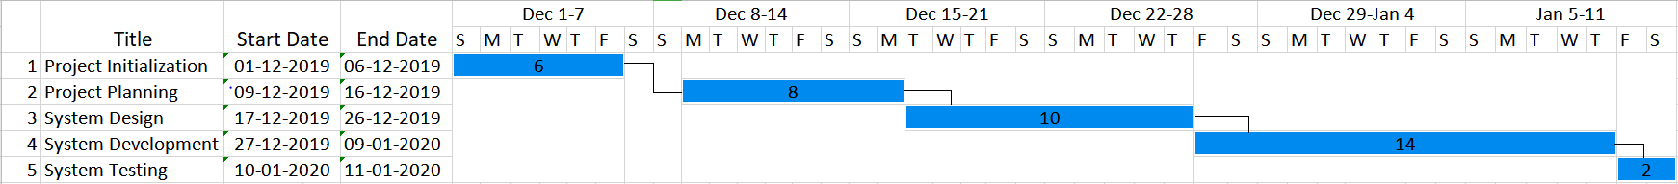

Conclusion

Now, in the conclusion of the project, few projects can be consisting of all the parts that comes under the objective of project management, which may be wrong for some of the projects. It would be consisting of plenty of situations or factors. However, due to some issue in the size of project, maybe there would be some of the changes required in project or other reason would be the environment of the organization.

So far know, mostly in project what we see is the project management contains mostly theoretical parts and aspect of it . As, there are a lot of areas which may or may not be used in projects. It may be because of the difference of it from construction to research and development. In this project, the focus is on changings in the software of Lambton College. As, our group is making moodle software way better then now. By doing some changes in these areas everyone will see many changes on Moodle.

Citations:

(PressBook, 2003)

References:

PressBook. (2003). Retrieved from Risk Management: https://pm4id.org/chapter/11-3-project-risk-by-phases/