**1. INTRODUCTION**

* 1. **INTRODUCTION TO PROJECT**

The project titled as “Enterprise Resource Planning System (ERPS)” is developed in Django (Python) as front end and SQLite as backend. The main aim of the project is to create a web based application for the user. The main objective to develop this project is to create a platform which is student as well as Teacher friendly. This project will not only ease the workload on students but also reduce the burden of Teachers among their students. Student-Faculty management system is the perfect solution to deal with problems like:

1. Maintaining the Student attendance record.

2. Generating assignments.

3. To keep track on attendance as per Students.

4. To deal with MST’s and a lot more.

**Modules:**

The system comprises of 3 major modules with their sub-modules as follows:

* Admin:
  + Login: Admin can login his personal account.
  + Add/View Student: Admin add student detail into a system.
  + Add/View Teacher: Admin add Teacher detail into a system
  + Add Time-Table: Admin set and add time table.
* Teacher:
  + Login: Teacher can login in his personal account.
  + Add Assignment: Teacher can add assignment detail for the students.
  + Add Attendance: Teacher can add attendance detail into a database.
  + Add Result: Student can add result detail.
* Student:
  + Login: Student can login his personal account.
  + View Profile: Student can see his profile.
  + View Time-Table: Student can view all timetable detail.
  + View Assignment: Student can view all assignment detail added by teacher.
  + View Result: Student can view result.
  + View Attendance: Student can view attendance.
    1. **FEATURES**

ERPS has many features. The following list gives an overview of the main features included in the ERPS.

* + - To provides the facility to the students to keep track on their attendance on regular basis by keeping the entire attendance system online, thus eliminate contradiction.
    - Our application also has the feature of generating assignments online so that it is being received by each student.
    - To Share any official information will become be easy through this platform.
    - This system will provide previous MST’s and Final Exam’s question papers section ally by semester according to respective subject.
    - Students can easily post their queries and any other student or even Teacher may give the solution etc.
  1. **ABOUT THE TECHNOLOGY:**

Python is an interpreted high-level programming language for general-purpose programming. Created by Guido van Rossum and first released in 1991, Python has a design philosophy that emphasizes code readability, notably using significant whitespace. It provides constructs that enable clear programming on both small and large scales. Python features a dynamic type system and automatic memory management. It supports multiple programming paradigms, including object-oriented, imperative, functional and procedural, and has a large and comprehensive standard library. Python interpreters are available for many operating systems. Python, the reference implementation of Python, is open source software and has a community-based development model, as do nearly all of its variant implementations. Python is managed by the non-profit Python Software Foundation.

* + 1. **FRONT END :**

**Django Framework:**

Django is a [Python](https://en.wikipedia.org/wiki/Python_(programming_language))-based [free and open-source](https://en.wikipedia.org/wiki/Free_and_open-source_software) [web framework](https://en.wikipedia.org/wiki/Web_framework), which follows the model-template-view (MTV) [architectural pattern](https://en.wikipedia.org/wiki/Architectural_pattern_(computer_science)). It is maintained by the [Django Software Foundation](https://en.wikipedia.org/wiki/Django_Software_Foundation) (DSF), an independent organization established as a non-profit.

Features of Django:

* Ridiculously fast: Django was designed to help developers take applications from concept to completion as quickly as possible.
* Fully loaded: Django includes dozens of extras you can use to handle common Web development tasks. Django takes care of user authentication, content administration, site maps, RSS feeds, and many more tasks right out of the box.
* Reassuringly secure: Django takes security seriously and helps developers avoid many common security mistakes, such as SQL injection, cross-site scripting, cross-site request forgery and click jacking. Its user authentication system provides a secure way to manage user accounts and passwords.
* Exceedingly scalable: Some of the busiest sites on the planet use Django’s ability to quickly and flexibly scale to meet the heaviest traffic demands.
* Incredibly versatile: Companies, organizations and governments have used Django to build all sorts of things from content management systems to social networks to scientific computing platforms.

**HTML:**

HTML stands for Hyper Text Markup Language. It is used to design web pages using markup language. HTML is the combination of Hypertext and Markup language. Hypertext defines the link between the web pages. Markup language is used to define the text document within tag which defines the structure of web pages. This language is used to annotate (make notes for the computer) text so that a machine can understand it and manipulate text accordingly. Most of markup (e.g. HTML) languages are human readable. Language uses tags to define what manipulation has to be done on the text.  
HTML is a markup language which is used by the browser to manipulate text, images and other content to display it in required format. HTML was created by Tim Berners-Lee in 1991. The first ever version of HTML was HTML 1.0 but the first standard version was HTML 2.0 which was published in 1999.

Features:

* Platform independent language.
* It is not case sensitive language.
* Title, Lists, Paragraph, etc.
* Controls fonts, colors, positioning using CSS( Cascading Style Sheets).
* We can build tables.

**CSS:**

**C**ascading **S**tyle **S**heets, fondly referred to as **CSS**, is a simply designed language intended to simplify the process of making web pages presentable. CSS allows you to apply styles to web pages. More importantly, CSS enables you to do this independent of the HTML that makes up each web page.

CSS is easy to learn and understood but it provides powerful control over the presentation of an HTML document.

Features:

* **CSS saves time:**You can write CSS once and reuse same sheet in multiple HTML pages.
* **Easy Maintenance:**To make a global change simply change the style, and all elements in all the web pages will be updated automatically.
* **Search Engines:**CSS is considered as clean coding technique, which means search engines won’t have to struggle to “read” its content.
* **Superior styles to HTML:**CSS has a much wider array of attributes than HTML, so you can give a far better look to your HTML page in comparison to HTML attributes.
* **Offline Browsing:**CSS can store web applications locally with the help of offline cache. Using of this we can view offline websites.

**JAVASCRIPT:**

JavaScript is a very powerful **client-side scripting language**. JavaScript is used mainly for enhancing the interaction of a user with the webpage. In other words, you can make your webpage more lively and interactive, with the help of JavaScript. JavaScript is also being used widely in game development and[Mobile](https://www.guru99.com/mobile-testing.html)application development.

Features:

* Reuse same sheet in multiple HTML pages.
* JavaScript is a object-based scripting language.
* Giving the user more control over the browser.

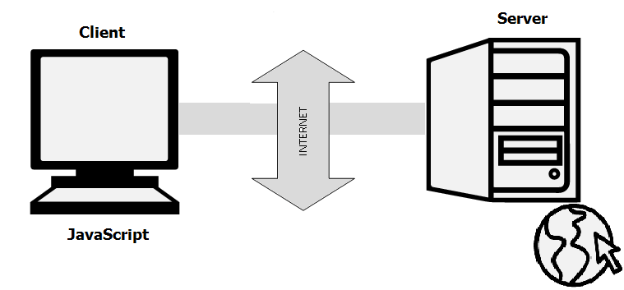

* It Handling dates and time.
* It Detecting the user's browser and OS,
* It is light weighted.
* JavaScript is a scripting language and it is not java.
* JavaScript is interpreter based scripting language.
* JavaScript is case sensitive.
* JavaScript is object based language as it provides predefined objects.
* Every statement in JavaScript must be terminated with semicolon (;).

**BOOTSTRAP:**

Bootstrap is the most popular HTML, CSS and JavaScript framework for developing a responsive and mobile friendly website. It is absolutely free to download and use. It is a front-end framework used for easier and faster web development. It includes HTML and CSS based design templates for typography, forms, buttons, tables, navigation, modals, image carousels and many others. It can also use JavaScript plug-ins. It facilitates you to create responsive designs. Bootstrap was developed by Mark Otto and Jacob Thornton at Twitter. It was released as an open source product in August 2011 on GitHub.In June 2014 Bootstrap was the No.1 project on GitHub.

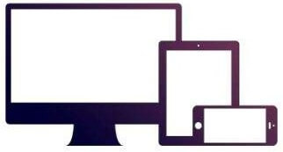

* + 1. **BACK END :**

**SQLITE:**

SQLite is a very easy to use database engine. It is self-contained, server less, zero-configuration and transactional. It is very fast and lightweight, and the entire database is stored in a single disk file. It is used in a lot of applications as internal data storage. The Python Standard Library includes a module called "sqlite" intended for working with this database. This module is a SQL interface compliant with the DB-API 2.0 specification. To use the SQLite module we need to add an import statement to our python script. SQLite is ACID-compliant and implements most of the SQL standard, generally following PostgreSQL syntax. However, SQLite uses a dynamically and weakly typed SQL syntax that does not guarantee the domain integrity.



This means that one can, for example, insert a string into a column defined as an integer. SQLite will attempt to convert data between formats where appropriate, the string "123" into an integer in this case, but does not guarantee such conversions, and will store the data as-is if such a conversion is not possible. SQLite is a popular choice as embedded database software for local/client storage in application software such as web browsers. It is arguably the most widely deployed database engine, as it is used today by several widespread browsers, operating systems, and embedded systems (such as mobile phones), among others. SQLite has bindings to many programming languages.

SQLite is a popular choice as embedded database software for local/client storage in application software such as web browsers. It is arguably the most widely deployed database engine, as it use today by several widespread browsers, operating systems, and embedded systems (such as mobile phones), among others. SQLite has bindings to many programming languages.

* 1. **ABOUT THE COMPANY**

The Company, Lally Infosys came into inception in the year 1997 on 14th October with a vision to be leader in the field of quality Education. Over these years of working the company has garnered a reputation among the masses as an institute, which means quality and has contributed to its maximum for the importance of investment in terms of Quality Delivery of Education as it is the Quality that matters and is the key to success.

 Lally Infosys is found to comply with the requirements of ISO 9001:2008.

Lally Infosys is the first one in Punjab to have ASSET INTERNATIONAL a high-end division of Aptech Ltd. The company had been rated as Microsoft’s best CTEC partner

In the end of year 2001 the company got associated with Punjab Technical University, Jalandhar Distance Education program. Lally Infosys got first position in all over India in IT and Management.

The company had tied up with the IT giants like Red Hat Linux, Microsoft, Sun Microsystems, HP, Suse Linux.The Company has also tie up with Tally Champs.

Since 2014, company has been working with an NGO Fikar-e- Hondh(CCC) who works for social work and charity like fostering poor families financially, tree plantation , blood donation etc.  From 2014, Company is also a Regional Centre of LPU Distance Education Program having learning centers in 6 Districts i.e. Jalandhar, Amritsar, Pathankot, Tarantaran, Kapurthala, Gurdaspur  . The company is headed by Mr.Sukhwinder Singh Lally a renowned personality of Jalandhar.  A widely travelled man he has been a pivot behind the success of many enterprises various locations in the globe. In year 1995 he moved back to his nation with a mission to start some business where he could also serve his society and nation.

This vision led to the genesis of an educational institution. He is also the Ex-Chairman of ‘The Goraya Marketing Society’, Vice President ‘All India PTUDEP Associates’, Ex-Director of ‘The Jalandhar Central Co-operative Bank and at present Governing secretary of Jat Sikh Council. He has been awarded with International Achievers ‘Award during 25th Indo-Thai entrepreneurs. He also got another awards like business buzzard of north India by India today, sanik welfare award, awarded for the major contribution to organizing blood donation camps and honored by MCJ for the contribution in the campaigning for smart city Jalandhar, Tree plantation, campaign to create awareness for traffic rules, yearly distributed blankets and school uniforms, free education to war suffers and handicaps etc. Company has also given training to various corporate like Punjab Land Records, Central Bank of India, Jalandhar Doordarshan, Jalandhar central cooperative bank Usha International, Allahabad Bank, Rail Coach Factory, State Bank of India, BSF, Commander works Engineer, Punjab police, Air Force



1. **FEASIBILITY STUDY**

Feasibility Study is a preliminary study undertaken to determine and document a project’s viability. The term feasibility study is also used to refer to the resulting document. These results of this study are used to decide whether to proceed with the project, or table it. If it indeed leads to a plan being approved, it will – before the real-work of the proposed project starts – be used to ascertain the likelihood of the project’s success. It is an analysis of possible alternative solutions to a problem and a recommendation on the best alternative.

It, for example, can decide whether an order processing be carried out by a new system more efficiently than the previous one.

**2.1 Operational feasibility:**

**Operational feasibility** involves questions such as whether the technology needed for the system exits, how difficult it will be built, and whether the firm has enough experience using that technology. The assessment is based on an outline design of system requirements in terms of Input, Processes, Output, Fields, Programs, and Procedures. This can be qualified in terms of volumes of data, trends, frequency of updating to give an introduction to the technical system. The application is the fact that it has been developed on Windows 10 platform and a high configuration of 4 GB RAM on Intel Core i5 processor. This is technically feasible.

**2.2 Financial and Economic feasibility:**

Establishing the cost-effectiveness of the proposed system i.e., if the benefits do not outweigh the costs, then it is not worth going ahead.

In the fast-paced world today, there is a great need for online social networking facilities. Thus the benefits of this project in the current scenario make it economically feasible.

**2.3 Handling Infeasible Projects:**

We did not face any infeasibility during this project because we used Pycharm to build this project. We installed it on laptop quickly because it is available free of cost. Whenever we got errors or difficulties in the project, our project guide helped and provided the way to proceed. We completed the project before the deadline successfully.

### 2.4 Time feasibility:

A time feasibility study will take into account the period in which the project is going to take up to its completion. A project will fail if it takes too long to be completed before it is useful. Typically this means estimating how long the system will take to develop, and if it can be completed in a given time period using some methods like payback period. Time feasibility is a measure of how reasonable the project timetable is. Given our technical expertise, are the project deadlines reasonable? Some projects are initiated with specific deadlines. It is necessary to determine whether the deadlines are mandatory or desirable.

1. **METHODOLOGY/ PLANNING OF WORK**

**Designing Layer:**

In which designing of user interface screens can be done through buttons, text box, labels, etc. It can be done through any basic technologies like HTML, CSS, JavaScript, Bootstrap.

**Business Layer:**

The logic behind the buttons, text boxes can be done under business layer. It can be done by technology like Python (Django). All the logics behind the business layer can be done in Python (Django).

**Back-end Database Layer:**

Every application and projects use a database to store the information, which can processed between different modules of application and project. Different types of backend technologies can be used to store the data like SQLite, Fire Base etc.

Data Flow Diagram

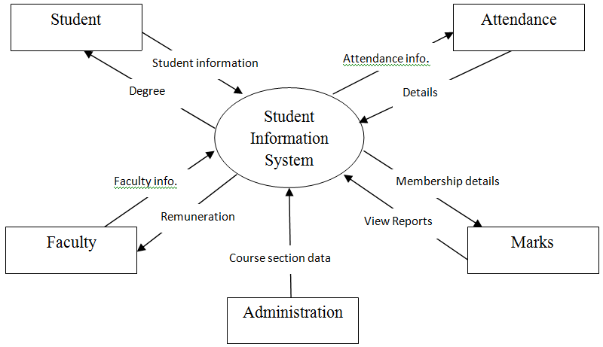

Fig. 1

1. **FACILITIES REQUIRED FOR PROPOSED WORK**

**Hardware**: Processor Intel core i5 and above.

**Operating System:** Windows 8, Windows 10

**Internet Connection:** Wi-Fi, Mobile Data

**Browser:** Google chrome latest version

**Database:**  SQLite

**Performance:**  The turn-around time of the project will be medium.

**Software:**Pycharm , Django, Visual Studio

1. **SNAPSHOTS**

* **Home Page:**

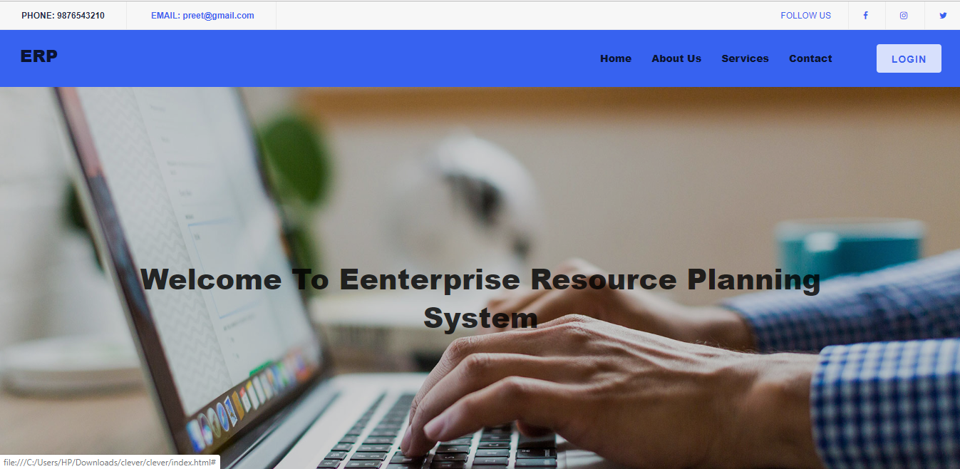

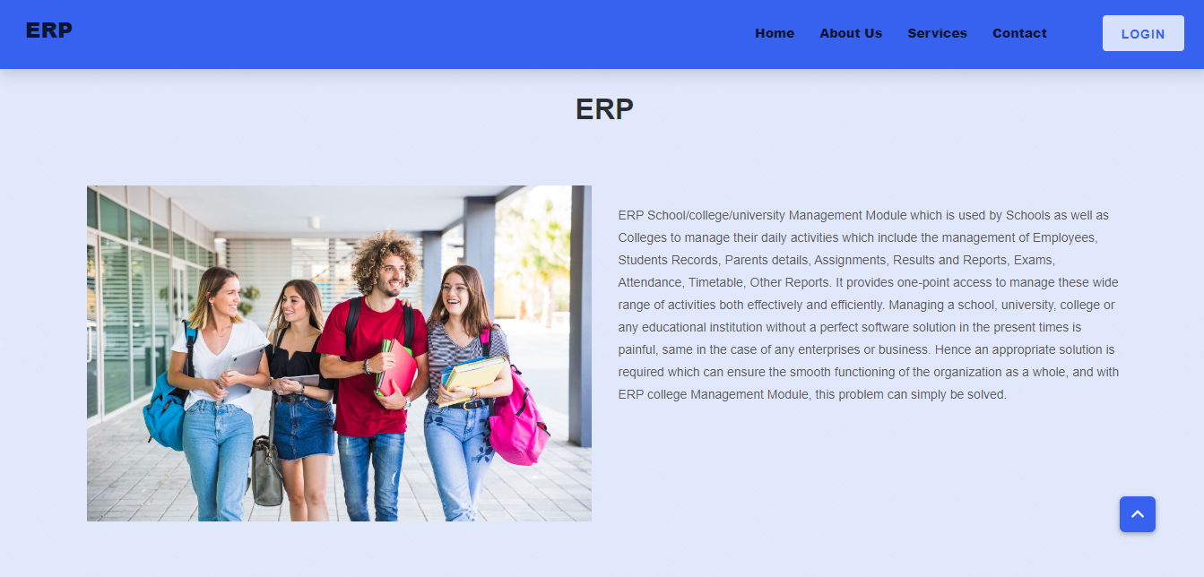

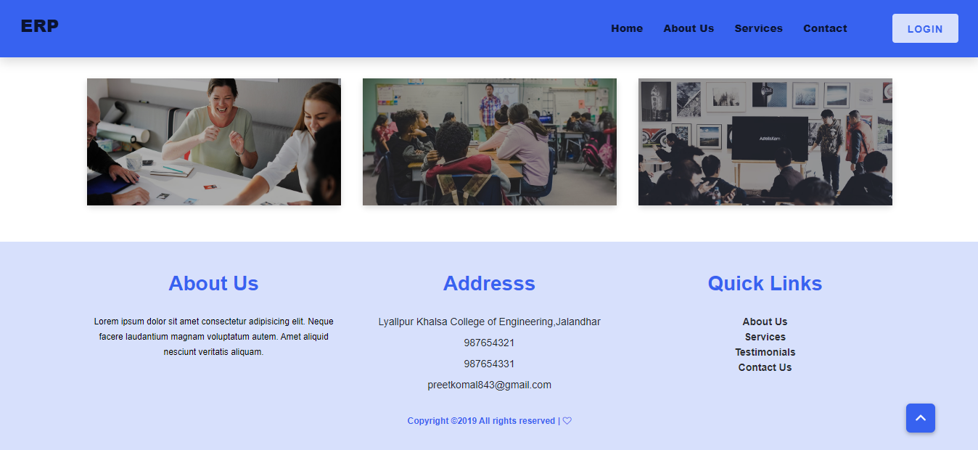

* **About Us Page:**

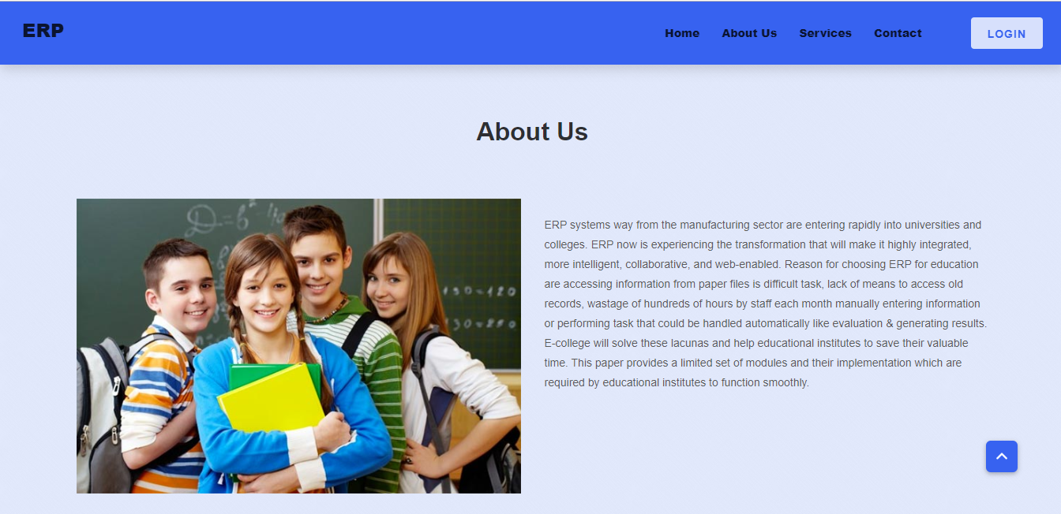

* **Services :**

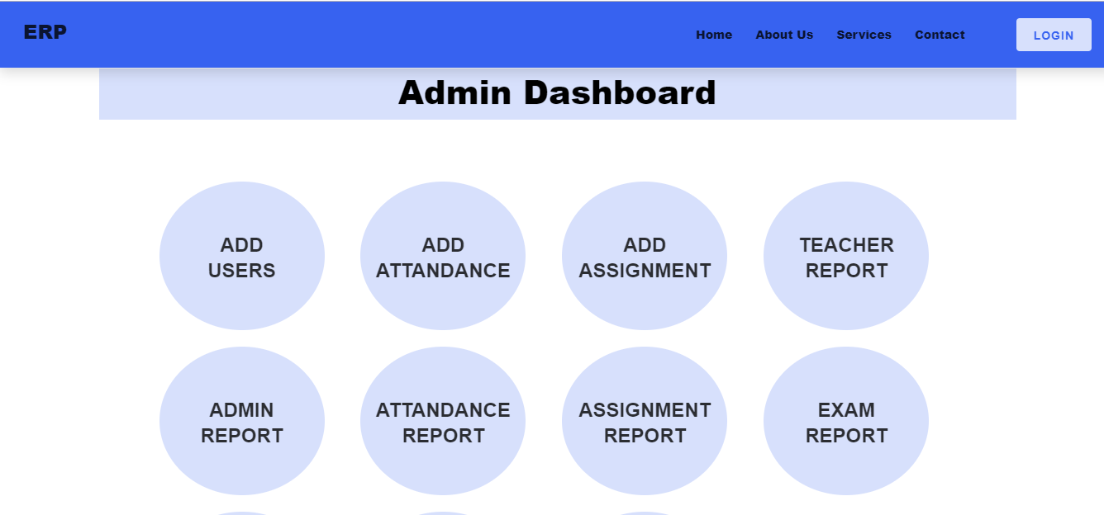

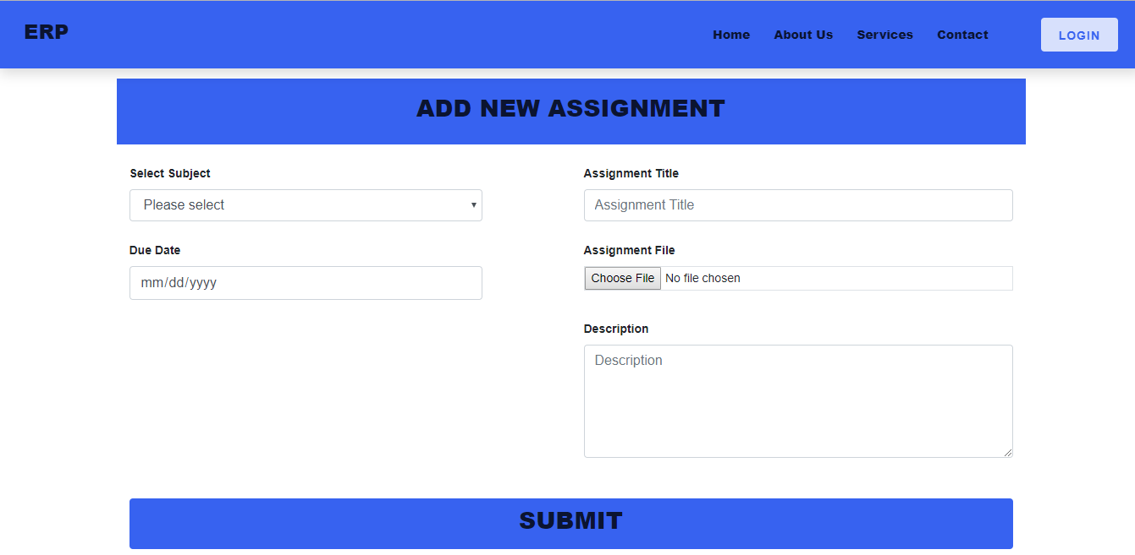

* **Contact Us:**

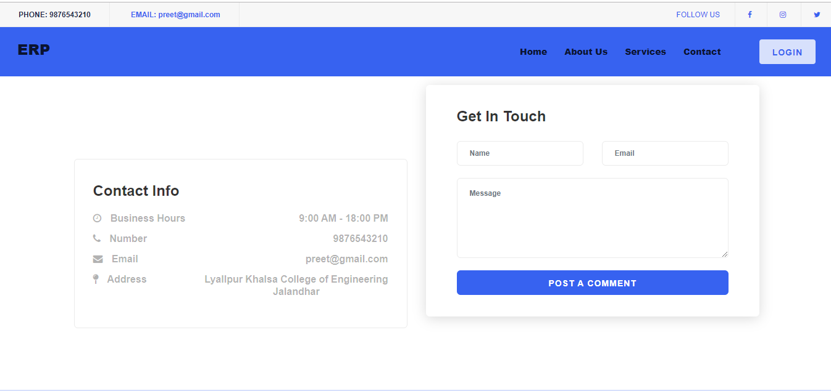

1. **CONCLUSION**

Enterprise Resource Planning System is the system that deals with the issues related to a particular institution. It is the very useful to the student as well as the faculties to easy access to finding the details. This project is successfully implemented with all the features and modules of the college management system as per requirements. The college ERP provides appropriate information to users based on their profiles and role in the system. This project is designed keeping in view the day to day problems faced by a college system.

1. **BIBLIOGRAPHY**

* The Complete Reference Python 3.7 Python documentation and Django documentation.
* [www.geeksforgeeks](http://www.geeksforgeeks)
* [www.w3schools.com](http://www.w3schools.com)