**Computer Hardware Software Workshop**

**Mini Project-3**

Group Members : Harshit Gupta(2021UCS1621)

Ayush Kumar (2021UCS1636)

Komal Raj (2021UCS1649)

Batch: Computer Science Engineering ,Section-2

Collaboration Email: gear5.akh@gmail.com

Topic : Power-Bi

Question 1:

Explore Power View, Power Query

A.Create a table Employee(empid, gender, department, salary, country, year_of_joining)

connect to Employee data file.

Remove missing gender and department values.

Extract year_of_joining column and visualize number of employees w.r.t year of experience in the company.

B.Perform self-join using Power Query.

C.Aggregate salary with gender and Visualize using Pie chart.

**Solution:**

1. Extract year_of_joining column and visualize number of employees w.r.t year of experience in the company.

Step 1:

We created a table containing following columns and rows:

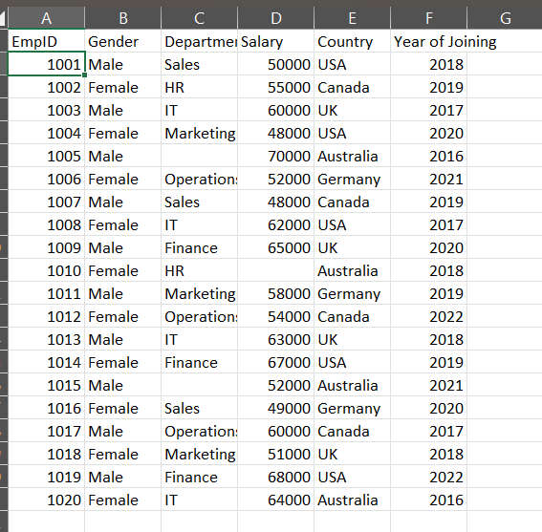

Step 2:

Removing null values from the table using the query :

= Table.SelectRows(#"Added Custom1", each ([Gender] <> null or [Department]<>null or [Salary]<>null))

The resulting table looks like:

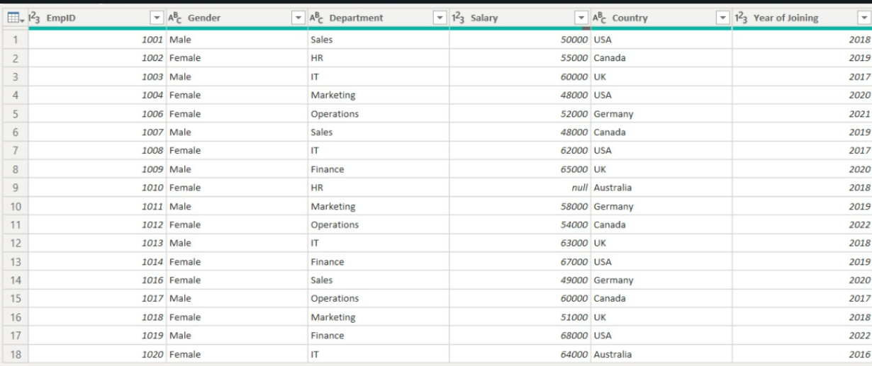

Step3: now,we have to add a new column named years_of_experience by following steps  
 Addcolumns->custom columns->put column name as “years_of_experience” and formula as

= Date.Year(DateTime.LocalNow()) - [Year of Joining]

The resultant table looks like this :

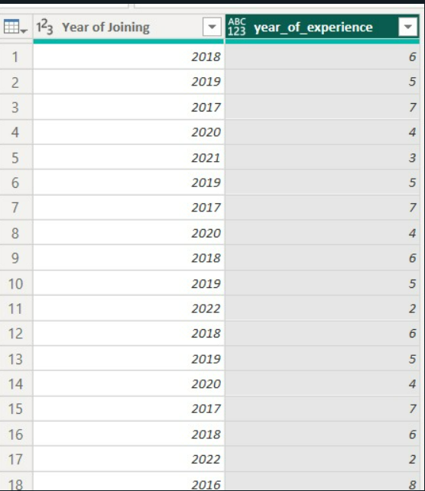

Step 4: Using group by query ,we extracted no. of employees w.r.t years of experience.



Resultant table for this query :

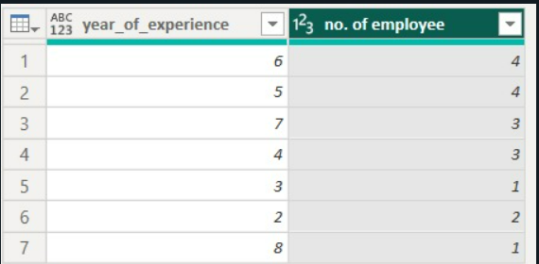

Step5: Visualization is done with the power bi pie chart tool and following is the result .

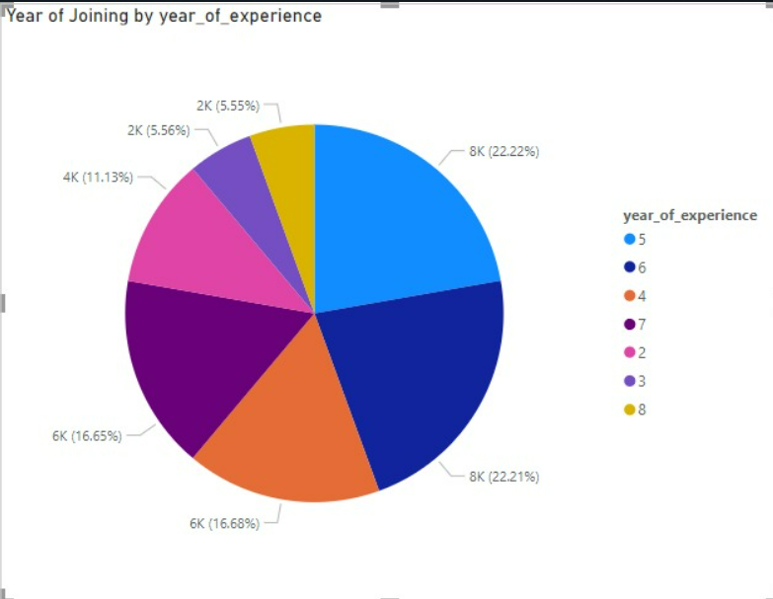

Visualisation using funnel looks like:

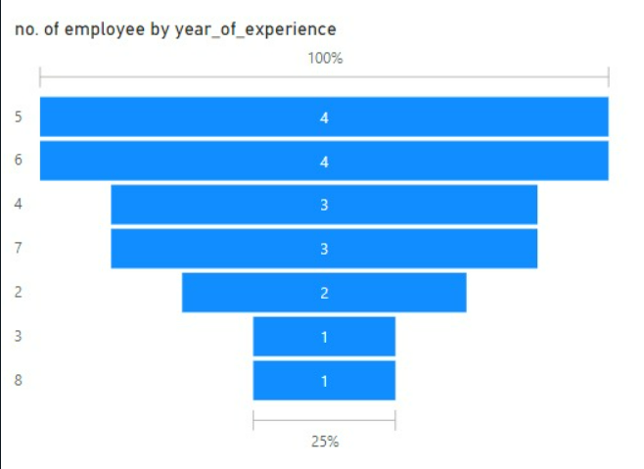

Visulaisation using Histogram is as follows:

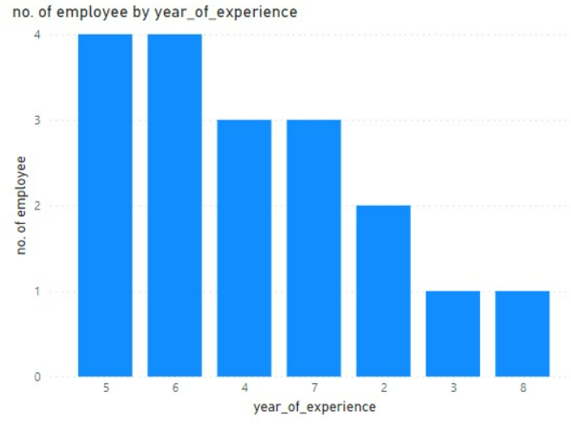

1. Perform self-join using Power Query.

Step1: Using power Bi, transform table and then Home-> Merge Queries

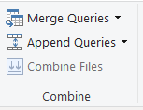

Select the sheet1 in dropdown (Self join is joining the table with itself ,so we will use same table as both inputs as shown below)

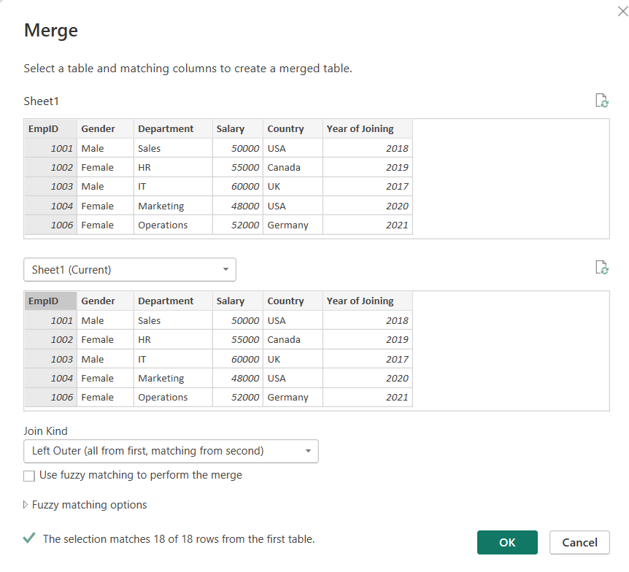

Step2:

After merging the table looks like following:

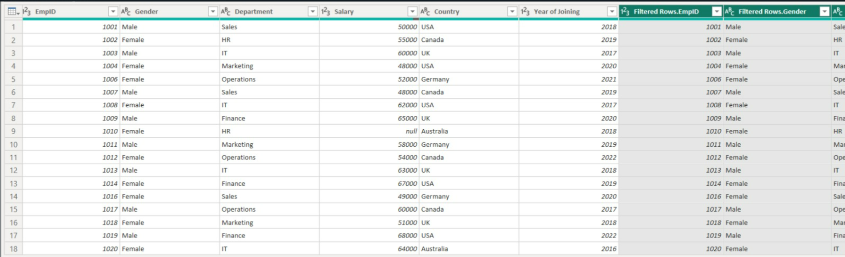

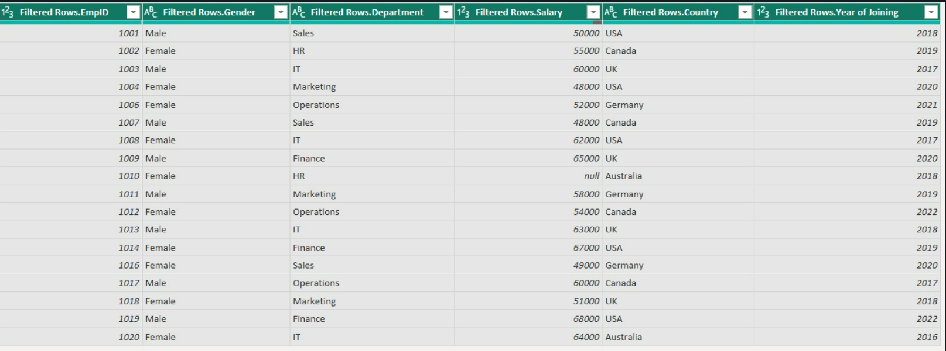

1. Aggregate salary with gender and Visualize using Pie chart.

Step1: By using the following group by query ,we can get aggregate salary with gender .



The resultant table is as follows

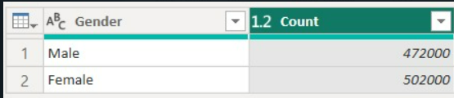

Step 2: Visualisation is done by using Powerbi pie chart tool

Following is the resultant pie chart .

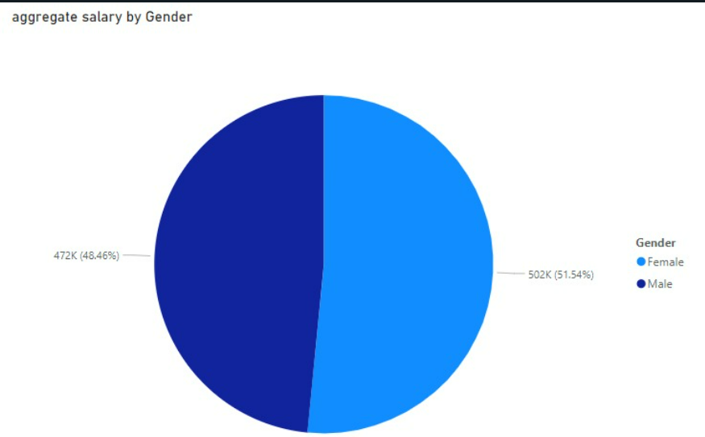

**Question 2.**

Visualize the result of any Machine Learning algorithm on any dataset of your choice in PowerBI.

Solution:

Step1: For dataset, we used sns library to download the dataset named Diamond.  
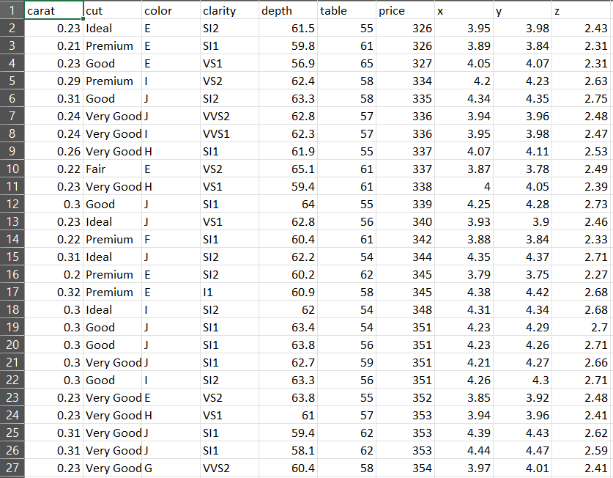

Step2:Connected the data through power BI(transform data ).  
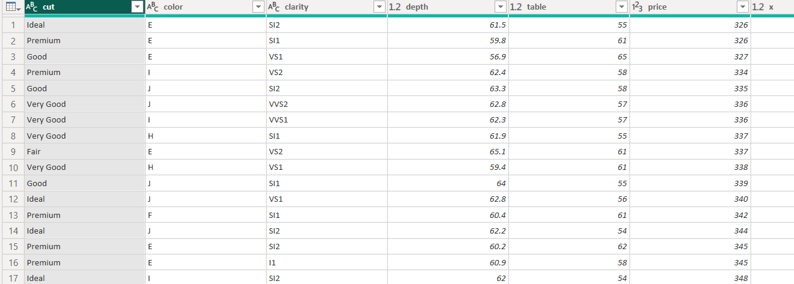

Step3: Go to transform->run python script



Step 4:

Using the following python script ,run it on the power BI

# 'dataset' holds the input data for this script

import pandas as pd

from sklearn.neighbors import KNeighborsRegressor

from sklearn.model_selection import train_test_split

from sklearn.preprocessing import StandardScaler

knn = KNeighborsRegressor(n_neighbors=7)

X=dataset.drop(['price','x','y','z'],axis=1)

X=pd.get_dumies(X)

y=dataset['price']

features=X.columns

s = StandardScaler()

X = s.fit_transform(X)

X_train,X_test,y_train,y_test = train_test_split(X,y)

knn.fit(X_train,y_train)

dataset['prediction']=knn.predict(X)

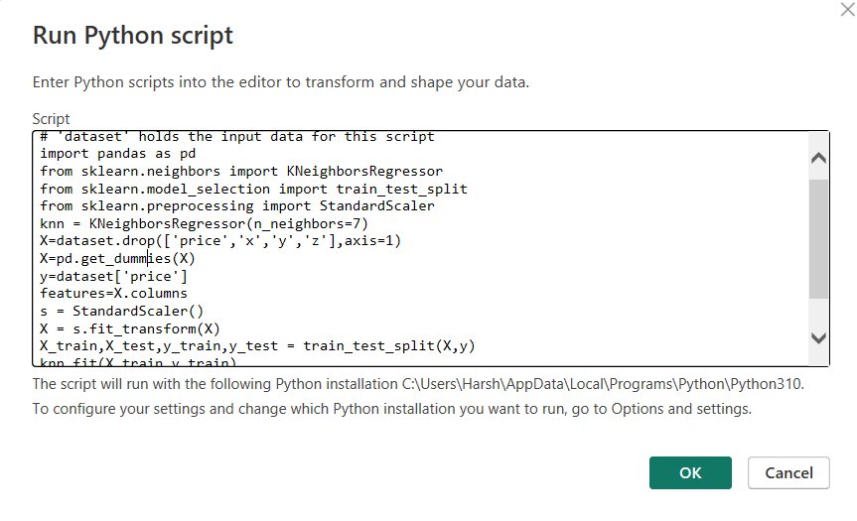

Step5:

After running the script, a column named prediction was created ,predicting the price of diamond.

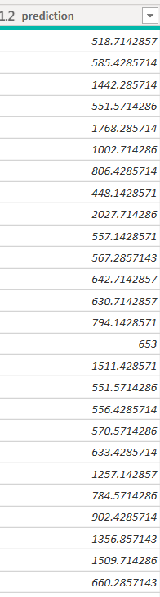

Step6:Visualising data by using Power Bi tools :

1. By using line graph :

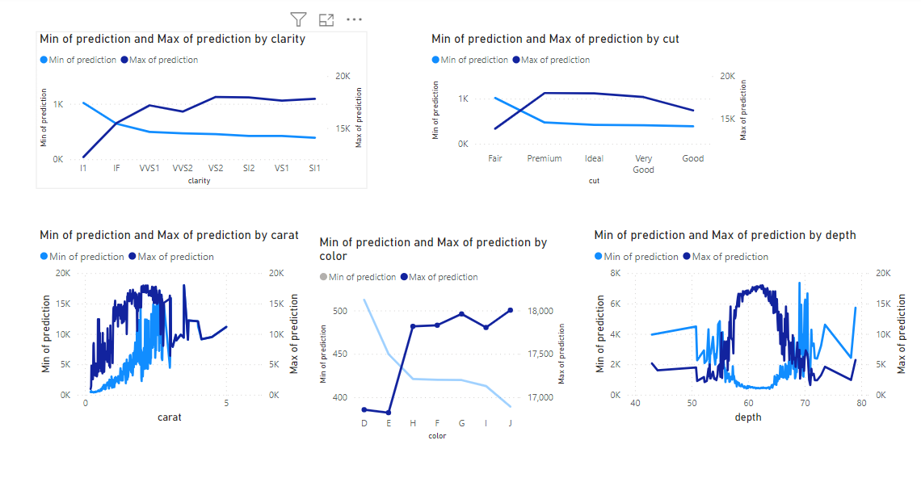

1. By using scatter plot:

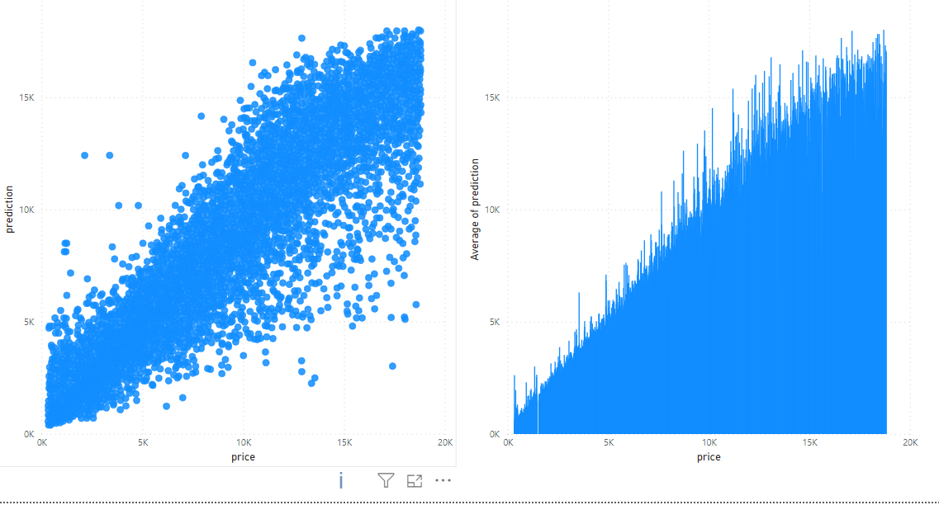

Conclusion:

The visualization using Power Bi is done .