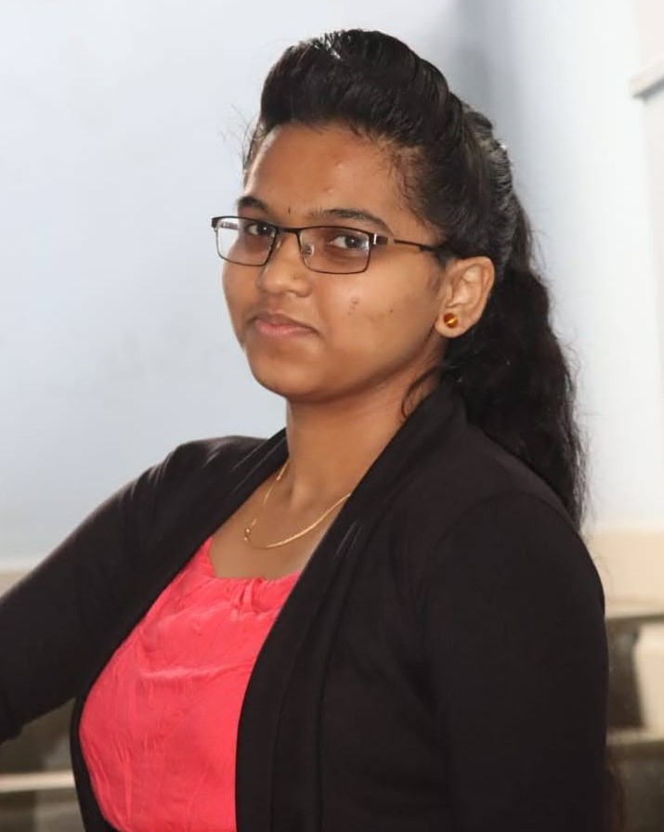 |  | Komal S Kallanagoudar
Profile  To work in a challenging environment which allows me to utilize and upgrade my technical, professional as well as personal skills and contribute towards the organizational growth and development.  Contact  PHONE:  +91 8971731395  EMAIL:  komalskgoudar@gmail.com  Skills  C, C++, Java, Python, Java Script,  HTML  Certificates  Web Application Technologies and Django  Hobbies  Reading Books  Art and craft  Drawing |  | work Experience  Worked as Programmer Trainee in Cognizant  Oct 30 2021 – Sep 09 2022  eduction  MCA - M.S. Ramaiah Institute of Technology, Bangaluru  Feb 2023 - June 2024  8.67  BCA - C.S.I. College of Commerce, Dharwad  June 2018 - Nov 2021  88%  PUC - Karnataka Science College, Dharwad  June 2016 – April 2018  71%  SSLC - Shree Parshwanatha English Medium High School, Gadag  June 2015 – April 2016  92.32%  projects  - Online Fee Payment System  - Smart Traffic Management Sysetm using Iot (Sensors)  - Student Budjeting Application  - SmartFlow: Prioritize Emergency Vehicle and Traffic Rules Monitoring System (Using Camera)

