Temperature and humidity monitoring @HHES

**Sensor:** [**SHT31**](https://sensirion.com/products/catalog/SHT31-DIS-B)

**Client:** [**Raspberry Pi Zero**](https://www.raspberrypi.com/products/raspberry-pi-zero/)

**Server:** [**Raspberry Pi 3 Model B**](https://www.raspberrypi.com/products/raspberry-pi-3-model-b/)

**Tutorial:** [**Reddit**](https://www.reddit.com/r/raspberry_pi/comments/x24aem/raspberry_pi_and_reading_sht3x_sensors/)

**Wiring of the sensor**

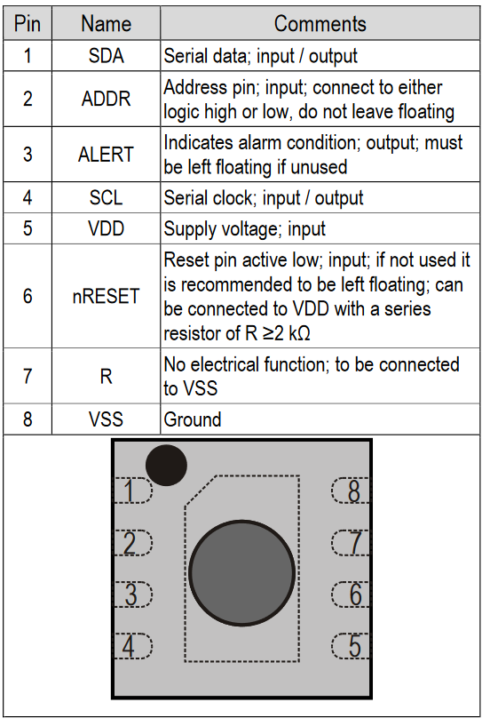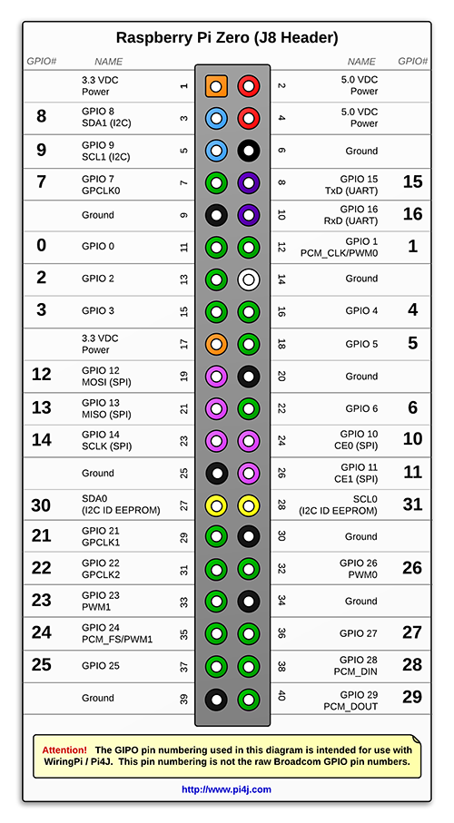

| **SHT31 PIN** | **RPI Zero PIN** |
| --- | --- |
| **1 (SDA)** | **3 (SDA1)** |
| **2(ADDR)** | **1 (3V3)** |
| **3 (ALERT)** | **NC** |
| **4 (SCL)** | **5 (SCL1)** |
| **5 (VDD)** | **1 (3V3)** |
| **6 (nRESET)** | **NC** |
| **7 (R)** | **NC** |
| **8 (VSS)** | **6 (GND)** |

**Functional overview**

**Communication with the sensor:**

**Protocol:** I2C

**Sensor address:** 0x45

**File:** [**sht31.py**](http://sht31.py)

**Function:** get_measurement()

**Communication with the server:**

**Protocol:** TCP

**Server socket:** 192.168.1.43:51378

The server serves all the clients i.e. Rpi Zeros that are responsible for sending in measurement data.

If the client cannot get to the server, it sleeps for a random period before retrying. The randomness is implemented because the sensors take periodic measurements, so it could be the case that the sending would synchronize and a sensor would be forever blocked from sending.

**Setting up a new sensor**

1. Copy the SD-card from an existing RPI zero using Balena-Etcher.
2. In the file /home/pi/Documents/RPI-temperature/sensor/sensor_config.json change the variable ID to one that is not in use.
3. Create a new panel on Grafana by clicking on an existing panel ...->more->duplicate On the new panel ...->edit change the ID by which the table is selected to the new sensor’s ID.

**Switching to a new network:**

First the sensors should be given the new network’s SSID and PASSWORD, do this as documented here in: [Method 2: Enable Wifi via wpa_supplicant](https://www.seeedstudio.com/blog/2021/01/25/three-methods-to-configure-raspberry-pi-wifi/?srsltid=AfmBOopN5twctvxUWjDAO6SzB95za2vgWbr4DA9oEp3GeQ7nkWzSwtuG) do this using an SD-card reader. **Do not try to power up the sensor before doing this as it will go into a boot loop!**

Then you should connect the server and get its new IP address that will be used later.

In the next step all the IP addresses have to be manually reconfigured in the following files:

/home/pi/Documents/RPI-temperature/sensor/sensor_config.json

/home/pi/Documents/RPI-temperature/server/server_config.json

for the sensor and server respectively. For the sensors this has to be done without booting them, else they will go into a bootloop because they cannot connect to the server.