**Model-View-Controller (MVC) Model**

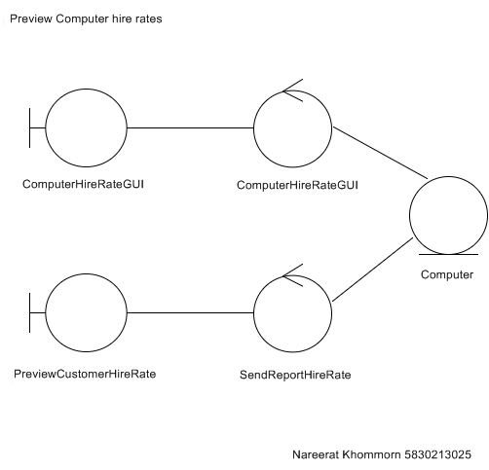

**Sequence Diagram**

