PROJECT REPORT
OBELIUS
A Privacy-First RAG Assistant with Personal Memory, a Telegram Bot, and an MCP Server
Company Internal Knowledge Base Assistant — built for two demo tenants,
Obelius Technologies and Eternal Technologies
Author
Komiljon Kosimov
Program
RAG Systems & Personal Memory — Hogwarts, 2026
Date
8 July 2026

Table of Contents

1. Executive Summary
Obelius is a privacy-first Retrieval-Augmented Generation (RAG) assistant that lets employees ask plain-language questions and get answers pulled directly from their own company's internal documents — HR policies, IT security rules, onboarding guides, expense policies, and meeting notes — instead of digging through PDFs or repeatedly asking HR the same question.
The system serves two independent demo tenants, Obelius Technologies and Eternal Technologies, through three interchangeable front ends that share one backend: a web chat application, a Telegram bot, and an authenticated Model Context Protocol (MCP) server for AI coding assistants. Every surface performs the same retrieval — a combination of vector search (Qdrant), a knowledge graph (Neo4j), personal memory (MongoDB), and an optional agentic web search — before generating an answer with a locally-hosted language model (Ollama), so that no company document or chat message needs to leave infrastructure the project owner controls.
The project began as a two-week class assignment ("Company Internal Knowledge Base", domain #3 of the course proposal sheet) and grew, over roughly three months of iterative development, into a working multi-tenant product covering authentication, document ingestion, graph-augmented retrieval, conversational memory, web search, and a secure external tool-access surface. Along the way the project survived a full memory-budget crisis on its free-tier hosting, two embedding-model migrations, and a full move from a paid cloud LLM to a fully local one — each documented in Section 7 together with the concrete fix that was shipped.
This report documents the problem the system solves, how it is built, the difficulties encountered during development and how they were resolved, the current architecture and data flow, and the improvements planned next.

2. Introduction

2.1 Background and Motivation
Every mid-sized company accumulates a pile of internal documents — an employee handbook, an IT security policy, onboarding material, expense rules, meeting notes — that employees are expected to already know, but rarely do. New hires ask HR the same five questions every week; engineers dig through a shared drive to check whether a tool is allowed before installing it; nobody remembers exactly what was agreed in last month's meeting. A search bar over those documents, backed by a language model that can actually answer in plain language, removes almost all of that friction.
The catch is that the documents involved are exactly the ones a company cannot casually hand to a third-party cloud API: salary bands, disciplinary procedures, security configurations, and strategic discussion routinely live inside an "HR policy" or "meeting notes" folder. Any assistant built for this domain has to treat privacy as a structural requirement, not an afterthought — which is the reason this project is built around locally-hosted inference (Ollama) and strict per-tenant data isolation, rather than a thin wrapper around a public LLM API.

2.2 Problem Statement
Employees need fast, accurate answers to questions that are already written down somewhere inside the company, but the information is hard to find, and getting an answer from a person is slow and repetitive. At the same time, a company cannot adopt an AI assistant for this purpose if doing so means its internal, often sensitive, documents are transmitted to and logged by an external vendor, or if one company's data could ever leak into another company's answers on a shared platform.
Concretely, the system needed to solve four sub-problems at once:
- Retrieval accuracy — surface the right passage from the right document, with a citation, instead of a plausible-sounding guess.
- Tenant isolation — guarantee that Obelius Technologies' documents are never retrievable by an Eternal Technologies employee, and vice versa, even though both are served by the same backend and the same vector database.
- Data locality — keep chat content and document content off third-party AI vendors' servers, which ruled out permanently depending on a cloud LLM API for the finished product.
- Reach — meet employees wherever they already are, via a browser tab or a Telegram chat, without duplicating the retrieval and generation logic for each surface.

2.3 Objectives
- Build a RAG pipeline that answers questions from company documents with a visible source citation, so a user can verify the answer rather than simply trust it.
- Enforce multi-tenant data isolation at the storage layer, not just in the user interface.
- Ship two user-facing clients — a web chat app and a Telegram bot — against one shared backend.
- Layer in personalization (a lightweight memory of who the user is and what they have asked before) and general-knowledge coverage (agentic web search) without breaking the tenant boundary.
- Migrate the language model and embeddings fully to a locally-hosted model (Ollama), so the finished system's privacy story is an actual property of the deployed system, not a slide in a proposal.
- Expose a read-only, authenticated integration surface (MCP) so external AI tools can query the same knowledge base under the same access rules as a human user.

3. System Overview

3.1 Who It Is For
The primary users are regular employees who need a quick, accurate answer to something already written down inside the company but hard to find — a new hire checking how many vacation days they get, an engineer checking the IT security policy before installing software, or someone recalling what was agreed in last month's meeting.
Secondary users are HR and IT staff, who benefit from fewer repetitive questions landing in their inbox, and company leadership, who get a system where the only people who can see a document are the people who work at the company that owns it.

3.2 Core Capabilities
- Document-grounded chat — upload PDFs, DOCX, TXT or CSV files, or query the company's pre-loaded knowledge base, and get answers with the source filename and page cited.
- Knowledge graph augmentation — entities and relationships extracted from documents (people, teams, policies) are queried alongside plain vector search, catching relational questions a similarity search alone would miss.
- Personal memory — a short, evolving profile per user (role, recurring topics, preferences) so answers can be personalized without the user repeating context every time.
- Conversation history — every logged-in conversation is saved, titled automatically by the LLM, and browsable from a sidebar (web) or an inline-button history menu (Telegram).
- Agentic web search — general-knowledge or "live data" questions that fall outside the company's documents are answered by planning search queries, running them, and reading the top results, with the choice to search made automatically per turn.
- Guest mode — anyone can try the assistant without an account; uploaded documents and chat history are tied to a temporary browser session and migrated into a real account on first login.
- Multi-tenant isolation — Obelius Technologies and Eternal Technologies are served by the same backend and the same databases but can never see each other's data.
- MCP tool access — the same retrieval stack is exposed, read-only and authenticated, to MCP clients such as Claude Code or Claude Desktop.

4. System Architecture

4.1 High-Level Architecture
Three client surfaces — the web chat UI, the Telegram bot, and external MCP clients — all terminate in one FastAPI application (internally named "Obelius"). The application layer exposes REST routes for chat, upload and history; a Telegram webhook router; and a separate authenticated MCP endpoint. All three consume the same set of services underneath: document/graph retrieval, an LLM service with context management, personal memory, and agentic web search. Those services in turn depend on Qdrant, Neo4j and MongoDB for storage, and on a locally-hosted Ollama server for every embedding and generation call.
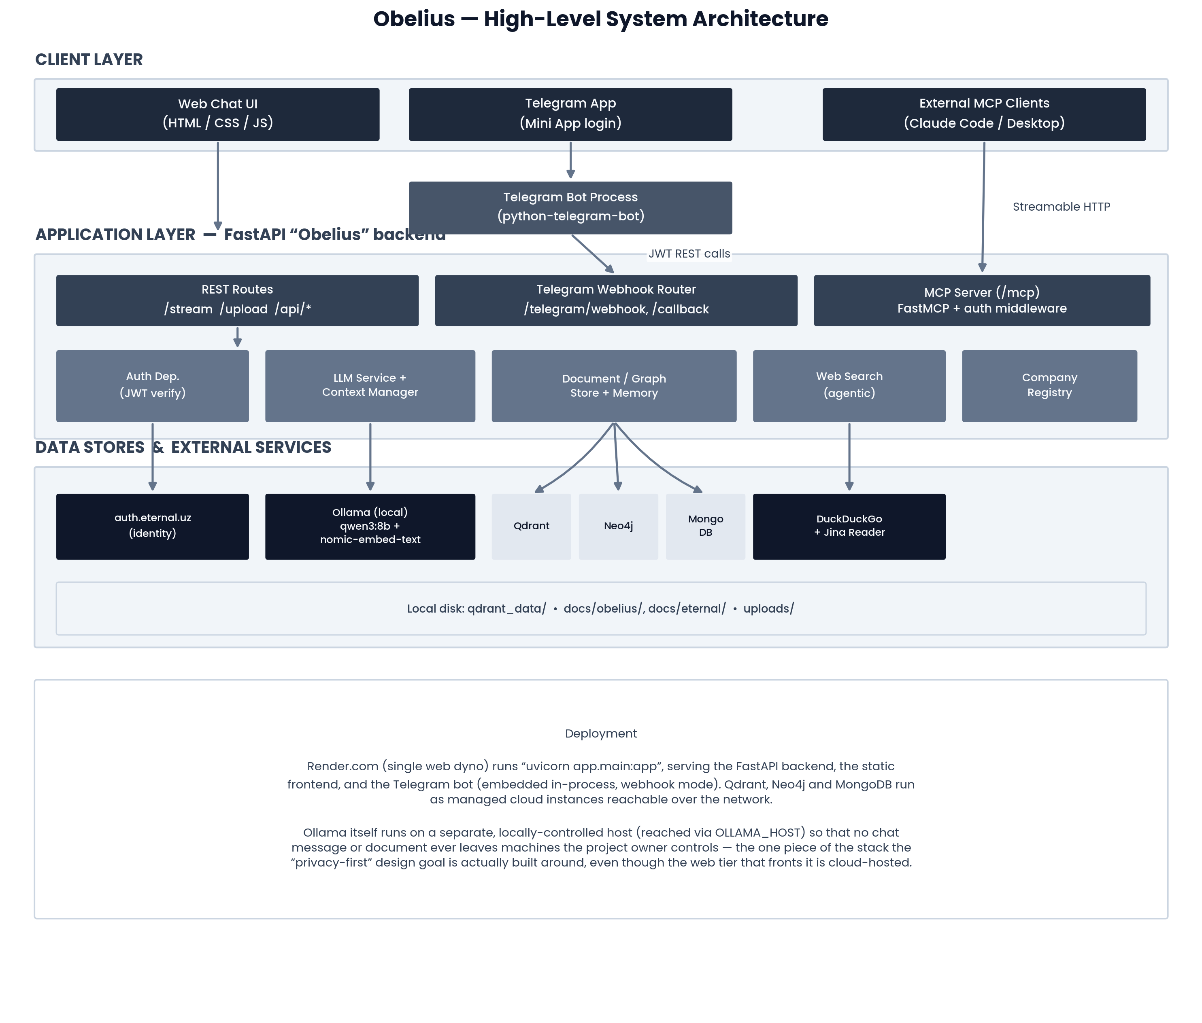
Figure 1 — High-level system architecture: clients, the FastAPI application layer, shared services, and their backing stores.

4.2 Technology Stack
Layer | Technology | Purpose
Backend | Python 3, FastAPI, Uvicorn | REST API, SSE streaming, dependency-injected auth, static file serving
Frontend | HTML5, CSS3, vanilla JavaScript, marked.js, three.js | No-build chat UI: streaming renderer, history drawer, animated background
Bot | python-telegram-bot (PTB) 21.6 | Telegram Mini App auth, inline keyboards, webhook / polling modes
Vector store | Qdrant (cloud or local disk) | Per-tenant, per-conversation semantic search over document chunks
Knowledge graph | Neo4j | Entity/relationship extraction and graph-augmented retrieval
Database | MongoDB (Motor async driver) | Conversations, messages, user memory, settings, Telegram sessions
LLM & embeddings | Ollama (local): qwen3:8b, nomic-embed-text | Fully local chat generation and embeddings
Web search | DuckDuckGo (ddgs) + Jina Reader | Agentic query planning, search, and page-content enrichment
Auth | External identity provider (auth.eternal.uz), JWT | Single sign-on shared by the REST API, MCP server, and Telegram bot
Integration | Model Context Protocol (MCP) / FastMCP | Read-only tool access to the RAG stack for MCP clients
Deployment | Render.com (web dyno), render.yaml | Hosts the FastAPI backend and the embedded Telegram bot (webhook mode)

4.3 Multi-Tenant Isolation Model
Rather than standing up separate infrastructure per company, isolation is implemented as a partition key. Every document chunk stored in the single shared Qdrant collection ("company_docs") is tagged with a session_id-shaped key: COMPANY_BASE for Obelius Technologies, COMPANY_eternal for Eternal Technologies, or a per-conversation key for a user's own uploads. Every retrieval call filters on the caller's own set of keys only, and the same partitioning is mirrored in the Neo4j knowledge graph. Onboarding a new company today is literally adding one entry to a Python dictionary (services/companies.py) — a deliberate simplicity trade-off documented further in Section 9.
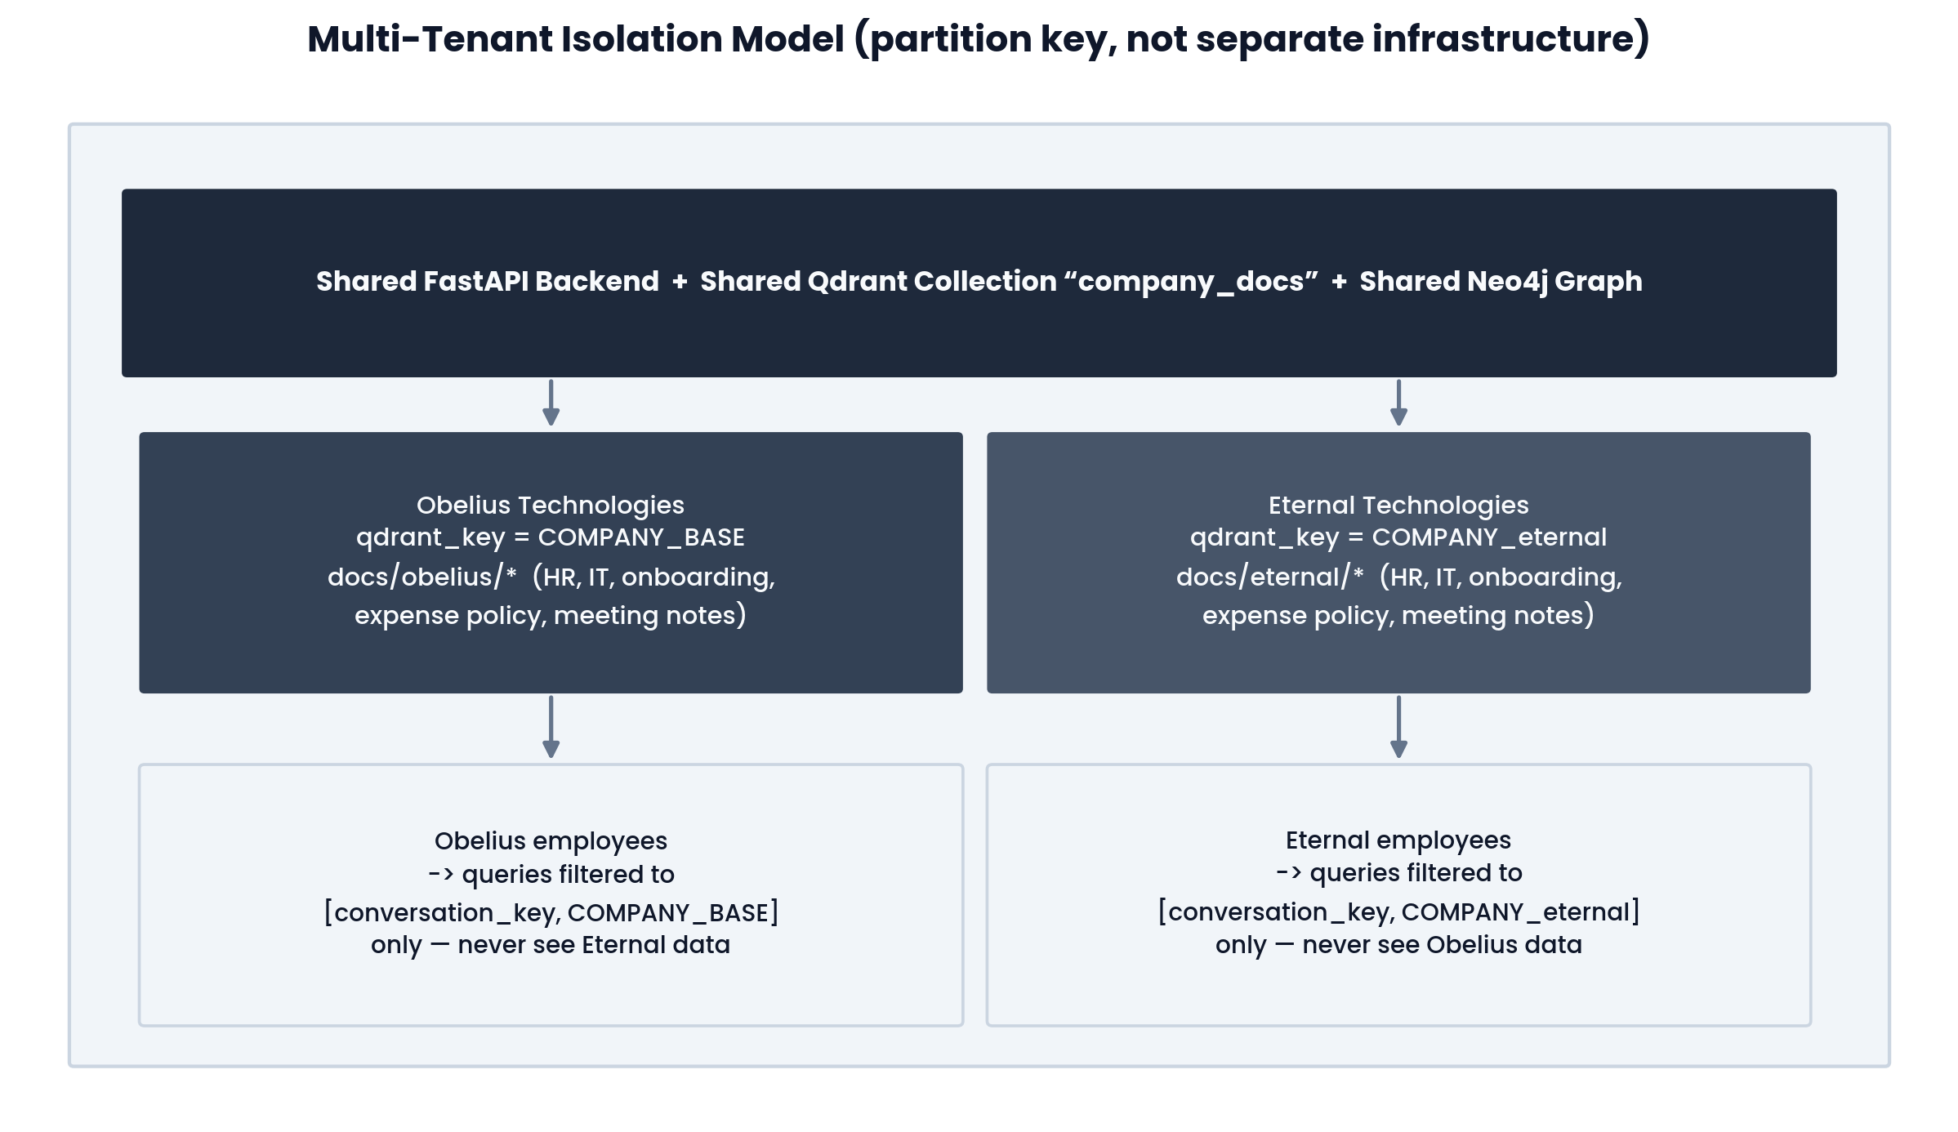
Figure 2 — Two tenants, one backend and one set of databases, separated entirely by partition key.

5. Application Structure and Data Flow

5.1 Repository Structure
Path | Contents
backend/app/main.py | FastAPI app, lifespan startup/shutdown, router mounts, CORS, MCP mount
backend/app/routes/ | process.py (/stream), upload.py, history.py, company.py
backend/app/services/ | document_store, graph_store, ollama_client, llm_service, context_manager, web_search, memory, mongo, companies, auth_dep
backend/app/mcp_server.py | FastMCP tool definitions and DNS-rebinding / host-allowlist configuration
backend/app/telegram_router.py | FastAPI routes for the Telegram webhook and OAuth-style callback
telegram/ | Standalone bot process: bot.py, config.py, handlers/, keyboards/, services/
frontend/ | index.html, script.js, style.css — the web chat client
docs/obelius/, docs/eternal/ | Pre-loaded per-tenant document sets (HR, IT, onboarding, expense, meeting notes)
render.yaml, start.sh | Deployment and local-run configuration

5.2 Request Lifecycle — POST /stream
The chat endpoint is the core of the system: every user turn, from either client, passes through the same eleven-step pipeline before a token is ever sent back.
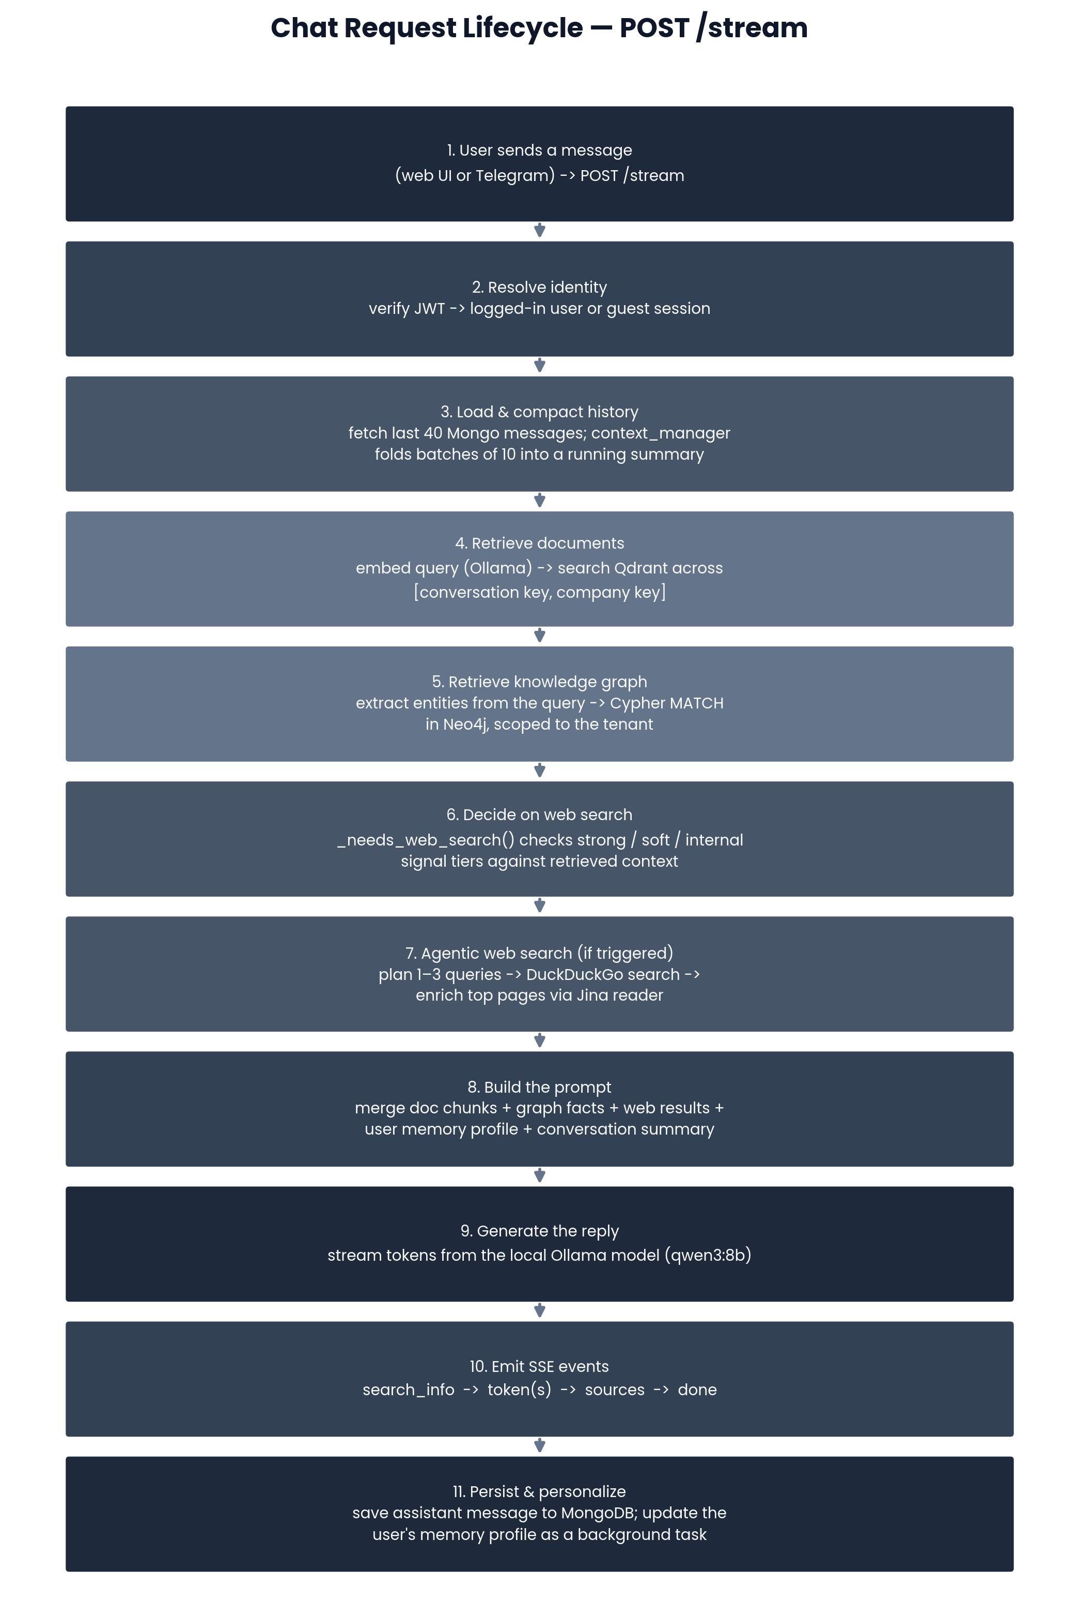
Figure 3 — The full request lifecycle behind a single chat turn.

5.3 Retrieval-Augmented Generation Pipeline
Document retrieval embeds the user's message with the local nomic-embed-text model and searches Qdrant across the caller's own conversation key plus, for logged-in users, their company's key. Chunks are produced with an 800-character sliding window and a 120-character overlap, and only matches above a 0.50 cosine-similarity threshold are kept. Uploaded files (PDF via PyPDF2, DOCX via python-docx, plus plain text and CSV) are parsed, chunked, embedded and upserted in the background as soon as they are received.

5.4 Knowledge Graph Layer
Alongside vector search, every uploaded document is also passed through a small LLM extraction step that pulls out up to 40 subject-relation-object triples (e.g. "Alice — MANAGES — Engineering Team") and writes them into Neo4j with parameterized Cypher MERGE statements, scoped to the same tenant/session key used in Qdrant. At query time, a second small LLM call extracts up to six entity names from the question, and a Cypher MATCH returns any relationships touching those entities as plain-text facts, which are folded into the prompt as a synthetic "Knowledge Graph" source. The graph layer is entirely best-effort: any Neo4j failure is caught and logged, never surfaced to the user, so a missing or misconfigured graph database degrades retrieval quality without breaking the chat.

5.5 Context Summarization and Personal Memory
Because the local model's usable context window is far smaller than the cloud model the project started with, conversations are compacted with a fixed-size checkpoint-batch scheme: the first ten messages are sent to the model in full; on the eleventh, those ten are folded into a single ~120-word summary in one LLM call, and only messages since that checkpoint are sent raw until the next batch of ten accumulates. For logged-in users the running summary is persisted on the conversation document, making the folding cost amortized to effectively zero after the first pass.
Separately, a lightweight memory service maintains up to 40 deduplicated facts and a prose summary per user in MongoDB, regenerated periodically as new facts are extracted from each turn in the background — this is what lets the assistant remember, for example, that a given user is on the engineering team without them repeating it.

5.6 Agentic Web Search
Not every question can or should be answered from company documents. A three-tier signal classifier decides, per turn, whether to search the public web: strong live-data signals (weather, "latest", explicit "search for") always trigger a search; company-internal-sounding phrasing (policy, HR, salary, "in the document") suppresses it even with no document match, to avoid mixing public information into an answer that should say "not covered by your company's documents"; everything else defaults to a search as a safe fallback for general-knowledge questions. When triggered, the system plans one to three optimized search queries with the LLM, runs them in parallel against DuckDuckGo, and enriches the top results with full page text fetched through a Jina Reader proxy — all before the final answer is generated. Both the web UI and the Telegram bot expose a single shared on/off toggle for this behavior, persisted per user.

5.7 Telegram Bot
The bot is a separate python-telegram-bot process (or, in production, embedded in the same FastAPI process in webhook mode) that talks exclusively to the REST backend — never directly to the databases or the MCP server — using the same JWT issued by the external identity provider. Login happens through a Telegram Mini App button that redirects to the identity provider and back through a one-time state token; once authenticated, the bot mirrors the web app's core features: free-form chat with progressive message editing to simulate streaming, document upload, paginated conversation history, memory viewing, a company picker, and the shared web-search toggle.

5.8 Model Context Protocol (MCP) Server
A FastMCP server mounted at /mcp exposes four read-only tools — search_company_docs, query_knowledge_graph, web_search, and get_my_memory_profile — to any MCP-compatible client. Authentication is handled by a raw ASGI middleware (rather than a framework-level dependency, because Starlette's buffered middleware breaks the SSE-based Streamable HTTP transport MCP requires) that verifies the same bearer JWT used by the REST API. No tool accepts a user, company, or session identifier as an argument; every tool derives the caller's tenant from their verified identity alone, which closes off a cross-tenant access risk that would otherwise be unique to a scriptable client. A simple in-memory rate limit (20 calls per 60 seconds per user) protects against a client hammering the endpoint with LLM-backed tool calls.

6. Development Process
The project was built iteratively over roughly three months, starting from a two-day class prototype and growing feature by feature as each milestone was demoed and tested. The commit history reads less like a pre-planned schedule and more like a series of deliberate iterations — several features (web search, embeddings, RAM handling) were shipped, found lacking, and reworked more than once.
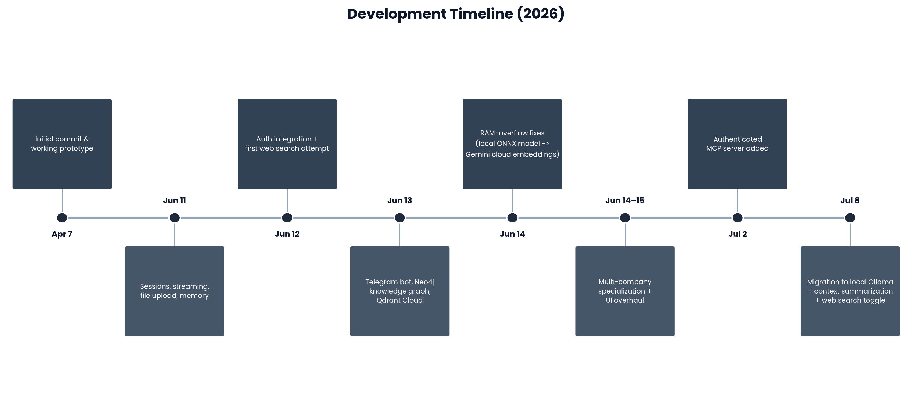
Figure 4 — Major milestones from the initial prototype to the current local-Ollama build.

6.1 Milestones
Date | Milestone
Apr 7 | Initial commit and working prototype — first end-to-end chat call.
Jun 11 | Sessions, output streaming, file upload, and a first pass at memory.
Jun 12 | External identity-provider authentication integrated; first (unrefined) web search attempt.
Jun 13 | Telegram bot with Mini App login added; Neo4j knowledge graph and Qdrant Cloud introduced.
Jun 14 | Four iterative fixes for a RAM-overflow crash on the hosting free tier (Section 7.1).
Jun 14–15 | Multi-company specialization (Obelius Technologies + Eternal Technologies); web UI overhaul; intelligent chat titling.
Jul 2 | Authenticated MCP server added, exposing the RAG stack to external AI tools.
Jul 8 | Full migration to a local Ollama model and embeddings; new context-summarization layer; shared web-search toggle.

6.2 Working Approach
- Build the smallest working slice first (a single Gemini-backed chat call), then layer in retrieval, auth, and multi-tenancy once the base loop worked.
- Treat production constraints (a 512 MB free-tier host) as real requirements, not something to fix later — the RAM-overflow incident shaped the embedding architecture for the rest of the project.
- Prefer reversible, incremental commits ("fix 1", "fix 2", "fix 3"...) over large rewrites, so each change could be tested in isolation against the deployed instance.
- Revisit and retune heuristics (web-search triggering, chunk size, score thresholds) with real usage rather than getting them right analytically up front.

7. Difficulties Encountered and Solutions
Six problems shaped the architecture more than anything planned in advance. Each is described here with its root cause and the fix that shipped, since the fix is often more informative than the symptom.

7.1 RAM Overflow on the Hosting Free Tier
The first embedding pipeline used fastembed's local ONNX model (BAAI/bge-small-en-v1.5), loaded in-process. On the platform's 512 MB free web-service tier, loading that model into memory alongside FastAPI crashed the service outright. The fix took four iterative commits in a single session: the local ONNX model was removed entirely in favor of Google's cloud embedding API (moving the memory cost off-box); the embedding model was swapped again to a newer cloud model with output truncated to match the existing 768-dimension Qdrant collection; the Qdrant collection's auto-detection logic was hardened to recreate itself when the stored vector dimension no longer matched; and chunk size, overlap and score threshold were retuned to reduce the number of paid embedding calls per upload.

7.2 Vector-Space Incompatibility After the Ollama Migration
Months later, the project moved deliberately back to local inference — this time via Ollama on the project owner's own machine rather than the constrained free-tier host — to actually deliver on the privacy promise the project was built around. The new local embedding model produces a 768-dimension vector like the cloud model it replaced, but in an entirely different, incompatible vector space, meaning every previously-embedded document chunk would have silently returned irrelevant results. This was solved with a one-off migration script (reembed_documents.py) that scrolls every point already stored in Qdrant and re-embeds its saved text with the new local model in place, leaving every other field untouched.

7.3 A Smaller Context Window for the Local Model
The local qwen3:8b model has a materially smaller usable context budget than the cloud model it replaced, and that budget already has to fit the system prompt, retrieved documents, graph facts, web results, and the user's memory profile. This directly motivated a new context-summarization component: conversations are folded into a running summary every ten messages rather than resent in full, keeping arbitrarily long conversations within an 8192-token budget without the user noticing a quality drop.

7.4 Web Search Over- and Under-Triggering
An early, flat keyword list for deciding when to search the web either searched too eagerly (treating an internal HR question as a general one) or not at all (refusing to answer an obviously public question because no company document matched). The fix was an explicit three-tier signal classifier — strong, soft, and internal signals — tuned across several follow-up commits with real examples (for instance, deliberately excluding bare words like "today" from the strong-signal list after they falsely triggered on sentences like "I joined today").

7.5 MCP as a New, Scriptable Attack Surface
Exposing the RAG stack over MCP introduced an authentication surface unlike the browser-facing REST API: a scripted client could, in principle, pass someone else's session or company identifier as a tool argument. The fix was defense-in-depth: every MCP tool derives its caller's tenant purely from a server-verified token, never from a client-supplied argument, and the auth check itself reuses the exact same token-verification function the REST API already relies on, so there is a single source of truth for what counts as a valid session. Because the transport requires Server-Sent Events, the auth check had to be written as raw ASGI middleware rather than a standard framework middleware, which would have buffered and broken the stream.

7.6 Preserving Guest Data Across Login
A user can upload documents and chat before creating an account, tied to a temporary browser session id. Without extra handling, that work would be orphaned the moment the user logs in and gets a real, persistent conversation id. The /api/migrate-session endpoint solves this by importing the guest's messages into a new conversation and re-tagging their uploaded document chunks in Qdrant from the old session key to the new conversation key, so nothing uploaded before login is lost.

7.7 Summary Table
# | Problem | Root Cause | Resolution
1 | Service crashed on free-tier hosting | Local ONNX embedding model loaded in-process exceeded 512 MB RAM | Moved embeddings to a cloud API, then retuned chunking to cut request volume
2 | Retrieval silently broke after switching to local embeddings | New and old embedding models occupy incompatible vector spaces despite matching dimensions | One-off script re-embeds every stored chunk in place
3 | Long conversations exceeded the local model's context budget | Local model has a smaller practical context window than the prior cloud model | New checkpoint-batch summarization folds history every 10 messages
4 | Web search fired too often or not at all | Flat keyword heuristic couldn't distinguish internal from general questions | Three-tier signal classifier, iteratively tuned on real examples
5 | MCP surface risked cross-tenant data access | Scriptable clients can supply arbitrary tool arguments, unlike a browser UI | Tools derive tenant identity only from a verified token; shared verification logic; rate limiting
6 | Guest uploads/chat lost on login | Guest work is tied to a temporary session id, not a persistent account | Migration endpoint imports messages and re-tags document chunks to the new account

8. Security and Privacy Considerations

8.1 Data Locality
Chat generation and embeddings run entirely on a locally-hosted Ollama server rather than a third-party AI vendor. This is the single design decision the rest of the privacy story depends on: no document text or chat message needs to be transmitted to an external model provider for the assistant to function.

8.2 Tenant Isolation
Every retrieval call is filtered to the caller's own partition keys at the storage layer (Qdrant payload filters, Neo4j session-scoped Cypher queries) rather than relying on the UI to simply not display another tenant's data. An unassigned user does default to the base tenant's key rather than being rejected outright, which is flagged as a limitation in Section 9.

8.3 Authentication
Obelius does not own user accounts or passwords; identity is fully delegated to an external identity provider, and a single token-verification function is shared by the REST API, the MCP server, and (indirectly, through REST calls) the Telegram bot, so there is exactly one place that decides whether a session is valid.

8.4 Injection Safety
Neo4j writes use parameterized Cypher MERGE statements rather than string interpolation, and for logged-in users the conversation history used to build a prompt is always the authoritative, server-stored history rather than anything the client claims it to be — closing off a class of prompt-injection-via-fabricated-history attack from a modified client.

8.5 Rate Limiting
The MCP surface applies a simple per-user rate limit, since each tool call can trigger a real embedding, LLM, or web-search request that a browser-based UI would otherwise throttle implicitly through normal user behavior.

9. Current Limitations
Several trade-offs were made deliberately for a project of this scope and are worth stating plainly rather than glossing over:
- Deployment/inference gap — production hosting runs the FastAPI backend on a standard cloud web dyno, which does not itself run Ollama; the local model must be hosted separately and kept reachable via OLLAMA_HOST, which is not yet automated.
- Shared infrastructure, not isolated infrastructure — tenants are separated by a partition key inside one shared Qdrant collection and one shared Neo4j graph, not by dedicated per-tenant infrastructure; this is simple to operate but a deeper isolation guarantee (e.g. separate collections or database instances) would be needed for a real multi-customer product.
- Unassigned-user default — a logged-in user with no company selected silently reads the base tenant's documents rather than being blocked, which is convenient for demos but the wrong default for a production access-control model.
- In-memory MCP rate limiting — the per-user call counter lives in process memory, so it resets on restart and would not be shared across multiple server instances.
- Character-window chunking — documents are split by a fixed character window rather than sentence or token boundaries, which occasionally cuts a chunk mid-sentence.
- Not truly token-streamed — the SSE endpoint currently waits for the entire local model generation to finish before replaying it as a sequence of token events, rather than forwarding tokens as they are produced.
- N+1 query pattern — the conversation list endpoint computes each conversation's message count with a separate query rather than a single aggregation.
- Hardcoded tenant registry — adding a new company today means adding an entry to a Python dictionary and redeploying, rather than a self-serve onboarding flow.
- Webhook secret regenerates on restart — the Telegram webhook secret defaults to a random value unless explicitly pinned in configuration, which invalidates the previously-registered webhook on every restart if left unset.

10. Testing and Verification
As a single-developer project built under course deadlines, verification has been manual and scenario-driven rather than backed by an automated test suite — an honest gap that is called out explicitly in Section 12 as a next step. The approach taken so far:
- End-to-end manual testing of the chat flow against both demo tenants, confirming that a question answerable from Obelius Technologies' documents never surfaces Eternal Technologies content and vice versa.
- Upload verification — confirming that PDF, DOCX, TXT and CSV files are parsed, chunked, embedded, and retrievable in the same session immediately after upload.
- Guest-to-account migration — manually verifying that documents and messages created before login are present and answerable after logging in.
- Telegram bot testing against a dedicated test bot token, covering login, document upload, history browsing, and the shared web-search toggle.
- Production incident response as a test in itself — the RAM-overflow crash (Section 7.1) was effectively discovered through real deployment rather than a pre-emptive load test, and each of the four follow-up fixes was verified by redeploying and confirming the service stayed up under the free-tier memory limit.
- Manual prompt tuning — the web-search signal classifier and the RAG capability wording in the system prompt were both refined by trying real questions and adjusting the keyword tiers or prompt language until the assistant's behavior matched expectations.

11. Results and Current State
As of this report, Obelius runs as a working multi-tenant assistant with:
- Two fully populated demo tenants (Obelius Technologies, Eternal Technologies), each with six pre-loaded internal documents.
- A deployed web chat client and an authenticated Telegram bot, both backed by the same FastAPI service.
- Retrieval that combines vector search, a knowledge graph, personal memory, and agentic web search in a single response.
- A fully local inference path (Ollama, qwen3:8b + nomic-embed-text) with no remaining dependency on a third-party LLM vendor for chat or embeddings.
- An authenticated, rate-limited MCP server giving external AI tools the same retrieval capability as a logged-in human user.
- A documented history of production incidents and fixes that shaped the current architecture, rather than a system that has only ever run in a development environment.
In short: the proposal's closing goal — moving from a cloud-LLM prototype to a system whose privacy guarantee is an actual deployed property, not a plan — has been met.

12. Future Improvements

12.1 Near-Term
- Automate Ollama availability for the hosted deployment (a managed GPU box or a co-located host reachable from Render) so OLLAMA_HOST is no longer a manually-maintained dependency.
- Persist the MCP rate limiter (e.g. to MongoDB or Redis) so it survives restarts and works correctly across multiple server instances.
- Replace the N+1 conversation message-count query with a single aggregation pipeline.
- Pin WEBHOOK_SECRET explicitly in configuration rather than relying on a random per-restart default.
- Route the Telegram "clear memory" action through the REST API like every other mutation, instead of writing to MongoDB directly from the bot process.

12.2 Medium-Term
- Move to sentence- or token-aware chunking instead of a fixed character window, to stop occasionally splitting a chunk mid-sentence.
- True token-level SSE streaming, forwarding tokens as the local model produces them instead of materializing the full generation first.
- A self-serve company-onboarding flow to replace the hardcoded tenant registry, including a real default-tenant policy for unassigned users.
- Stronger per-tenant isolation (dedicated Qdrant collections or Neo4j databases per company) for a genuine multi-customer deployment model.

12.3 Longer-Term
- An automated test suite (unit tests for retrieval/ranking logic, integration tests for the auth and multi-tenancy boundary) to replace the current manual verification process.
- Expanding the MCP tool surface (still read-only) with finer-grained document and graph queries as real external-tool use cases emerge.
- Usage analytics per tenant (question volume, unanswered-question patterns) to help a real customer company see where its documentation has gaps.

13. Conclusion
Obelius set out to answer a narrow but realistic question: can an AI assistant give employees fast, sourced answers from their own company's internal documents without those documents ever leaving infrastructure the company controls? Building two working demo tenants, rather than a single hypothetical example, forced every design decision — from how documents are partitioned in storage to how a token is verified — to hold up under an actual cross-tenant boundary rather than a diagram.
The path from a two-day class prototype to the current system was not linear: a real production memory crash, two embedding-model migrations, and an iteratively-tuned web-search heuristic all left their mark on the architecture, and each is documented in this report specifically because the difficulty and its fix were more instructive than a clean success story would have been. What remains — deploying Ollama itself alongside the hosted service, tightening tenant isolation further, and adding automated tests — is a reasonable, concrete list rather than an open-ended one, which is itself a sign the core system is in a stable enough place to build on.

Appendix A — Environment Variables Reference
Variable | Default | Purpose
OLLAMA_HOST | http://localhost:11434 | Base URL of the local Ollama server
OLLAMA_CHAT_MODEL | qwen3:8b | Chat/generation model
OLLAMA_EMBED_MODEL | nomic-embed-text | Embedding model
OLLAMA_NUM_CTX | 8192 | Context window requested per generation call
QDRANT_URL / QDRANT_API_KEY | (unset → local disk) | Qdrant Cloud connection; falls back to on-disk Qdrant if unset
NEO4J_URI / NEO4J_USER / NEO4J_PASSWORD | (unset → graph disabled) | Neo4j connection for the knowledge-graph layer
MONGO_URI | mongodb://localhost:27017 | MongoDB connection for conversations, memory, and sessions
AUTH_BASE_URL | https://auth.eternal.uz | External identity provider used for token verification
BOT_TOKEN / BOT_MODE | — / polling | Telegram bot token and run mode (polling or webhook)
WEBHOOK_URL / WEBHOOK_SECRET | — / random | Public webhook base URL and Telegram secret-token header value
BACKEND_URL | http://localhost:8001 | Backend base URL used by the standalone Telegram bot process
MCP_ALLOWED_HOSTS | private-ai-web.onrender.com | Allow-listed hostnames for MCP DNS-rebinding protection

Appendix B — API Endpoint Reference
Method & Path | Auth | Description
POST /stream | optional | Core chat endpoint (SSE): retrieval + graph + web search + generation
POST /upload | session | Upload and embed documents (PDF, DOCX, TXT, CSV)
GET /api/conversations | required | List the caller's conversations
POST /api/conversations | required | Create an empty conversation
DELETE /api/conversations/all | required | Delete all of the caller's conversations
DELETE /api/conversations/{id} | required | Delete one conversation
GET /api/conversations/{id}/messages | required | Full message history for one conversation
POST /api/migrate-session | required | Import a guest session's messages/documents after login
GET /api/companies | public | List the tenant registry
GET / POST /api/user/company | required | Get or set the caller's active company
GET / POST /api/user/websearch | required | Get or set the shared web-search toggle
POST /api/auth-verify | public | CORS proxy to the external identity provider
POST /telegram/webhook | secret header | Telegram update ingress (webhook mode)
GET /telegram/callback | state token | Auth redirect handler for the Telegram Mini App login
/mcp (Streamable HTTP) | bearer JWT | MCP tool surface: 4 read-only tools

Appendix C — Glossary
Term | Meaning
RAG | Retrieval-Augmented Generation — answering with a language model grounded in retrieved documents
Tenant | One isolated company/customer sharing the platform (here: Obelius Technologies, Eternal Technologies)
Embedding | A numeric vector representing the meaning of a piece of text, used for similarity search
Vector store | A database optimized for nearest-neighbor search over embeddings (here: Qdrant)
Knowledge graph | A network of entities and relationships extracted from documents (here: Neo4j)
SSE | Server-Sent Events — a one-way streaming HTTP response format used by the /stream endpoint
MCP | Model Context Protocol — a standard that lets AI tools call external functions/resources securely
JWT | JSON Web Token — a signed token used to represent an authenticated session
IDOR | Insecure Direct Object Reference — a vulnerability class where a client can access another user's data by supplying a different identifier
Checkpoint-batch summarization | This project's context-management scheme: folding conversation history into a summary every fixed number of messages

