In this week , the company organize a mini event. This event is based on the result of Lotte. The customer need to give a number containing two digits. People who have right number and comment at the earliest time will be winner and gain a prize.To improve the efficiency of this game , I shared this event on my wall on Facebook

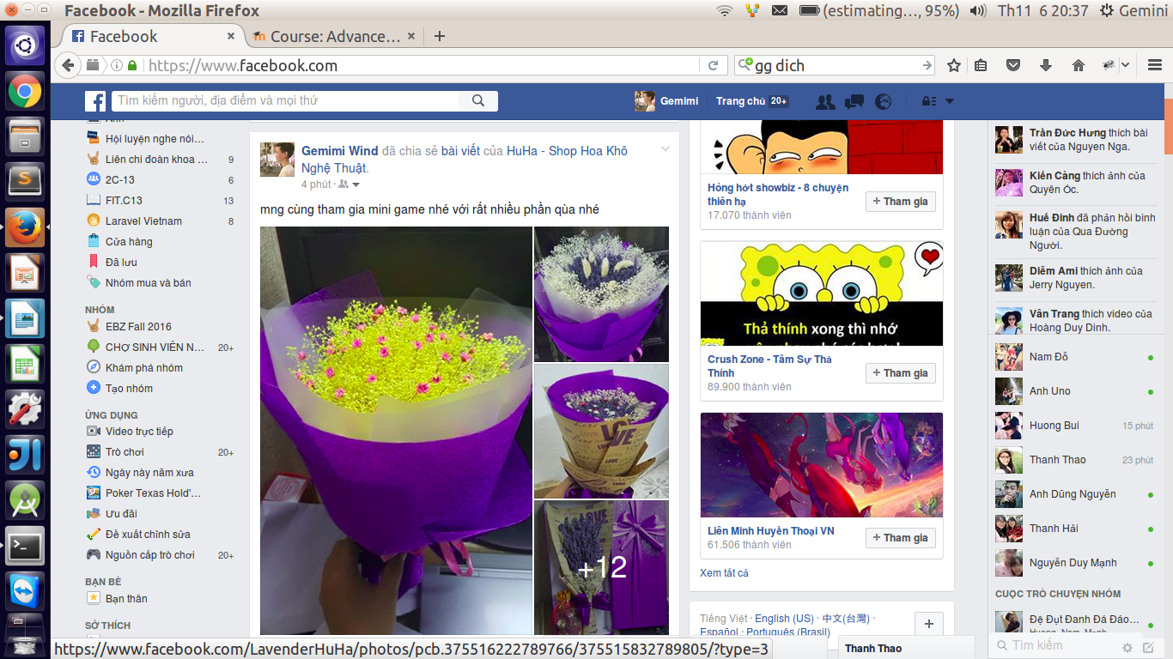

Also I tagged some my friends as well as my acquaintance to invite them to join in this event

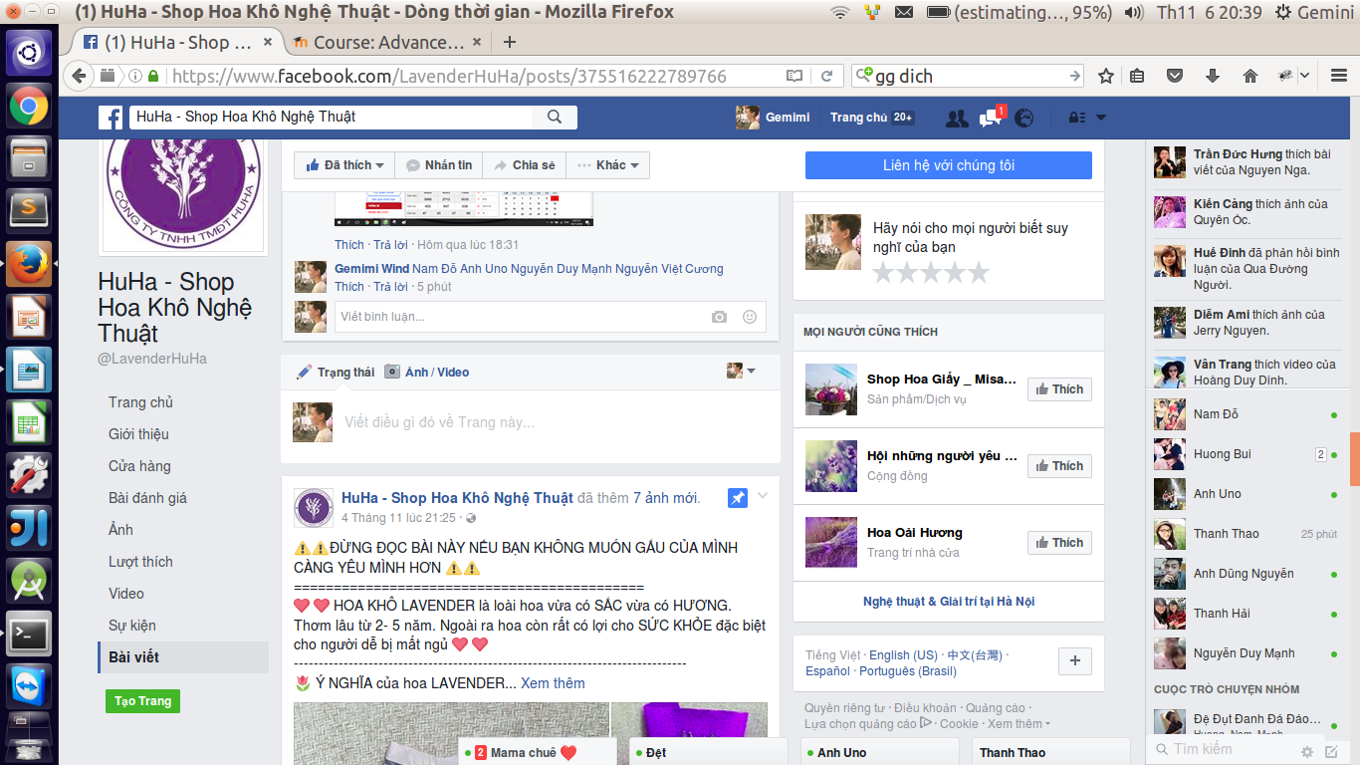

And we realize that many people engaged in this event. As we determined, there were more than 100 people joining this events. We hoped that the business can organize more and more events on the future to attract more customers.

Also, I continued to advertise for the business by spreading it on Facebook. I shared the product of business. I posted them on groups on Facebook. Moreover, I continued invite my friends like this page. At the end of week, we got the below results

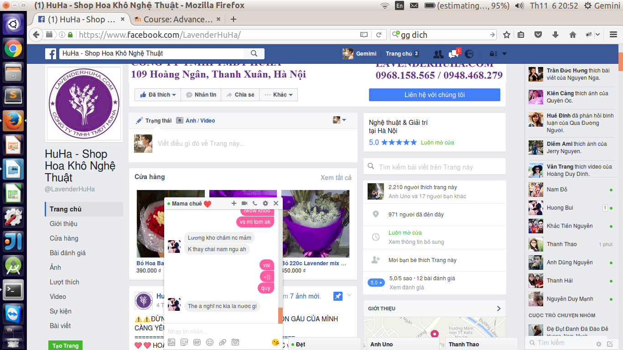

The results was quite goods. We hope that in the future, the like of this page will continue increase significantly.

At the same time, we find the prototype for building a website for the business. We give it to the representative and wait to their confirmation. If it is accepted, we will custom it to suitable with business.