TRAVEL BOOKING SYSTEM

-*Team AgileTrio*

Mentor: Renu Gehlot

[Linkedin](https://www.linkedin.com/in/renu-gehlot-42655532a/)

Members: 1) Milli Ranka (CSE)[Linkedin](https://www.linkedin.com/in/milli-ranka-42997b31b/)

2) Samriddhi Sirohi (CSE)[Linkedin](https://www.linkedin.com/in/samriddhi-sirohi-a35460328)

3) Komal Dheer (CSE)[Linkedin](https://www.linkedin.com/in/komal-dheer-341255333/)

Project Overview:

A simple computer program made using C++ to provide convenience in booking seats and storing passenger data. It eliminates the need of queue at the platforms and saves passenger’s time and effort, and hence providing a better travel experience

What it does?

**-Allows user to book seat**

**-Shows which seats are already booked**

**-Can update a booking (Name, age, destination, seat or date of travel)**

**-Can cancel a booking if needed**

**- Saves all data in a CSV file**

Objectives:

**-Design and implement a booking system using C++.**

**-Apply Object Oriented concepts.**

**-Learn to use file handling for persistent data storage.**

**-Practice clean code writing and version control using Git and GitHub.**

**SYSTEM FEATURES:**

**-Add new booking having attributes like name, age , destination, date, seat number, and a unique ID.**

**-View all bookings in a tabular format.**

**-Search booking by name, destination, date, or ID.**

**-Edit existing bookings.**

**-Cancel bookings using Booking ID.**

|  |  |
| --- | --- |
| **Features** | **Description** |
| **Add booking** | **Make new bookings having auto generated unique IDs.** |
| **View booking** | **Displays all bookings in a well formatted tabular output.** |
| **Search booking** | **Search booking by passenger name or destination.** |
| **Edit booking** | **Modify an existing booking’s details.** |
| **Cancel booking** | **Delete a booking using booking ID.** |
| **File storage** | **Booking data is stored to a file for persistence.** |

Key Features:

Main Menu :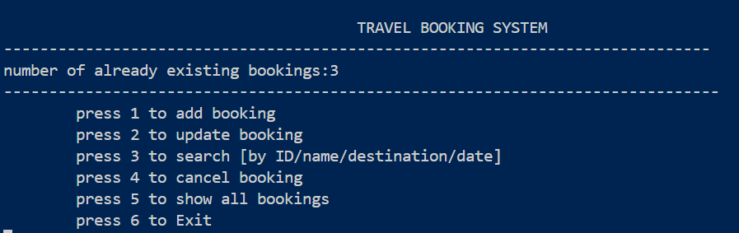

**1]Add booking: Users can add a new booking with an automatically generated unique ID.**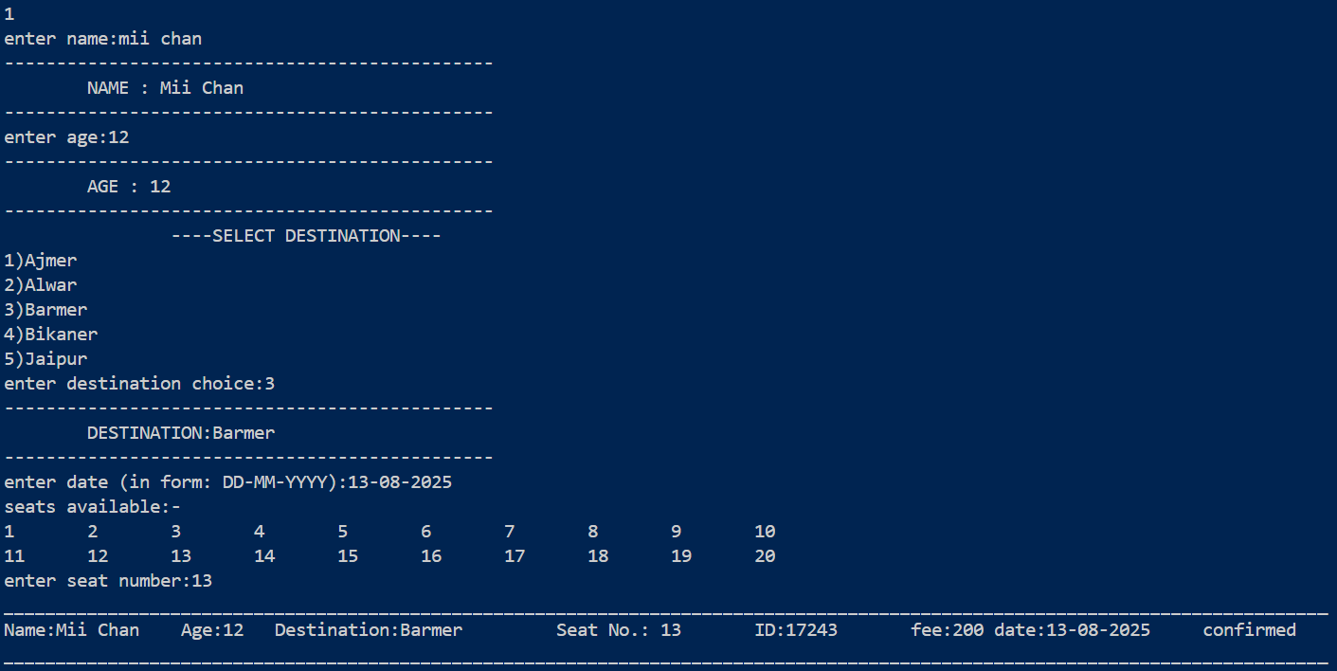

**-it checks whether the name is in correct format or not.**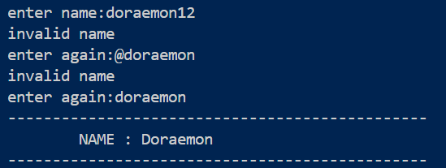

**-takes only numeric inputs for age.**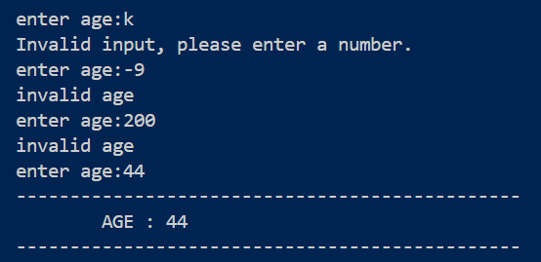

**-shows which seats are already booked.** 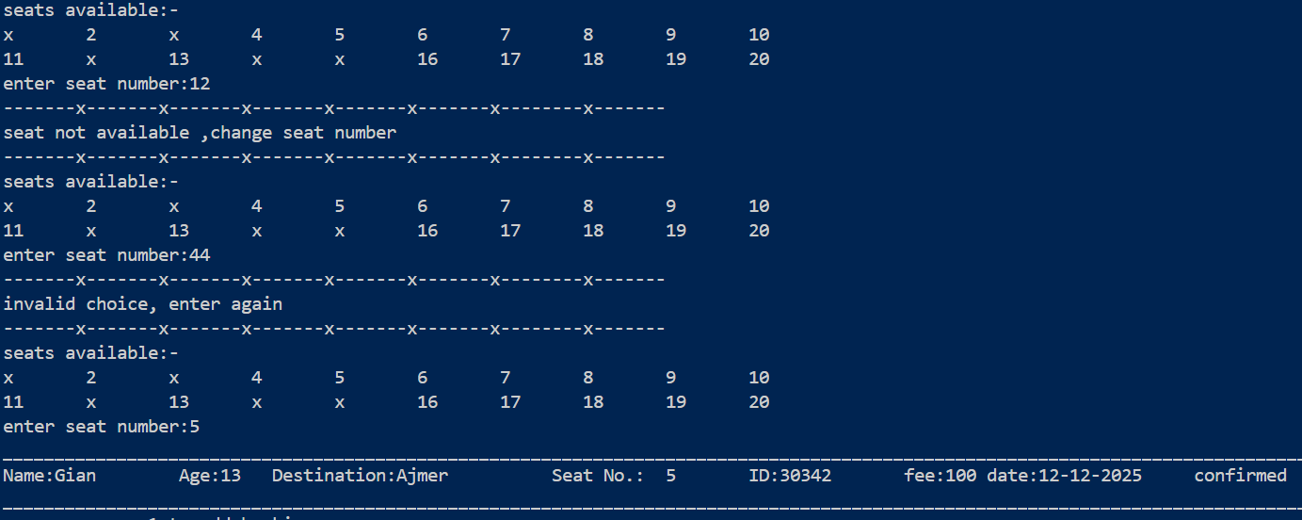

**2]Cancel booking: cancels the booking and removes it from the data storage file.**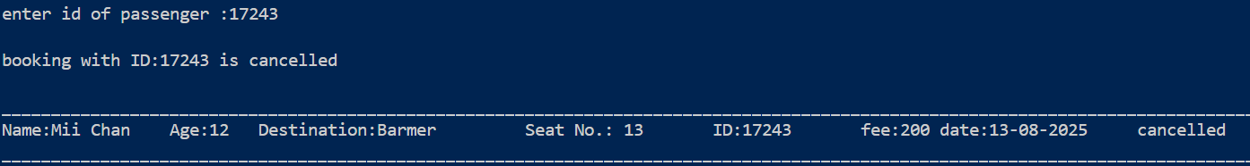

**3]Edit booking: Modify the attributes of existing booking like name, age, destination, date and seat number.**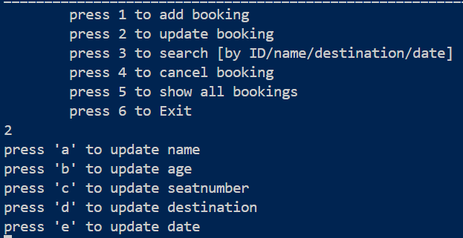

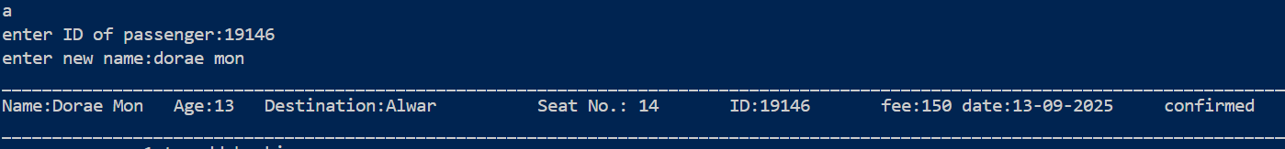

**4]** **View booking: It shows all the booking data present in data file in tabular, readable format.**

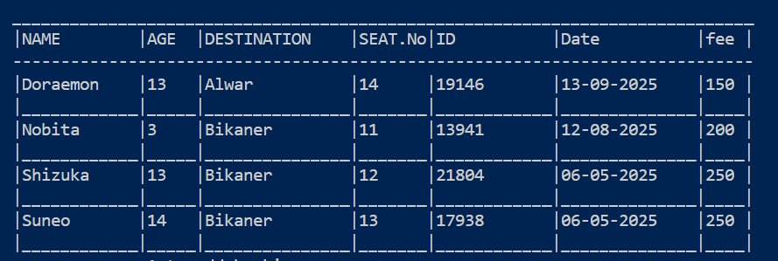

**5] Search booking: search and show the booking having entered value of attributes.**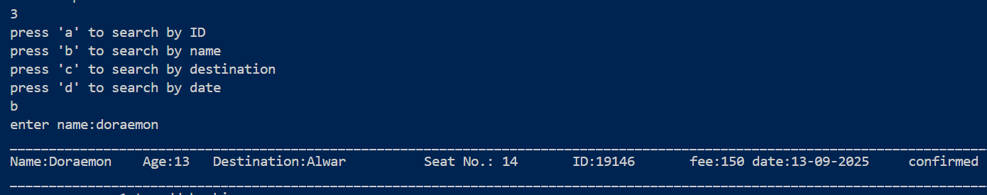

To exit system:

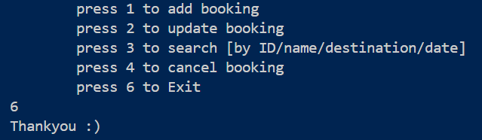

Requirements/Tasks:

Task1: Planning and System Design

-Defined system requirements.

-Outlined class and function design.

-Sketched class diagram

-Defined user input/output structure

Task2: Booking Management Module.

-Created booking class with members- name, age, destination, date, price and seat number & methods create and display.

Added functionalities:

1)Cancel the existing bookings.

2)Update existing bookings.

Task3: View/Search/Seat Summary

-Used iomanip library to display data in a proper tabular format.

-Improved data management of system by adding the feature of searching the booking using name, date, destination and id.

-Added functions for checking the availability of seat to avoid creating booking having same seat for same date and destination.

Task4: Final Integration & Menu System

-Created interactive menu with 6 options (add booking, update booking, search booking, cancel booking, show bookings, and exit)

-Handled loop control and invalid input.

-Performed testing with edge cases.

Task5: Documentation & Submission

-Cleaned and formatted final code.

-Wrote detailed documentation (via this file).

-Created README.md for the project.

-Pushed final project to GitHub.

GitHub Submissions:

<https://github.com/KomlDheer/Travel-Booking-System.git>

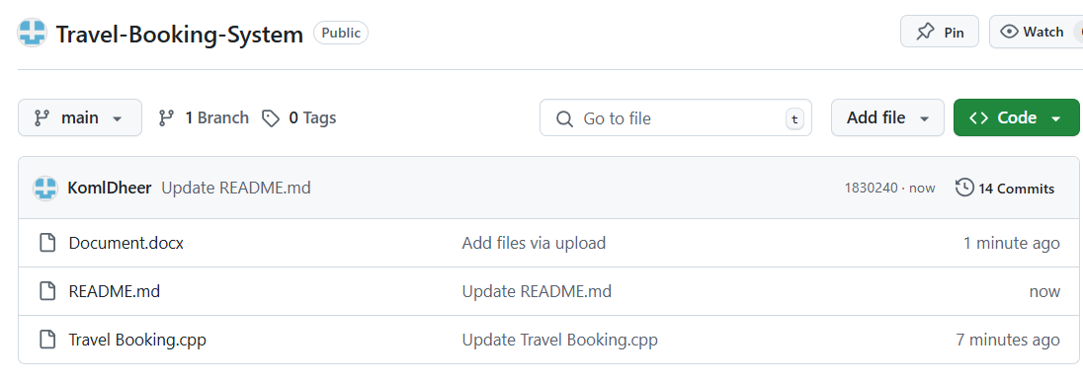

Travel Booking System

README.md 🡨Project instructions and sample input

Travel Booking.cpp 🡨Main booking functionality

Document.docx 🡨Full Documentation

Learnings:

**The journey of figuring out how an apparently simple looking booking system works was full of learnings. We learned how simple logic applied at each level in the program ultimately solves the bigger and complex looking problems. The major concepts that we learned were:**

**-Object-Oriented Programming (OOP)**

**-File Handling**

**-Input Validation and Error Handling**

**-User Interface design**

**-Problem Solving and Debugging.**

**We also enhanced our knowledge of C++ programming language and explored the features of the language which were mightily useful but still not known.**

ORGANIZED BY:

SPARK- Programming club (M.B.M. University)