# 3-D PLASMA ART

Phillip Lane, Monushka Sicar, Nicolas Ramirez, Burdley Colas, and M.J. Soileau

### Dept. of Electrical and Computer Engineering, College of Optics and Photonics, University of Central Florida, Orlando, Florida, 32816-2450

### *Abstract* — A laser damaging system with outdated technologies is redesigned to be modernized, smaller in size, versatile, and safe during operation. The system is connected to a computer associated with an electronics subsystem to move 3 stepper motors in the XYZ vectorized positions corresponding the rendered image. To etch in the crystal glass, an Nd-Yag pulsed laser set at the wavelength 1064 nm propagates through optical elements controlling the laser beam properties. The letters “UCF” are etched with 1 inch cube into a 2.75-inch cube in all sides with a 17-um diameter beam spot.

### *Index Terms — data* transfer, diodes, image reconstruction, optical control, image convertors, Q-switch laser, laser ablation

### I. Introduction

The 3-D PLASMA ART is designed to allow a user to engrave elevated 2-D images into a transparent crystal glass. Although 3-D, the padded images are split into layers. Plasma of each layer is performed to create the 3-D image inside a glass. It is based off the outdated 3-D laser induced damage system, Fig. 1, from the UCF College of Optics and Photonics, that etched into 6 glasses simultaneously; all of the same images. Despite the reduction in product output, the 3-D Glass Laser Plasma Art System provides increased user friendliness, laser safety shielding, and smaller physical footprint.

For ease of use, 2-D images of either black & white, or of color, are the starting point of damaging. 2-D images are initially taken through a conversion process: 2-D Image -> Bitmap -> Tracing/SVG -> Extrusion/STL. The STL output is then used to generate G code instructions that describe 3 linear movements. The linear movements are simultaneous as to create a 3-D effect of a 1064 nm wavelength laser beam relative to a crystal glass. A 3-D like image becomes the result.

A vital key to achieving 3-D movement between the laser beam and crystal glass is the use of an Atmel Atmega 328P microcontroller (MCU). It is function consists of deciphering G code instructions into the appropriate motor driving signals; a step signal and a direction signal.

The two signals are control inputs to GeckoDrive’s G201X stepper driver that then induces the movement achieved by three NEMA-23 size bipolar stepper motors. One motor moves the laser beam along the z-axis while two motors move a crystal glass throughout the XY plane.

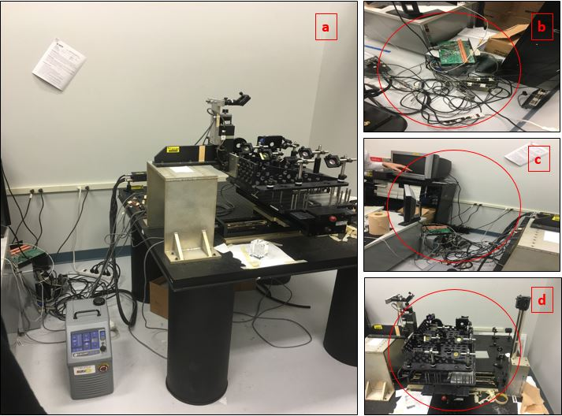

Fig. 1 (a) Old Laser induced damage system (b) Electrical components are exposed and dangerous (b) Computer system outdated (c) Optical system to etch six glasses simultaneously, hazardous due to exposed laser beam.

### II. System Hardware

Each physical subsystem is presented separately to zoom in on its role in realizing the final product. Technical specifications are provided about each as to focus only on important features related to their value.

*A. Microcontroller Power Supply*

All the electronics of the electronics within our 3D PLASMA ART besides the laser, and motor drivers are powered through Direct Current (DC) power. Since our design is being used in the United States of America, the standard main external power supply that is provided is Alternating Current (AC) Power. Because that the power needs to be converted to a digital nature for lower voltage electronics, providing a constant output voltage. This is cultivated through a power adapter that is specifically for the microcontroller that we are using. The power adapter that was selected has an input voltage of 100 - 240 VAC with a current of 600 mA and an output voltage of 12 VDC. Since the microcontroller Atmega 328P requires 5V to power on, the power adapter needs to be stepped down to at least 5V to active the microcontroller.

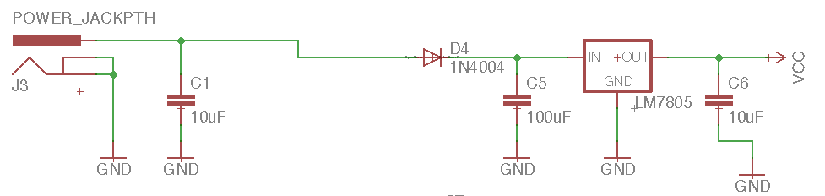

Fig. 2. 12 V to 5 V Regulation Conversion.

Fig. 2 above shows the process in which it takes to take the power that is coming from the power adapter of 12VDC to come out as 5V DC. The power jack is where the power adapter is inserted, from there the power goes through a capacitor, the filters some of the noise that may exist from the wall outlet. For the Voltage regulator LM7805, for the power adapter the voltage passes through a diode. Diode 1N4004 which is being used because it can withstand a reverse voltage of 400V, opening the circuit disallowing the negative voltage to enter in the regulator circuit [1]. Having the diode present where it is located it causes a one volt drop from the 12 volts supply from the power supply adapter. The relationship between the voltage in and the voltage out is as follows:

*LM7805 has a 2V drop out

The Voltage Regulator LM7805, within the datasheet that is provided by Texas Instrument there is a standard capacitance that should be used on the input lead and on the output lead. For the regulator, it can give out a minimum of 4.8V and maximum of 5.2V, what we would like for it to produce is 5V, with a current of 500mA. Along with knowing our end results we added capacitors to clear out some ripples that may occur. The power supply adapter is an already regulated 12V source, therefore capacitors may not be needed to clear out the ripples. With the voltage regulator, there is a recommended capacitance, because of the adapter we disregarded the recommended value. A 10 uF bypass capacitor, label C1, is added it is used to short any high frequency noise present at adaptor's output. The same concept is utilized with bypass capacitor at C5 of 100uF, and C6 of 10 uF.

It is very crucial to maintain a steady DC nature of the power, because of the sensitive low voltage devices is critical to avoid damaging them.

For the LM7805 a heat sink circuit is not needed to be created, on the grounds of there is already built heatsink with the component and the power wasted maintains within the parameters. The equation to calculate the power wasted is as follows:

Power wasted = (Voltage in - Voltage out) *IC (2)

Power wasted = (12 V - 5V) * 500mA

Power wasted = 3.5Watts

*B. FTDI Chip*

The FTDI FT232RL is a very essential component when it comes to the hardware. This chip is a commonly used integrated circuit (IC) that is used to convert information that is sent through USB to UART signals. This is provided to be very imperative to the process as to it allows the computer to communicate to the microcontroller without an extra need of another program.

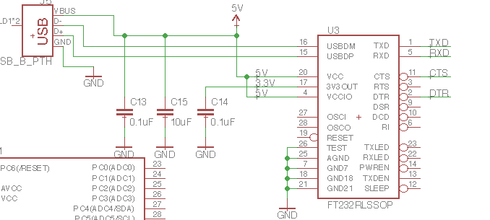

Fig. 3. USB-to-Serial Communication Circuit via FT232RL Chip.

In the Fig. 3, there are several important pins that are crucial. Pin DTR is an important pin, this pin allows the MCU to auto-reset when new firmware is programmed to it. This feature is important when flashing the grbl firmware to the MCU during the development and configuration of the firmware. The DTR pin acts as a pulse, jumping from 5V to 0V, to reset the MCU. However, the pulse is too quick for the MCU to be placed in reset mode. The MCU needs to be in reset for at least 2.5 microseconds. Shown later in Fig. 5 is an RC charging circuit, where the voltage across a 0.1 uF capacitor serves as input to the MCU reset pin. Combined in series with a 1 kilo-ohm resistor, the capacitor drops to 0 V and charges to 5 V when the DTR pin pulses from 5 V to 0 V. The charging characteristic of the capacitor is based on the following equation:

Vcap denotes the capacitor voltage; VCC denotes to the MCU’s voltage input, R denotes the circuit resistor; C denotes the capacitor’s value; t denotes the time at which the capacitor charges to a voltage. After substituting the following values: VCC = 5 V, R = 1000, C = 0.1 * 10e-06, and solving for time t, the capacitor takes 22.314 microseconds to charge from 0 V to 1 V. This is evident in Fig. 4 below. This period is sufficient as it is well above the 2.5 microseconds MCU reset threshold.

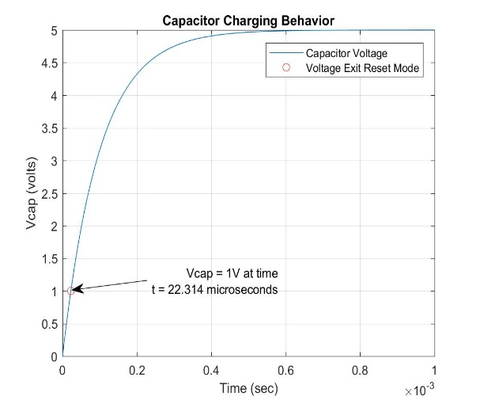

Fig. 4. 0.1 uF capacitor charging from 0 V to 5 V; 22.314 microseconds to charge up to 1 V.

Next, the FTDI FT232RL is built to receive automatically 5V from the USB, from the label VBUS. From there since there is a possibility of noise coming from the computer there are two capacitors placed on the voltage source that is coming directly from the USB. From there data is sent from the computer through the two data signals on the USB that are label +/- D to the FTDI chip. Since the 3.3V of the FTDI is not needed in this situation having it floating is not an option and it is sent to ground through a capacitor.

TxD and RxD are crucial pins located on the FT232RL. Which stands for Transmit data, and Receive data. These pins are connected on the microcontroller. The TxD is connected to the RxD on the microcontroller, and the RxD is connected to the TxD on the microcontroller. The FT232RL sends information to the microcontroller to tell the microcontroller where to move the motors. By the same means as the microcontroller is receiving data, it can send data back to the user via the FT232RL that a command is completed. When commands are completed, additional commands can be sent and stored until they are ready to be executed.

*C. Microcontroller*

The brains of the electronics are the ATmega 328P microcontroller. Its features include UART communication, sufficient flash memory at 32 kB, and 6 digital Input/output pins. 3 of the 6 pins are capable of pulse-width-modulation (PWM) output as well. PWM capability is essential for controlling the speed of the stepper motors defined within a user’s G code instructions.

Logic *lows* and *highs* are defined in project as 0 volts and 5 volts, respectively. The digital outputs of the ATmega 328P are inherently defined in this manner as well. This makes the microcontroller more compatible with other electronics whose highs and lows are defined similarly.

The operating voltage of the Atmega 328P is between 1.8V - 5.5 V, from the power supply that passes through a voltage regulator drops the voltage down to a consistent 5V, providing more flexibility in the microcontroller’s operating frequency

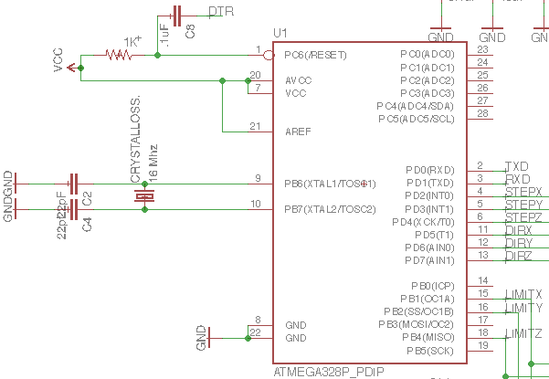

Fig. 5. Microcontroller Circuit

In Fig. 5 above is the schematic design for the Atmega328P microcontroller. The AVCC, VCC and, AREF are connected directly to the 5V that is provided from the voltage regulator. Even though the AVCC is not being used based off the date sheet it is still to be connected to the voltage source of the microcontroller [2]. AREF is used as an analog reference pin, along with VCC is the direct voltage input of the microcontroller.

On Pin PB6/PB7 there is a crystal oscillator connected, of 16mHz. With crystal oscillator connected with two capacitors that lead to grown forms a feedback with internal circuitry that uses RC timing making a clock for the microcontroller.

The pins that are left on the microcontroller that we are using are digital pins that are connected to the drivers that are further connected to the motors. Within these pins information such as the number of steps and direction the motor should move is sent from the microcontroller to the devices.

*D. Stepper Motor Drivers*

Geckodrive’s G201X stepper driver serves as the interface between the signal outputs of the ATmega 328P and the stepper motors.

Important characteristics include micro-stepping and current limiting. Each driver provides a 10 micro-step resolution, dividing each full motor step into 10 smaller steps. This feature allows the stepper motors to achieve higher precision in positioning for both the crystal glass and the laser beam. As a result, the image inside the final product may have a higher resolution than if only full steps of the motor were implemented.

Current limiting is essential for the prevention of overheating for both the motors and drivers themselves. Each driver is designed to allow up to 7 amps to flow into the coils of each motor phase. According to its specification manual, driver heatsinking is required in cases where 3 amps or more flow into the motor coils [3]. The drivers are set using onboard driver switches to allow up to 2 amps to flow. After much testing, the motors do not overheat and are able to achieve the performance needing during a damaging process. The electrical characteristics required by the project motors are discussed in the following section.

*E. Stepper Motor*

Three bipolar NEMA-23 size stepper motors, manufactured by OMC StepperOnline, were selected based on their torque performance and electrical characteristics. Under no load conditions, each motor achieves upwards of 340 oz.-in of torque. This specification is based on a desired load of 20 lbs. during the damaging process.

Each motor is rated at 1.8 amps/phase. This amount of amperage is achievable when combined with the G201X stepper drivers that allow up to 7 amps of current to flow into any stepper motor. By limiting the motor current flow to 2 amps as mentioned before, full motor torque can be achieved while preventing the possibility of heat buildup.

*F. Motor Driver Power Supply*

The G201X drivers are powered using a single DC switching power supply. The supply unit provides 36 volts and an amperage of up to 14 amps. Its voltage and current outputs are sufficient enough to satisfy demands of the stepper drivers, achieving desired performances.

*G. XY and Z Stage*

The purpose of the XY stage is to hold and reposition the crystal glass during a damaging process started by the user. After much research, a CNC mill developed by Sherline Direct was selected based its cost effectiveness. There were many options of platforms for the holding the crystal glass, but this part of the system is solely based on the cheapest device being able to get the job done.

In the final system, the mill is tilted 90 degrees where the x-axis is parallel to the floor and the y-axis is perpendicular to the floor. The z-axis stage holding the focusing lens is a reused part from the previous damaging machine. The lens in which it holds simply repositions the focal point of the laser beam using a focusing lens. The lens is facing the XY stage. Therefore, the laser beam is perpendicular to it. When the depth of an image undergoes a change, the focusing lens will be repositioned.

### III. System Software

The software used to control the laser induced damage system is a custom-made software that contains all required pre-processes to the final damaging process. These include 2D to 3D conversion, Gcode creation, and communications between computer and the laser induced damage system. The target system for the software is a Windows 10 operating system and all testing has been done using a Windows 10 system.

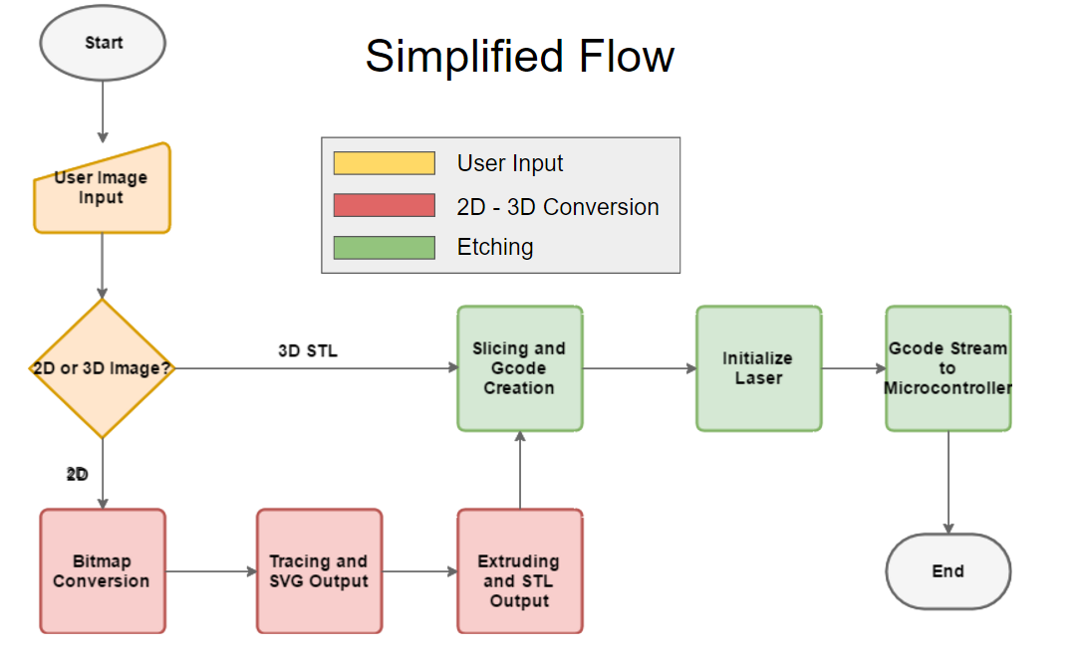

Fig. 6. High Level Software Diagram

*A. User Interface*

The main aspect of the software design is the user interface. The user interface is where the user interacts with the laser induced damage system and can perform all the software procedures which are described within the following points.

One of the main goals when designing the user interface was ensuring that the process was as automated as possible. This also meant that the amount of required user input was kept as minimal as possible. The outdated system software was clunky, slow, and took many steps to get through the whole process of damaging with the laser system. At times, external programs were required to be order to move on to the next step of the damaging process. Instead, this new software and user interface was designed so that there was no need to go to external programs by bringing all the steps together into a single user interface.

The other main design of the user interface was creating a simple, effective, and easy-to-use design for the user, such that almost any user that wanted to use the system would can use it within a minimal amount of time.

The programming language behind the user interface is Python, a well-known and growing programming language. Python is used due to its simplicity in writing and both for its vast standard library and external libraries by community support. To create the user interface, Python’s standard library for UI design is used, which is known as TkInter. Tkinter is a Python layer built upon Tk/Tcl GUI toolkit.

*B. 2-D to 3-D Conversion*

An important feature of the software design is the capability of transforming a 2-dimensional image into a 3-dimensional object. This is done by taking input from the user as an image file with the acceptable file types as being JPG, PNG, or BMP. These images can be of any dimensions of quality, but a high quality, low in size image with only a few types of colors works best. After inputting the image from the user, then three steps are taken to convert it to a functioning 3-dimensional object.

The first step is converting the 2-dimensional raster image into a monochrome bitmap type. The reason for this conversion is because it allows for the image to be traced into a vectorized file, which will be elaborated in the next step. Converting from the 2-dimensional raster image to a bitmap file is done by an external program called ImageMagick, an image conversion program that is usable from the command-line. ImageMagick is also a free software that is usable in both open source and proprietary configurations under the Apache 2.0 license [4].

The second step in the conversion process is the tracing of the bitmap image from the second step. In short, tracing a bitmap means transforming the bitmap into a smooth, scalable image [5]. The way that this is done in the software is by using a program called Potrace that can be used in the command-line. It is free program that is licensed under the GNU General Public License. Potrace takes in a bitmap file, traces the file which converts it to a vectorized file type known as an SVG file. This output file is not only smoother than the bitmap file, it is also scalable. The reason for creating a vectorized file is so that the image can be extruded, or expanded, in the z-direction, to create a 3-dimensional image that is ready for damaging using the laser induced damage system.

The last step in the conversion process is extruding and converting the 2-dimensional SVG image file to 3-dimensional stereolithography or STL image object. A STL file is a file that has information to describe a 3D object. This information is given in terms of triangles,meaning that the coordinates of a triangle is given within each line of the STL file, all coming together to form the 3-dimensional object in its complete and solid form. The way that this is done in the software is by using an external software known as FreeCAD [6]. Freecad is a 3-dimensional modeler with many uses. The software makes use of its ability to extrude an object in the z-axis, to give it a visible thickness. This is done through the software by using Freecad’s Python API. After extruding the turning the image into a 3D object, Freecad then exports the object as a STL file, achieving the final objective of converting the 2D image into a 3D image or object.

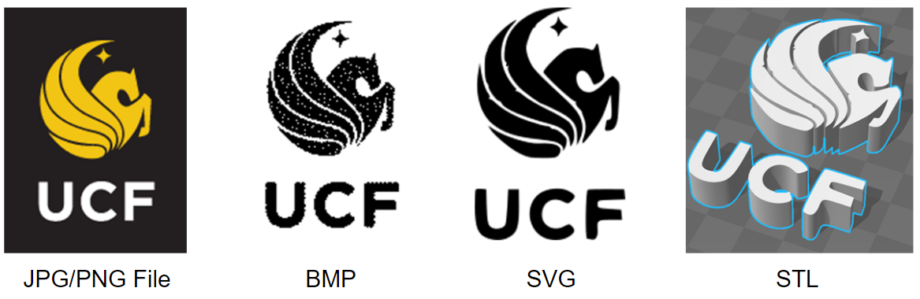

Fig. 7. 2D-to-3D Conversion Process

*C. Image Slicing and Gcode Generation*

In order for the laser induced damage system to etch the object that is input within the software, the software needs to be able to tell the motors to move in certain ways so that the laser can etch the outline of the object into the glass. The way that this is done is by using Gcode commands.

Gcode is a standardized motor control language used by CNC milling machine and 3D printing machines. The language tells the motors the destination of the movement, what path to take (arc or linear), and how fast to move [7]. Putting Gcode commands together allow for the motors to move in such a way that the 3D object is outlined by the motor movements. For the Gcode commands to be created for a given 3D object, a software tool commonly known as a “slicer” is used.

Slicers are software programs that take a 3D object, “slice” the object into horizontal layers, and then convert each layer into Gcode commands such that the commands outline the motor’s path for that given layer. Put together, the resulting Gcode is a group of layered pathways of the 3D object.

The slicer that is used in the software is known as Slic3r [8]. Slic3r is a slicing tool that is used to produce toolpaths for 3D printers, and which carries out all the procedures as described earlier. It is a free software licensed under the GNU Affero General Public License, Version 3, and is capable of being used through the command-line (which is how it is used within the damaging software). Slic3r is configurable to fit many different laser induced damage systems, including this project’s laser induced damage system. To use slic3r, the 3D STL file provided by the software is input into the program and the resulting Gcode is quickly generated and exported to a Gcode file. The Gcode file contains all the commands for the motors to follow to etch the object into the glass.

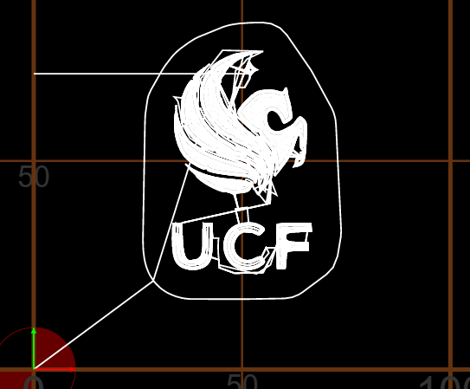

Fig. 8. Toolpath created by Gcode Commands

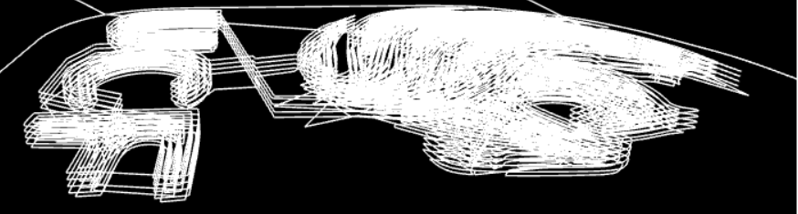

Fig. 9. Layers Produced by Gcode

*D. Gcode Streaming*

The last major function of the laser induced damage system software is to deliver the Gcode file to the microcontroller so that the firmware can interpret the Gcode and move the motors accordingly so that the laser can etch the 3D object into the glass. This is done in the software by using a Python written script that uses the pyserial module to establish a connection with the microcontroller, and afterwards begin streaming the Gcode file via USB to the microcontroller.

The streaming script used in the software is a modified example script provided by the microcontroller’s firmware. This script accounts for the serial buffers use by the microcontroller and allows for the next Gcode command to be immediately fetched, preventing what is known as buffer starvation.

The script also uses the well-known Python module known as Pyserial [9]. This library provides a way to use serial ports and carry out serial communications between different ports. The important function is the capability of opening a serial communication stream between the host computer and the microcontroller. This is so that the Gcode can be streamed to the microcontroller continuously, so that each command can be interpreted and processed by the firmware. The command are then carried out by moving the connected motors in whatever movements that are described by the Gcode.

In addition to communication with the microcontroller, the final software design will communicate with the laser system through USB-to-RS232 interface to turn the laser on and off. The laser will be turned on before the damaging process begins and turned off once the damaging process concludes.

*E. Microcontroller Firmware: GRBL*

The signals required to control a stepper motor via a stepper driver are the step and direction signals. The step signal is a PWM signal that controls the motor’s speed. The direction signal, usually at a logic high or logic low, determines the direction (clockwise or counterclockwise) of the motor shaft. The system takes advantages of using three drivers to control three stepper motors. As a result, there are 3 logic signals and 3 PWM signals needing to be outputted simultaneously. Such a capability is essential for achieving the 3-D repositioning of the laser beam’s focal point relative to the crystal glass.

This is where GRBL plays a role. This open source firmware is originally written by Simen Svale Skogsrud in 2009 and whose current development is being led by Sungeun K. Jeon Ph.D [10]. GRBL is written in optimized C, allowing for any user to make simple modifications to its program if needed. Specifically, version 0.9j of the GRBL firmware is utilized by the 3-D PLASMA ART.

The following block diagram depicts a high level flow of how the firmware accepts and executes G code commands.

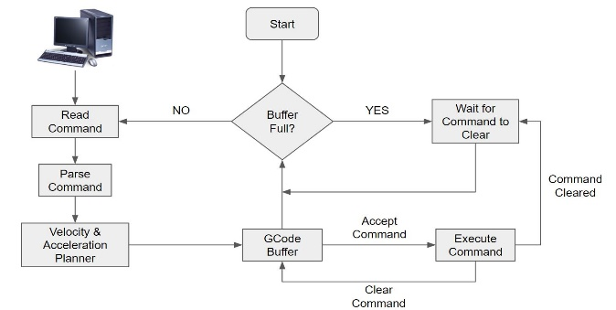

Fig. 10. GRBL Firmware Block Diagram of G Code Command Execution.

Starting the middle of the diagram, GRBL sits and waits for G code commands to be passed to its buffer. Its buffer stores up 16 commands to be executed. After accepting the next available command, the appropriate step and direction signals are outputted to the G201X drivers. The Execute Command box of the diagram indicates this. Simultaneously, GRBL can accept new commands into its buffer from the user computer so long as there is space within it buffer. If no space is available, no new commands are accepted until at least one command is cleared from its buffer post-execution.

### III. System Optics

The optical system comprises of the most important part of the 3D PLASMA ART, the laser. To render the computer-generated images, the laser light is the energy source that is used to ablate the crystal. The laser beam goes through a sequence of optical elements to attend a beam spot radius with respect to the resolution aiming for each damage spot and the final resolution of the image rendered.

To etch the glass, a laser is needed with the support of other optical elements to get the desired resolution. In addition to the laser, a polarizer and a half wave-plate are set in plate to form an analyzer to control the power of the laser beam. Also, a focusing lens are place along the optical axis, to have an orthogonal z-axis to the linear stage for the XY-axis.

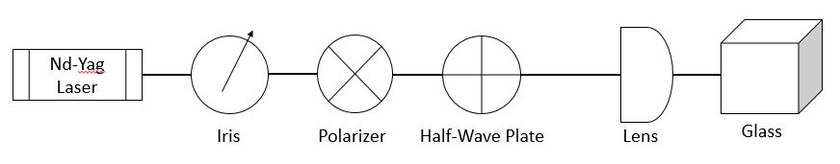

Fig. 11. Optical System Schematic along the z-axis.

*A. Laser*

A pulsed Laser is used. The ULTRA CFR Nd-Yag Laser system is light used to etch in the glass. It is a system that is composed of a compact laser with nonlinear optics, and an Integrated Cooler and Electronics (ICE). [12] The nonlinear optics in the laser head give us the ability to have other wavelengths such as 532 nm, 355 nm, 266 nm and 1576 nm asides of 1064 nm.

For our respective system, the laser is set to operate at 1064 nm and 8.5 energy level and 10 pulse frequency. A diagnosis was performed on the laser operation. As seen in figures 12-14**,** using a HR4000 Ocean Optics Spectrometer the spectrum was recorded. We detected 532 nm and 1064 nm. Fig. 15**,** shows the relationship of the energy level which can be control from the laser ICE and the output measured energy.

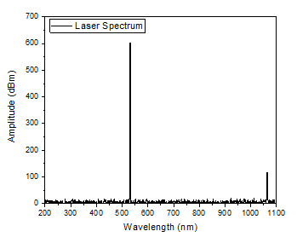

Fig. 12. ULTRA CFR Laser System Spectrum at 532 nm.

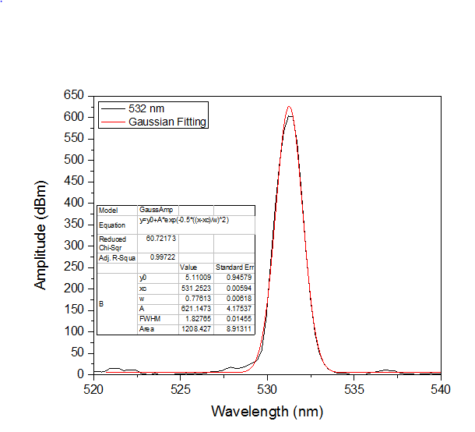

Fig. 13. 532 nm with a FWHM of 1.83 nm.

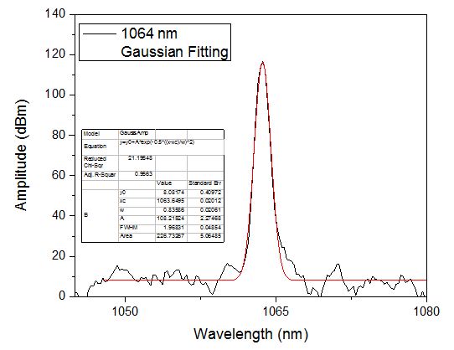

Fig. 14. 1064 nm with a FWHM of 1.97 nm.

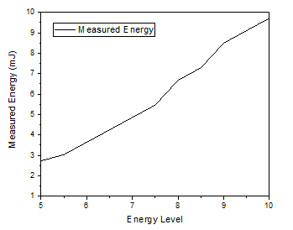Fig. 15. Energy Level ICE vs Measured Energy—1064 nm.

*B. Lens Selection*

The lens inserted in the optical system is a plano-convex lens with 25.4 mm focal length and 25 mm diameter. Using equation (5) the beam spot to etch in the laser is determined.

Wf=1.22 * (λf)/ (nπwl)(5)

Using this formula, we calculate the spot size entering the glass to be approximately 17-um diameter. Moreover, the depth of focus of is calculated using equation (6).

∆f = (π/2) * (wf/λ)2 (λ) (6)

The depth of focus is calculated to be at 20.8 cm yielding to a focal point to be at 10.4 cm.

VII. Conclusion

The final project of the 3D laser laser induced damage system is expected to be operational for a long period of time. The current system is smaller in size comparatively to the old system. It is relatively faster to time to etch a rendered because the speed of the stepper motors and the low load of the XY-axis. The software system is now simpler to use. The optical system is now only comprised of a single focusing lens.

### Engineering Team:

**Nicolas Ramirez**, a senior computer engineering student at the University of Central Florida. He plans to graduate with a Bachelor of Science in Computer Engineering in May of 2017. Afterwards he will be starting a full-time position at Intel Corporation in Folsom, California, where he can apply his knowledge of computer systems as a SSD Validation and Debug Engineer.

**Burdley Colas**, is an aspiring Optics and Photonics Science and Engineering student. His future career path is to be with Harris Corporation as Radio Frequency (RF) Photonics Engineer, R&D. His long-term goals are to pursue a graduate degree in RF Photonics Communication Systems, and Patent Law.

**Phillip Lane**, an aspiring electrical engineer, plans to become a USAF Developmental Engineer. Later, he hopes to pursue an M.S. of Electrical Engineering and train to be a USAF Flight Test Engineer.

**Monushka Sicar**, is currently a senior at University of Central Florida and will receive her Bachelors of Science in Electrical Engineering in May 2017. She plans to start a full-time position at Eaton Corporation, where she will be placed in an engineering leadership program. She plans in the future to attend graduate school for Biomedical Engineering, and Engineering Management.

### Acknowledgement

Dr. M.J. Soileau from the College of Optics and Photonics sponsored this project.

### References

[1] *1.0A Standard Recovery Rectifier,* NTE Electronics Inc., Bloomfield, NJ, pg. 1, Rev. 11-12.

[2] *Atmel 8-bit microcontroller with 4/8/16/32 KBytes*, Atmel Corporation, San Jose, CA, 2015.

[3] *G201X/G210X User Manual,* GeckoDrive Inc., Tustin, CA, 2011, pg. 6.

[4] ImageMagick Studio LLC, (2017) ImageMagick [Online] Available: <https://www.imagemagick.org/script/index.php>

[5] P. Selinger, (2017) Potrace, Transforming bitmaps into vector graphics. [Online] Available: [http://potrace.sourceforge.net](http://potrace.sourceforge.net/)

[6] FreeCAD Project, (2017) FreeCAD. [Online] Available:<https://www.freecadweb.org/wiki/About_FreeCAD>

[7] Multiple Authors, (2017). G-code. [Online]. Available: <https://en.wikipedia.org/wiki/G-code>

[8] Slic3r Project, (2017) About Slic3r. [Online]. Available: <http://slic3r.org/about>

[9] Pyserial, (2017) Welcome to Pyserial’s Documentation. [Online] Available: <https://pythonhosted.org/pyserial/>

[11]Sonny Jeon (2017). *About GRBL* [Online]. Available: <https://github.com/grbl/grbl/wiki>

[12] User’s Manual ULTRA CFR Nd-Yag Laser System, Big Sky Laser, January 2004, Rev G DOC0040