FULL STACK DEVELOPMENT WITH MERN PROJECT DOCUMENTATION

Introduction
Project Title : ShopSmart : Your Digital Grocery Store Experience
Team id : LTVIP2025TMID53033
Team Members:

Team Leader:
KOPPULA RAVI TEJA SRI– Full Stack Developer & Project Coordinator
Responsible for overall planning, coordination, GitHub management, and integration of frontend and backend.

Team Member:
KOMMU PRATHIBHA– Frontend Developer
Works on the React-based UI, handles component design, page routing, and user interactions.

Team Member:
KOMMURI VAISHNAVI– Backend Developer
Builds RESTful APIs using Node.js and Express.js, manages authentication and server logic.

Team Member:
KOLLI MOUNIKA– Database Administrator
Designs and manages MongoDB schemas, handles CRUD operations and ensures data consistency.

Project Overview
  - Purpose:
The purpose of ShopSmart is to digitize the traditional grocery shopping process by providing a seamless, fast, and reliable online platform. It aims to:
  - Enable users to shop for groceries anytime, anywhere.
  - Minimize physical store visits and long queues.
  - Connect customers with local grocery vendors.
  - Offer a personalized and user-friendly shopping experience.
  - Support vendors in managing inventory and increasing sales digitally.

  - ​

Features
👤 User Features
  - Easy Registration & Login
  - Browse Products by Category & Brand
  - Add to Cart & Wishlist
  - Apply Promo Codes & Discounts
  - Secure Payments (UPI, Card, Wallet)
  - Live Order Tracking
  - View Order History & Reorder

🛍️ Vendor/Admin Features
  - Add/Edit/Delete Products
  - Manage Stock & Pricing
  - View Orders & Sales Reports
  - Control Product Availability
  - Manage User Queries

📱 Other Key Features
  - Responsive Design (Web & Mobile)
  - Smart Search & Filters
  - Personalized Product Recommendations
  - Role-Based Access (User, Vendor, Admin)
  - Notifications via Email/SMS

Architecture

System Architecture Diagram
+ +

| User Interface |
| (React.js / Mobile) |
+-----------+ +

| v
+ +

| Backend API Layer |
| (Node.js + Express) |
+-----------+ +

| v
+ +

| Authentication |
| (JWT / Middleware) |
+-----------+ +

| v
+ +

| Database |
| (MongoDB) |
+ +

Components
- Frontend (React.js)
  - Handles UI/UX for customers, vendors, and admins
  - Interacts with backend via REST APIs
  - Responsive design for web and mobile

Backend (Node.js + Express)
  - REST API layer for handling user requests
  - Routes for user, product, cart, order, and admin operations
  - JWT-based authentication and authorization

Database (MongoDB)
  - Stores users, products, carts, orders, and vendor data
  - Enables flexible schema and fast querying

Authentication
  - Secures user sessions using JWT
  - Role-based access: user, vendor, admin

External Services (Optional)
  - Payment Gateway (e.g., Razorpay/Stripe)
  - Email/SMS Notification APIs
  - Cloud Storage for product images (e.g., Cloudinary)

Setup Instructions Prerequisites
  - Node.js >= 18
  - MongoDB installed and running (local or cloud - MongoDB Atlas)
  - npm or yarn

Installation
git clone https://github.com/your-username/ShopSmart.git cd ShopSmart
cd server npm install cd ../client npm install

Environment Variables

Create a .env file in the /server folder with the following content: PORT=3000
MONGO_URI=mongodb+srv://yourusername:<db_password>@cluster0.mongodb.n
et/shopsmart?retryWrites=true&w=majority&appName=Cluster0 JWT_SECRET=your_jwt_secret
🔐 Replace <db_password> with your actual MongoDB password.
✅ Make sure your IP is whitelisted in MongoDB Atlas or use 0.0.0.0/0 for open access (development only).

Running the Application
- Start the backend server:
cd server npm start
Runs at http://localhost:3000

Start the frontend:
cd ../client npm run dev
Runs at http://localhost:3000

Folder Structure
ShopSmart/
│
├── client/ # Frontend (React.js)
│ ├── public/ # Static files

│ | └── src/
│ | ├── assets/ | # Images, icons
│ | ├── components/ | # Reusable UI components
│ | ├── pages/ | # Route-based page components
│ | ├── context/ | # React context (e.g., Auth, Cart)
│ | ├── services/ | # API calls

│ ├── App.jsx # Main app component
│ └── main.jsx # React DOM entry point
│
├── server/ # Backend (Node.js + Express)
│ ├── config/ # DB connection, JWT config
│ ├── controllers/ # Request handlers
│ ├── models/ # Mongoose models (User, Product, Order)
│ ├── routes/ # API route files
│ ├── middleware/ # Auth, error handling
│ ├── utils/ # Helper functions
│ ├── .env # Environment variables
│ └── server.js # Entry point for backend
│
├── .gitignore # Files/folders to ignore in Git
├── README.md # Project documentation
└── package.json # Root config (optional if monorepo)5.Running the

Application Frontend:
- cd client
- npm start

Backend:
- cd server
- npm start
- API Documentation
🔐 Authentication & Users

Method | Endpoint | Description | Access
POST | /api/auth/register | Register a new user | Public
POST | /api/auth/login | Login and receive JWT token | Public

GET | /api/users/me | Get current user info | Private

🛒 Products

Method | Endpoint | Description | Access
GET | /api/products | Get all products | Public
GET | /api/products/:id | Get product by ID | Public
POST | /api/products | Create new product | Admin/Vendor
PUT | /api/products/:id | Update product details | Admin/Vendor
DELETE | /api/products/:id | Delete a product | Admin/Vendor

□ Cart

Method | Endpoint | Description | Access
GET | /api/cart | Get user cart | Private
POST | /api/cart | Add item to cart | Private
PUT | /api/cart/:id | Update item quantity | Private
DELETE | /api/cart/:id | Remove item from cart | Private

📦 Orders

Method | Endpoint | Description | Access
POST | /api/orders | Place a new order | Private
GET | /api/orders | Get current user’s orders | Private
GET | /api/orders/all | Get all orders (admin only) | Admin
PUT | /api/orders/:id | Update order status (e.g. shipped, delivered) | Admin

 Admin/Vendor Management

Method | Endpoint | Description | Access
GET | /api/users | Get all users | Admin

DELETE | /api/users/:id | Delete a user | Admin
GET | /api/dashboard/stats | Get overall statistics | Admin
- Authentication
  - User Registers/Login
  - Server verifies credentials
  - If valid, server returns a JWT token
  - Token is stored in client (localStorage/cookies)
  - Protected routes require the token in headers

User Interface
Home Page with product search
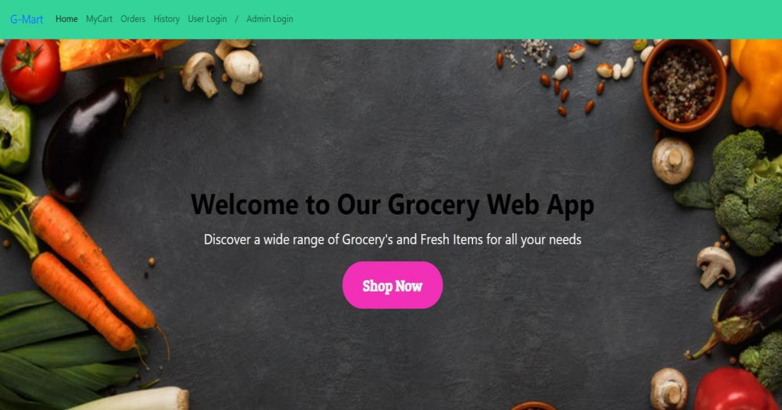
Login form

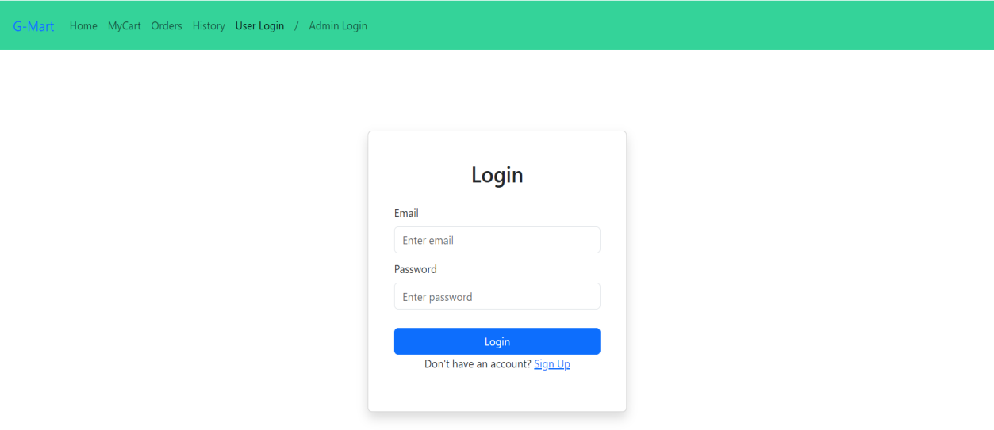

Items Page:-
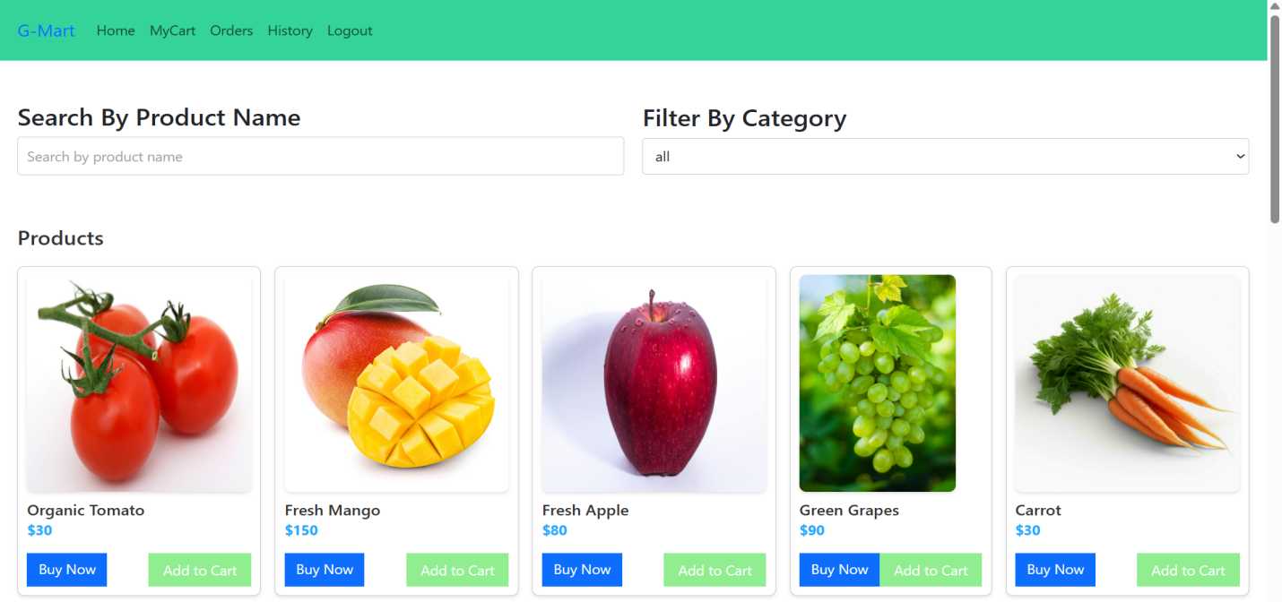
My Cart:-
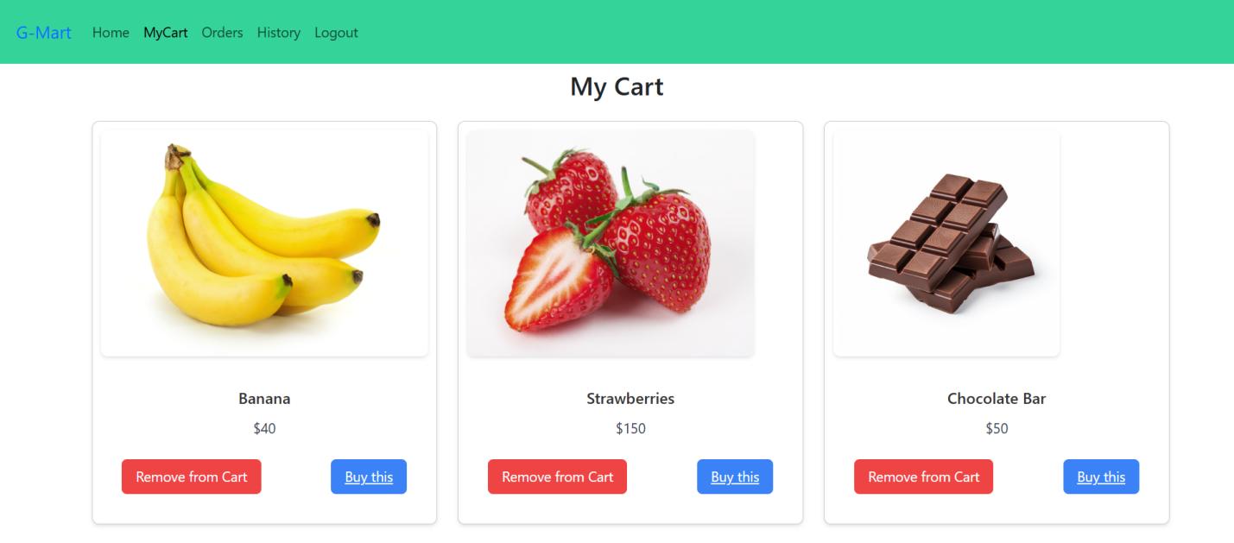

My Orders Page:-

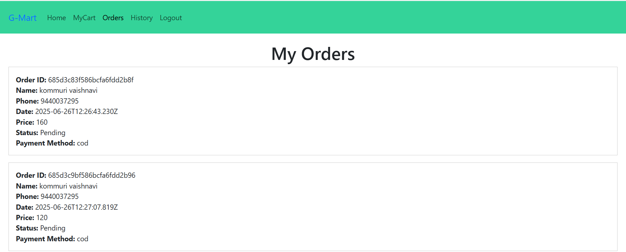

My History Page:-

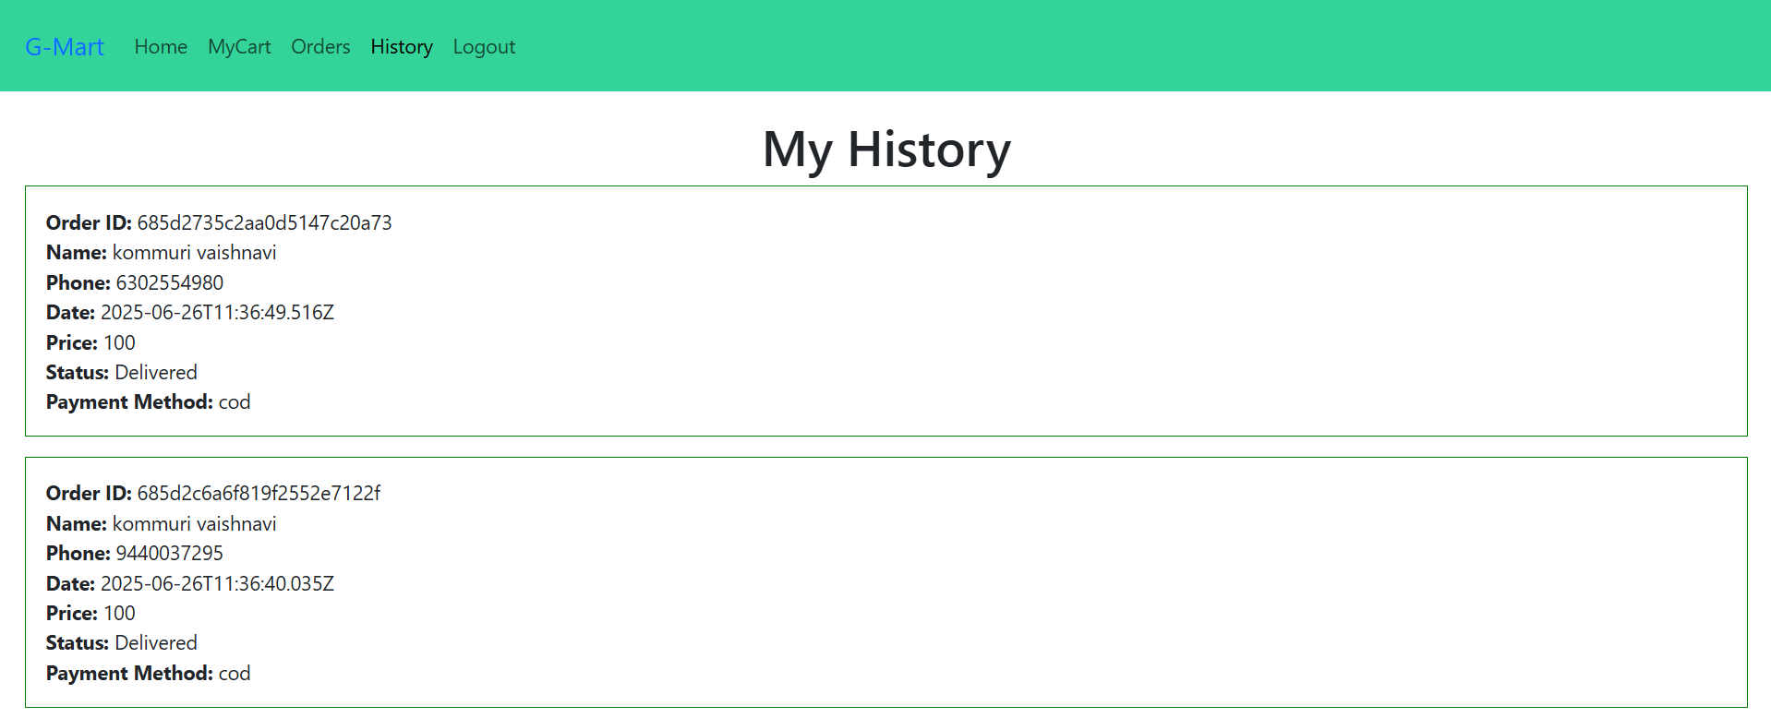

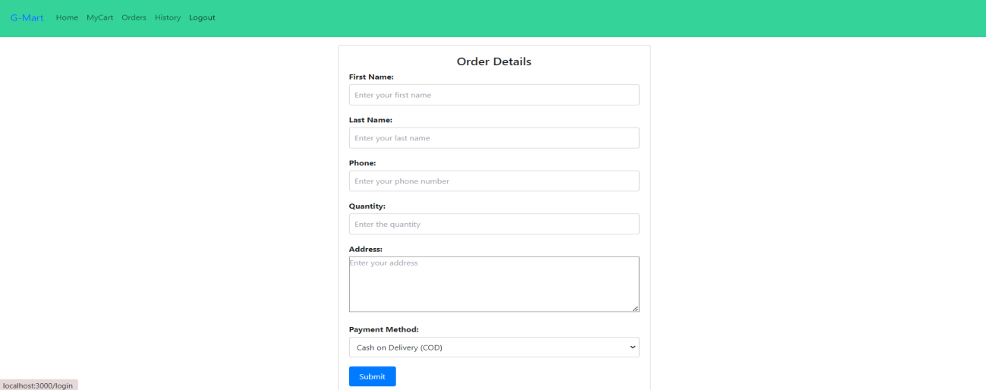
Place Order Page:-
Admin Dashboard Page:

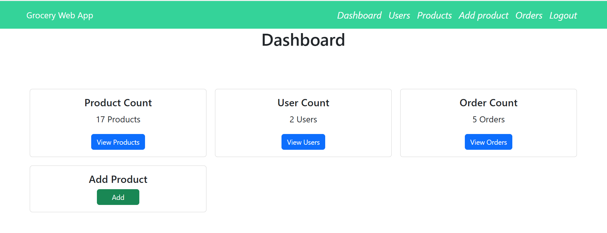

Users Page:-

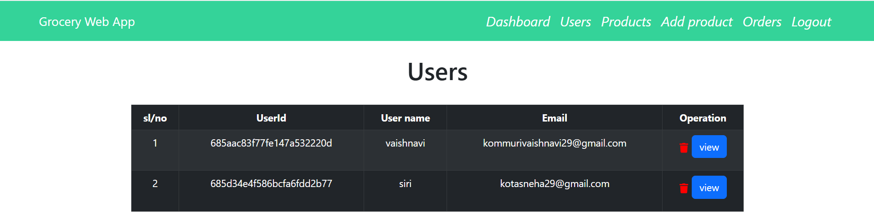

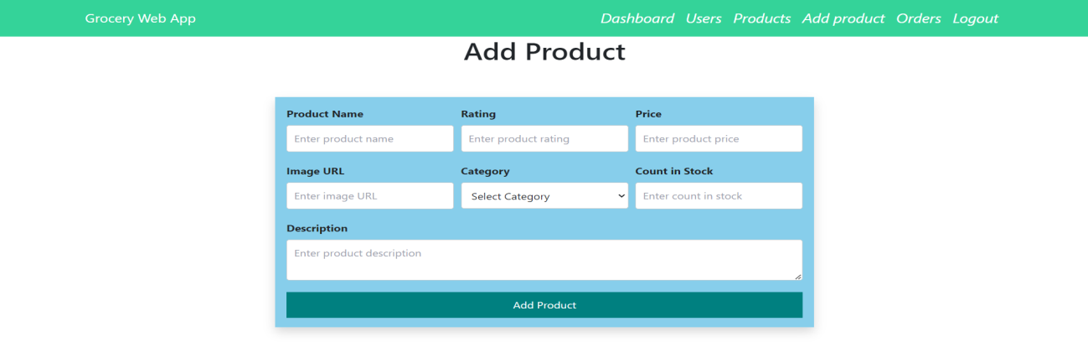
Add Product page:-

Admin Orders Page:-

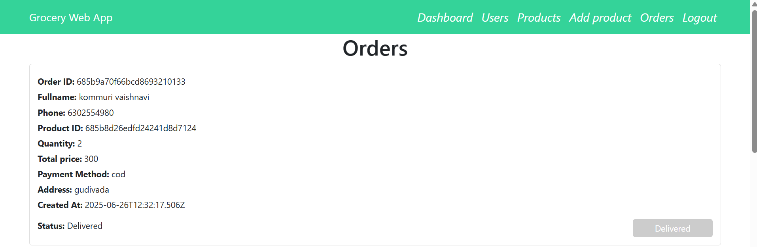

Testing
The ShopSmart application is tested using Postman for API endpoint validation and manual UI testing to ensure smooth user experience across registration, login, cart, and checkout flows. Automated testing can be added using Jest and Supertest for backend coverage.

Demo Link:
https://drive.google.com/file/d/1u8KX92v3QVg6c3j4Ggyw8_RE8Je2PQcL/view?usp=sharing

Known Issues
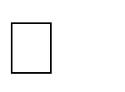
❌ No automated test coverage – Testing is currently manual; missing unit and integration tests.

⚠️ Limited error handling – Some API responses lack detailed validation or error messages.

📦 No pagination or filtering in product APIs – May affect performance with large datasets.

🔐 Token expiration handling not implemented – JWT tokens do not auto- refresh, requiring manual re-login.

Future Enhancements

Add Refresh Tokens – Implement secure token renewal to improve authentication flow.

Mobile App Version – Build a native mobile app using React Native or Flutter.

Inventory Auto-Update – Integrate real-time stock tracking for vendors.

AI-Powered Suggestions – Use machine learning to improve product recommendations.

Chat Support System – Enable live chat between customers and vendors.
Subscription/Auto-Order Feature – Allow users to set recurring grocery orders.
Multi-language Support – Expand user base by adding regional language options.
Invoice & Billing Module – Generate downloadable order invoices for customers.
Analytics Dashboard – Provide vendors/admins with real-time sales insights.

