Flight Ticket (One way) Booking ID: NF2ADUE560831031226, (Booked on 09 April 2025)



ANSH TIWARY

KOMOLIKA CHAKRABORTY

Barcode(s) for your journey Chennai-Kolkata on IndiGo

|  |  |  |  |  |
| --- | --- | --- | --- | --- |
| Chennai - Kolkata  Fri, 9 May 2025 • Non stop • 2h 30m duration | | | | |
| IndiGo 6E-923  PNR S5CSWW | Chennai  MAA 21:10  Fri, 9 May  Chennai Internati Terminal 1 | hrs  onal | 2h 30m    Airport | Kolkata  23:40 hrs CCU  Fri, 9 May  Netaji Subhash Chandra Bose International Airport |
| SAVER  Economy  check-in: 15 kgs (1 piece only) per adult | |  | Regular Fare  cabin: 7 kgs (1 piece | only) per adult |
| TRAVELLER  MS. KOMOLIKA CHAKRABORTY Adult  MR. ANSH TIWARY Adult | | SEAT | MEAL | E-TICKET NO  S5CSWW  S5CSWW |

You have paid INR 11268

Avoid Long Queues at the Airport with DigiYatra



DIGI YATRA

Use DigiYatra — the Ministry of Civil Aviation’s mobile app to enjoy a hassle-free airport experience, for your upcoming flight. It enables you to activate face scan for check-in at the airport with 2 easy steps:

Step 1: Pre-verifying your identity using Aadhaar Card details Step 2: Updating your upcoming flight’s boarding pass

[Know More](https://www.makemytrip.com/promos/digi-yatra.html/?region=in)

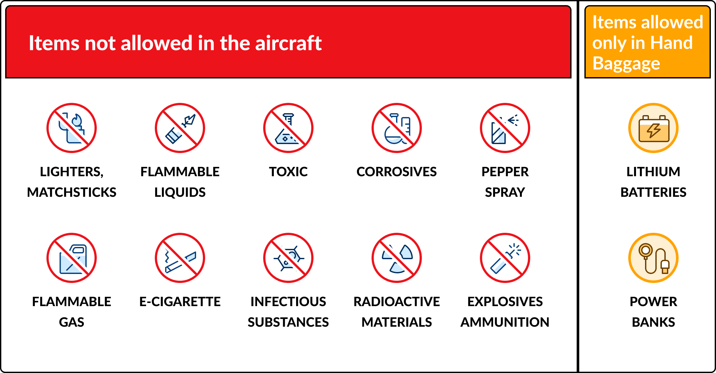

IMPORTANT INFORMATION

* Check-in Time : We advise you to reach the airport atleast 3 hours before departure. Check-in counter generally closes 60 minutes before scheduled departure. It may vary from airline to airline and so it is advisable to check with the airline once.
* DGCA passenger charter : Please refer to passenger charter by clicking [Here](https://www.civilaviation.gov.in/ministry-documents/passenger-charter-of-rights)
* Check travel guidelines and baggage information below: : Carry no more than 1 check-in baggage and 1 hand baggage per passenger. If violated, airline may levy extra charges.
* Unaccompanied Minors Travelling: : An unaccompanied minor usually refers to a child traveling without an adult aged 18 or older.Please check with the airline for their rules and regulations regarding unaccompanied minors, as these can differ between airlines.
* Valid ID proof needed : Carry a valid photo identification proof (Driver Licence, Aadhar Card, Pan Card or any other Government recognised photo identification)
* Please do not share your personal banking and security details like passwords, CVV, etc. with any third person or party claiming to represent MakeMyTrip. For any query, please reach out to MakeMyTrip on our official customer care number.

You can view all cancellation, date change and baggage related information [here](https://supportz.makemytrip.com/MyAccount/Communication/param?eid=M53YNkMruhBSxqAUGueJVhwN3jQ5freIRbEkQPW6768%3D&bid=9pS1rKz3GQ3jbgKNfL2iOALYm6%2BIAt1pqrY/zUkW7vc%3D&cno=47DVMcp7NIPmWjjYDz1icw%3D%3D&act=1&cmp=Flight_EticketModify&lang=eng&region=in) , If you want to manage your booking, you visit MyTrips section using this [link](https://supportz.makemytrip.com/MyAccount/Communication/param?eid=M53YNkMruhBSxqAUGueJVhwN3jQ5freIRbEkQPW6768%3D&bid=9pS1rKz3GQ3jbgKNfL2iOALYm6%2BIAt1pqrY/zUkW7vc%3D&cno=47DVMcp7NIPmWjjYDz1icw%3D%3D&act=1&cmp=Flight_EticketModify&lang=eng&region=in)

Contact MakeMyTrip +91124 4628747 / +91124 5045105 (India Number)

Contact IndiGo 0124-6173838, 0124-4973838