## **实验二：性能观测**

1. numClients=8

numSamples=256

改变objectSize

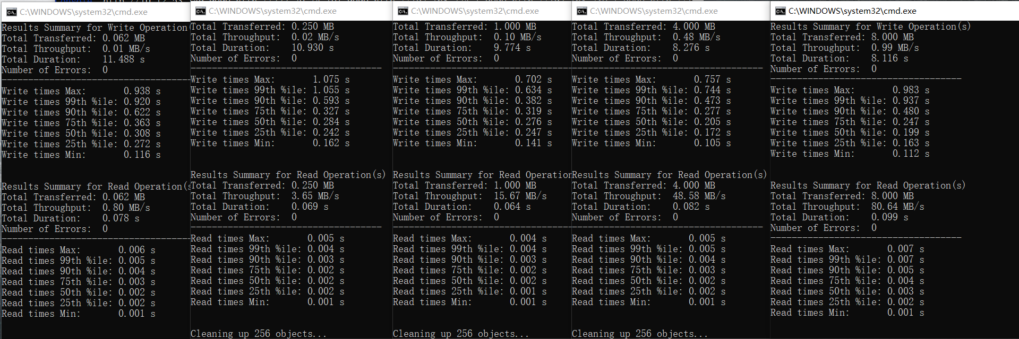

1. 1024 4096 16384 32768

Total Throughput随着objectSize变大而变大

1. numSamples=256

objectSize=1024

改变numClients

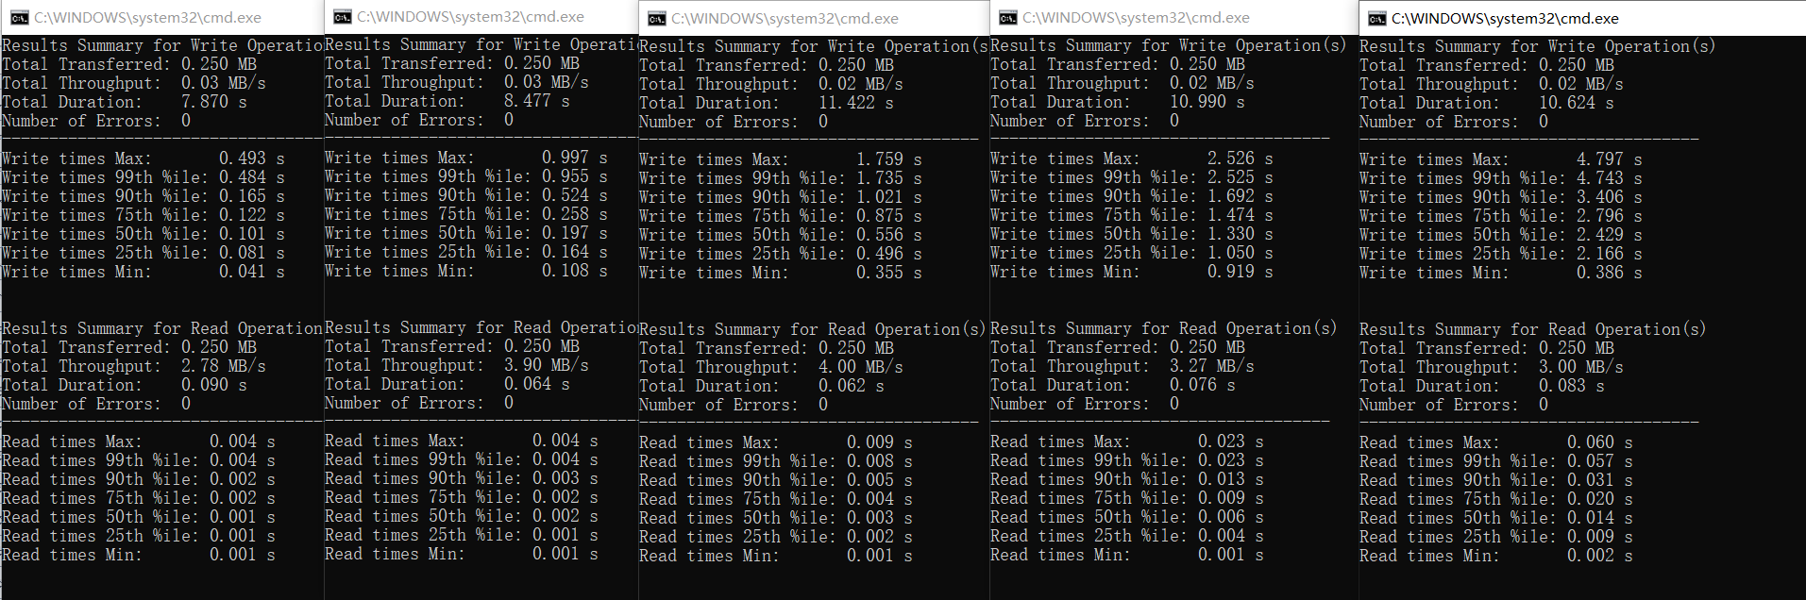

1. 8 16 32 64
2. numClients=8

objectSize=1024

改变numSamples