 | Dr. SPM International Institute of Information Technology  Naya Raipur  in association with  Chhattisgarh Infotech Promotion Society (CHiPS) | 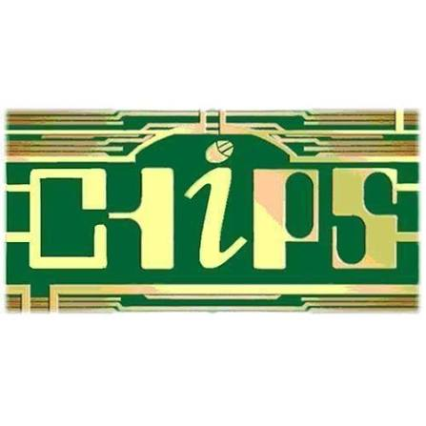

M O N T H L Y P R O G R E S S R E P O R T
CHiPS-RTI Project
Submitted by | Komendra Sahu
Designation | CMIT Fellow
Project | RTI Assistent
Role | RAG, Evaluation and Web Application Development
Mentors | Swati Garg
Organisation | Chhattisgarh Infotech Promotion Society (CHiPS)
Date of Submission | 24 / 07 / 2026

1. Project Focus
The CHiPS-RTI project converts scanned Hindi and English government and RTI documents into a searchable, explainable question-answering system. It combines document preprocessing, OCR, text optimisation, semantic chunking, vector indexing, hybrid retrieval, knowledge-graph enrichment, PIO/officer lookup, evaluation workflows and protected official-web verification in a web application.
Core Objectives:
- Build a Reliable Document Pipeline: preprocess PDFs, perform OCR, preserve page structure and produce searchable Markdown and JSON outputs.
- Deliver Grounded Retrieval: combine dense and sparse search in Qdrant with parent-child context, reranking and knowledge-graph support.
- Support RTI Operations: provide PIO analysis, officer-directory lookup, cited answers, source documents and controlled Section 4(1)(b) verification.
- Measure Quality and Safety: run benchmark experiments, track retrieval and answer metrics, record human reviews, detect regressions and expose protected Prometheus metrics.

2. System Architecture & Technology Stack
The platform follows a modular pipeline architecture. Flask and Node.js provide the web application, PostgreSQL stores officer and evaluation records, Qdrant stores embeddings, and local or remote language/OCR providers generate grounded results. The design separates ingestion, retrieval, generation, evaluation and web verification so each layer can be tested and improved independently.
Layer | Components / Description | Details
Client Layer | Browser Clients | Candidates, PIOs, administrators and reviewers
Frontend Proxy | Flask and Node.js Web UI | HTML/CSS/JavaScript interface, evaluation center and source viewer
Backend API | Flask REST and streaming endpoints | Authentication, RAG queries, PIO analysis, evaluation and web verification
Database & Tasks | PostgreSQL evaluation/officer store; in-process experiment workers | Dataset, experiment, result, review, version and alert tables
Document Processing & OCR | PyMuPDF, image preprocessing, Docling and configurable OCR providers | Hindi/English OCR, structured Markdown/JSON and page traceability

3. Week-wise Progress
The reporting period focused on integrating the document-to-answer pipeline, strengthening the evaluation control center and connecting the protected metrics endpoint to the web application. Work covered OCR and smart extraction, optimisation, chunking, hybrid RAG retrieval, PIO workflows, evaluation experiments, regression alerts and source-grounded responses.
Week | Period | Work Carried Out
Week 1 | 25.05.2026 to 29.05.2026 | Reviewed the RTI domain, project objectives, repository structure and existing document-processing and retrieval components.
Week 2 | 01.06.2026 to 05.06.2026 | Mapped the end-to-end flow from scanned PDFs through OCR, optimisation, chunking, embeddings and the web interface.
Week 3 | 08.06.2026 to 12.06.2026 | Worked on preprocessing and OCR outputs, including page structure, bilingual text handling and traceable structured Markdown/JSON.
Week 4 | 15.06.2026 to 19.06.2026 | Integrated semantic chunking, metadata handling and vector indexing for searchable document collections.
Week 5 | 22.06.2026 to 26.06.2026 | Strengthened hybrid RAG retrieval using dense and sparse search, reranking, parent-child expansion and knowledge-graph context.
Week 6 | 29.06.2026 to 03.07.2026 | Developed and refined PIO analysis, officer-directory routing, source citations and source-document viewing.
Week 7 | 06.07.2026 to 10.07.2026 | Implemented controlled Section 4(1)(b) official-web verification with source safety, evidence validation, caching and audit records.
Week 8 | 13.07.2026 to 17.07.2026 | Integrated the evaluation control center for benchmark datasets, experiment execution, retrieval/answer metrics and result comparison.
Week 9 | 20.07.2026 to 24.07.2026 | Scraping the CIC , SIC document and processing

4. Monthly Summary
The first phase consolidated the repository architecture and document pipeline, including PDF preprocessing, OCR, Markdown optimisation, Hindi spelling correction, semantic chunking and page-level traceability. The retrieval layer was then connected to BGE-M3 embeddings, Qdrant hybrid search, parent-child expansion and knowledge-graph context so that answers could be grounded in source passages.
The subsequent phase focused on operationalising the application. PIO analysis, officer-directory routing, official-web verification and source viewing were integrated into the Flask/Node interface. The evaluation center now supports benchmark upload, experiment execution, metric calculation, result comparison, human review, regression alerts and a protected Prometheus text endpoint for monitoring.

5. Work Planned for the Next Period
- Expand benchmark coverage with more representative Hindi/English RTI cases, labelled relevance passages and adjudicated answer-quality examples.
- Complete deployment hardening, including durable PostgreSQL/Qdrant configuration, secret rotation and a dedicated scoped Prometheus service token.
- Add operational dashboards and continue improving UI feedback, failure explanations, citation presentation and evaluation result exports.
- Run regression tests across OCR, retrieval, PIO routing, web verification and evaluation workflows, incorporating mentor and stakeholder feedback.

