Wittgenstein Apartment
A Sense-Level Behavioral Predicate Resource for Character-Centered Computational Systems
Furkan Yaşar
Independent Researcher · Istanbul, Türkiye
Correspondence: furkanyasar1924@gmail.com · www.furkanyasar.me
Abstract
Computational representations of human action require an intermediate modeling layer between lexical meaning and executable behavior. This paper presents Wittgenstein Apartment (WA), a sense-level behavioral predicate resource. WA combines fine-grained sense information from lexical-semantic resources with character-relative repertoire access, contextual executability, goal relations, and operational routing. Its core structure is the Superclass → Behavioral Predicate Family → Action Sense hierarchy. The current version contains 14 superclasses, 541 behavioral families, and 2,904 active Action Senses. The Basic Human Action (BHA) / Character Specific Action (CSA) distinction separates actions into default and evidence-gated repertoires according to whether additional positive evidence about a character is required, rather than according to action difficulty. Scene Dependency, Affordance Gates, and Action Anatomy separate repertoire access from situational executability. Goal Ontology links the same Action Sense to different goal contexts, while Functional Projection preserves semantic identity and provides operational routing for downstream systems. The paper positions WA as a reusable intermediate representation between lexical semantics and narrative, agent, and planning systems, and discusses its main application surfaces in automated planning, character simulation, and neuro-symbolic action validation.
Keywords: behavioral predicates; lexical semantics; knowledge representation; character modeling; automated planning; computational narrative

1. Introduction
Lexical resources can represent in detail what an action means, whereas planners, game engines, and artificial agent systems must define through explicit rules which actions can be selected and executed. These are different representational levels. For a character system, knowing the meaning of a predicate such as “walk,” “authorize,” or “anesthetize” is not sufficient. The system must also distinguish which behavioral family the exact action sense belongs to, whether it can be assumed to belong to an ordinary character’s initial repertoire, and under what conditions it can be executed in the current scene. This paper focuses on that intermediate representational problem between lexical semantics and computational action representation.
To address this gap, we present Wittgenstein Apartment (WA), a sense-level behavioral predicate resource that preserves lexical sense distinctions while connecting human-oriented actions to character-relative repertoire access, contextual executability, goal relations, and downstream operational use. WA asks a central question: how can human actions be represented computationally with respect to character and world conditions without losing lexical sense distinctions or reducing them to application-specific hard-coded action lists?
The problem arises because existing resource families were designed for different tasks. WordNet organizes words through synsets and lexical-semantic relations (Miller, 1995). VerbNet models verb classes in terms of thematic roles, selectional restrictions, and syntactic-semantic frames (Kipper et al., 2008). FrameNet links lexical units to participant roles through frame semantics (Fillmore, Johnson, & Petruck, 2003), while PropBank annotates predicate-argument realizations in corpora with semantic roles (Palmer, Gildea, & Kingsbury, 2005). By contrast, automated planning and game-AI systems operate over executable operators, preconditions, effects, and application-specific domain knowledge. Constructing and maintaining planning domains therefore remains a distinct knowledge-engineering problem (Lindsay et al., 2020; Oswald et al., 2024).
WA introduces a behavioral representation layer between these two ends. Core identity is maintained at three levels: Superclass defines a broad behavioral domain, Behavioral Predicate Family defines an intensional behavioral region, and Action Sense defines the smallest stable behavioral identity. Release v1.0 contains 2,904 active Action Senses across 14 Superclasses; 435 belong to the Basic Human pool and 2,469 to the Character Specific pool. The Family Definition layer contains 541 behavioral families. Each Action Sense is also associated with execution/context metadata such as task structure, scene dependency, affordance gates, and participant structure (Wittgenstein Apartment Behavioral Predicate Resource, v1.0).
The architecture is distinguished by separating three questions. The first concerns behavioral identity: “What exactly is this action?” The second concerns character repertoire: “Can this character be assumed to have access to this action without additional character-specific evidence?” The third concerns situational executability: “Can this action be performed here and now?” This separation prevents semantic identity, character-relative repertoire, and world/scene feasibility from collapsing into a single can/cannot field.
This paper makes four contributions. First, it develops a sense-level action architecture in which the lemma is not treated as the final behavioral identity. Second, the Basic Human Action (BHA) and Character Specific Action (CSA) distinction defines default and evidence-gated character repertoires. Third, Scene Gate and Affordance layers separate repertoire availability from situational executability. Fourth, Goal Ontology and Functional Projection connect semantic authority to downstream retrieval and routing. Together, these components provide a reusable behavioral substrate for applications such as narrative systems, agent architectures, domain authoring, and symbolic validation.
The remainder of the paper first relates this positioning to late Wittgenstein’s meaning-as-use perspective and to neighboring computational resources. It then presents WA’s core resource architecture and character-relative repertoire model. Subsequent sections describe the goal, context, and projection layers, followed by potential applications and the current scope of the resource.
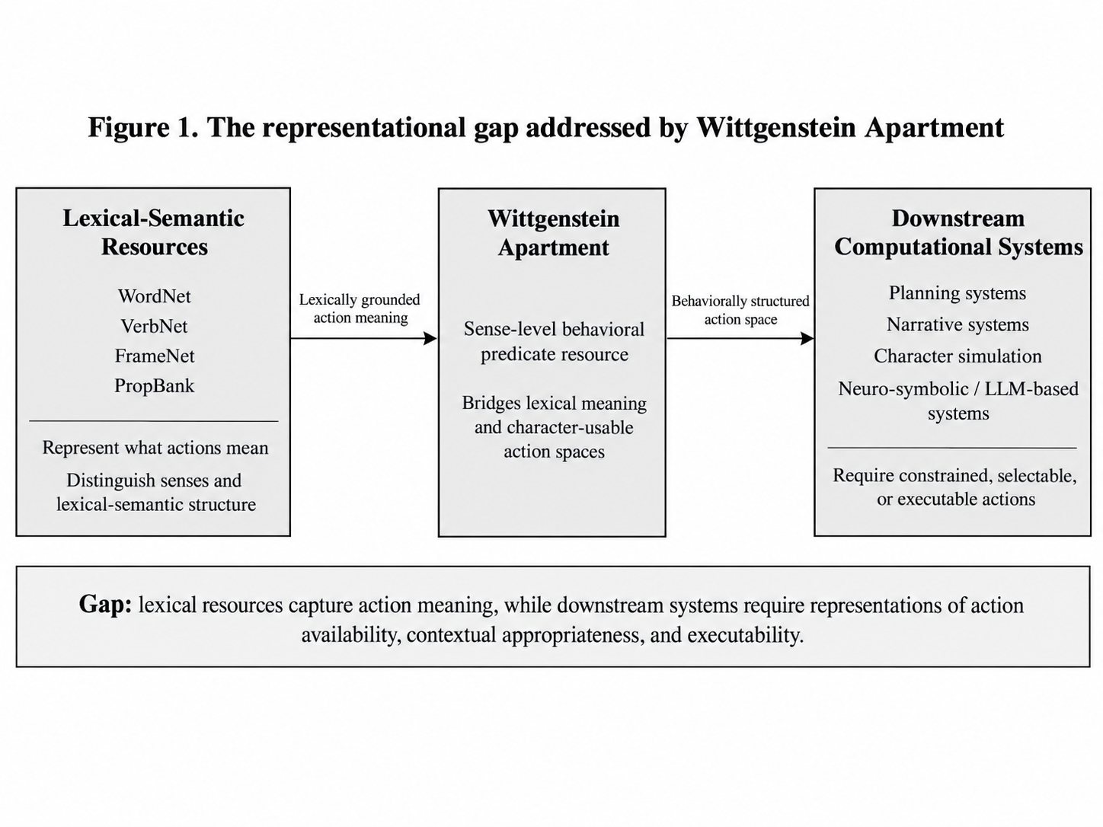

2. Conceptual Positioning and Related Work

2.1. Meaning, Use, and Behavioral Identity
The name Wittgenstein Apartment reflects a methodological affinity with the later Wittgenstein’s treatment of meaning in relation to use and activity. In Philosophical Investigations, the meaning-as-use perspective challenges the idea that word meaning can always be explained by a single context-independent essence and emphasizes that lexical form and identity-in-use are not equivalent (Wittgenstein, 2009; Biletzki & Matar, 2026). WA turns this philosophical affinity into a narrower engineering principle: the same lemma may encode different behavioral identities under different participant structures and conditions of use.
This principle is directly reflected in the resource’s sense-level design. WALK is not a single behavioral identity. WALK.v.1 represents ordinary ambulation, WALK.v.2 an accompanying or escort-oriented transit sense, and WALK.v.9 the “walk an animal” sense associated with companion-animal care. Separating the same lexical form into distinct Action Senses places semantic authority at the Action Sense level rather than at the lemma level. Context sensitivity is therefore not left as an unconstrained interpretive problem; it is bounded computationally through stable IDs, family membership, definitions, and participant/context metadata.
The term Behavioral Predicate Family serves a related function. Wittgenstein’s notion of family resemblance draws attention to conceptual families that need not share a single necessary essence. WA, however, makes family boundaries more explicit through intensional definitions and inclusion/exclusion rules because the resource must remain machine-readable. The philosophical motivation is therefore not the classification scheme itself, but the principle that superficial lexical similarity should not be conflated with behavioral identity.

2.2. From Lexical-Semantic Resources to Behavioral Representation
WordNet, VerbNet, FrameNet, and PropBank form the most immediate neighboring family of resources for WA. WordNet provides a lexical sense inventory and semantic relations; WA can use these for lexical grounding and traceability while retaining project-level authority over behavioral families, character repertoires, and world-context decisions. VerbNet provides rich representations of thematic roles and syntactic-semantic verb behavior. WA shifts the focus from linguistic realization to the behavioral status of an action sense at the character and system level. FrameNet models scene structure through semantic frames and Frame Elements, whereas a Scene Gate in WA is execution-context metadata that marks whether an exact action identity requires a social, institutional, or ritual context. PropBank annotates observed predicate-argument instances in corpora; WA organizes a reusable action inventory prior to any particular narrative instance.
These resources are better understood as layered rather than competing representations. WA can consume distinctions from lexical-semantic resources and carry them into an action-oriented representation. In particular, retaining the WordNet background layer as external lexical evidence keeps project-specific behavioral identity separate from external lexical provenance.

2.3. Commonsense Event Knowledge and Computational Narrative
Commonsense resources such as Event2Mind, ATOMIC, and GLUCOSE focus on plausible intentions, effects, reactions, or causal explanations associated with events (Rashkin et al., 2018; Sap et al., 2019; Mostafazadeh et al., 2020). They provide rich answers to questions such as “What commonsense relations are expected when an event occurs?” WA addresses an earlier representational stage: before event inference begins, it identifies the exact Action Sense, determines which character repertoires may contain it, and records the scene/world conditions under which it can be executed.
Within computational narrative research, approaches such as Story Intention Graph and DramaBank link realized narrative events to goals, plans, beliefs, outcomes, and affect (Elson, 2012). IPOCL approaches narrative generation at the planner level by combining character intentionality with causal plan structure (Riedl & Young, 2010). WA enters at a different point: rather than generating or explaining an event sequence in a particular story, it organizes a reusable action space at the sense level for use by narrative and planning systems.

2.4. Planning, Domain Authoring, and the Intermediate Representation Gap
HTN and related symbolic planning approaches require explicit domain knowledge about complex tasks, decomposition methods, preconditions, and state transitions (Georgievski & Aiello, 2015). This expressive power also creates a domain-authoring burden. WA’s PRIMITIVE/COMPOUND distinction, together with scene and affordance metadata, systematizes a semantic-behavioral starting surface from which application-specific planning domains can be constructed. Planner operators can therefore be linked to stable action senses and semantic metadata rather than to ad hoc action names detached from lexical resources.
Taken together, these comparisons reveal an intermediate representational gap. Lexical resources primarily answer “What does a predicate mean, and how is it realized in language?” Commonsense resources ask “What intentions, effects, or explanations are associated with an event?” Planners ask “Which operator can be selected under which conditions, and how can a goal be reached?” Figure 1 summarizes this representational gap and positions WA between lexical-semantic resources and downstream computational systems. WA occupies the layer between them by asking: “Which exact human-oriented Action Sense exists in the system, for which characters can it be assumed, and in which contexts can it be executed?”
Table 1. Related resource families and WA’s representational focus
Resource family | Primary focus | WA’s complementary focus
WordNet | Lexical senses and synset relations | Sense-level behavioral identity and downstream character/context metadata
VerbNet | Verb classes, roles, and syntactic-semantic behavior | Behavioral status and usability of the Action Sense
FrameNet / PropBank | Frames, participants, and corpus predicate-argument structures | Reusable action inventory and context/executability layer
ATOMIC / Event2Mind / GLUCOSE | Event-centered commonsense intents, effects, and explanations | Action identity and repertoire/context constraints prior to inference
SIG / narrative planning | Narrative events, intentions, plans, and sequence generation | Reusable behavioral action space prior to a narrative instance
HTN / symbolic planning | Operators, decomposition, and goal-directed search | Planner-facing semantic-behavioral domain substrate
Wittgenstein Apartment | Intermediate layer between lexical semantics and executable agents | Separation of identity, character repertoire, and situational executability

This positioning locates WA’s contribution in the explicit connection it establishes among distinct representational levels within a single resource architecture. The remainder of the paper describes the data model of this intermediate layer and its character-relative behavioral logic.

3. Behavioral Predicate Resource Architecture
WA’s core resource architecture separates behavioral knowledge into three stable semantic levels rather than collecting it in a flat verb list: Superclass, Behavioral Predicate Family, and Action Sense. This separation prevents broad behavioral domains and exact sense identity from being forced into the same classification decision. Superclass supports navigation and high-level grouping; Family defines behavioral inclusion and exclusion boundaries. As shown in Figure 2, Action Sense provides the stable semantic unit to which contextual and operational metadata are attached.
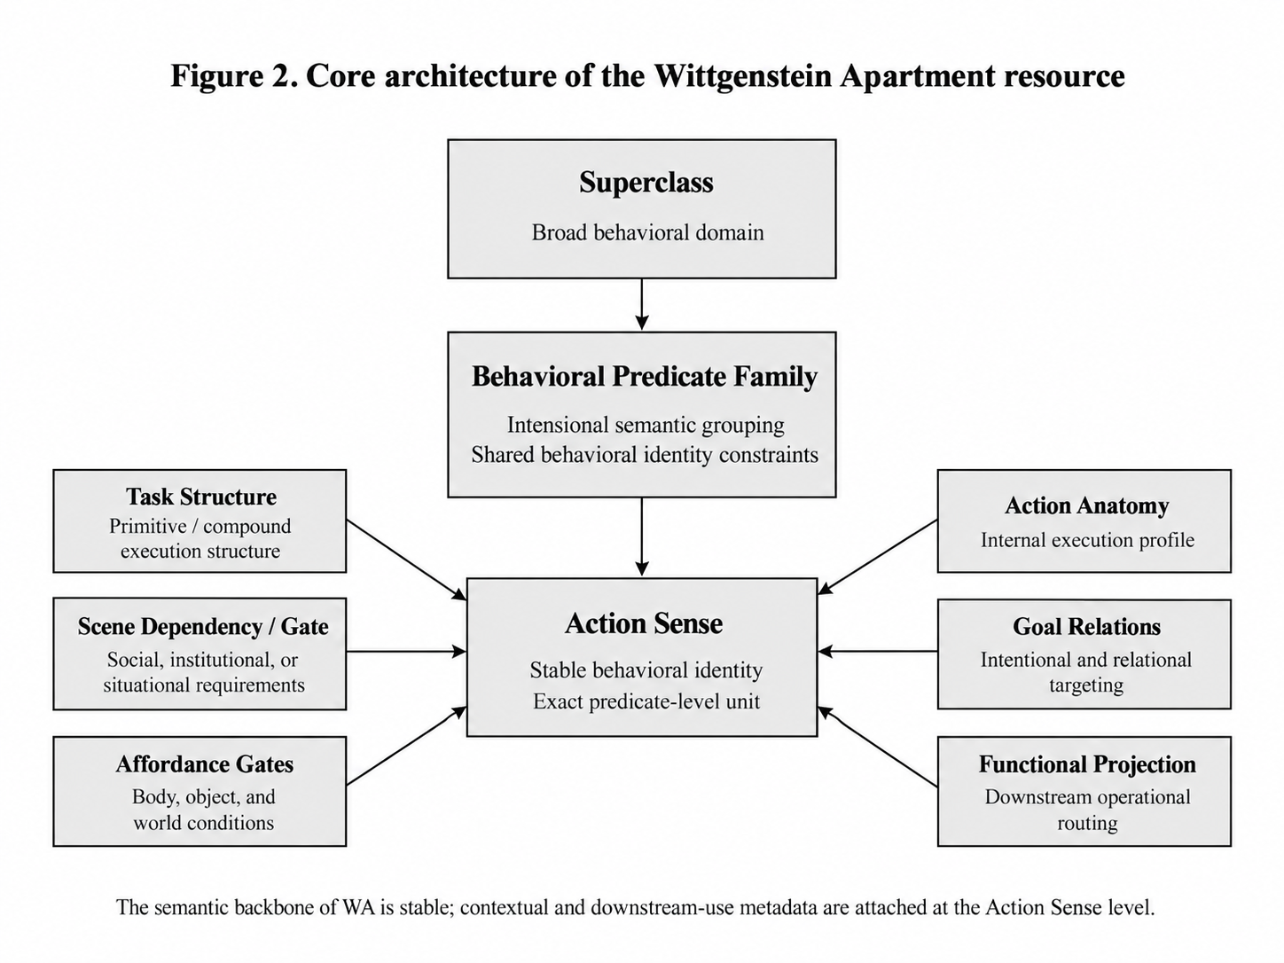
Table 2. Core semantic layers in WA
Level | Core question | Resource function
Superclass | Which broad behavioral domain does the action belong to? | Organizes broad behavioral regions and narrows the Family search space.
Behavioral Predicate Family | Within which intensional behavioral family is the sense interpreted? | Defines the shared semantic core, participant expectations, and boundary rules.
Action Sense | Which exact behavioral meaning is represented? | Provides stable behavioral identity and the primary cross-layer join unit.

3.1. Superclass and Behavioral Predicate Family
The current resource uses 14 Superclasses: CARE, COGNITION, COMBAT, COMMUNICATION, ECONOMY, EMOTION, LEISURE, LOCOMOTION, MANIPULATION, PERCEPTION, SOCIAL, STATE_MAINT, SURVIVAL, and TRANSPORT. These classes form the top navigational level of the taxonomy. LOCOMOTION covers movement of the actor’s own body through space; TRANSPORT covers changing the location of another entity through carrying or conveyance; MANIPULATION covers direct physical change to an object or the environment. Such distinctions narrow the search space for selecting a Family and Action Sense.
Behavioral Predicate Family is the principal intermediate level of semantic authority. Family membership is determined not merely by lemma similarity but by an intensional definition, agent/patient constraints, expected result or telos, and boundary rules. The current Family Definition layer contains 541 families. This design separates semantically distinct Action Senses within the same broad Superclass while preventing thousands of senses from becoming isolated, unrelated records.

3.2. Action Sense and Stable Identity
Action Sense is the smallest stable behavioral identity in WA. The lemma is the lexical access surface; identity is fixed by a specific Sense Variant and definition. Polysemy is a central motivation for this design: WALK.v.1, WALK.v.2, and WALK.v.9 share the same lemma but may belong to different Families and carry different participant/context structures. Cross-layer references are therefore established through the Action Sense ID.
Each core action record is tracked by a stable ID in the WA.ACT format. Stable identity allows a record to remain traceable even when lexical source mapping, the Turkish definition, synonym lists, or downstream projections change. Layers such as WordNet Background, Goal Ontology, Non-Goal Exceptions, and Functional Projection link back to the same action through this ID. This creates an explicit join boundary between lexical provenance and project authority.

3.3. Sense-Level Metadata
The Basic Human and Character Specific sheets use the same core schema. They therefore represent different repertoire statuses over the same Action Universe rather than separate ontologies. A core record combines identity/hierarchy, lexical description, execution/context, and authority/retention fields.
Table 3. Core Action Sense field groups
Field group | Main fields | Function
Identity / hierarchy | Action Sense ID; Superclass; Family Name; Family ID | Stable sense identity and position in the semantic hierarchy
Lexical / descriptive | Lemma; Sense Variant; Source Sense ID; EN/TR Definition; Synonyms | Sense description and lexical provenance
Execution / context | Task Structure; Scene Dependency; Scene Gate Type; Affordance Gates; Action Anatomy | Task decomposition, contextual requirements, and participant structure
Authority / retention | Human Agent Eligible; Predicate Support; Process Reaction | Usage status of the record within the active universe

Co-locating these fields in the same row does not collapse them into a single decision type. Family constrains semantic identity; Task Structure describes execution decomposition; Scene and Affordance fields describe context and feasibility; authority flags record why an entry is retained in the resource. Keeping these layers distinct allows downstream systems to consume only the dimensions they require.

3.4. Resource Scope and Authority
The current core resource contains 2,904 active Action Senses: 2,469 Character Specific and 435 Basic Human. Wittgenstein_Apartment_Behavioral_Predicate_Resource_v1.0.xlsx carries the core semantic authority. Wittgenstein_Apartment_Functional_Projections_v1.0.xlsx is a projection layer that re-indexes the same Action Senses under downstream functional views such as SPEAK, COMBAT, INSPECT, MOVE, MAKE, USE, TAKE, and GIVE. Projection does not alter core identity; it provides a routing surface between the resource and an application.
The workbooks are therefore physical distribution formats, while stable IDs and semantic relations form the architectural backbone of the resource. The same Action Sense may carry different relations across lexical, goal, and operational layers, but its semantic identity remains anchored to a single stable reference. This architecture also explains why the character-relative repertoire decision described in the next section is made at the exact Action Sense level rather than at the Family or lemma level.

4. Character-Relative Behavioral Repertoires: BHA and CSA
A central contribution of WA to character modeling is that the Action Universe is not exposed to every character with the same initial access. The Basic Human Action (BHA) / Character Specific Action (CSA) distinction functions as an access policy that determines whether an exact Action Sense can be assumed within a default character repertoire. The relevant question is not how difficult or rare the action is, but whether it is semantically reasonable to assume access to that behavior without additional information about the character.

4.1. Default and Evidence-Gated Repertoires
BHA is the default repertoire surface for Action Senses that do not require an additional skill, occupation, role, institutional authority, or marked behavioral history to be assigned to a character profile. This default is defeasible: bodily capacity, biography, or other explicit character properties may revise access when new information becomes available. The logic is structurally similar to Reiter’s account of default reasoning; WA applies the distinction as a resource policy under incomplete character knowledge rather than as a formal logic system (Reiter, 1980).
CSA contains Action Senses that require positive character evidence. Such evidence may consist of specialized training or learned skill, occupational or domain exposure, social role, institutional authority, specialized practice, status identity, or a marked behavioral repertoire. ANESTHETIZE.v.1 illustrates the distinction clearly: the action may be primitive in execution terms, but its ordinary use presupposes medical competence. LICENSE.v.1 is evidence-gated primarily because of institutional authority rather than physical complexity. By contrast, a compound everyday action such as CLEAN_HOME can remain in the default repertoire. PRIMITIVE/COMPOUND and BHA/CSA are therefore maintained as independent axes.
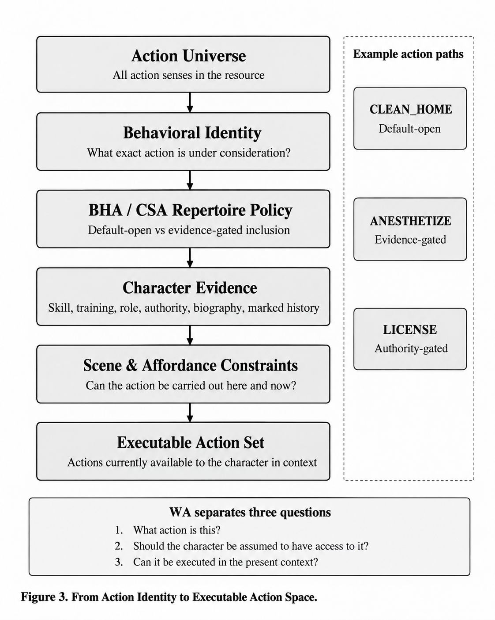
Table 4. Core logic of the BHA/CSA decision
Dimension | BHA | CSA
Baseline repertoire | Can be assumed initially without additional character-specific information. | Requires positive character evidence for initial access.
Learned competence | Action identity does not presuppose specialized technical training. | The sense constitutively presupposes learned or specialized competence.
Role / authority | No specific social or institutional status is required. | Role, responsibility, or institutional authority is constitutive of access.
Marked repertoire | Can be retained as ordinary baseline behavior. | Requires character evidence when the behavior is sufficiently marked, even if it is not technical.

4.2. Separating Repertoire from Situational Executability
A character’s repertoire-level access to an Action Sense does not imply that the action can be executed in the current scene. WA represents these decisions through separate metadata. Scene Dependency and Scene Gate Type indicate whether the action identity depends on a particular social/contextual configuration such as RELATION, ROLE, INSTITUTION, or RITUAL. Affordance Gates specify BODY, OBJECT, and WORLD conditions. A character may therefore have access to a surgical action because of competence while being unable to execute it because the required instrument is absent. Conversely, the presence of the necessary tools does not grant a specialized medical repertoire to an untrained character.
This separation is compatible with the concept of affordance: environments and agent capacities can create particular action possibilities (Gibson, 1979), but WA does not reduce repertoire membership to physical or environmental opportunity alone. For social and institutional actions, Searle’s account of status functions is also informative; actions such as authorize or license may require not only motor capacity but also a particular social status or institutional authority (Searle, 2010).
Table 5. Three distinct decision levels in WA
Layer | Question | WA mechanism
Behavioral identity | What exactly is this action? | Superclass → Family → Action Sense
Character repertoire | Can this character be assumed to have access to this sense? | BHA / CSA + positive character evidence
Situational executability | Can this action be performed here and now? | Scene Gates + BODY / OBJECT / WORLD affordances

4.3. Sense-Level Repertoire Policy
The BHA/CSA decision is not inherited at the lemma or Family level. Some senses within the same Family may be default while others are evidence-gated; the same lemma may also carry different repertoire statuses across different senses. The decision unit is Action Sense ID + Sense Variant + Definition. Polysemy is therefore preserved within repertoire policy, and generalizations such as “this verb is usually basic” do not replace exact sense-level decisions.
Figure 3 illustrates this filtering process from the global Action Universe to the character’s contextually executable action set. The resulting character behavior space is narrowed in two stages. First, the Action Universe is projected into a character-relative repertoire through BHA/CSA status and character evidence. Scene and affordance conditions then determine the executable subset of that repertoire in the current situation. Subsequent application layers may add cost, preference, morality, planning, or narrative rules to this subset. WA’s contribution is to organize semantically the behavioral access space on which these later decisions operate.

4.4. Theoretical Implications
The BHA/CSA distinction defines a defeasible repertoire policy for character modeling. It lies at the center of WA’s intermediate representation between lexical semantics and executable agent systems. The semantic layer states what an action is, the repertoire layer indicates for which characters it may be assumed, and the context layer determines whether it can be performed in the current situation. Behavioral identity, access, and feasibility can therefore be related around the same stable Action Sense without being conflated.

5. Context, Goals, and Operational Projection
Once the core architecture fixes the behavioral identity of an Action Sense, WA represents how the same action can be executed, which contexts it requires, and how it can be exposed to downstream systems through separate layers. The key principle is the separation of semantic identity from operational use. An Action Sense’s position within a Family defines what it is; Task Structure, Scene Dependency, Affordance Gates, and Action Anatomy describe its execution and contextual properties. Goal Ontology adds intentional relations, while Functional Projection adds application-facing access routes. Figure 4 summarizes the separation between stable semantic identity, goal relations, and downstream operational projection. A single action record can therefore preserve its lexical-semantic trace while also supporting more operational questions posed by narrative, agent, or planning systems.

5.1. Execution Structure and Scene Context
Task Structure is the first axis describing how an Action Sense should be treated for execution. The current resource contains 2,635 PRIMITIVE, 173 COMPOUND, 48 NOT_TASK, and 28 CONTEXT_DEPENDENT records; the field is blank for 20 new or not-yet-reviewed records. PRIMITIVE distinguishes actions that can be modeled as a single basic execution step or state transition, whereas COMPOUND marks task surfaces that may require multiple substeps or a completion chain. This distinction is not identical to task decomposition in HTN planning, but it provides a planner-facing metadata surface compatible with the primitive/non-primitive distinction used in hierarchical planning systems (Georgievski & Aiello, 2015).
Scene Dependency indicates whether the action can be resolved without establishing a specific social or institutional structure. In the current resource, 2,462 Action Senses are marked FREE and 422 are marked SCENE_GATED. SCENE_GATED records are associated with RELATION, ROLE, INSTITUTION, RITUAL, or MULTI_GATE. A physically simple action can therefore retain its contextual requirements when it depends on a particular institution or role. Rather than asking who can perform the action, Scene Gate identifies the social or institutional configuration in which the action identity can be meaningfully executed.
Table 6. Functions of execution and context layers
Layer | Core question | Resource function
Task Structure | Is the action single-step, compound, or outside task structure? | Specifies the level of execution decomposition.
Scene Dependency / Gate | Does it require a specific relation, role, institution, or ritual? | Carries contextual legitimacy and scene-requirement information.
Affordance Gates | Are the required body, object, and world conditions available? | Represents immediate physical/environmental executability constraints.
Action Anatomy | Which participant roles take part in the action? | Provides a sense-level role signature for scene construction and validation.

5.2. Affordance Gates and Action Anatomy
Affordance Gates represent the basic conditions required for an action to be executable in the current world state through BODY, OBJECT, and WORLD components. These components may occur individually or in combination. An action that is available at the repertoire level may therefore remain non-executable when a required object is absent or the world configuration is unsuitable. This structure operationalizes the repertoire–executability distinction introduced in Section 4: character evidence constrains the behavioral repertoire, while affordance metadata constrains applicability in the current situation.
Action Anatomy complements the same problem from the perspective of participant structure. The resource contains 109 distinct anatomy sequences. Signatures such as Agent + Recipient, Agent + Target, Agent + Theme, and Agent + Theme + Destination represent agentive actions, while structures containing Experiencer and Stimulus cover perception, emotion, or state-adjacent records. Action Anatomy is stored as a compact signature of the typical participant roles associated with an Action Sense. This preserves semantic role information for later scene construction, argument validation, or executable-operator mapping.

5.3. Goal Ontology: From Action Identity to Goal Relations
In WA, goal information is not embedded in Action Sense identity; it is maintained as a separate relation layer. This design allows the same Action Sense to be associated with different goals, outcomes, or contextual goal variants. The current Goal Ontology contains 4,193 relation rows covering 2,739 unique active Action Senses. Linking one Action Sense to multiple goal relations creates a one-to-many representation rather than duplicate actions. In addition, 151 Action Senses are retained as Non-Goal Exceptions for state, reaction, outcome, or instrumental surfaces that should not be forced into a direct goal relation.
The Goal Type layer distinguishes intentional statuses such as ATOMIC_INTENT, COMPOUND_INTENT, STATE_GOAL, OUTCOME_GOAL, MENTAL_ORIENTATION, and SUPPORTING_PLAN_STEP. Task Structure answers “How is this action executed?” whereas Goal Type asks “What goal-related role does this action play?” The Target and complement fields further distinguish links to persons, objects, states, or relations. Goal Ontology therefore adds intentional context for planning and narrative reasoning without turning the action inventory into a second verb hierarchy.

5.4. Functional Projection: From Semantic Authority to Operational Routing
The Functional Projection Layer re-indexes Action Senses from the core resource under operational surfaces that application systems can use more directly. The current projection workbook contains eight primary routes: SPEAK, COMBAT, INSPECT, MOVE, MAKE, USE, TAKE, and GIVE. A total of 1,392 projection rows cover 1,361 unique Action Senses. Rather than reclassifying the full core Action Universe, this layer creates reusable operational entry points for selected actions.
Each projection row preserves the core Action Sense ID and semantic metadata while adding First Intent, Second Intent, and Requirement fields. First Intent specifies the broad operational route, while Requirement identifies an implementation surface such as DIALOG, SYSTEM, ANIMATIONS, INVENTORY, UI, AUDIO, or VFX. Lexically distinct speech actions can therefore be retrieved through the same SPEAK route while preserving their exact Action Sense identities and Family information. The projection layer functions as an explicit interface between semantic authority and engine-facing routing.
Table 7. Current scope of Functional Projection
Operational route | Projection rows | Primary use surface
SPEAK | 600 | Dialog and communication routing
COMBAT | 110 | Attack / kill action routing
INSPECT | 44 | Inspection, system, and UI interaction
MOVE | 160 | Movement and animation/system routing
MAKE | 173 | Creation / transformation operations
USE | 78 | Object/system interaction
TAKE | 102 | Inventory acquisition and manipulation
GIVE | 125 | Transfer and inventory/system routing

5.5. Integrated Representation Chain
Taken together, these layers produce a sequence of independent decision surfaces rather than a single “action list.” Action Sense and Family fix semantic identity. BHA/CSA constrains the character-relative repertoire. Scene and Affordance metadata test executability in the current context. Goal Ontology describes intentional use, while Functional Projection defines the operational route in a downstream system. The same stable Action Sense can therefore be traced across lexical, character, world, goal, and implementation contexts.
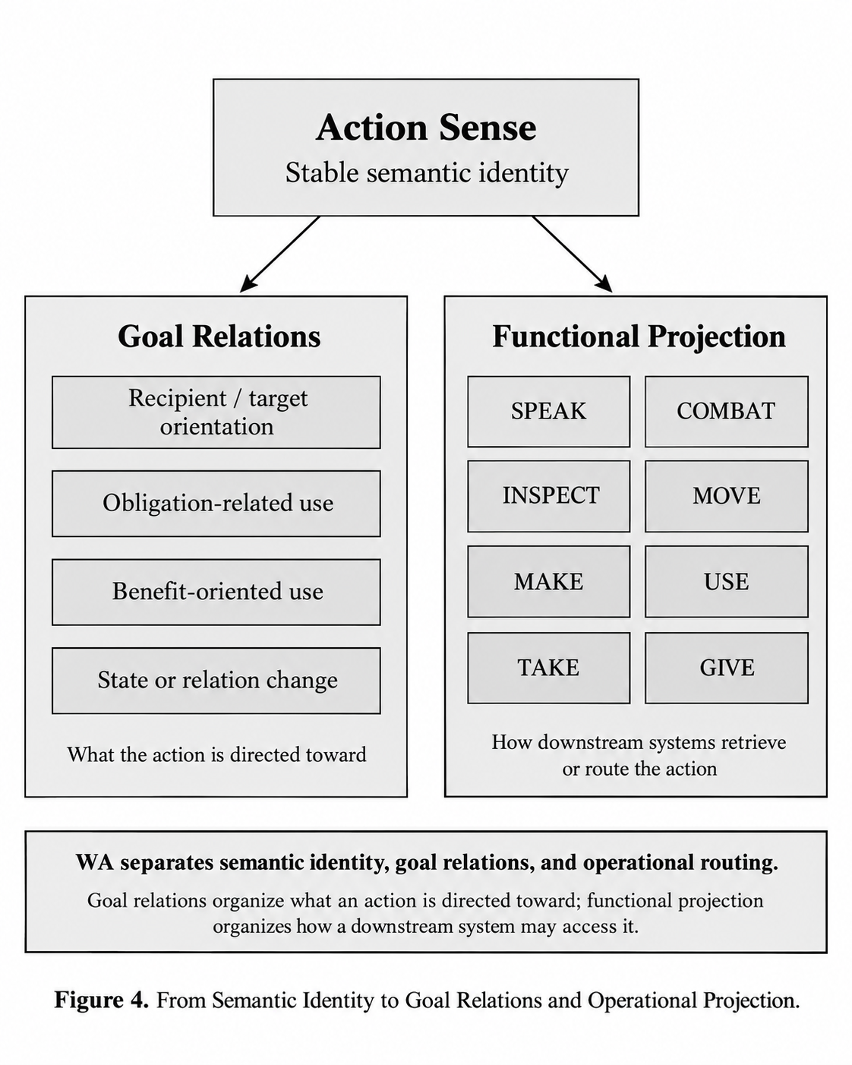
This representation is particularly relevant to narrative simulation and automated planning. Rich domain knowledge is a central input to HTN planning (Georgievski & Aiello, 2015); WA supports the construction of application-specific planner formalisms by providing reusable semantic and contextual metadata for human-oriented actions. Different applications can therefore preserve the same Action Sense authority while defining their own precondition/effect models, planner operators, animation bindings, or dialog logic on top of it.

6. Application Areas and Limitations
WA’s core contribution is its ability to preserve the same Action Sense identity across lexical semantics, character repertoire, contextual executability, goal relations, and operational routing. This makes the resource a shared behavioral substrate to which different computational systems can attach their own rules. This section discusses three near-term application areas: automated planning and domain authoring, character-centered narrative systems, and neuro-symbolic action validation. It then summarizes the scope boundaries of the current release.

6.1. Automated Planning and Domain Authoring
Constructing domain models for automated planning still requires substantial human effort. Oswald et al. (2024) identify planning-domain model generation as one of the major manual stages in AI planning and investigate large language models for generating PDDL domains from natural-language descriptions. This problem is directly related to the representational gap addressed by WA: a planner requires not only action names but structured domain knowledge about semantic identity, contextual applicability, and task structure.
WA provides a reusable starting surface for domain authoring. Fields such as Action Sense, Task Structure, Scene Dependency, Affordance Gates, and Action Anatomy clarify the behavioral unit to which an application developer can attach operator, precondition, effect, or decomposition rules. Different planners can therefore use the same semantic action authority while generating execution rules specific to their own formalisms. In projects that require broad human behavioral repertoires, this approach can reduce the knowledge-engineering cost of defining the action inventory from scratch for each application.

6.2. Character-Centered Narrative and Simulation Systems
Narrative planning has long used automated planning to generate stories, interpret narratives, and relate character actions to goals. A recent survey by Cardona-Rivera et al. (2024) shows that narrative planning supports reasoning about characters, events, and narrative affordances through a range of plan-based methods. Earlier work combining story and simulation similarly sought to connect semi-autonomous character agents with high-level story direction (Riedl, Stern, & Dini, 2006).
WA offers these systems an explicit way to constrain character action space before plan or story selection begins. The BHA/CSA layer separates behaviors that can be assumed by default from those requiring positive character evidence; Scene and Affordance metadata then determine which part of that repertoire is executable in the current scene. Character behavior can therefore be selected from an action subset that is compatible with both the character repertoire and scene conditions rather than being driven solely by global plot requirements.
The same structure can support computational tracking of character development. If a character projection is recomputed over time, Action Senses that become closed, conditional, or available can be represented as a behavioral repertoire trajectory. This does not define an “agency score.” Instead, it turns change in a character’s behavioral space into a measurable object and opens new analytical surfaces for computational narratology and interactive narrative research.

6.3. Neuro-Symbolic and LLM-Based Action Validation
Large language models are strong at natural-language generation and commonsense reasoning, yet reliably satisfying explicit constraints in planning tasks remains an active research problem. Shao et al. (2025) address constraint satisfaction in LLM-based planning through a neuro-symbolic framework that combines generation with a symbolic verifier and show that explicit symbolic feedback can improve planning accuracy. For WA, this result is not evidence of a direct integration; it illustrates a broader research direction in which structured behavioral knowledge can be paired with generative systems.
In such architectures, WA could provide a semantic constraint layer between action proposal and action validation. When an LLM or another generative agent proposes an action, Action Sense mapping can be used to check character repertoire, scene requirements, and affordance conditions. The model’s generative flexibility can thus be retained while action selection is constrained by explicit behavioral knowledge. The performance of this use case requires separate empirical evaluation; the contribution of the current resource is the explicit and traceable action representation that could support such a verifier or constrained-generation system.
Table 8. Main downstream application surfaces of WA
Application area | Layer provided by WA | Additional requirements in the downstream system
Planning / domain authoring | Sense-level action inventory; task, scene, affordance, and participant metadata | Formal precondition/effect definitions, search/planning algorithm, application-specific world model
Narrative / character simulation | BHA/CSA repertoire; goal relations; contextual executability | Character profiles, dynamic world state, narrative policy or planner
LLM / neuro-symbolic validation | Stable Action Sense and explicit behavioral constraints | Action-to-sense mapping, verifier logic, runtime integration, and empirical evaluation

6.4. Scope and Limitations
The current release provides a broad behavioral predicate resource with an explicitly defined scope. Its coverage reflects the available lexical resources, project definitions, and the semantic review process conducted to date. The BHA/CSA distinction operates as a repertoire policy for character modeling. Different applications may therefore add projection and constraint layers that reflect their own population, genre, or world assumptions.
The current release also retains several visible normalization and cross-layer integration gaps. These include legacy/alias differences at the Family identifier level and incomplete lexical or goal-layer links for a limited number of recently added Action Senses. These cases are documented in the resource documentation and define maintenance areas for later versions without preventing use of the core Action Sense architecture.
Character Projection is defined in the current release as an application contract through which character-relative access decisions can be constructed; per-character population data are left to downstream applications. This separation keeps the resource reusable across different games, narratives, and agent implementations while requiring downstream systems to model character evidence, dynamic state, and access policy explicitly.

7. Conclusion and General Discussion
Wittgenstein Apartment was developed as a sense-level behavioral predicate resource targeting the intermediate representation problem between the lexical meaning of human-oriented actions and their character-centered computational use. Its starting point is the absence of a direct mapping between the detail provided by lexical-semantic resources about action meaning and the selectable, executable action representations required by planning, simulation, and narrative systems. Rather than bridging this gap with a single operator list, WA represents action identity, character-repertoire status, contextual executability, goal relations, and downstream use as separate but connectable layers.
At the core of this approach is the Superclass → Behavioral Predicate Family → Action Sense architecture. Stable Action Sense identity distinguishes different behavioral meanings associated with the same lexical form, while the Family level provides an intensional semantic region for those senses. Metadata such as Task Structure, Scene Dependency, Affordance Gates, and Action Anatomy expose the structural and contextual conditions under which an action can be used without changing its identity. The resource therefore establishes a traceable connection between lexical provenance and application-facing action knowledge.
For character modeling, the paper’s central proposal is the BHA/CSA distinction. It asks whether an exact Action Sense can be assumed in a default repertoire before asking whether a character can physically execute the action. Basic Human Actions may enter the initial repertoire without additional character-specific evidence, whereas Character Specific Actions require learned competence, occupational experience, social role, institutional authority, or other positive character evidence. Keeping Scene and Affordance layers separate from this repertoire decision establishes a clear computational boundary among behavioral identity, repertoire availability, and situational executability.
Goal Ontology and Functional Projection extend the core in two different directions. Goal relations connect an Action Sense to different intentional and contextual target surfaces, while Functional Projection re-indexes the same semantic authority through operational routes such as SPEAK, COMBAT, INSPECT, MOVE, MAKE, USE, TAKE, and GIVE. This allows the same behavioral record to connect to planning, game-AI, narrative, or generative-agent applications without losing semantic identity in implementation-specific details.
WA’s contribution extends beyond the size of its action inventory. It proposes a representation architecture in which distinct computational questions about human behavior can be connected on the same data surface without being conflated. The resource provides reusable action knowledge for domain authoring, repertoire constraints for character-centered narrative systems, and an action-validation surface for neuro-symbolic or LLM-based systems. The performance effects of these use cases remain to be measured in application-specific empirical studies; the present work provides the explicit and traceable representation layer on which such experiments can be built.
The current release is positioned as a publishable and extensible research resource. Known normalization and cross-layer coverage differences remain visible in the documentation. The priority for future work is not continual restructuring of the core taxonomy, but demonstrating how the resource can be consumed by different downstream systems. Application studies on planner-domain generation, character-specific action filtering, narrative simulation, and symbolic validation can test WA’s practical value and identify which metadata layers carry the most information for different tasks.
Within this framework, the Wittgenstein Apartment research program focuses on a practical question: how can human-oriented actions that preserve lexical sense distinctions be represented explicitly enough for character-relative and context-sensitive computational systems? WA answers by holding semantic identity stable while separating character, world, goal, and implementation layers around it. This intermediate representation aims to provide a common and reusable working surface between lexical semantics and executable agent behavior.

References
Biletzki, A., & Matar, A. (2026). Ludwig Wittgenstein. The Stanford Encyclopedia of Philosophy. https://plato.stanford.edu/entries/wittgenstein/
Cardona-Rivera, R. E., Jhala, A., Porteous, J., & Young, R. M. (2024). The Story So Far on Narrative Planning. Proceedings of the International Conference on Automated Planning and Scheduling, 34(1), 489–499. https://doi.org/10.1609/icaps.v34i1.31509
Elson, D. K. (2012). DramaBank: Annotating Agency in Narrative Discourse. Proceedings of LREC 2012.
Fillmore, C. J., Johnson, C. R., & Petruck, M. R. L. (2003). Background to FrameNet. International Journal of Lexicography, 16(3), 235–250. https://doi.org/10.1093/ijl/16.3.235
Georgievski, I., & Aiello, M. (2015). HTN planning: Overview, comparison, and beyond. Artificial Intelligence, 222, 124–156. https://doi.org/10.1016/j.artint.2015.02.002
Gibson, J. J. (1979). The Ecological Approach to Visual Perception. Boston: Houghton Mifflin.
Kipper, K., Korhonen, A., Ryant, N., & Palmer, M. (2008). A large-scale classification of English verbs. Language Resources and Evaluation, 42(1), 21–40. https://doi.org/10.1007/s10579-007-9048-2
Lindsay, A., Franco, S., Reba, R., & McCluskey, T. L. (2020). Refining Process Descriptions from Execution Data in Hybrid Planning Domain Models. Proceedings of the International Conference on Automated Planning and Scheduling, 30(1). https://doi.org/10.1609/icaps.v30i1.6742
Miller, G. A. (1995). WordNet: A Lexical Database for English. Communications of the ACM, 38(11), 39–41. https://doi.org/10.1145/219717.219748
Mostafazadeh, N., Kalyanpur, A., Moon, L., et al. (2020). GLUCOSE: GeneraLized and COntextualized Story Explanations. Proceedings of EMNLP 2020, 4569–4586.
Oswald, J., Srinivas, K., Kokel, H., Lee, J., Katz, M., & Sohrabi, S. (2024). Large Language Models as Planning Domain Generators. Proceedings of the International Conference on Automated Planning and Scheduling, 34(1), 423–431. https://doi.org/10.1609/icaps.v34i1.31502
Palmer, M., Gildea, D., & Kingsbury, P. (2005). The Proposition Bank: An Annotated Corpus of Semantic Roles. Computational Linguistics, 31(1), 71–106. https://doi.org/10.1162/0891201053630264
Rashkin, H., Sap, M., Allaway, E., Smith, N. A., & Choi, Y. (2018). Event2Mind: Commonsense Inference on Events, Intents, and Reactions. Proceedings of ACL 2018, 463–473.
Reiter, R. (1980). A logic for default reasoning. Artificial Intelligence, 13(1–2), 81–132. https://doi.org/10.1016/0004-3702(80)90014-4
Riedl, M., Stern, A., & Dini, D. (2006). Mixing Story and Simulation in Interactive Narrative. Proceedings of the AAAI Conference on Artificial Intelligence and Interactive Digital Entertainment, 2(1), 149–150. https://doi.org/10.1609/aiide.v2i1.18770
Riedl, M. O., & Young, R. M. (2010). Narrative Planning: Balancing Plot and Character. Journal of Artificial Intelligence Research, 39, 217–268.
Sap, M., Le Bras, R., Allaway, E., Bhagavatula, C., Lourie, N., Rashkin, H., Roof, B., Smith, N. A., & Choi, Y. (2019). ATOMIC: An Atlas of Machine Commonsense for If-Then Reasoning. Proceedings of AAAI, 33, 3027–3035.
Searle, J. R. (2010). Making the Social World: The Structure of Human Civilization. Oxford University Press. https://doi.org/10.1093/acprof:osobl/9780195396171.001.0001
Shao, J.-J., You, H.-J., Cai, G., Dai, Q., Dong, Z., & Guo, L.-Z. (2025). Breaking the Self-Evaluation Barrier: Reinforced Neuro-Symbolic Planning with Large Language Models. Proceedings of the Thirty-Fourth International Joint Conference on Artificial Intelligence, 6129–6137. https://doi.org/10.24963/ijcai.2025/682
Wittgenstein, L. (2009). Philosophical Investigations (4th ed.; P. M. S. Hacker & J. Schulte, Eds.). Wiley-Blackwell.
Wittgenstein Apartment Behavioral Predicate Resource. (Version 1.0). Wittgenstein_Apartment_Behavioral_Predicate_Resource_v1.0.xlsx; Wittgenstein_Apartment_Functional_Projections_v1.0.xlsx; Behavioral Predicate Model documentation, Sections 2–11.

