Jesse Draper

CS210 Project 3

This program is designed to use a class to implement a map count of items from an input file. The program will keep key value pairs of the input and the frequency of the word. The class for the program contains the map that stores the key values pairs of words and their frequency. We first open the file for reading the inputs and create the items as part of the map in the constructor for ItemList.

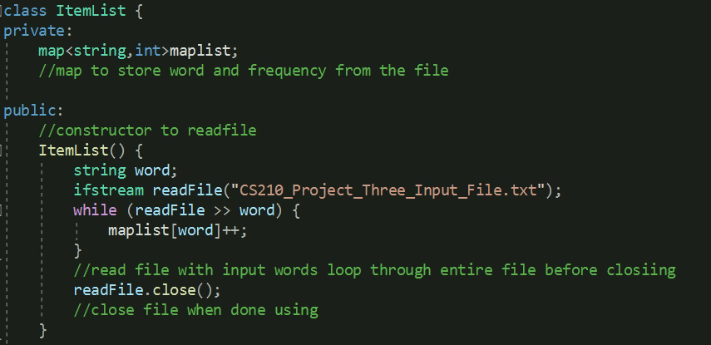

From there we build public mutators to allow searching of a word via the list created based off of user input

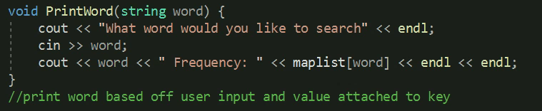

We also utilize a for loop to iterate through the values in map list. Using &const allows us to get all values for the variable in the map and iterate over the key and value pair via the first and second method.

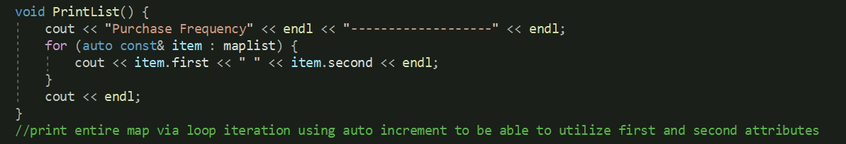

The same process is utilized for the histogram however an additional for loop is used to generate a character for the value attached to the key .

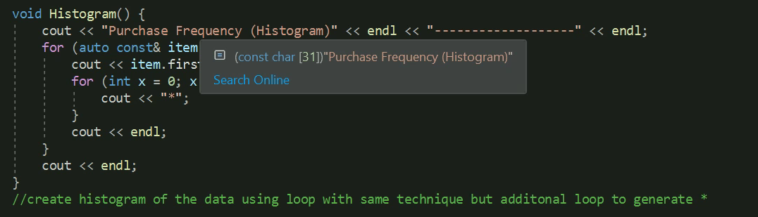

A store data method is used to create a file to output the results of the map into after it is generated.

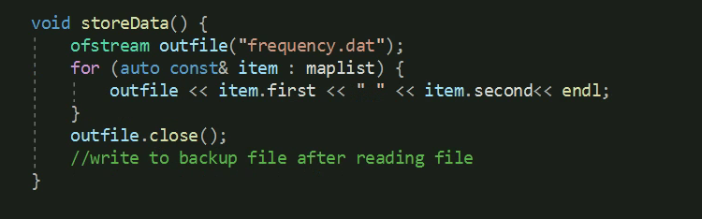

Using a menu we can use user input to determine the function called and iterate through the menu.

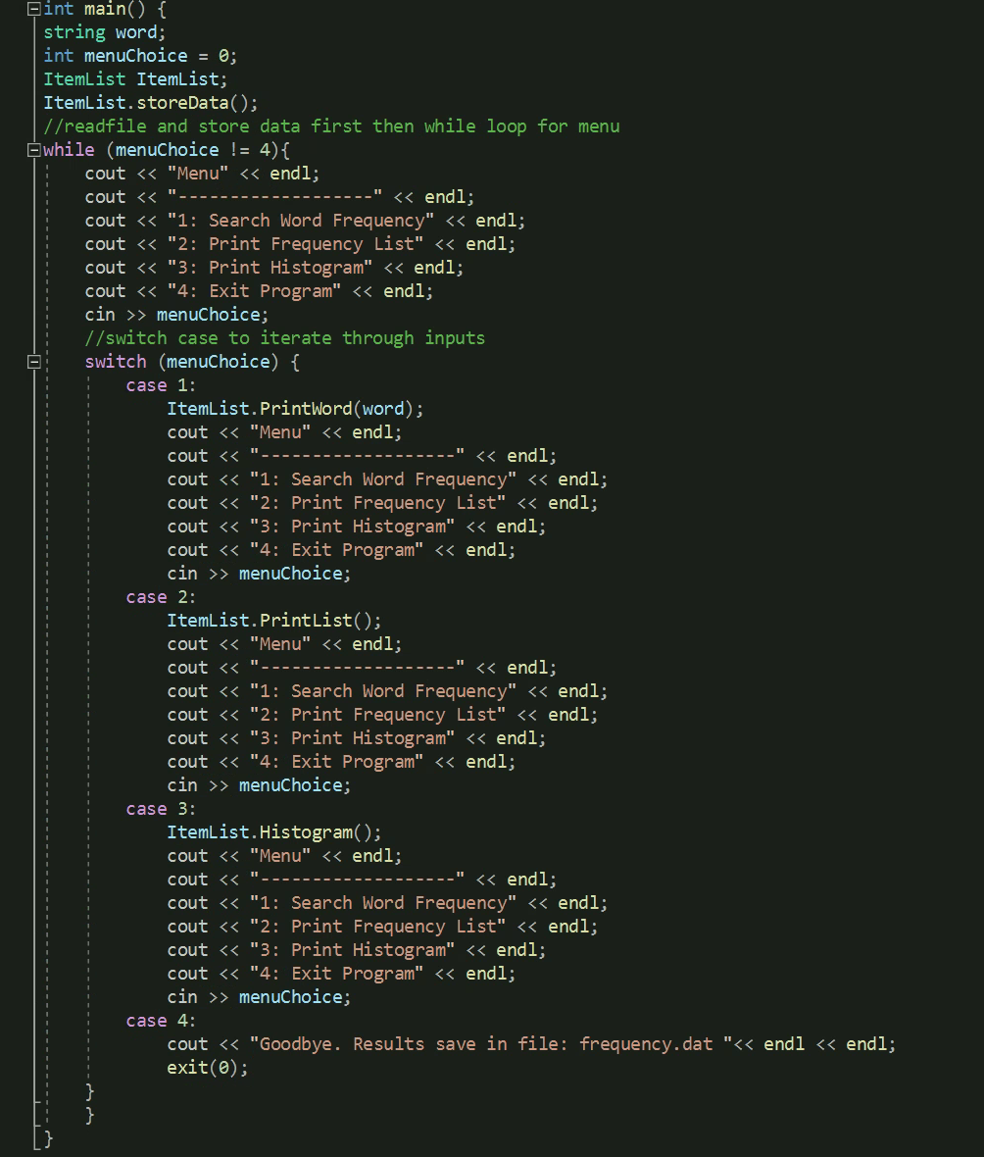

A separate function could be used for menu to dismiss repeat code.